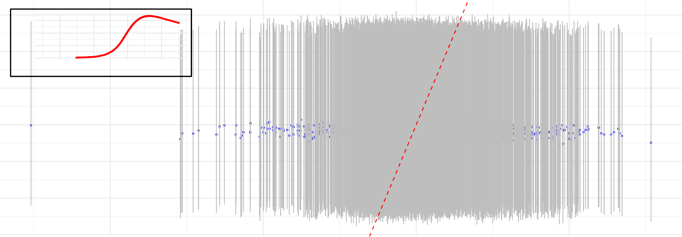
0.06−
0.04
0.02
0.00
−−
−
−
− − −
−
− − − −−− −− − −−− −− −−−−− −−− −−−−−−−−−−−−−−−−−−− −−−−−−−−−−−−− −−−−−−− −−−−−−−−−−−−−−−−−−−−−− −−−−−−−−−−−−−−−−−−−−−−−−−−−−−−−−−−−−−−−−−−−−−−−− −−−−−−−−−−−−−−−−− − −−−−−
−
−
− − −
−
−−−−−−−−−−− −− −−−−−−−− −−−−−−−−−−−−−− −−−−−−−−−− −−−−−−−−−−−−−−−−−−−−−−−−−−−−−−−−−−−−−−−−−−−−−−−−−−−−−−−−−−−−−−−−−−−−−−−−−−−−−−−−−−−−−−−−−−−−−−−−−−−−−−−−−−−−−−−− − − −− − −−−−−−
−
−− −−−−−−− −−−−−−−− −− −−−−−−−−−−−−−−−−−−−−−−−− −−−−−−−−−−−−−−−−−−−−−−−−−−−−−−−−−−−−−−−−−−−−−−−−− −−−−−−−−−−−−−−−−−−−−−−−−−−−−−−−−−−−−−−−−−−−−− −−−− −− −− −− − − −−
− − − −−
− −−−−−−−−− −− −−− −− − −− −−−−− −− −−−−−−
−− − −
−
−
−
−
−
−−−−−−−− −−− −−−− −−−−−− −−−−−−−−−−−−−−−−−−−−−−−−−−−−−−−−−−−−−−−− −−−−−−−−−−−− −−−−− −−−− −−−−−−−−− −−− −−−−−−−− − −− −−−−−
−−−−−
−
−− − −
− −
−
− −− −−− −−−−−−−−−−−−−− −−−− −−−−−− −− − −− − −−
− − − −
− −−
−
−− −
−
−
−
− −−
− − − − −−
− −− −
−
−
− −
−−
−
10
11
12
13
−
− −−
−−
−
−
−
− −
−
−
− − −
−−−−−−−−−−− − −−−−−−−−− −−− −−−−−−−−−−−−− −−−−−−−−−− −−−−−−−−−−−−−−−−−−−−−−−−−−−−−−−−− −−−−−−−−−−−−−−−−−−−−−−−−−−−−−−−−−−−−−−−−−−−−−−−−−−−−−−−−− −−−−−−−−− −−−−− −− −−−−−
−
−− −− −− − −−−− −− −−−−−−−−−−−−−−−−−−−−−− −−−−−−−−−−−−−−−−−−−−−−−−− −−−−−− −−−− − −−−−−−−−−−−−−−−−−−−−−−− −−−− −−−−− −
− − − −−
− −−−−−−−−− −− −−−−−− −− −−−−−−−− −
−−−−−−
−−
− −
−
− −
−− −− − −−
− −−
− −
−
−−
− − −
−− −− − −−− −− −−−−−−− −−−−−−−−−−−−−−−−−−−−− −−−−−−−−−−−−−−−−−−−−−−−−− −−−−−−−−−−−− −−−−−−−−−− −−−−−−−−−−−−−−−−−−−−−−−−−−−−−− −−−−−−−−−−−−−−−−−−− −−−−−−−−−−−−− −− −− −−−
−
− −−−−−− − −−− −− −−−−−−−−−−−−−−−−−−−−−−−− −−−−−−−−−−−− −−−−−−−−−−−−−−−−−−−−−−−−−−−−−−−−−−−− −−−−−−−−−−−−−−−−−−−−−−−−−−−−−−−−−−−− −−−−−− −−− −− −−−−− −− −−−− − −−
−
− −−
− −
− −− −−− − −−−−−−− −−−−−−−− −−−−−−−−−−−−−−−−− −−− −− −
− −
− −
−
−− −− − −
− − −
− −−−− −−−−−− −−− −−−−−
− − −
− −− −−
−−
−
Prediction Intervals

12.3

12.2

12.1

12.0

11.9

11.8

11.7
10 11 12 13

Observed Values

