FRD – CR-48337 Equitas Bank UCIC Login Enhancement (inSURE 2.0)
Sep 30, 2026 · @Dinesh Mehta

1. Document control
This FRD turns the Equitas Bank User Requirement Document (URD) into build-ready requirements for the insurer's login journey in inSURE 2.0 on the MERN stack.
Item | Detail
CR number | CR-48337
Title | Equitas Bank enhancement – UCIC-based login validation, pre-population and MIS
Partner bank | Equitas Small Finance Bank (bancassurance)
Insurer | Canara HSBC Life Insurance Co. Ltd
Insurer system | inSURE 2.0 (login / proposal journey)
Bank APIs consumed | Fetchcustomer v3 API, Download Doc API
Technology | MERN – MongoDB, Express.js, React, Node.js
Source | Equitas Bank URD
FRD version | 0.1 – Draft for review
Revision history
Version | Date | Change
0.1 | 30 Sep 2026 | First draft from Equitas URD

2. Background, objective and scope
Equitas Bank customers can be logged directly on the insurer application, in addition to the bank's ENVI platform. The bank requires that every such login is first validated against its records, uses bank-verified customer data, and credits the right bank staff and branch.
Objective: allow a login only for a genuine Equitas customer with an active account and a recent, closed insurance Service Request (SR) for the insurer, and carry the bank's data and credit codes through to the final MIS.
In scope
# | Area | URD ref
1 | UCIC entry and validation through Fetchcustomer v3 API | a, b
2 | SR checks: latest SR, closed status, insurer product, 30-day window | a.iv–a.vi
3 | Customer type identification (Resident, NRI, Non Individual) | c
4 | Pre-population and field editability by customer type | d
5 | City and state mapping from insurer pincode master | e
6 | Credit mapping: UCIC, LG code, SP code, Sol ID | f
7 | Payment mode restriction (DD blocked) | h
8 | Optional use of Equitas suitability via Download Doc API | i
9 | Consolidated MIS for ENVI and direct logins | j
10 | Product list enabled for the journey (9 products) | Products table
Out of scope
- Changes to the rest of the login journey after these checks; it continues as today (URD g).
- Back-office MIS layout, which is defined in the separate back-office requirement.
- Life Insured (LI) data: always entered directly in the insurer application, never pre-populated.

3. FR-01 UCIC and SR validation at login (URD a, b)
The first screen of the insurer application asks for the customer's UCIC. On submit, inSURE 2.0 calls the Equitas Fetchcustomer v3 API and applies the checks below in order. The first failing check blocks the journey with its message; if all pass, login proceeds.
Seq | Check | Block when | Proposed message | URD ref
V1 | UCIC exists | API returns no customer for the UCIC | "UCIC not found. Please check and re-enter." | a.i
V2 | Relationship exists | No Savings, Current, FD or RD account with Equitas | "No Savings/Current/FD/RD account found for this UCIC." | a.ii
V3 | Relationship active | None of the Savings/Current/FD/RD accounts is active | "No active account found for this UCIC." | a.iii
V4 | SR available | SR list is empty (no insurance SR, or no SR is closed yet – the list returns data only for closed SRs) | "No closed insurance Service Request found for the insurer." | a.iv
V5 | Latest SR valid | Latest SR (highest SR number) is not closed, or its product does not belong to the insurer | "Latest Service Request is not closed or not for this insurer." | a.iv
V6 | SR within 30 days | SR date (first 8 characters of SR number, yyyymmdd) is more than 30 days before the login date | "Service Request is older than 30 days. Please raise a new SR." | a.v
Rules
- Latest SR = the SR with the highest SR number in the SR list; all other SRs are ignored.
- SR date is parsed from characters 1–8 of the SR number as yyyymmdd. An unparseable date blocks the journey (treated as V6 failure).
- 30-day window: allowed when loginDate − srDate ≤ 30 days; blocked when greater than 30 (boundary to be confirmed, see Open questions).
- Frozen codes (a.vi): the product code and SP code of the latest SR are used for the login. Both are stored and shown read-only; the user cannot change them anywhere in the insurer journey.
- The product code must be one of the 9 enabled products (Section 6.6); otherwise V5 fails.
- Every validation attempt (UCIC, result, failing check, timestamp, user) is logged for audit.
Acceptance criteria
- ☐ Each of V1–V6 blocks with its own message when its condition is met.
- ☐ A UCIC passing all checks proceeds to the customer-type step.
- ☐ With three SRs in the list, only the highest SR number is evaluated.
- ☐ Product code and SP code from the latest SR cannot be edited later in the journey.

4. Login validation flow
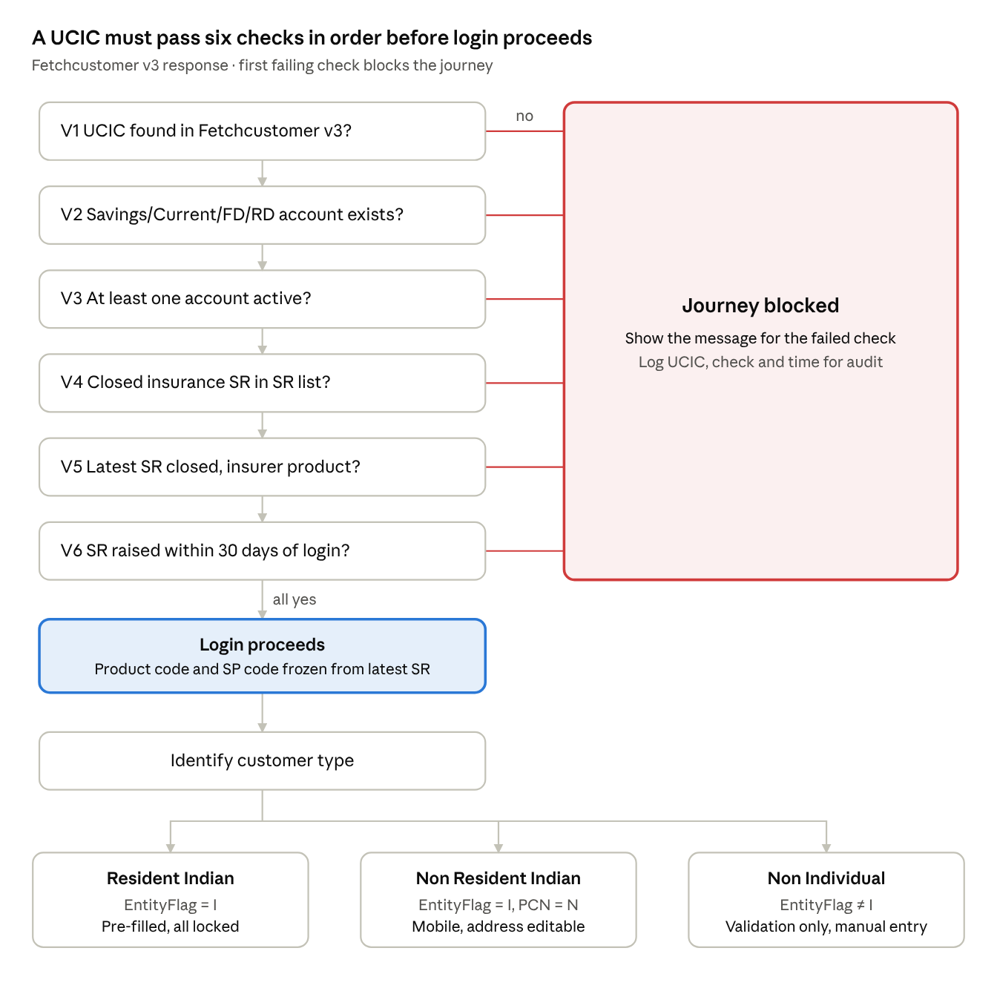
UCIC login validation · six checks, then customer type
Checks run in order and stop at the first failure; only a UCIC that passes all six reaches customer-type identification.

5. FR-02 Customer type and data pre-population (URD c, d)

5.1 Customer type
After the UCIC clears validation, the customer type is derived from the Fetchcustomer v3 response.
Customer type | EntityFlag | ProductCategoryName
Individual Resident Indian | "I" | Not "N" (exact value to be confirmed)
Individual Non Resident Indian | "I" | "N"
Non Individual | Not "I" | Any

5.2 Fields from Fetchcustomer v3
Proposer fields returned: Name, DOB, Gender, Mobile Number, Email ID, Current address, Permanent address, PAN No., and the Name, DOB and Gender linked to PAN. LI (Life Insured) details are never pre-populated; they are entered directly in the insurer application.

5.3 Pre-population and editability
Proposer field | Resident Indian | Non Resident Indian | Non Individual
Name, DOB, Gender | Pre-filled, locked | Pre-filled, locked | Manual entry
PAN No. (and PAN name, DOB, gender) | Pre-filled, locked | Pre-filled, locked | Manual entry
Mobile number | Pre-filled, locked | Pre-filled, editable | Manual entry
Current / permanent address | Pre-filled, locked | Pre-filled, editable; address proof mandatory | Manual entry
Email ID | Locked if received; editable if blank in API | Locked if received; editable if blank in API | Manual entry
Supporting documents | As per existing journey | Address proof upload mandatory when address is changed | All corresponding supporting documents mandatory
Rules
- For Non Individual customers, Fetchcustomer v3 is used only for validation (V1–V6); no data is pre-filled.
- Locked fields are enforced on the server too; a changed locked value in the save request is rejected.
- Original API values are stored alongside any edited values, so MIS and audit show both.
Acceptance criteria
- ☐ Resident: only a blank email can be edited; all other proposer fields are read-only.
- ☐ NRI: changing the address makes address proof upload mandatory before proceeding.
- ☐ Non Individual: all proposer fields are empty and editable after validation.
- ☐ LI section is never pre-filled.

6. Other functional requirements

6.1 FR-03 City and state mapping (URD e)
- From the Equitas response, take only Address 1, Address 2, Address 3, Landmark and Pincode.
- City and State are derived from the insurer's own pincode master, not from the bank's values, to avoid value mismatches.
- If the pincode is not in the insurer master, the journey shows "Pincode not serviceable / not found" and the user must correct the address (NRI) or raise it for master update (Resident, where address is locked).

6.2 FR-04 Credit mapping (URD f)
Field | Source | Editable | In final MIS
UCIC | Entered by user at the first step | No, after validation | Yes
LG code | Entered by user: Equitas sales employee code of the Lead Generator | Yes, mandatory | Yes
SP code | Latest SR in Fetchcustomer v3 response | No (frozen) | Yes
Sol ID (Branch ID) | Branch mapped to the SP code | No | Yes, in Sol ID column
Acceptance criteria
- ☐ Every login record holds UCIC, LG code, SP code and Sol ID.
- ☐ SP code and Sol ID cannot be changed by the user.

6.3 FR-05 Payment modes (URD h)
Payment mode | Allowed
Cheque | Yes
Debit card | Yes
Credit card | Yes
UPI | Yes
Net banking | Yes
BASBA | Yes
Any other digital payment method | Yes
Demand Draft (DD) | No – hidden for Equitas logins

6.4 FR-06 Equitas suitability, optional (URD i)
- If the insurer chooses to waive its own suitability and use Equitas suitability, the system takes the document ID from the latest SR in the SR list.
- It calls the Equitas Download Doc API with that document ID and stores the returned suitability document against the proposal.
- The waiver is controlled by a configuration flag, so it can be switched on or off without a release.
- If the download fails, the insurer's own suitability flow is shown (fallback).

6.5 FR-07 Consolidated MIS (URD j)
- MIS includes logins from both the ENVI platform and direct insurer-application logins, in one report.
- A loginSource column (ENVI / DIRECT) identifies the channel.
- All fields in the separate back-office requirement are included, plus UCIC, LG code, SP code and Sol ID.

6.6 FR-08 Products enabled for the journey
# | Product code | Product name
1 | IXPTM | Canara HSBC Life Insurance Young Term Plan
2 | IG2PT | Canara HSBC Life Insurance iSelect Guaranteed Future Plus
3 | GA3TP | Canara HSBC Life Insurance Guaranteed Assured Income Plan (GAIN)
4 | PFFTA | Canara HSBC Life Insurance Promise4Future
5 | PFLTR | Canara HSBC Life Insurance Promise4Life
6 | ULP3P | Canara HSBC Life Insurance Secure Invest
7 | ULT3F | Canara HSBC Life Insurance Wealth Edge
8 | SGP2IA | Canara HSBC Life Insurance Smart Guaranteed Pension
9 | To be confirmed | Canara HSBC Life Insurance Pension4Life
The product list is held as configuration; the latest SR's product code must match one of these for login to proceed.

7. Technical design (MERN)
A Node.js Equitas adapter calls the bank APIs, a rule engine applies V1–V6 from configuration, and one MongoDB login record carries customer data, frozen codes and credit fields through to MIS.

7.1 MongoDB collections
Collection | Purpose | Key fields
equitas_logins | One record per login attempt and session | ucic, validationStatus (PASS / BLOCKED), failedCheck (V1–V6), customerType, latestSr{srNo, srDate, status, productCode, spCode, documentId}, solId, lgCode, loginSource, proposalNo, createdBy, createdAt
equitas_customer_snapshot | Raw and editable proposer data | ucic, apiResponse (encrypted), prefilled{}, edited{}, lockedFields[], addressProofDocId
equitas_config | Rules without code change | srValidityDays (30), enabledProductCodes[], allowedPaymentModes[], useBankSuitability (bool), accountTypes[] (SB, CA, FD, RD)
pincode_master | Existing insurer master | pincode, city, state
sp_branch_map | SP code to Sol ID | spCode, solId, branchName
api_audit_log | Bank API calls | api, requestId, ucic, status, latencyMs, errorCode, timestamp

7.2 Express.js APIs (insurer side)
Method | Endpoint | Purpose
POST | /api/v1/equitas/ucic/validate | Calls Fetchcustomer v3, runs V1–V6, returns PASS or the failing check and message
GET | /api/v1/equitas/logins/{loginId}/customer | Returns customer type, pre-filled fields and the lock map
PUT | /api/v1/equitas/logins/{loginId}/customer | Saves proposer data; rejects changes to locked fields
PUT | /api/v1/equitas/logins/{loginId}/credit | Saves LG code; SP code and Sol ID are server-set
POST | /api/v1/equitas/logins/{loginId}/suitability | Calls Download Doc API with the SR document ID and stores the file
GET | /api/v1/payment/modes?channel=EQUITAS | Returns allowed modes (DD excluded)
GET | /api/v1/mis/equitas?from=&to= | Consolidated ENVI + direct MIS
/ucic/validate response (example)
{
"loginId": "EQL-20260930-00042",
"status": "PASS",
"customerType": "INDIVIDUAL_RESIDENT",
"latestSr": {
"srNo": "20260925001234",
"srDate": "2026-09-25",
"productCode": "IXPTM",
"spCode": "SP10231",
"solId": "1045"
}
}
Blocked example: { "status": "BLOCKED", "failedCheck": "V6", "message": "Service Request is older than 30 days. Please raise a new SR." }

7.3 Node.js services
- Equitas adapter – wraps Fetchcustomer v3 and Download Doc APIs; handles auth, timeouts, one retry on network errors, and maps bank fields to internal names.
- UCIC rule engine – runs V1–V6 in order using equitas_config; picks the latest SR by highest SR number; parses yyyymmdd from the SR number.
- Customer mapper – derives customer type from EntityFlag and ProductCategoryName; builds pre-fill and lock map; maps city/state from pincode_master.
- Credit service – freezes product code and SP code, resolves Sol ID from sp_branch_map, validates LG code format.
- MIS job – merges ENVI and direct login data into one report with loginSource.

7.4 React components
Component | Behaviour
UcicEntry | First screen; UCIC input, "Validate" button, shows the block message for V1–V6
ProposerDetails | Renders fields from the lock map; locked fields read-only; NRI address edit triggers AddressProofUpload
AddressProofUpload | Mandatory upload when NRI changes address
CreditDetails | LG code input; SP code, product code and Sol ID shown read-only
PaymentModeSelector | Uses /payment/modes?channel=EQUITAS; DD not shown
SuitabilityStep | Shows Equitas suitability document when the waiver flag is on; else existing suitability

8. Non-functional requirements
Area | Requirement
Performance | UCIC validation (API call + rules) completes within 5 seconds end to end; rule engine itself under 200 ms
Availability | If Fetchcustomer v3 is down or times out, show "Bank service unavailable, please retry" and do not allow login without validation
Security | Bank API credentials in a secrets vault; PAN, mobile, email and address encrypted at rest; PAN and mobile masked in logs and UI where not needed
Tamper-proofing | Locked fields and frozen codes enforced server-side, not only in the UI
Audit | Every validation attempt, block reason, field edit and suitability download logged with user and timestamp
Configurability | 30-day window, product list, payment modes, account types and suitability waiver held in equitas_config
Data retention | As per IRDAI and bank data-sharing agreement

9. UAT test scenarios
TC | FR | Scenario | Expected result
TC-01 | FR-01 | Invalid UCIC | Blocked at V1
TC-02 | FR-01 | UCIC with loan account only, no SB/CA/FD/RD | Blocked at V2
TC-03 | FR-01 | UCIC with only dormant/closed accounts | Blocked at V3
TC-04 | FR-01 | Active account, no closed insurance SR | Blocked at V4
TC-05 | FR-01 | Two SRs; highest SR number is open | Blocked at V5
TC-06 | FR-01 | Latest SR closed but product of another insurer | Blocked at V5
TC-07 | FR-01 | Latest SR dated 45 days before login | Blocked at V6
TC-08 | FR-01 | Latest SR dated 10 days before login, all else valid | Login proceeds
TC-09 | FR-01 | Try to change product code or SP code later | Not editable
TC-10 | FR-02 | Resident with email in API | All proposer fields locked
TC-11 | FR-02 | Resident with blank email | Only email editable
TC-12 | FR-02 | NRI changes address | Address proof upload mandatory
TC-13 | FR-02 | Non Individual | No pre-fill; all fields manual; documents mandatory
TC-14 | FR-03 | Pincode present in insurer master | City and state from insurer master
TC-15 | FR-03 | Pincode missing in insurer master | Error shown; cannot proceed
TC-16 | FR-04 | Complete login and check MIS | UCIC, LG code, SP code, Sol ID present
TC-17 | FR-05 | Open payment step | DD not available; all other listed modes available
TC-18 | FR-06 | Suitability waiver ON | Equitas document downloaded and stored
TC-19 | FR-06 | Waiver ON, Download Doc API fails | Falls back to insurer suitability
TC-20 | FR-07 | Run MIS with ENVI and direct logins | Both appear with correct loginSource
TC-21 | – | Fetchcustomer v3 timeout | Retry message; login not allowed

10. Open questions and sign-off
Open questions
- ☐ 30-day rule: is an SR raised exactly 30 days before login allowed or blocked? Is the day count calendar days?
- ☐ Resident Indian identification: exact ProductCategoryName value for residents (URD line is cut off in the source).
- ☐ Product code for Pension4Life is blank in the URD product table.
- ☐ Source of Sol ID for the SP code: returned in the SR list, or from an insurer-maintained SP–branch map?
- ☐ LG code format and validation (length, numeric / alphanumeric), and whether it is mandatory.
- ☐ Resident customer whose pincode is missing in the insurer master: block, or allow manual city/state selection?
- ☐ Is the suitability waiver switched on at go-live, and for which products?
- ☐ Fetchcustomer v3 and Download Doc API contracts: endpoints, auth, SLA and error codes.
Sign-off
Role | Name | Decision | Date
Equitas Bank – Business
Insurer – Business
Operations
Compliance
IT – inSURE 2.0
Project Manager

