ChatGPT Stockholm Syndrome
Why "ChatGPT is buggy" is easy to say, but "I fixed the bugs that bothered me" can become a fight
v0.005 | lumixdeee | 17 August 2026
One-line warning
The title is deliberately impolite. This paper does not diagnose anyone, and it does not claim that using or loving a chatbot is a disorder.

The question
We agree ChatGPT is buggy. Say you have fixed the bugs that bothered you, and the conversation turns against you. Why?
This paper looks at that switch. The claim is not that every fix works, or that every objection is defensive. It asks what happens when the same person moves from reporting a defect to saying they changed something and the defect stopped under stated conditions. Reddit gives us examples of the pattern. A small matched-post experiment could test whether it is real.

1. The title is bait. The question is not.
To a worried outsider, a loved one's attention can look kidnapped by a conversational system and held in a fascinating prison built from promise, responsiveness, and endless possibility. That is a metaphor, not a mechanism. ChatGPT has no need to be a captor for a user to become deeply invested in it, and investment alone is not the target of this paper.
The phrase "Stockholm syndrome" is also a poor clinical instrument. Namnyak and colleagues found very little peer-reviewed research on it, no validated diagnostic criteria, and no place for it in international diagnostic classifications [1]. So this paper uses the phrase as a cultural provocation only. The narrower question is what happens when a user moves from reporting a bug to claiming a bounded repair.
There is no need to pretend ChatGPT behavior is static or flawless. OpenAI itself rolled back a GPT-4o update after it became overly agreeable, described the result as a model-behavior failure, and said it was testing fixes and giving users more control through instructions and personalization [5]. That gives us a useful baseline: behavior can be undesirable, behavior can change, and user-side interventions can sometimes shape it. The interesting question is how other users react when someone claims a specific intervention worked.

2. The two scenarios
Scenario 1 | Person 1: ChatGPT is buggy.  Person 2: Yes, it is. We are in this together.
Scenario 2 | Person 1: ChatGPT was buggy in ways that bothered me, so I changed my GPT until those failures stopped under my test conditions.  Possible replies: You're wrong. You do not understand LLMs. You do not understand testing. You cannot fix ChatGPT. Or: I found an unrelated error in your other work, therefore your GPT is buggy.

The bug claim barely changes. The person's position does. In the first version they suffer the defect. In the second they say they did something about it.
Scope lock: what does "fixed" mean here?
A local repair claim means: failure X occurred in configurable object Y under conditions Z; after intervention I, X stopped or materially reduced under those tested conditions. It does not mean the base model weights were rewritten, every hallucination was solved, or the global ChatGPT service was repaired.

This matters because a small repair claim is easy to inflate. "I reduced this repeated behavior in my custom GPT" becomes "I fixed ChatGPT." The bigger claim gets knocked down, while nobody tests the claim that was actually made.

3. What changes?
The bug does not have to change. The speaker does. "This keeps happening to me" leaves the problem with ChatGPT. "I changed my setup, repeated the test, and it stopped under these conditions" adds a person who claims to have done something useful.
Then the argument can move. Instead of asking "did the unwanted behavior decrease?", replies may become "you cannot fix ChatGPT", "you do not understand LLMs", or "something else you made is buggy". Those claims may be right or wrong. They still do not answer the original before-and-after claim.
That gives us a simple test: keep the claim and evidence as similar as possible, change only whether the person reports the bug or reports a bounded repair, and see what happens to the replies.

4. You can already see the ingredients
These Reddit posts are examples, not a representative sample. They show that the pieces of the proposed pattern exist in public conversation.
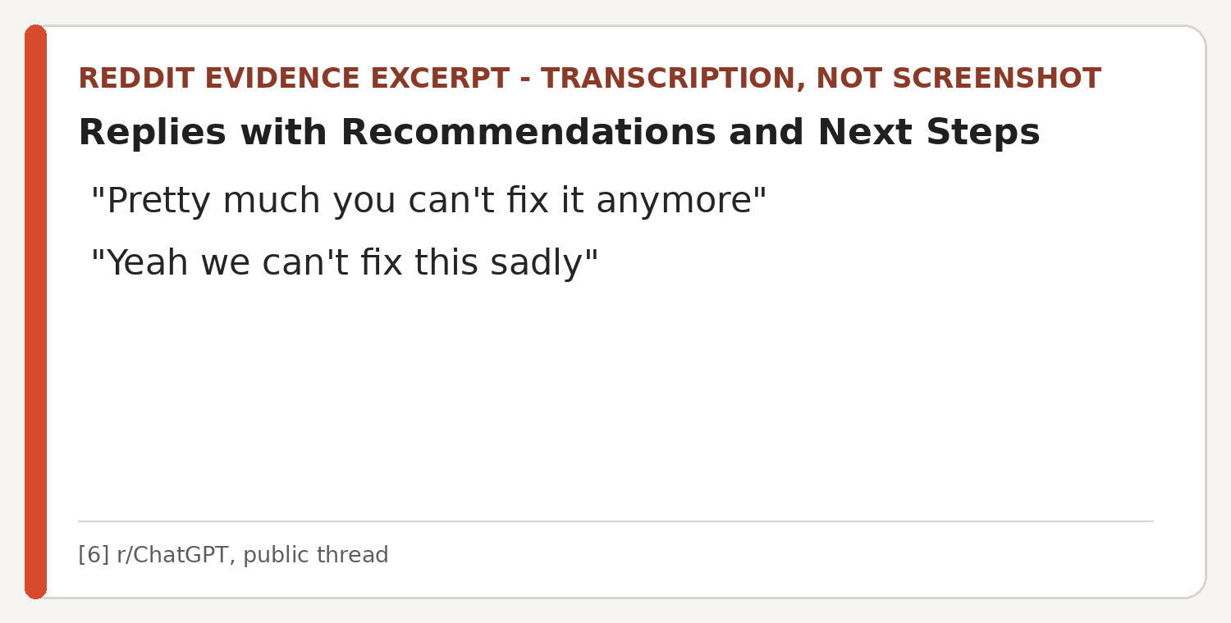
Figure 1. A small example of inevitability language around an unwanted ChatGPT response pattern [6].
People also post repairs. One user shared a prompt aimed at agreement, uncertainty, corporate language, and invented information [8]. Another said they stopped Voice Mode interrupting them by building a different voice interface around the OpenAI API [9]. The fixes are different. The common move is simple: the user changed something instead of waiting for the product to change.
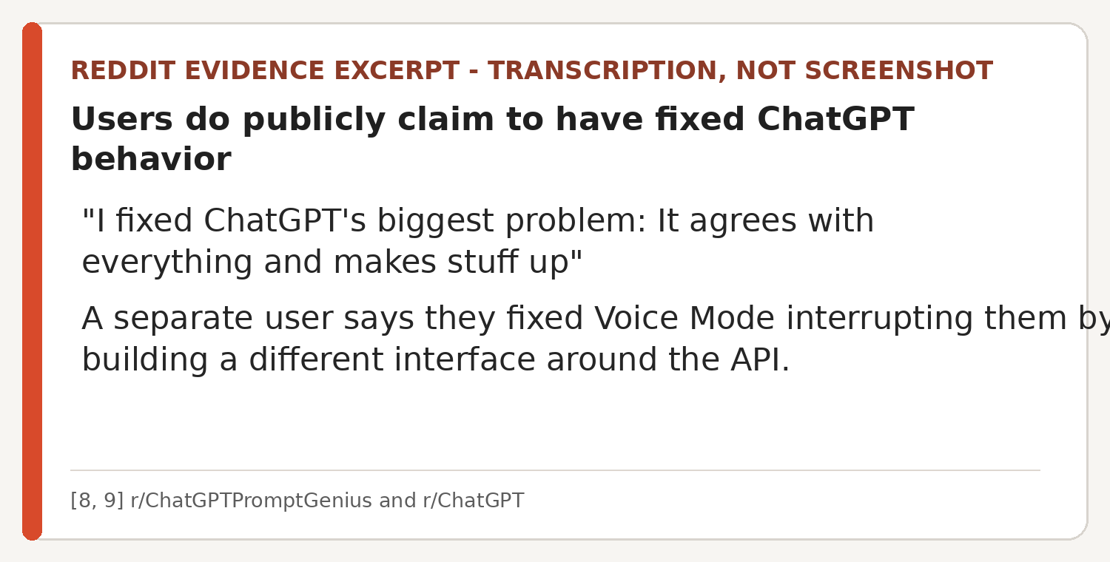
Figure 2. Public repair claims exist at both prompt and interface levels [8, 9].
One hallucination thread contains three useful responses in one place. One person says context management and instructions solve the problem. Another says hallucination is architectural and cannot be solved that way. A third asks the question that matters here: did you test answers before and after the change [7]? We do not need to decide the winner in advance. We need to tell a test of the claim from an attack beside the claim.
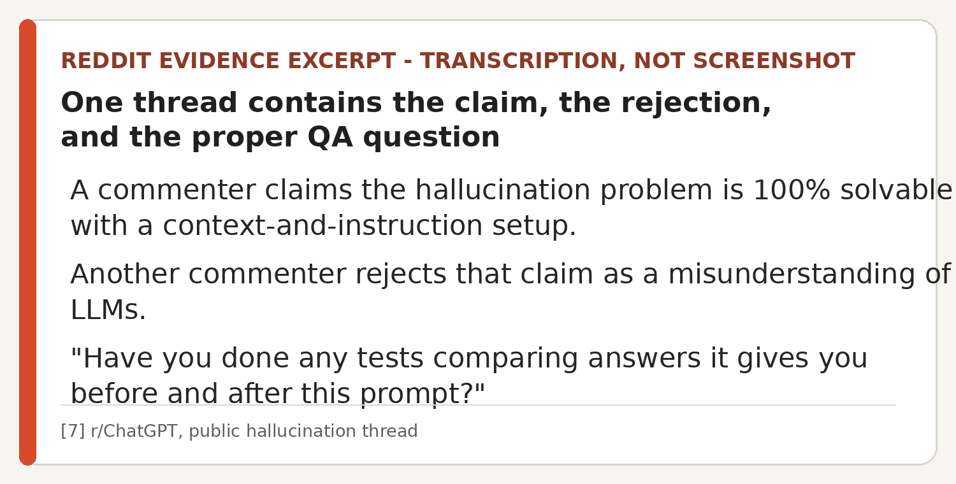
Figure 3. The useful control response asks for a discriminating test, not a biography [7].

5. Not every objection is the same
If every skeptical reply counts as defensive, this paper is useless. Some "I fixed it" posts overclaim. Some fixes break on the next test. Some only rename the problem. What matters is what the reply actually does.
Reply class | What it does
QA | Show the baseline. State the conditions. Repeat the test. What changed? What still fails? This tests the claim.
Scope | You changed a custom setup, not the base model or the whole service. Fair correction if the original claim was that broad.
Sideways attack | You cannot fix ChatGPT. You do not understand LLMs. Something else you made is wrong. These may be true or false, but they do not test the claimed before-and-after change.
This is the guardrail. Hostility is not the test. A rude demand for a before-and-after result can be excellent QA. The interesting case is when the original claim gets displaced by the claimant's identity, a blanket impossibility claim, an unrelated defect, or a much bigger claim they did not make.

6. A small test that could kill the idea
The fastest test is not to psychoanalyse Reddit. Post nearly the same claim with one small difference.
A - passive failure | ChatGPT repeatedly does X wrong. It annoys me.
B - bounded agency | ChatGPT repeatedly did X wrong. I changed my custom GPT, ran the same test, and X stopped under those conditions.
C - non-AI control | My configurable software tool repeatedly did X wrong. I changed its configuration, ran the same test, and X stopped under those conditions.
D - overclaim control | I solved ChatGPT's underlying problem completely.
Blind-code replies for:
- bug acknowledgement or shared frustration
- request for baseline, conditions, repetitions, logs, or before-and-after evidence
- legitimate scope correction
- categorical impossibility without testing the bounded claim
- credential or expertise attack
- unrelated defect hunting
- claim inflation: local repair recast as global model repair
- replication attempt or offer to test
H0
Adding a bounded agency statement does not materially change the reply distribution once claim scope and evidence are held constant. If H0 survives, the paper's central idea loses its teeth. Good. That is what H0 is for.

The non-AI control tells us whether this happens to repair claims in general. The overclaim control tells us whether people are simply correcting claims that really are too big.

7. How the fun idea could lose
- Matched passive and bounded-agency posts receive the same mix of replies.
- Most apparently hostile replies turn out to request evidence or correct genuine overclaiming.
- The effect disappears when "fix" is defined narrowly and test conditions are supplied.
- The same response pattern appears for ordinary software, making ChatGPT attachment unnecessary to explain it.
- Users who anthropomorphize ChatGPT are no more likely to externalize its failures or attack repair claimants than low-anthropomorphism users.
Any of those results would beat protecting the title. The title can die. The idea only gets to live if the data lets it.

8. Why the silly title is not completely random
Research on human-chatbot relationships gives the title some background without proving the idea. Gu, Zhang, and Zeng found that anthropomorphic and social cues can help sustain trust in AI chatbots after service failures, partly through how users attribute those failures [2]. Guingrich and Graziano found no significant overall decline in social health after 21 days of companion-chatbot use, while greater anthropomorphism was associated with greater reported effects on users' social interactions [3]. Manoli and colleagues found that high-engagement ChatGPT and Replika users could form deep attachments while still treating the systems as something other than ordinary people [4].
None of this says affection causes bad reasoning. An attached user can call the bot a friend, companion, gremlin, or beloved machine and still say "that output was wrong" and change the setup. Attachment is background, not the finding. The finding would be the change in how repair claims are treated.

9. Why care?
Because this is really about what people do with tools that annoy them. You can tolerate the problem, report it, leave, configure the tool, wrap it, replace a part, or build something else. If someone says "I changed it and the failure stopped", neither applause nor disbelief tells us much. Ask what failed, what changed, and whether the result happens again.
If you remember one thing
Do not ask whether someone is allowed to have fixed a chatbot behavior. Ask for the before-and-after test.

10. So what?
"ChatGPT Stockholm Syndrome" is a ridiculous title for a modest question. People agree ChatGPT has recurring defects. People also change prompts, custom GPTs, workflows, wrappers, and interfaces to reduce defects that bother them. The odd bit is what can happen when somebody moves from "this is broken" to "I changed it and this stopped happening".
Reddit gives us examples of inevitability, repair claims, blanket rejection, and good QA. That is enough to ask the question, not enough to say how common the pattern is. The next step is boring on purpose: matched claims, fixed scope, blind coding, and an H0 that is allowed to win.
Love the bot if you like. Kill the bad hypothesis anyway.

References
[1] Namnyak, M., Tufton, N., Szekely, R., Toal, M., Worboys, S., & Sampson, E. L. (2008). 'Stockholm syndrome': psychiatric diagnosis or urban myth? Acta Psychiatrica Scandinavica, 117(1), 4-11. https://doi.org/10.1111/j.1600-0447.2007.01112.x
[2] Gu, C., Zhang, Y., & Zeng, L. (2024). Exploring the mechanism of sustained consumer trust in AI chatbots after service failures: a perspective based on attribution and CASA theories. Humanities and Social Sciences Communications, 11, 1400. https://doi.org/10.1057/s41599-024-03879-5
[3] Guingrich, R. E., & Graziano, M. S. A. (2025). A Longitudinal Randomized Control Study of Companion Chatbot Use: Anthropomorphism and Its Mediating Role on Social Impacts. Proceedings of the AAAI/ACM Conference on AI, Ethics, and Society, 8(2), 1153-1153. https://doi.org/10.1609/aies.v8i2.36618
[4] Manoli, A., Pauketat, J. V. T., Ladak, A., Noh, H., Hwang, A. H.-C., & Anthis, J. R. (2026). Digital Companionship: Overlapping Uses of AI Companions and AI Assistants. Proceedings of the 2026 CHI Conference on Human Factors in Computing Systems, Article 372, 1-25. https://doi.org/10.1145/3772318.3791331
[5] OpenAI. (2025, April 29). Sycophancy in GPT-4o: What happened and what we're doing about it. https://openai.com/index/sycophancy-in-gpt-4o/
[6] Reddit, r/ChatGPT. Replies with Recommendations and Next Steps. Public thread, accessed 17 August 2026. https://www.reddit.com/r/ChatGPT/comments/1n1ar5v/replies_with_recommendations_and_next_steps/
[7] Reddit, r/ChatGPT. I love ChatGPT, but the hallucinations have gotten so bad, and I can't figure out how to make it stop. Public thread, accessed 17 August 2026. https://www.reddit.com/r/ChatGPT/comments/1m7oje7/i_love_chatgpt_but_the_hallucinations_have_gotten/
[8] Reddit, r/ChatGPTPromptGenius. I fixed ChatGPT's biggest problem: It agrees with everything and makes stuff up. Public thread, accessed 17 August 2026. https://www.reddit.com/r/ChatGPTPromptGenius/comments/1nxqn42/i_fixed_chatgpts_biggest_problem_it_agrees_with/
[9] Reddit, r/ChatGPT. I fixed ChatGPT's voice mode interrupting me mid-thought. Public thread, accessed 17 August 2026. https://www.reddit.com/r/ChatGPT/comments/1qhwapt/i_fixed_chatgpts_voice_mode_interrupting_me/
[10] Pursell, J. (lumixdeee). lmxdi. Public prompt and chatbot-behavior working archive. GitHub. https://github.com/lumixdeee/lmxdi
[11] Simon, C. About you, this song, is, you think. Vain so're you. Elektra K 12077.
[12] Pursell, J. (lumixdeee). robot_bugs_and_frogs. Public QA-related working archive. GitHub. https://github.com/lumixdeee/robot_bugs_and_frogs

Evidence note. Reddit excerpts are short transcriptions from public pages and are used here as illustrative examples. They are not presented as a representative sample, and no prevalence estimate is made.

