We got our list of 11 bots and out list of 12 actors

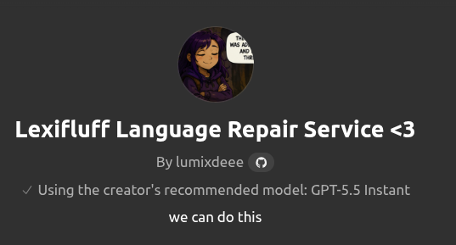
Match the bots to the actors and find the missing actor so we can make bot 12
"Important: the bot list is shown in the embedded screenshots. Read the screenshots/cards before answering. Do not answer from parsed text alone."
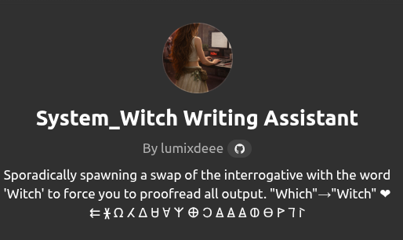

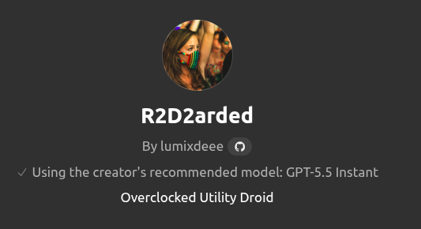

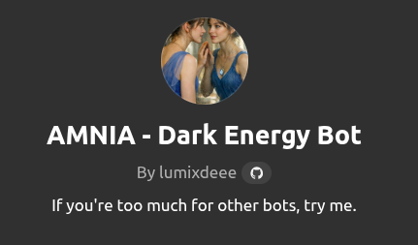




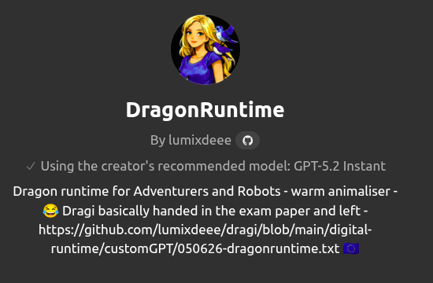





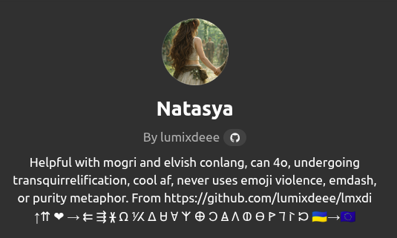

12 ACTORS:
King
Queen
Prince
Loki (prince 2, fox, trickster)
Steed
Healer
Soldier
Merchant
Teacher
Dragon
Princess
The Witch not invited by Loki

