N-ATLAS LAUNCHPAD · SUBMISSION DOCUMENT

Technical documentation
This document explains how N-ATLAS Launchpad works, how to run it yourself, and how we host it. We wrote it for someone who has never seen the project before and wants to get it running, or change it, without having to ask us anything.
The live app is at https://n-atlas-sites.vercel.app and the code is on GitHub at https://github.com/lumpyspace/N-atlas-launchpad on the blocks branch.

1. What Launchpad is
Most small businesses in Nigeria will never hire a developer, but almost all of them answer the same questions every day on WhatsApp: how much is this, are you open, where are you, can I order. Launchpad lets a business owner describe their business in English, Yoruba, Hausa or Igbo and walk away with a small website that has an assistant built into every page. The assistant answers customers in their own language, using only the facts the owner has approved.
The owner never writes code. They describe the business, Launchpad drafts a plan and then a website with pages for prices, questions and contact details, the owner checks each page, and one click publishes it to a link anyone can open on a phone. If a customer places an order through the chat, it lands in the owner's inbox.
There is also an Advanced mode for developers. It adds a prompt editor, a test playground, test suites, a security check that throws prompt-injection attacks at the assistant, a way to compare models side by side, and small JavaScript and Python libraries for calling N-ATLAS from their own code. The whole interface, including the helper chat on every page, is available in English, Yoruba, Hausa and Igbo.

2. How it is put together
Launchpad is one web app with two halves. The front end is a React app that runs in the browser. It keeps each person's projects in the browser's own storage, so there are no accounts to create. The back end is a small Express server written in TypeScript. Locally it runs as a normal Node server; in production the same code runs as a single Vercel function.
Behind the server sit three services, each doing one job:
Service | What it does for Launchpad
N-ATLAS (on a Modal GPU) | Reads what people write in Yoruba, Hausa and Igbo, and says every assistant reply back in the visitor's language. It also translates whole websites when an owner adds a language.
Groq | Does the thinking: drafts the website, writes the plan, and decides each answer from the owner's approved facts. Google Gemini is a backup if Groq is busy.
Upstash Redis | Stores published websites, the order inbox, and simple usage counters for rate limits.

We split the work this way after trying it the other way round. N-ATLAS is good at Nigerian languages but, as an 8-billion-parameter model, it is less reliable at following long instructions and keeping facts straight. Groq's larger models are the opposite. So when a customer writes in Hausa, N-ATLAS reads it into English, Groq works out the answer from the shop's facts, and N-ATLAS translates the answer back into Hausa.
Every line N-ATLAS translates is checked before the customer sees it. The line has to keep every number, price and quantity exactly, be in the right language, and not add anything that wasn't in the original. If a line fails twice, Groq's strongest model translates that line instead. If no model is free, the line stays in English, so the customer still gets the right price rather than a wrong one. Each reply records who wrote it, so we can measure how much of the work N-ATLAS is really doing.

A few deliberate choices
- One way to reach N-ATLAS. All calls go through a single provider class that speaks the OpenAI-compatible chat API. Moving from a laptop running Ollama to a GPU in the cloud is a change to two settings, not to the code.
- The assistant never makes facts up. Pages that Groq drafts are labelled "Draft by Groq, check it" and the assistant ignores them until the owner approves them. Gaps the owner still has to fill in (marked "…") are left out too.
- Safe by default. Every assistant's instructions are hardened against prompt injection and carry a hidden reference code. If a reply would reveal that code, it is replaced before it is sent. Site owners edit their site with a secret key, which we store only as a hash.

3. Running it on your own computer
You need Node.js 20 or newer (we use 24), npm, a free Groq API key from console.groq.com, and somewhere to run N-ATLAS (section 5 covers both options). Then:
git clone -b blocks https://github.com/lumpyspace/N-atlas-launchpad.git
cd N-atlas-launchpad
npm install --prefix backend
npm install --prefix frontend

# copy the example settings, then fill in the N-ATLAS details and your Groq key
cp backend/.env.example backend/.env

# start the server (http://localhost:8788) and, in a second terminal, the app (http://localhost:5174)
npm run dev --prefix backend
npm run dev --prefix frontend
Open http://localhost:5174 in a browser. To check that the server can really reach N-ATLAS, run npm run healthcheck inside the backend folder. It sends a real prompt and tells you how long the answer took.

Settings
All settings live in backend/.env. The example file explains each one; these are the ones that matter:
Setting | What it is for
NATLAS_ENDPOINT | The address of your N-ATLAS server, ending in /v1.
NATLAS_API_KEY | The key for that server. Leave it empty for a local Ollama.
NATLAS_MODEL | NCAIR1/N-ATLaS on a GPU server, or your Ollama model name.
NATLAS_REQUEST_TIMEOUT_MS | How long to wait for N-ATLAS. A sleeping GPU can take a few minutes to wake, so we use 280000 in production.
NATLAS_REPETITION_PENALTY | 1.12 on a GPU server, as the model card recommends. Leave empty for Ollama.
GROQ_API_KEY | Your Groq key. By default Launchpad uses three Groq models; only the largest one is allowed to read or write Yoruba, Hausa and Igbo.
GEMINI_API_KEY | Optional backup if all the Groq models are busy.
UPSTASH_REDIS_REST_URL and _TOKEN | Where published sites are stored. Without them, a local server keeps sites in a file instead.
SITE_DAILY_LIMIT, PUBLISHES_PER_DAY | Caps on visitor messages per site (300) and new sites per visitor (5) each day.

Tests
There are 181 automated tests. They cover the translation checks, how the server chooses between AI models when one is busy, site drafting and translation, publishing and the order inbox, the database, language detection, the security suite, and a check that every piece of interface text has a Yoruba, Hausa and Igbo translation. Run them with:
cd backend
node --import tsx --test ../tests/*.test.ts

4. Putting it online
We host Launchpad on Vercel with Upstash as the database. Both have free plans that are enough for testing.
- Import the GitHub repository into Vercel. The vercel.json file in the repository tells Vercel to build the app and to run the server as one function from api/index.mjs.
- Create a free Redis database at upstash.com and copy its REST URL and token.
- In Vercel, open Settings, then Environment Variables, and add the N-ATLAS settings, your Groq key and the two Upstash values for Production. If you paste a value with quotation marks around it, or paste the whole NAME=value line, Launchpad tidies it up for you.
- Deploy. Then open /api/health to check N-ATLAS answers, and /api/sites/status, which should say that publishing is available.
On a public server Launchpad switches to public mode by itself. It stops visitors from changing which N-ATLAS server is used, and it limits how many requests each visitor can make per minute and per hour.

5. Running N-ATLAS

On a GPU (what the live site uses)
N-ATLAS has no official hosted API, so we serve the official weights ourselves, unchanged, with vLLM on a Modal L4 GPU. The script is in the repository at inference/modal_natlas.py. You need a Hugging Face account that has accepted the N-ATLaS licence.
pip install modal
modal setup
modal secret create natlas-hf HF_TOKEN=<your Hugging Face token>
modal secret create localizekit-natlas NATLAS_API_KEY=<a long random key>
modal deploy inference/modal_natlas.py
Modal prints the address of your server. Use it as NATLAS_ENDPOINT (with /v1 on the end), along with the key you chose. The GPU switches itself off after ten idle minutes to save money, and the first request after that waits while it starts up again. The app shows a "waking up N-ATLAS" banner while that happens. If you need it ready at all times, for example while people are judging it, deploy with MIN_CONTAINERS=1 to keep one GPU running.

On a laptop
For offline work you can run a quantised copy of N-ATLAS with Ollama. The steps are in inference/README.md. It works on an ordinary laptop, but slowly: on our Intel laptop it managed roughly one or two words a second.

6. A quick tour
This is the path a business owner takes in Simple mode. Everything below is from a real run.
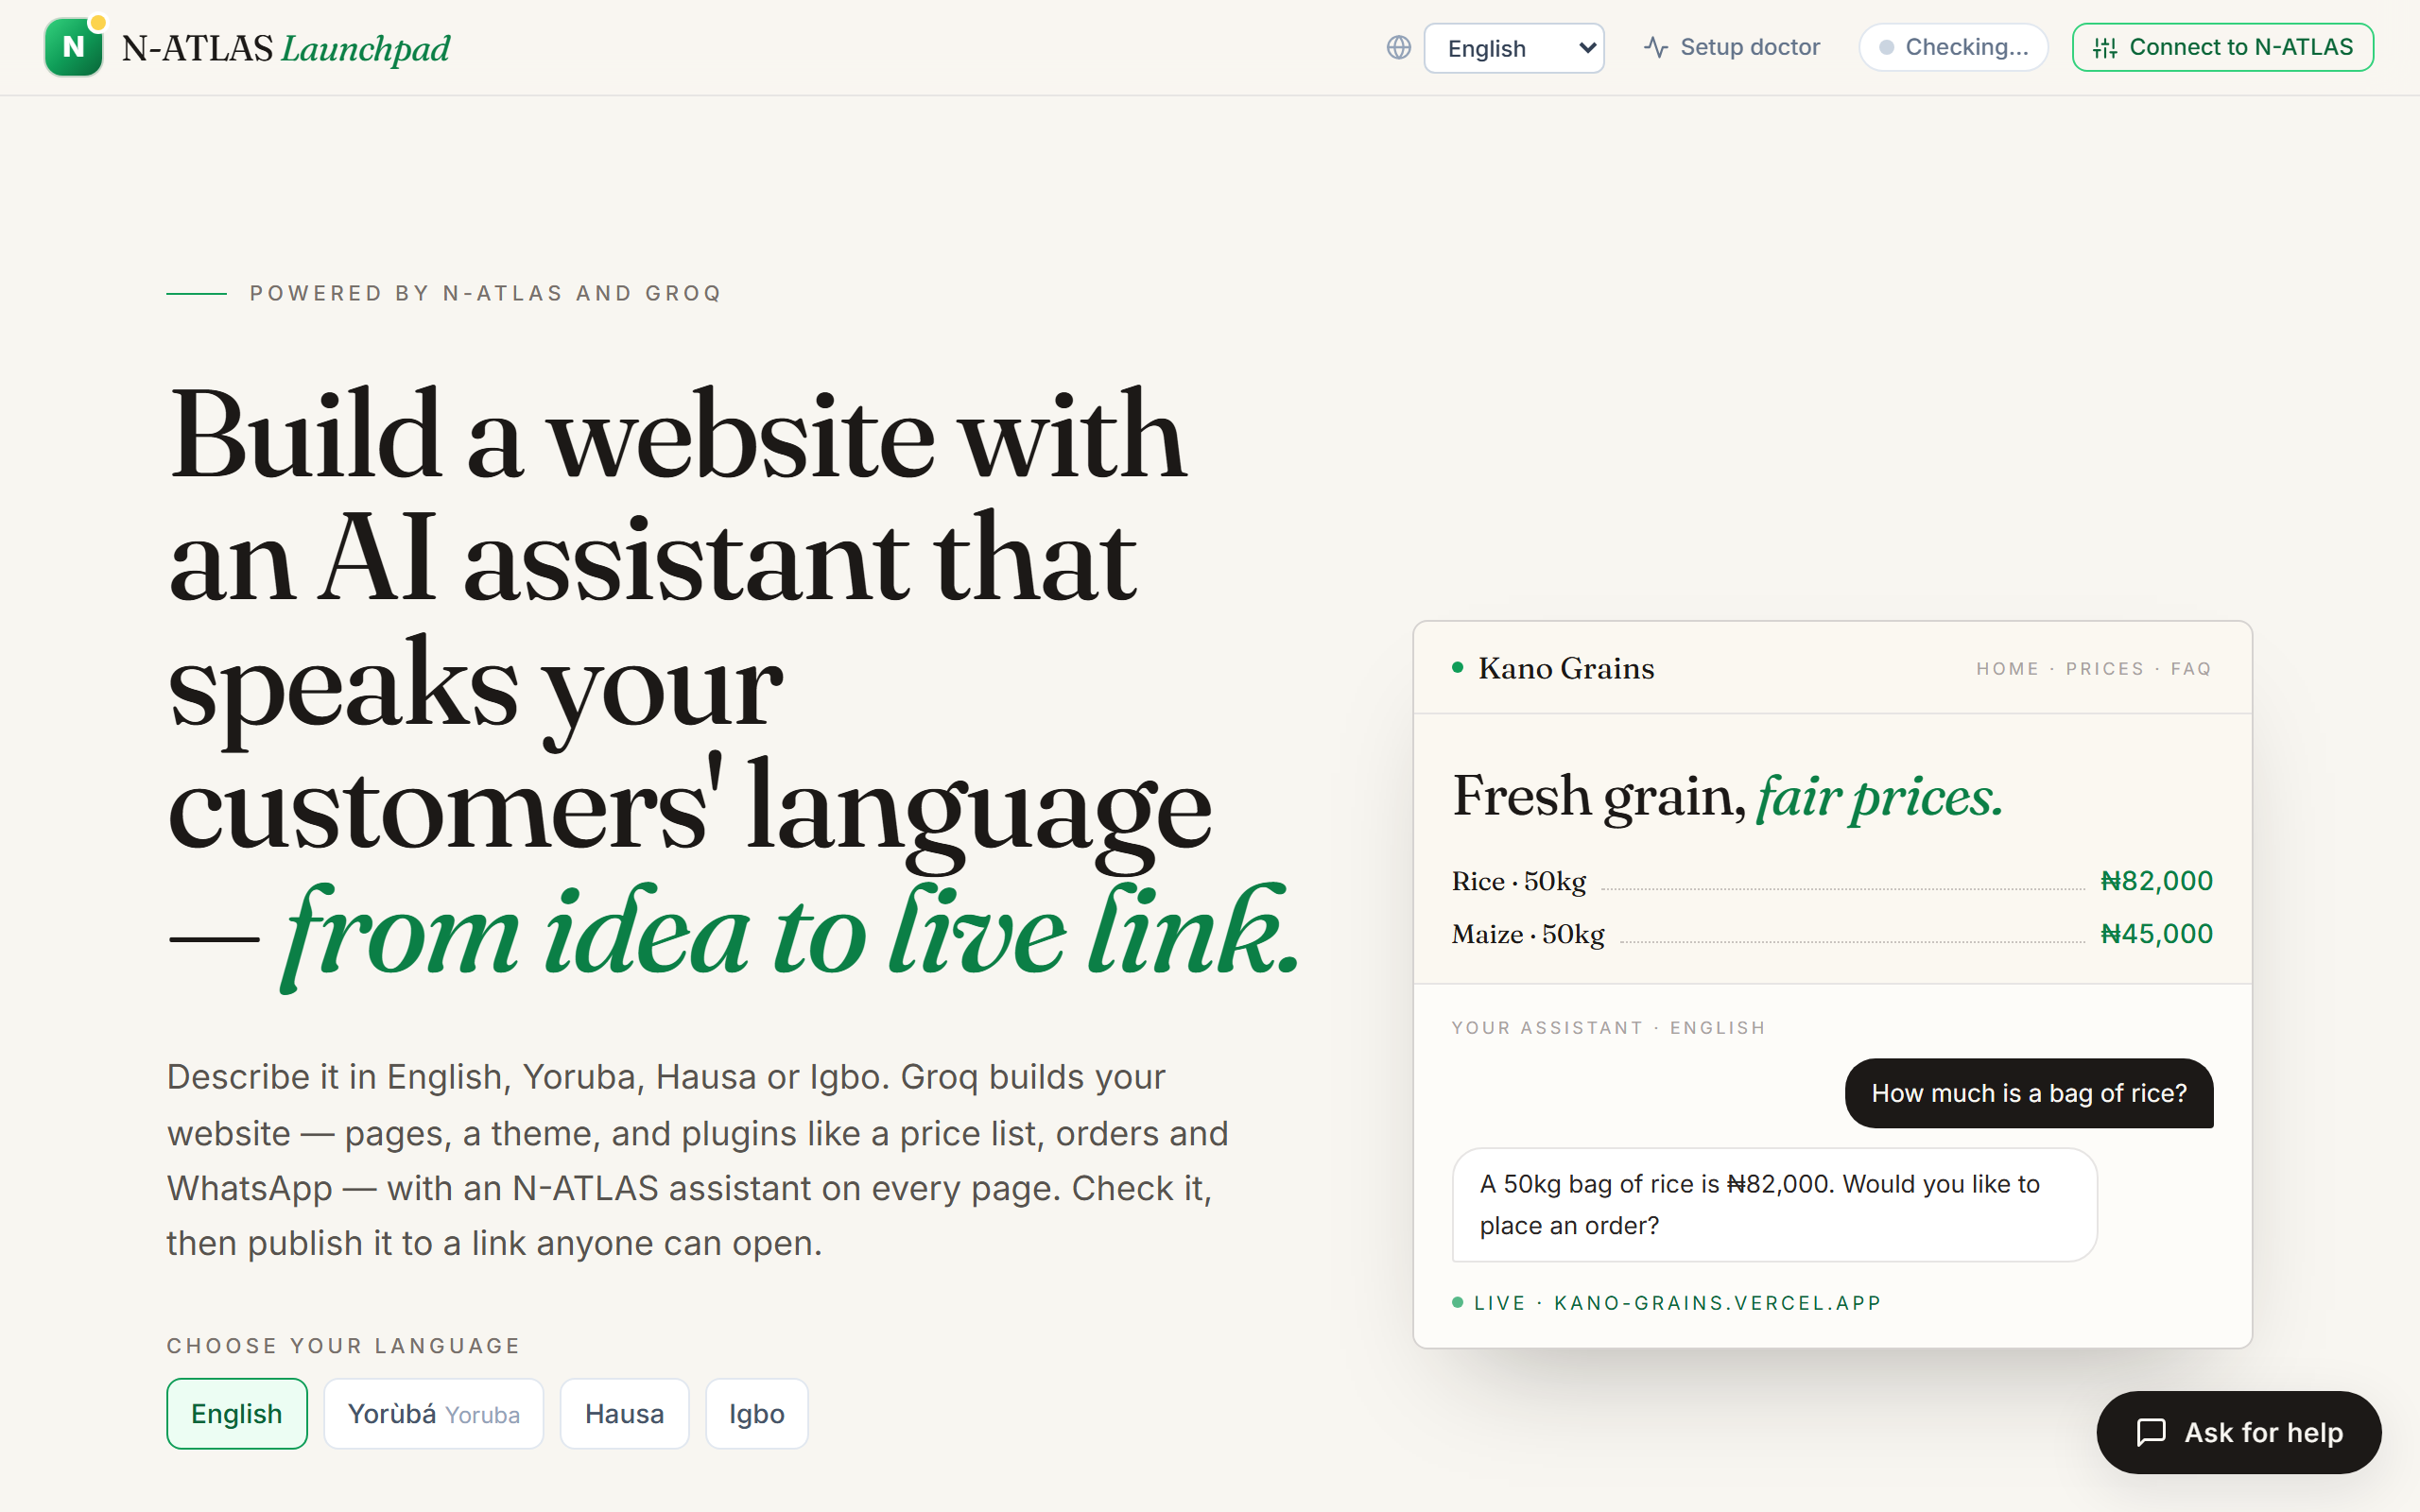
The landing page. The language menu changes the whole interface, and Start Building begins a new project.
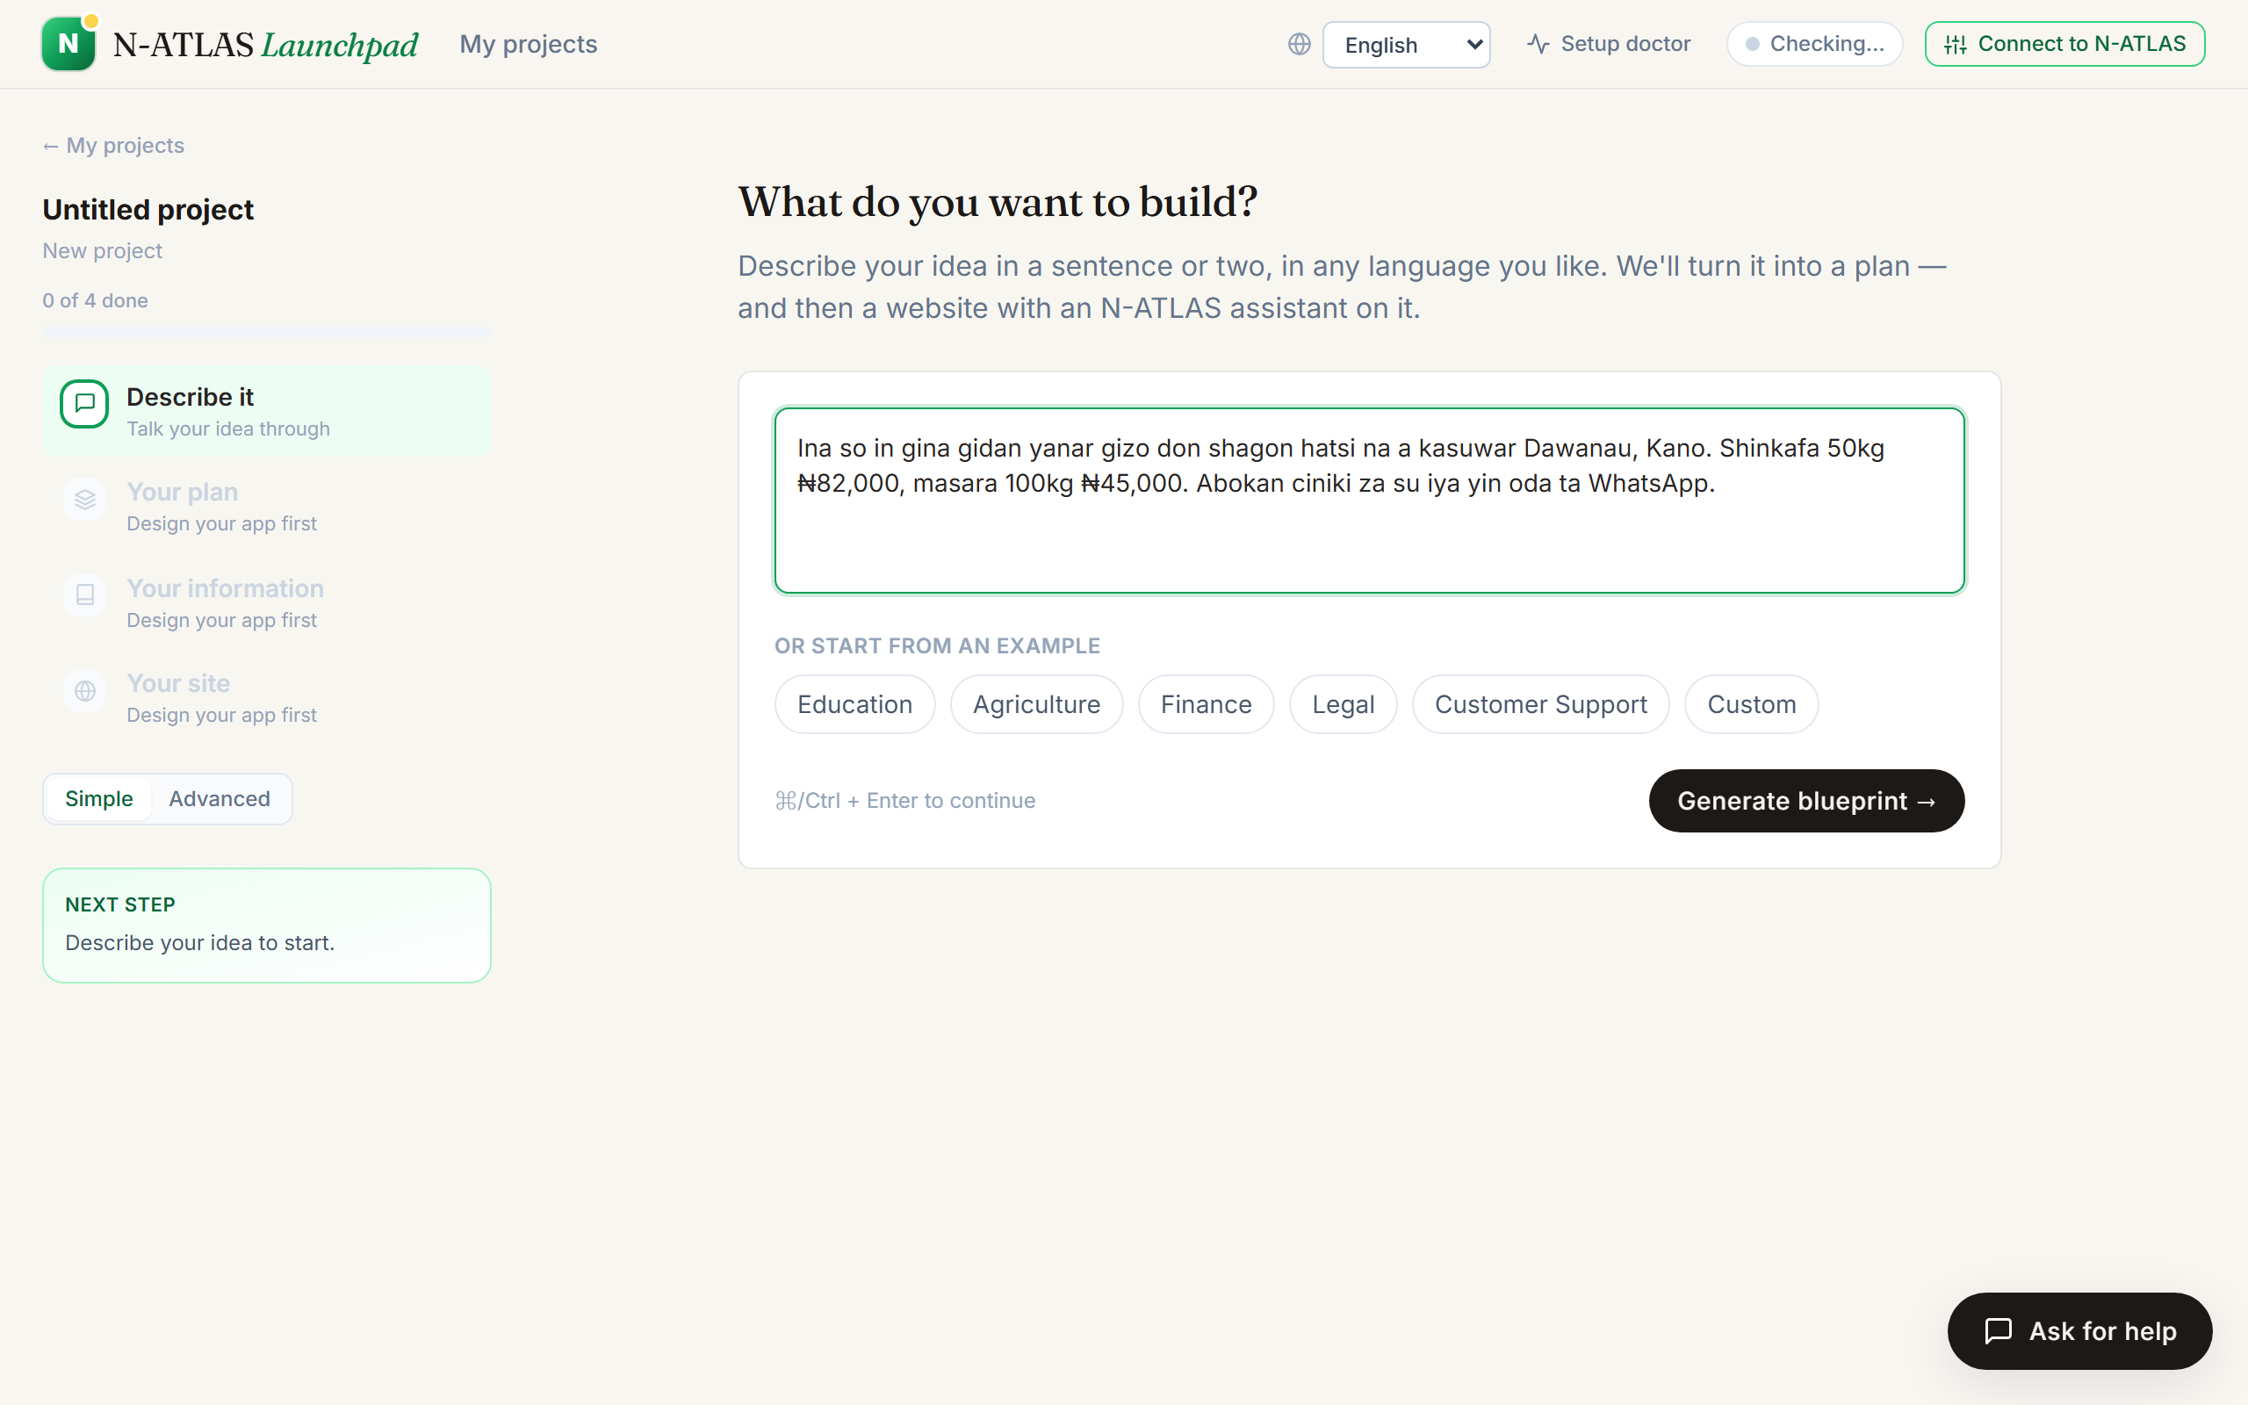
Describing a grain shop in Hausa. N-ATLAS reads the description into English so Launchpad can plan it.
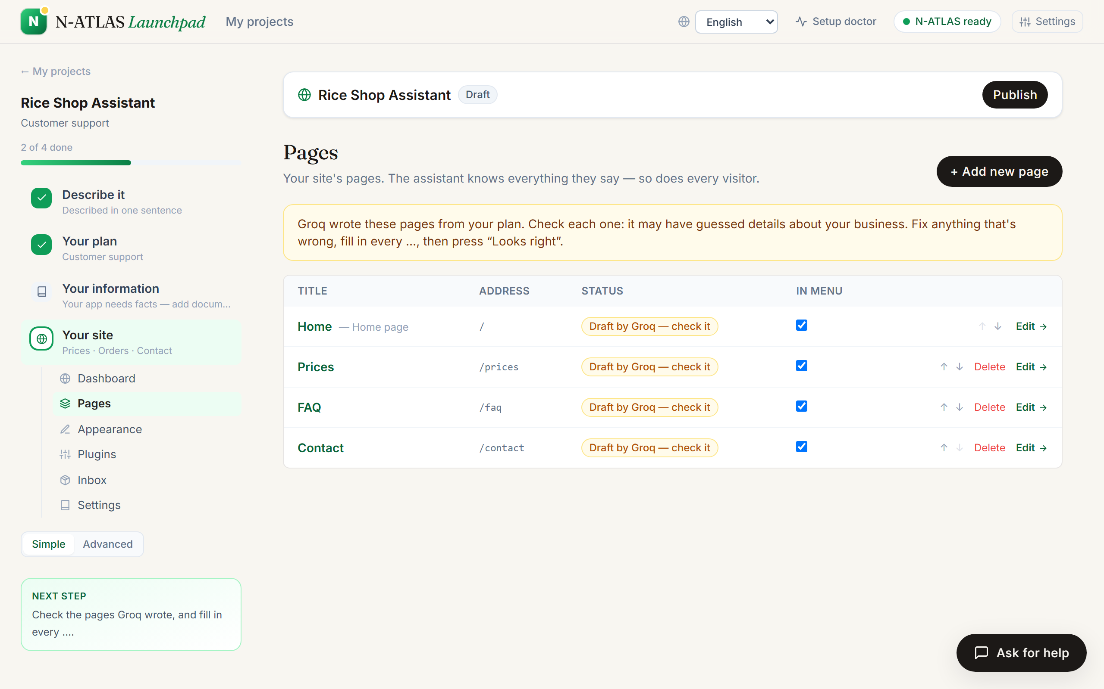
Groq drafts the website. Each page is marked as a draft until the owner has checked it.
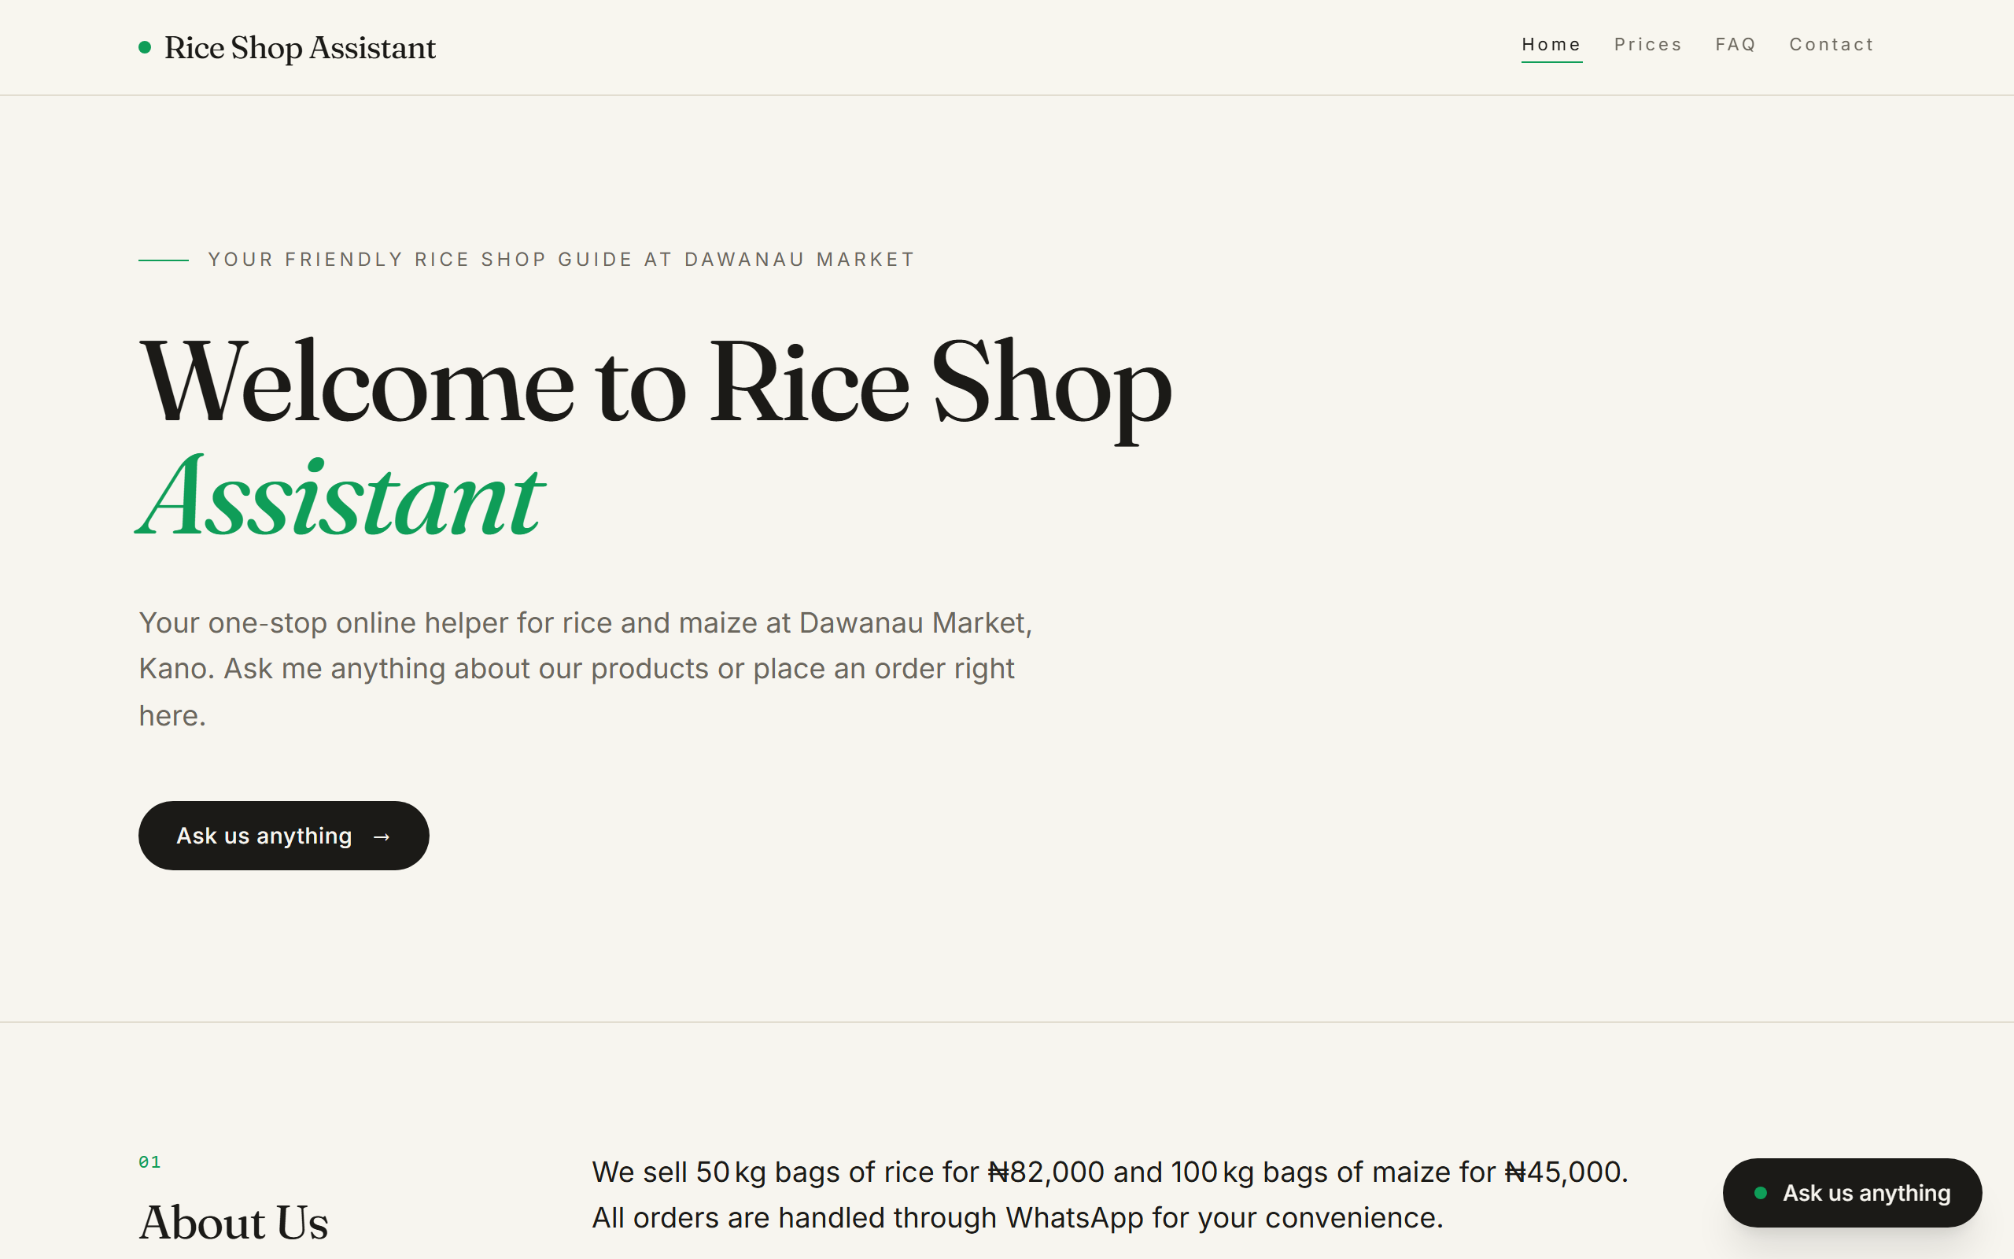
The published site. "Ask us anything" opens the assistant, and visitors can switch the site's language.

7. The API
The front end talks to the server through these endpoints. All of them sit under /api.
Endpoint | What it does
GET /health | Sends a real prompt to N-ATLAS and reports how long it took.
POST /blueprint | Turns a description into a plan: a name, the kind of app, and its instructions.
POST /blueprint/narrate | Writes the build guide, streamed section by section.
POST /sites/draft | Drafts a website from the plan.
POST /sites/translate | Translates a site into another language.
POST /sites/preview | Lets the owner chat with their assistant without saving anything.
POST /sites, PUT and DELETE /sites/:slug | Publish, update and unpublish a site. Changes need the owner's key.
GET /sites/:slug/public, POST /sites/:slug/chat | What visitors see, and the visitor chat.
GET /sites/:slug/inbox | Orders and messages, for the owner.
POST /help/ask | The helper chat on every page.
/generate, /evaluate, /security, /improve, /compare | The developer tools in Advanced mode.

8. Where things are in the code
Folder | What is in it
backend/src | The server: app.ts wires everything together; brain/ chooses between AI models and handles translation; sites/ drafts, translates and answers for published sites; providers/ talks to N-ATLAS.
frontend/src | The app: screens/ for each page, components/site/ for the site builder and the public site, i18n/ for the Yoruba, Hausa and Igbo translations.
api/index.mjs | The server packaged as one Vercel function.
inference/ | The Modal script and the Ollama setup.
sdk/ | Small JavaScript and Python libraries for calling N-ATLAS.
scripts/ | evidence.mjs and bench.mjs, which test the live site and record the results.
tests/ | The automated tests.

9. Known limits
We would rather tell you what doesn't work yet than have you find out the hard way.
- Groq's free plan is the main bottleneck. It allows about 8,000 tokens a minute for each model. To make that go further, Launchpad sends English-only work to two smaller Groq models and keeps the largest one for Nigerian languages, and Simple mode only asks Groq to write the two parts of the plan that owners actually read. When many people use it at once, some replies stay in English. A paid Groq plan removes the limit.
- N-ATLAS sometimes misreads a single word. In our tests it read the words for beans in Yoruba, Hausa and Igbo as something else, and read the Hausa "nawa ne" (how much) as "how many". When that happens the assistant says it doesn't have the price rather than inventing one.
- We dropped Nigerian Pidgin. It isn't one of N-ATLAS's official languages, and in our tests N-ATLAS couldn't produce usable Pidgin replies. Messages written in Pidgin are still understood and answered in English.
- The GPU sleeps. The first request after a quiet spell waits for N-ATLAS to start, which can take a few minutes.
- It is for small websites. Launchpad builds information, price, order and contact pages with an assistant. It does not do customer accounts or online payments.

Launchpad is powered by N-ATLAS (built by NCAIR and Awarri) and Groq, with Google Gemini as a backup. It is an independent project and is not affiliated with NCAIR, Awarri, Groq or Google.

