Lab7  
1.

       A) In an earlier lesson, it was mentioned that Java’s ArrayList implements 6 interfaces and extends one class. What are they?

Class: AbstractList

Interfaces: Serializable, Cloneable, Iterable, Collection, List, RandomAccess

Implements all optional list operations and permits all elements.

B-D) When “listsAreEqual” method is being called, it is using using original Object “equals” method which give us incorrect results.

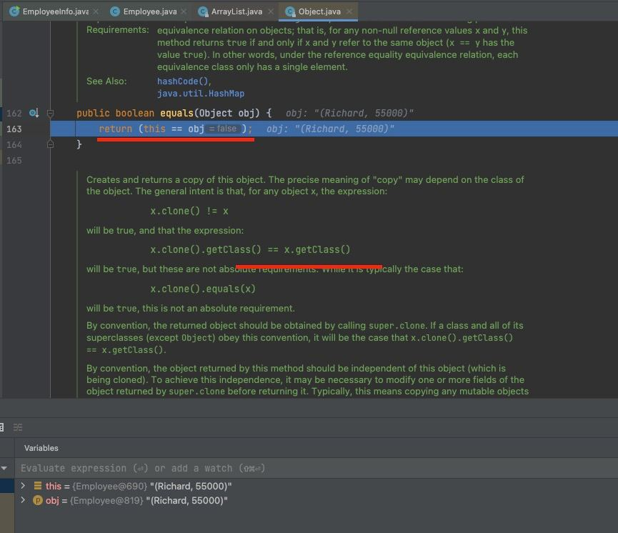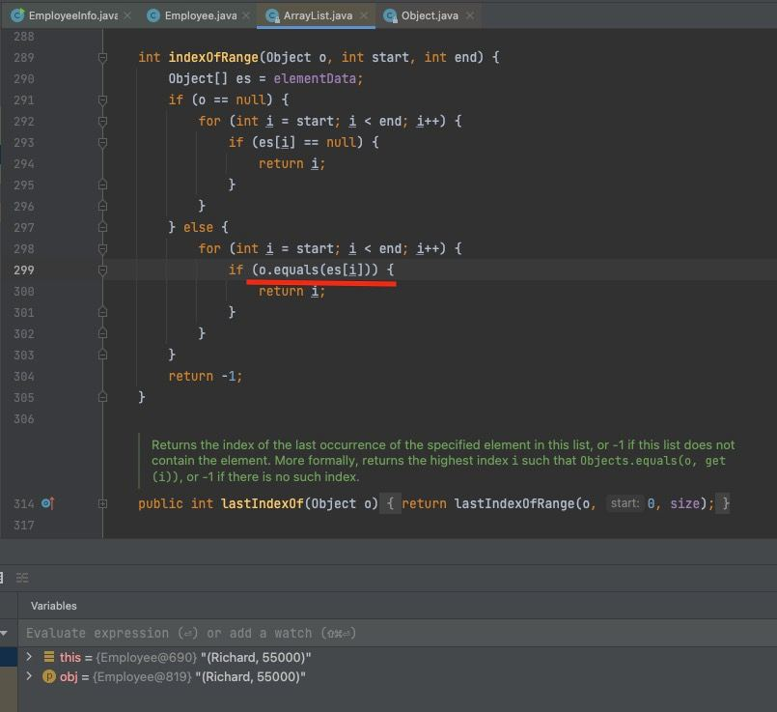

E)

i.

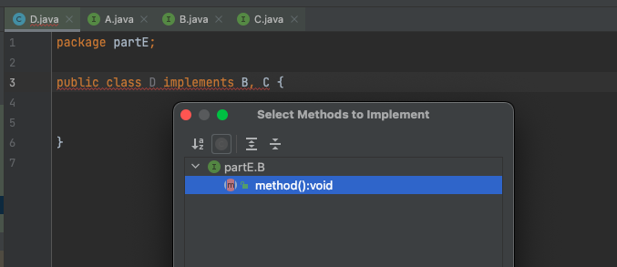

Derived interfaces and sub-interfaces would take higher precedence than other higher interfaces hierarchy.

Thus, D class would implement method() from sub-interfaces in order to resolve the conflict.

ii. Same conflict in this case as well. In order to resolve the conflict, a class must override method() while inheriting from sub-interfaces of interface A, which are B,C.