Touchstone 4 Template
Interactivity and Client-Side Data
Name: | Satomi Ito
Course: | Introduction to Web Development
Date: | 2026/9/17
Selected Client: | North Star Bakery

Important: Continue using the same client and website from Touchstone Task 2 and Touchstone 3. Submit this completed template as your single Touchstone file. Your linked project must contain the updated HTML, CSS, and JavaScript files.

Section 1: Project Link
Paste the URL to your public GitHub repository for this project. The repository should include all updated HTML, CSS, and JavaScript files required for this Touchstone.
Working Project Link: | https://github.com/luna029/Sophia_Touchstone4.git
Repository Link (if different): | https://luna029.github.io/Sophia_Touchstone4

Section 2: Implementation Explanation
Respond to every prompt below. Each response should be 2–4 sentences, refer to a specific element or behavior from your project, and explain how the implementation works. Reference your screenshots where requested.
Feature Purpose
Explain what your interactive feature helps users do and how it supports your client’s goals or audience. Identify the page where the feature appears and describe the user need it addresses.
Reference Screenshot 1 in your response.
Response:
First: I'm not very good at English, so I apologize if my writing is poor.
This is a product category filtering feature on the products.html page. It allows you to filter items—such as breads and pastries—without having to scroll through the entire product list, making it easier to find what you are looking for.

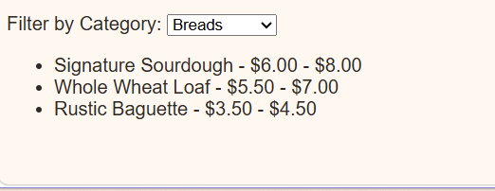

User Interaction
Describe how a user interacts with the feature step by step. Explain what JavaScript changes on the page after the user clicks, selects, or enters information.
Include the key action and the visible result.
Response:
First, the user visits the `products.html` page and clicks "Filter by Category." Next, they select "Bread," "Pastries," and "Cakes." The JavaScript `onFilterChange()` function executes and generates `<li>` elements. As a result, only the products matching the selected filters are displayed.

Form Validation
Identify at least two JavaScript validation checks you added to your form. Explain how invalid submission is prevented and how feedback appears near the relevant fields so users can correct their entries.
Reference Screenshot 2 and quote or summarize at least one error message.
Response:
I added two JavaScript validation checks on my `contact.html` form: checking if the name field is empty and checking if the email contains an "@" symbol. When someone leaves the name blank or types a bad email, JavaScript uses `event.preventDefault()` to stop the form from submitting. Then it displays an error message at the top of the form, such as "Please enter your name." so the user knows what to fix before trying again.
*In my environment, the error messages appear in Japanese.
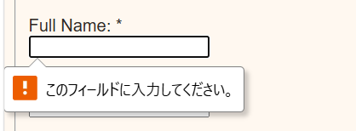

Data Storage
State whether you used localStorage or sessionStorage. Explain what data is stored, when it is saved, and when it is loaded again. Describe how this improves the user experience.
Reference Screenshot 3 and identify the restored or remembered data.
Response:
I used `localStorage` to save the user's filter selection. This improves the user experience by preserving the selection even after the page is reloaded; the screenshot shows that the choice (such as "Pastries") is remembered.

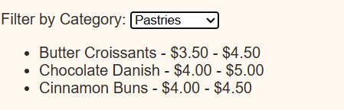

Technical Design
Explain how functions organize your JavaScript and how arrays or objects manage data. Name at least one function and one array or object, then describe what each does in your implementation.
For Advanced performance, the rubric expects at least two arrays or at least two objects.
Response:
I used functions to break the code into smaller units and an array of objects to manage the bakery's product information in one place. The `products` array stores the name and category for each bread or cake item. I created a `showProducts()` function that iterates through this array to generate the corresponding `<li>` elements on the page, resulting in cleaner, more readable code.

Challenges Encountered
Describe one specific problem you encountered while building or testing the feature, validation, or storage. Explain what was not working, how you identified the cause, and what change fixed it.
Focus on a real implementation decision rather than a general statement.
Response:
When I tested the category filter, the old items stayed on the screen and new items were added below them every time I changed the dropdown. I looked at my `showProducts()` function and realized I was appending new `<li>` elements without clearing the old ones first. I fixed this by adding `list.innerHTML = "";` at the start of the `showProducts()` function so the previous list is wiped clean before displaying the newly filtered items.

Section 3: Technical and Submission Checklist
Check each item after testing your project.
☐ One meaningful JavaScript feature responds to a click, selection, or user input. ok
☐ The feature updates the page dynamically and clearly supports the client’s goals. ok
☐ JavaScript is organized into multiple functions rather than one large block. ok
☐ At least one array or object is used to manage data. ok
☐ For Advanced performance, at least two arrays or at least two objects are used. ok
☐ At least two JavaScript validation checks are implemented. ok
☐ Invalid form submission is prevented. ok
☐ Clear validation feedback appears near the relevant fields. ok
☐ Users can correct errors without losing the information they already entered. ok
☐ localStorage or sessionStorage saves at least one meaningful piece of data. ok
☐ Stored data is loaded when the relevant page opens or reloads. ok
☐ All previous HTML, CSS, navigation, media, and form functionality still works. ok
☐ The working project link is included and opens without requiring sign-in. ok
☐ All six explanation sections are complete and use project-specific examples. ok
☐ At least three screenshots and captions are included below. ok

Section 4: Screenshots
Insert at least three clear screenshots. Crop each image so the relevant feature is easy to see, and add a short caption that explains what the screenshot proves.
Screenshot 1: Interactive Feature in Use
Show the feature after a user action and the resulting dynamic update on the page.
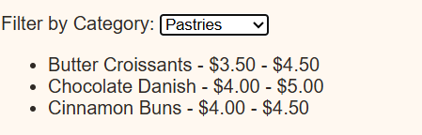
Caption: _ I operated the filter.___________________________________________________________
Screenshot 2: Form Validation Feedback
Show at least two validation messages displayed near the relevant fields while submission is prevented.
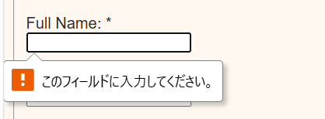
Caption: __ "Please fill out this field" error. In my environment, it is displayed in Japanese.__________________________________________________________
Screenshot 3: Browser Storage Working
Show data restored after a refresh or return visit, such as a remembered selection, saved favorite, or pre-filled field.
Caption: Filter information is retained even after reloading.____________________________________________________________

Section 5: Final Review
☐ The interactive feature works as expected after repeated testing. ok
☐ The page updates dynamically when the user takes the intended action. ok
☐ Validation prevents invalid submission and messages appear near fields. ok
☐ Valid form entries can proceed without unnecessary errors. ok
☐ Stored data saves and reloads correctly after refreshing or reopening the page. ok
☐ No JavaScript errors appear in the browser console during normal use. ok
☐ Navigation and relative file paths work across all pages. ok
☐ The project remains readable and usable at mobile and desktop widths. ok
☐ The submitted link and all screenshots match the final version of the project. ok

Section 1: GitHub Repository
Paste the URL to your public GitHub repository for this project. The repository should include all updated HTML, CSS, and JavaScript files required for this Touchstone.
Repository URL:
https://luna029.github.io/Sophia_Touchstone4
https://github.com/luna029/Sophia_Touchstone4.git
______________________________________

Updated Final Review Items
- ☐ Public GitHub repository link included ok
- ☐ Repository opens without requiring login ok
- ☐ Repository contains all updated HTML, CSS, and JavaScript files ok
- ☐ Interactive feature works as expected ok
- ☐ Form validation prevents invalid submission ok
- ☐ Feedback appears near the relevant fields ok
- ☐ Stored data persists correctly ok
- ☐ Previous HTML and CSS functionality remains intact ok

