#### 

Software Test Report

Red Opal Innovations

Version 1

Table of Contents

Overview, Test cases, Test process – page 3

Test results – page 4 to page 11

# Overview

This document is the software test report of the testing phase of the Marks software development project. It contains the results of tests, which were executed during the testing phase.

# Test cases

|  |  |  |  |
| --- | --- | --- | --- |
| Test case ID | Test case name | Summary | Expected results |
| 1 | Numeric test 1 | Provide a set of numbers | Correct average and sum values |
| 2 | Alphabetical test 1 | Provide a set of alphabetical characters | Exception error on input |
| 3 | Numeric test 2 | Provide a set of numbers | Correct average and sum values |

# Test process

All the tests 1..3 have been done on the 30th of May. Our experienced tester L has done all the tests. She used the provided prototype marks.py and the corrected version.

# Test results

**Test 1:**

At the first run the code has produced the following error:

**NameError: name 'MarksList' is not defined at line 17**

The advice to fix the typo and rename MarkList to the markList (as Python is case-sensitive) has been transferred to the developer L

The second version has immediately produced the next error:

**TypeError: unsupported operand type(s) for +: 'int' and 'str' at line 17**

The advice to apply the input type conversion has been transferred to the developer L and she has found that the input array has been initially built as an array of str and thus inappropriate for our task with int. The code fix has been applied and the input is now converted int.

The third version has eventually run well and was also used in the further tests.

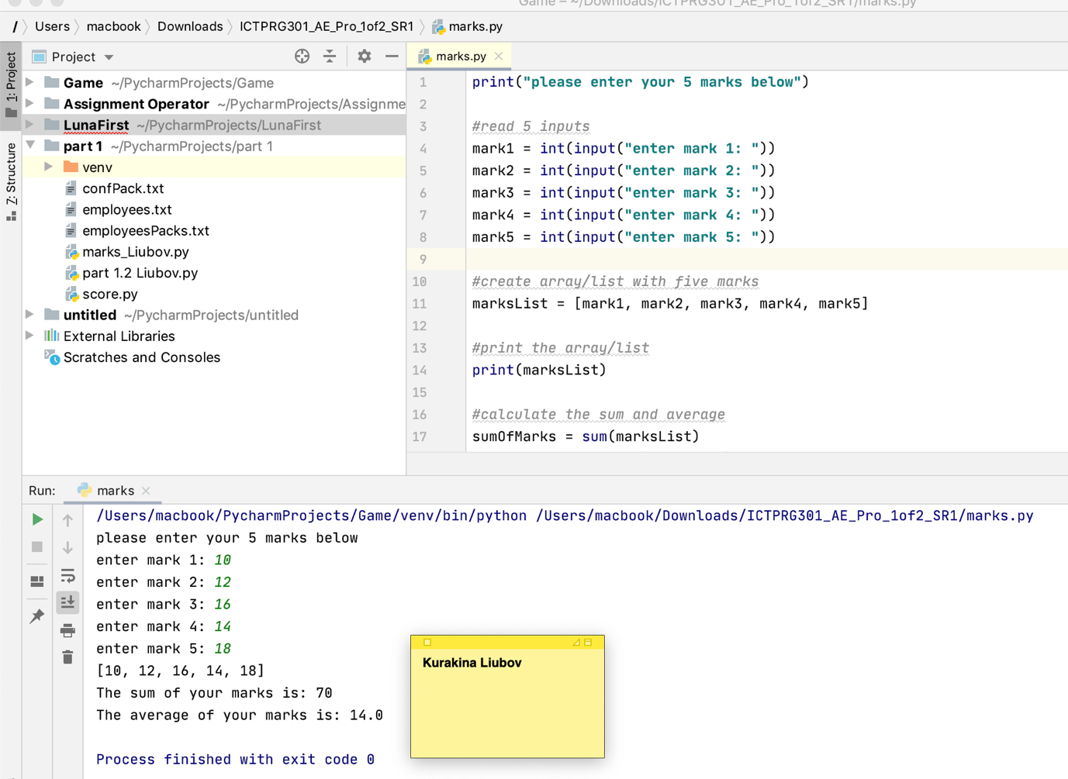

**Screenshot of the successful test on the latest code version**

**Test 2.**

At the first occurrence of the alphabetic character the program has raised the following error: **ValueError: invalid literal for int() with base 10: 'A'**

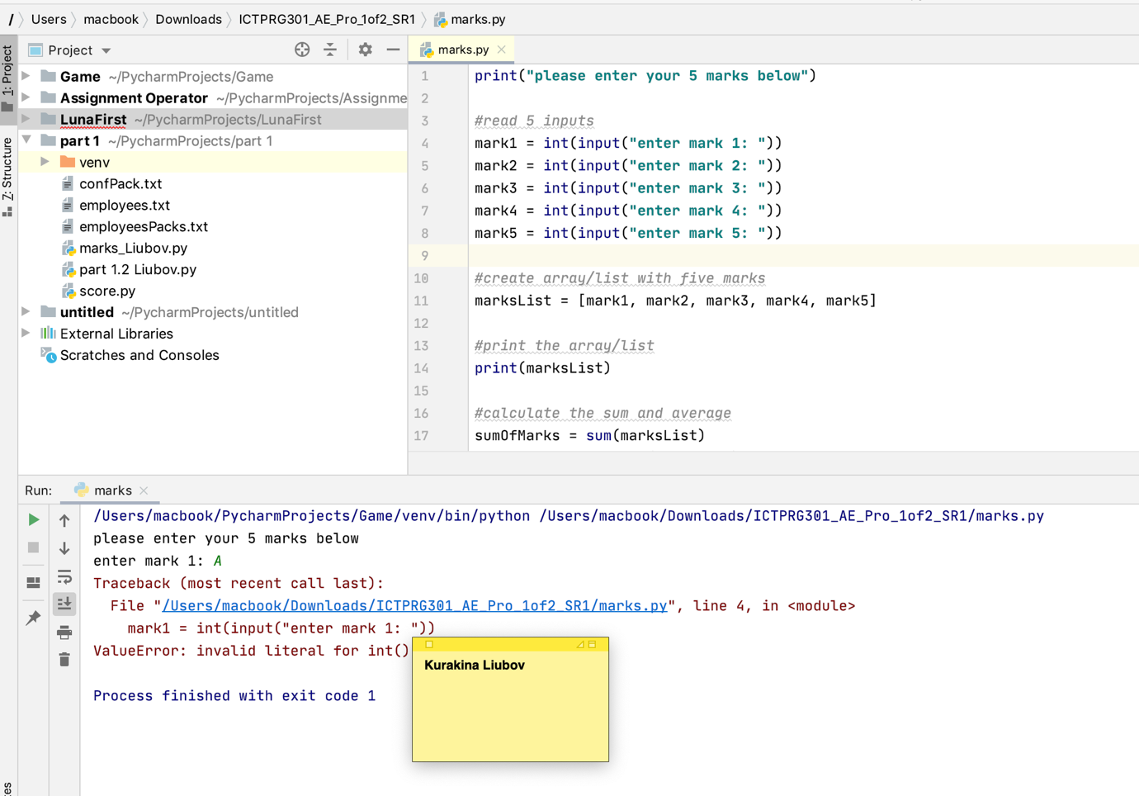

**Which is the expected result for this test**

**Test 3:**

The test has been run successfully from the 1st run.

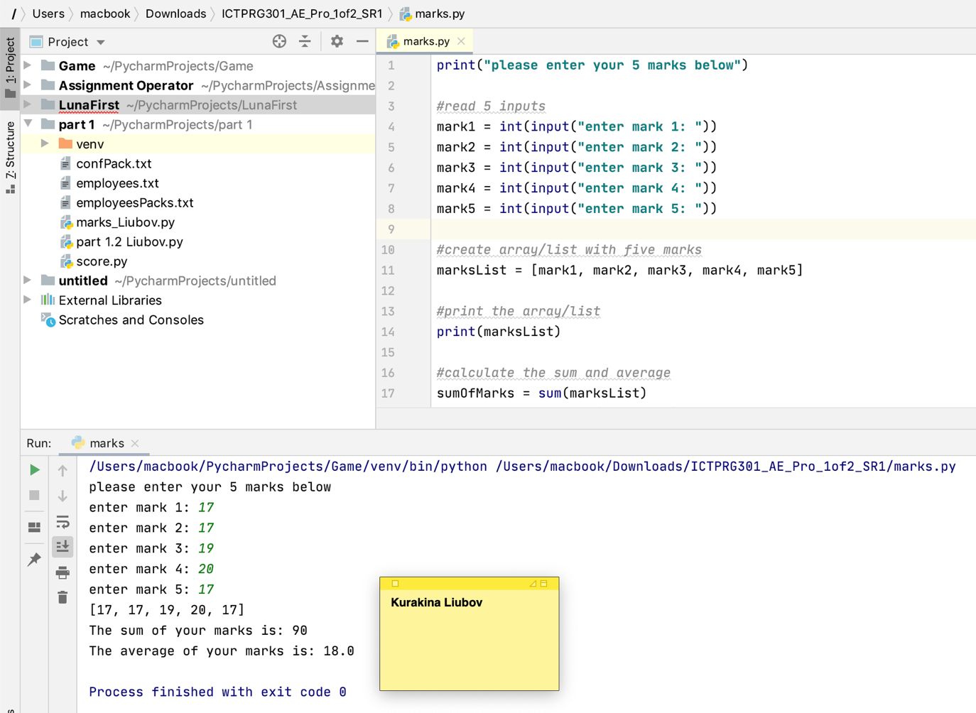

# Software evaluation

|  |  |
| --- | --- |
| Software specification | Evaluation |
| Ask user to input marks for five subjects | Passed |
| Display the inputted values | Passed |
| Calculate and display total sum | Passed |
| Calculate and display average mark | Passed |

# Software approval

Software is approved for installation by:

Name: Kurakina Liubov

Role: Lead Software Architect

Signature: {electronically signed by Liubov Kurakina}

Date: 30 May 2020