#### 

Software Test Report

Red Opal Innovations

Version 1

Table of Contents

Overview, Test cases, Test process – page 3

Test results – page 4 to page 8

Software evaluation, Software approval – page 9

# Overview

This document is the software test report of the testing phase of the Game software development project. It contains the results of tests, which were executed during the testing phase.

# Test cases

|  |  |  |  |
| --- | --- | --- | --- |
| Test case ID | Test case name | Summary | Expected results |
| 1 | Wrong nickname | Provide no nickname; Provide a whitespace. | Program handles these situations and runs normally. |
| 2 | Number out of range | Provide the number out of the given range (1..100) | Program ends with a proper error text – breaking the rules |
| 3 | Typical run – fail | Provide correct name; Give 1..6 subsequent number inputs; Be unlucky. | Program gives feedback to the user on all the stages, including the failure of guessing the number. |
| 4 | Typical run - success | Provide correct name; Give 1..6 subsequent number inputs; Be lucky this time and win the game! | Program gives feedback to the user on all the stages, including the wining. |

# Test process

All the tests 1..4 have been done on the 31th of May, the last day of Autumn. Our experienced tester L has done all the tests. She used the polished prototype version 0.9 which runs successfully on macOs.

# Test results

**Test 1:**

At the first run the code did not have any wrong name handling and was giving incorrect output:

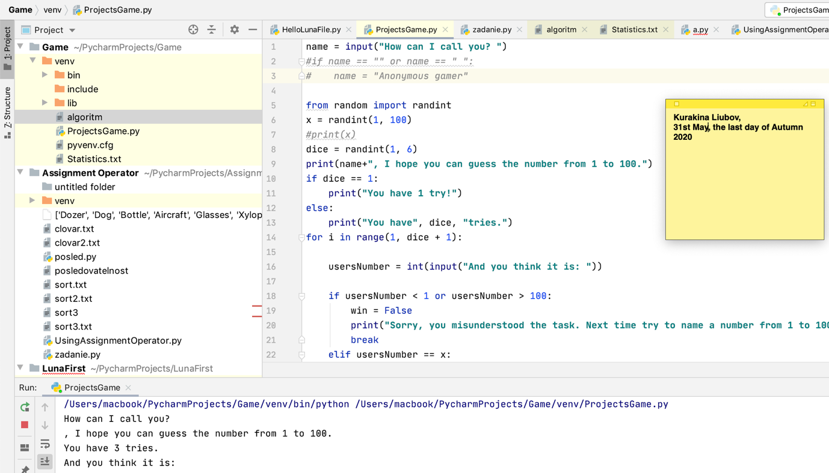

Statistics also showed improper empty name

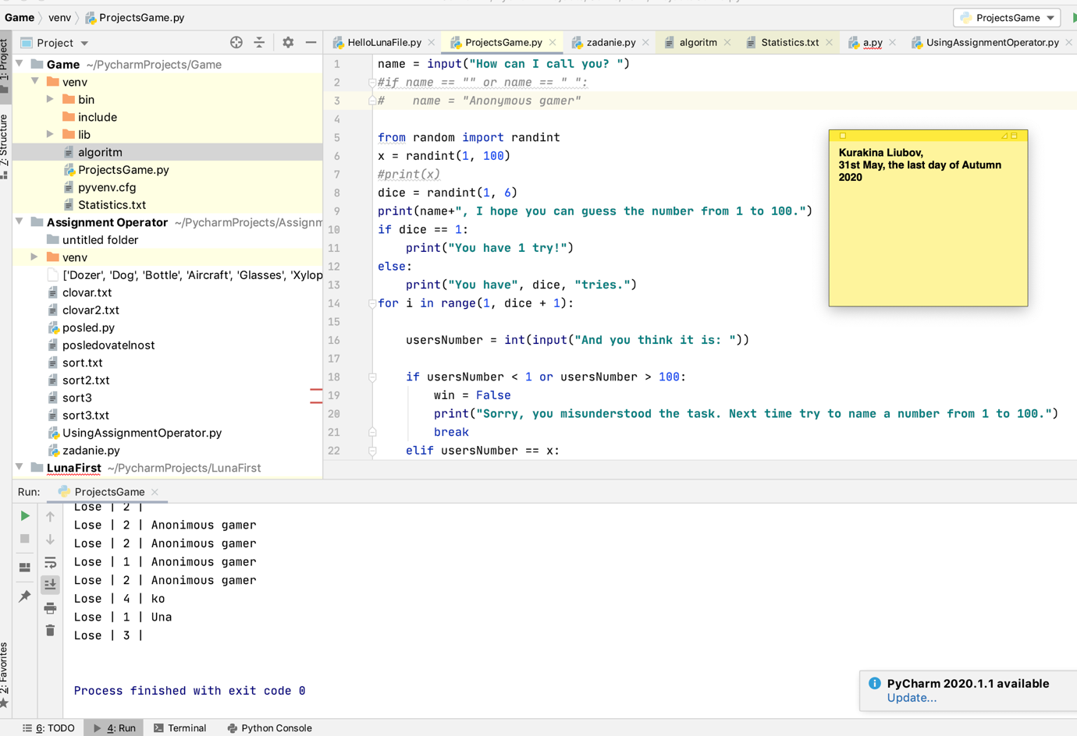

The developer L has made some changes to the code so both [no input] and [whitespace] inputs gave the same positive output:

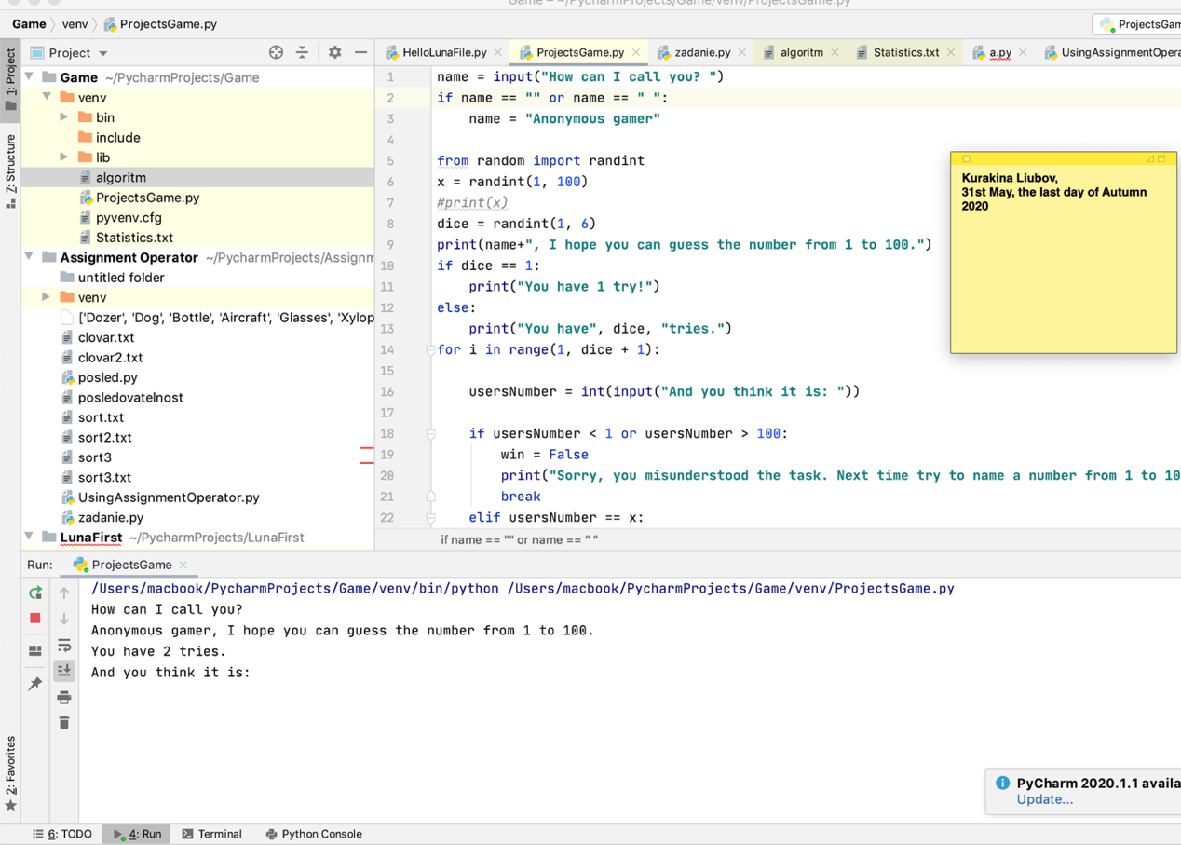

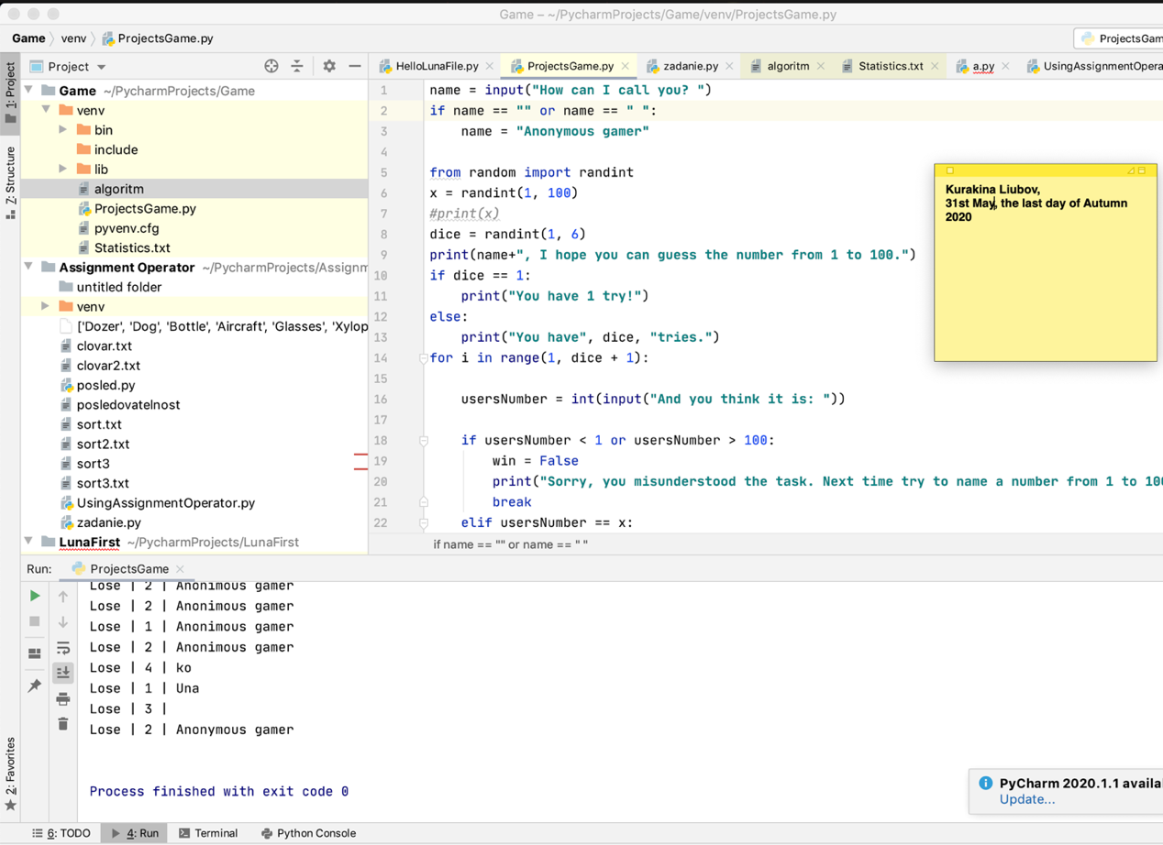

**Test 2.**

The test has successfully finished on the first try. After the tester L gave the number 150 out of range, the game has finished for him! Do not try to cheat the rules and better luck next time. Statistic results have popped out as well with a Lose against the tester L.

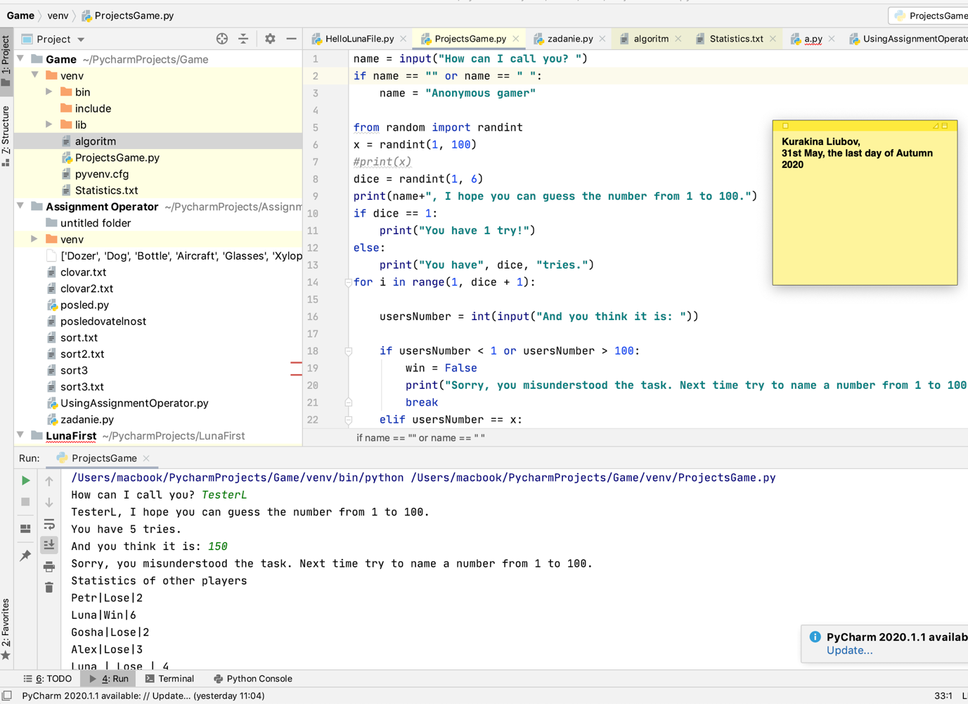

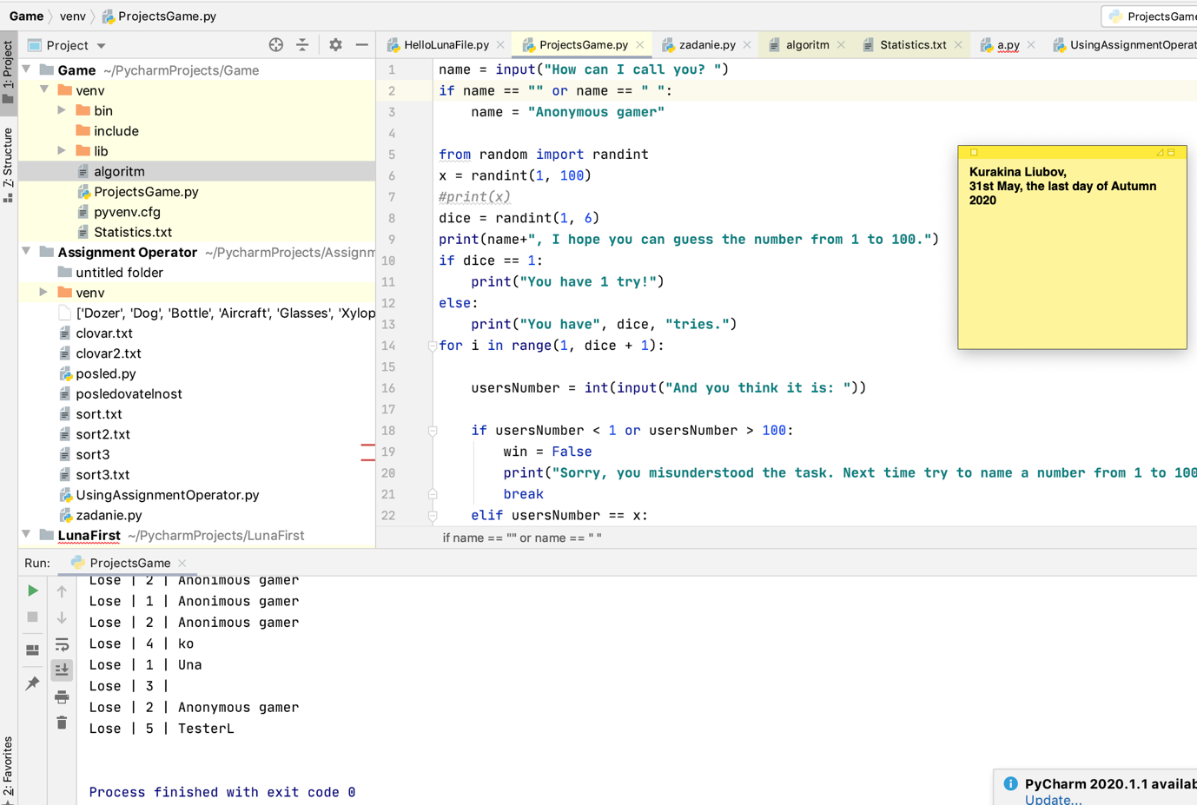

For **tests 3 and 4** tester L asked developer L to add an ability to debug the goal number in the console. The developer L was happy to help with that but insisted that this measure will be only temporary.

Both tests were successfully finished.

**Test 3:**

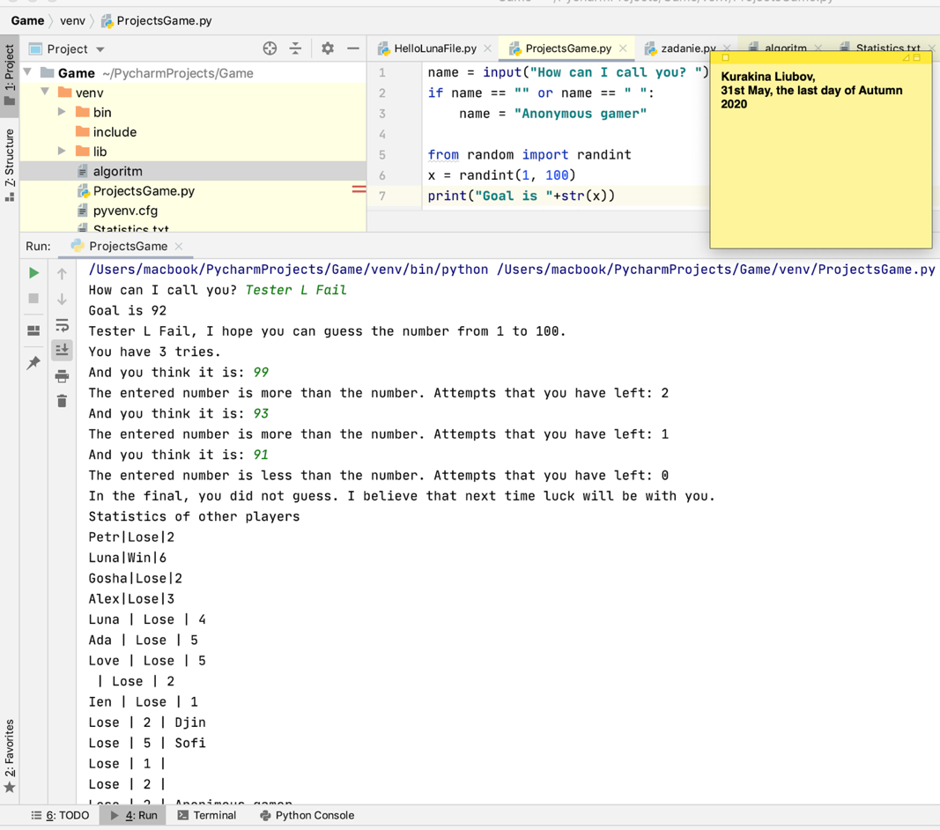

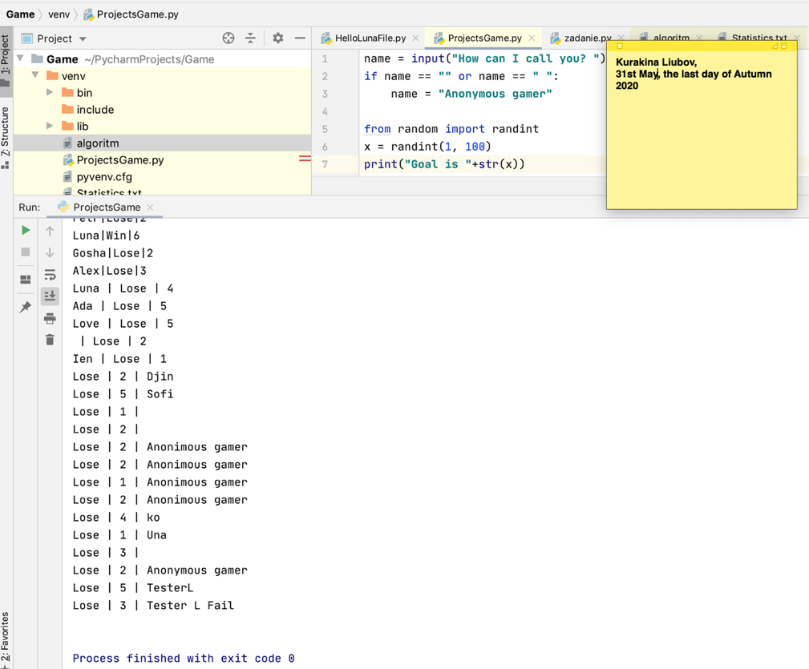

**Test 4:**

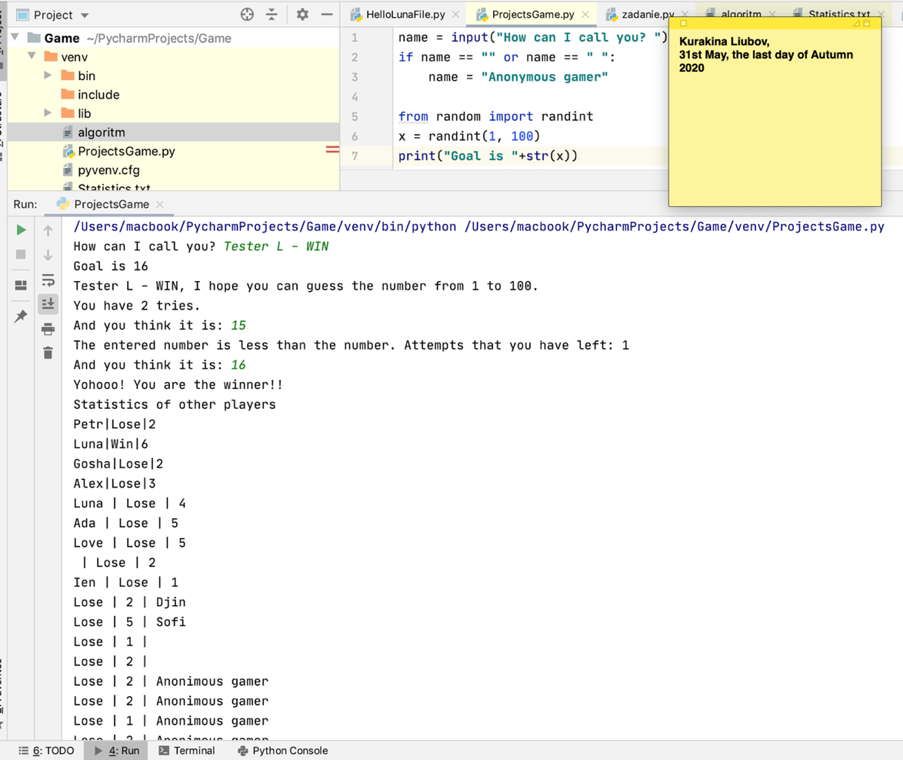

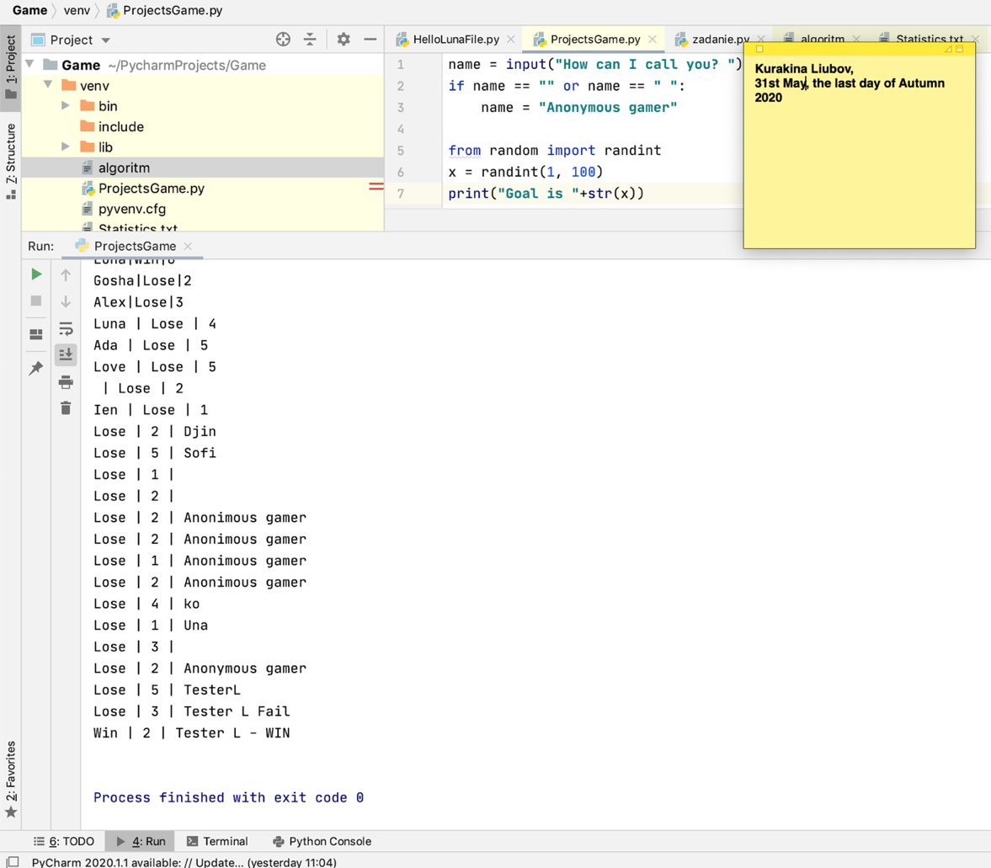

# Software evaluation

|  |  |
| --- | --- |
| Software specification | Evaluation |
| Game asks for a name | **Passed** |
| Game simulates two random numbers – goal number and current dice roll | **Passed** |
| Game asks numeric input X times where X = current dice roll. | **Passed** |
| Game provides feedback in case of unsuccessful or successful guess and finishes the turn in case of the later. | **Passed** |
| Game records statistics for every attempt and displays it after the turn. | **Passed** |
|  | |

# Software approval

Software is approved for installation by:

Name: Liubov Kurakina

Role: Leading Software Architect

Signature: {electronically signed by Kurakina Liubov}

Date: 31 May 2020