Lunarc Application Portal

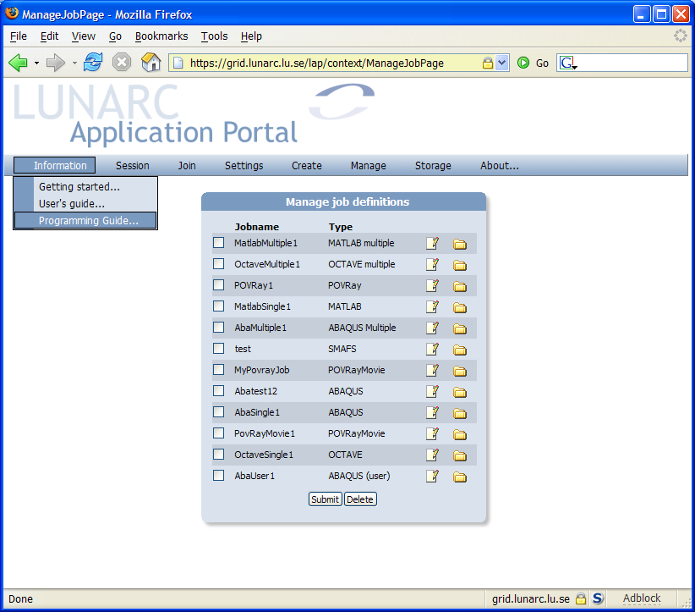

User’s Guide

Introduction
The Lunarc Application Portal is an effort to provide easy access grid resources for commonly available applications, such as MATLAB, Python, ABAQUS etc. The portal provides easy to use forms for each supported application where single and multiple jobs can created and submitted to the grid. Functions for controlling and monitoring jobs are also available.
As an additional service to the users a special client application has been developed, Grid Certificate Manager, which handles certificate request generation, grid proxy generation and certificate renewal. By using this application, the difficulties of using the grid portal should be reduced even further.

Getting access to the portal
To get access to the Lunarc Application Portal 3 steps are necessary. The steps (1) and (3) are not necessary to do every login.
❶ | Getting a signed Grid Certificate
❷ | Generating a proxy for logging into the portal
❸ | Applying for membership in a VO
The grid certificate is the equivalent of a passport in the real world. In the same way as with a normal passport, your identity needs to be proven. On the Grid, this is done by sending your certificate request to a certificate authority that checks your identity and returns a signed certificate that can be used for authentication on grid resources. The signed certificate establishes your identity on the grid.
To be able to log in to the portal a special time limited token, proxy, is needed. This token is generated from the Grid Certificate. The proxy is securely uploaded using SSL to the portal to be able to act on the users behalf. When the user logs out of the portal the proxy is destroyed automatically.
The Grid Certificate does not automatically allow access to Grid resource. To get access to resources membership in a Virtual Organisation (VO) is also required. From within the portal request for membership in a VO can be made.
The steps above can be done either using from a graphical user interface, Grid Certificate Manager, or using the command line tools provided by the ARC software. The Grid Certificate Manager can be used both for Linux and for Windows users. The ARC client tools are only available on Linux.

Grid Certificate Manager
The Grid Certificate Manager is a standalone application providing a user interface for all the tasks involved managing grid certificates. The program is available for Microsoft Windows and most Linux distributions supporting Python 2.3 and wxWidgets.

Installing and starting the Grid Certificate Manager
The Grid Certificate manager has been packaged into a standard binary installation, which can be downloaded from http://www.lunarc.lu.se/Software/gridman. The installation is started by clicking on the downloaded setup.exe file. An installation guide is shown. The installation will also install OpenSSL on the computer as a separate installation. The Grid Certificate Manager installation will return after a completed OpenSSL installation.
The grid certificate manager is starting by selecting Lunarc/Grid Certificate Manager from the program menu in Windows.

Grid Certificate Manager Window Layout
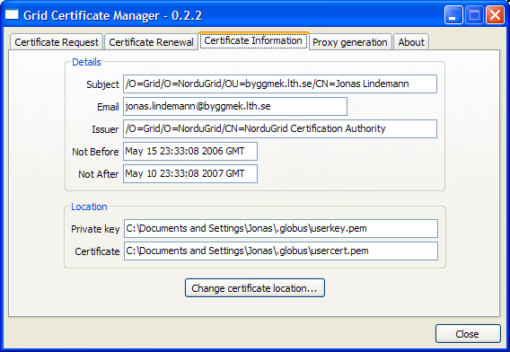
The Grid Certificate Window has four main tabs:
- Certificate Request – Handles generation of a certificate request and installation of a signed certificate.
- Certificate Renewal – Handles the renewal of an existing certificate and installation of a new certificate
- Certificate Information – Displays information on the installed certificate and corresponding private key.
- Proxy Generation – Handles creation of a grid proxy, used to when authenticating on the grid.
The usage of the described tabs are described in the following sections.

Generating a certificate request
The first step in getting a grid certificate is to generate a certificate request. This is done in the Certificate Request tab.
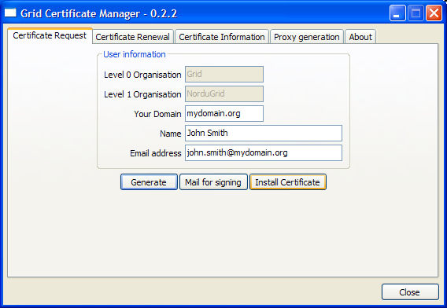
To complete the request 3 fields must be filled in:
- Your Domain – Your administrative domain (ex. mydomain.org).
- Name – Your real name (ex. John Smith)
- Email adress – Your email-adress. The domain after the @-sign should contain the same dmoain as in the Your Domain field.
To generate the request and private key, click Generate. A dialog is shown requesting a pass phrase for the private key.
NOTE: the private key pass phrase is not related to any other password, and must be different from, e.g., your system login password. Memorize well the password, as it cannot be reset! Although you can change the password any time (see Section 4.2.7), if you forget the password, you will have to request a new certificate. [From the Nordugrid User's guide]
Enter the selected pass phrase and click Ok to continue. To verify that a correct pass phrase has been given a second dialog is shown asking for a verification.
Click OK to continue. A new dialog is shown displaying a short summary of what is to be sent with the certificate request. Click Yes if the information is correct.
Next, a dialog is shown asking for where to store certificate information.
The default location is the ”Document and Settings\[User name]\.globus” folder on Windows. Click OK to accept the default location.
A certificate request (usercert_request.pem) has now been created together with a private key (userkey.pem). To get a signed certificate (usercert.pem) the certificate request must be mailed for signing. This is done by clicking on the Mail for signing button. This brings up a mail dialog containing the certificate request. Please enter your email address in the From field.
To mail the certificate request to the Certificate Authority click the Send button. To send the certificate request using a different mail client, click Copy to copy the request text to the clipboard and use Ctrl+V to paste into to the mail client.
A signed certificate should be mailed within a couple of days. Please see the next section on how to install this.

Installing signed certificate
In a couple of days after sending a certificate request, a signed certificate will be sent by mail. The Certificate Manager can be used to install this certificate as well. To install the received certificate select the following section in the mail:
-----BEGIN CERTIFICATE-----
..
-----END CERTIFICATE-----
Copy the selection to the clipboard using either Edit/Copy from the menu or Ctrl-C from the keyboard. In the Certificate request tab in the Grid Certificate Manager window, click Install certificate. An empty window is shown with a large text box. Click Paste or Ctrl-V to paste the selected certificate contents in the text box. To install the certificate click Install.
AVOID STORING YOUR PRIVATE KEY ON A PUBLIC FACILITY, SUCH AS A SHARED ACCESS COMPUTER, KEEP IT ON YOUR PRIVATE COMPUTER INSTEAD. COMPROMISED KEYS ARE REVOKED BY THE AUTHORITY.

Generating a Grid proxy
Generation of a grid proxy is done from the Proxy generation tab.
To generate a grid proxy, press the Generate button. This will bring up a dialog box asking for the passphrase for the private key.
Enter the passphrase and click OK. The default proxy length is set to 1 day and with cipher strength of 1024 bits. This can be changed in the Proxy Generation Options radio boxes.

Logging in to the Lunarc Application Portal
Loggin in to the Application Portal is done by transferring the proxy file to the portal. To open a browser with the start page of the Portal click Goto portal... in the Proxy generation tab. To log in, select the Log in from the Session menu. This will bring up a login form.
Select the newly generated proxy-file using the Browse... button and press the Login button. As noted before the default location of the proxy-file is ”Document and Settings\[User name]\.globus”. The name of the file is of the format “x509_up[Username]”.
To make it easier to select the proxy file, a special Copy button is located on the Proxy generation tab, which copies the location of the proxy-file to the clipboard. The contents of the clipboard can then directly be pasted into the login-form. The preferred login method is then as follows.
- Generate the proxy.
- Click Copy to transfer the proxy-file location to the clipboard
- Clilck Go to portal... to open a browser with the portal start page.

ARC client tools
The ARC command line tool can also be used to get access to the Lunarc Application portal. Please see chapters 4, 5 and 6 of the Nordugrid User's Guide for extensive information on this topic.

Generating a grid proxy
A proxy file is generated using the following commands:
[user@system user]$ grid-proxy-init
Your identity: /O=Grid/O=NorduGrid/OU=mydomain.org/CN=John Smith
Enter GRID pass phrase for this identity:
Creating proxy ......................................... Done
Your proxy is valid until: Mon Feb 13 11:58:07 2006
This will generate a proxy file located /tmp. The format of the file is “x509_up[uid number]”

Logging in to the Lunarc Application Portal
Loggin in to the Application Portal is done by transferring the proxy file to the portal. Open the portal start page. To log in, select the Log in from the Session menu. This will bring up a login form.
Select the newly generated proxy-file using the Browse button and press the Login button. As noted before the default location of the proxy-file is ”Document and Settings\[User name]\.globus”. The name of the file is of the format “x509_up[Username]”.

Using the application portal
Lunar Application Portal user interface is designed to mimic the appearance of a normal desktop application with windows and menu bar. All functionality of the portal is available through the menu bar. The menu bar is also organized that the user workflow is mimicked through the menus from left to right. The main user interface of the portal is shown in Figure 1.
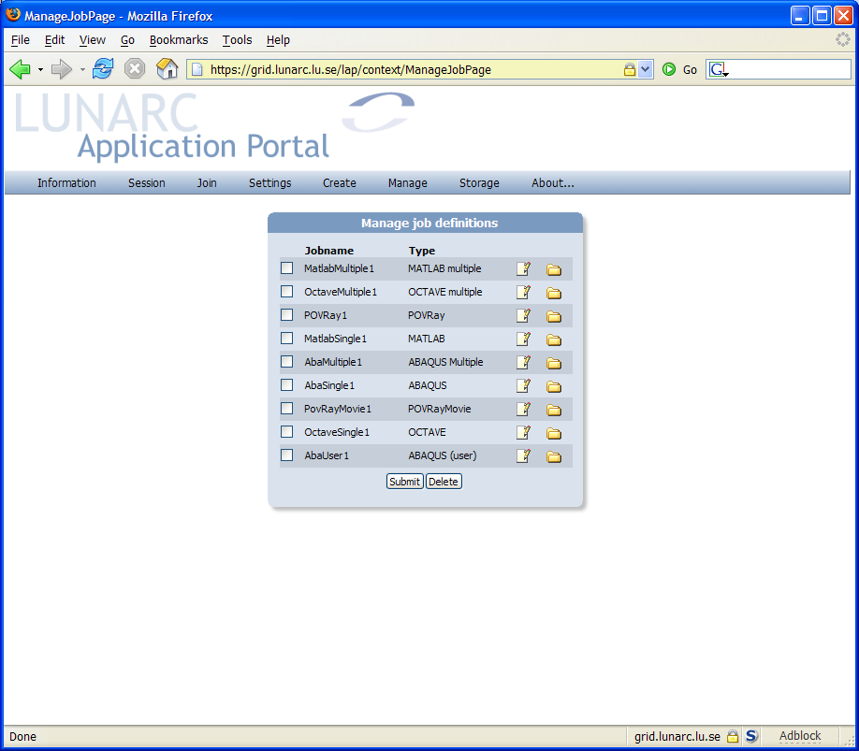
Menu bar
Work area
Forms and dialogs
Figure 1 - Application Portal user interface

Sessions and login
When logged in, the portal maintains information about the connection and user interface in a session. If a user is inactive for a longer period, the session expires and the user must log into the portal again. The session can also be expired manually, which is the equivalent of logging out.
Logging out from the session can be done from the Session menu and selecting Log out… This terminates the session and shows a dialog informing the user that a log out has occurred.
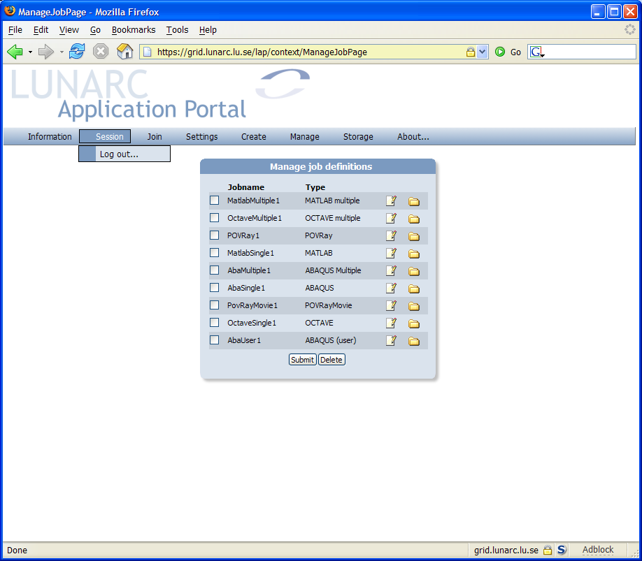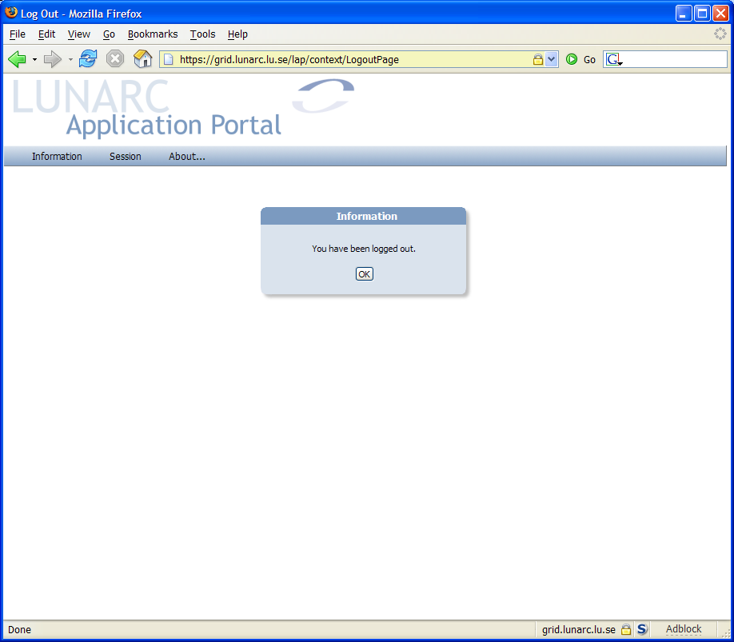
Figure 2 - Logging out from portal

Portal settings
The Settings menu handles all the user configurable settings. Under the Settings/User… menu the default mail address used in job submission or virtual organization registration can be set. A simple form is shown where the email address can be entered.
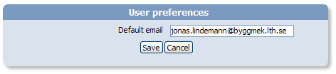
Figure 3 - User preferrences dialog
The Settings/Grid… menu can be used to limit the available resources when submitting jobs. This can speed up the submission time as it limits the number of queries the portal has to make for grid resources. The dialog is divided in 3 groups, preferred clusters, rejected clusters and a miscellaneous group, as seen in Figure 4.
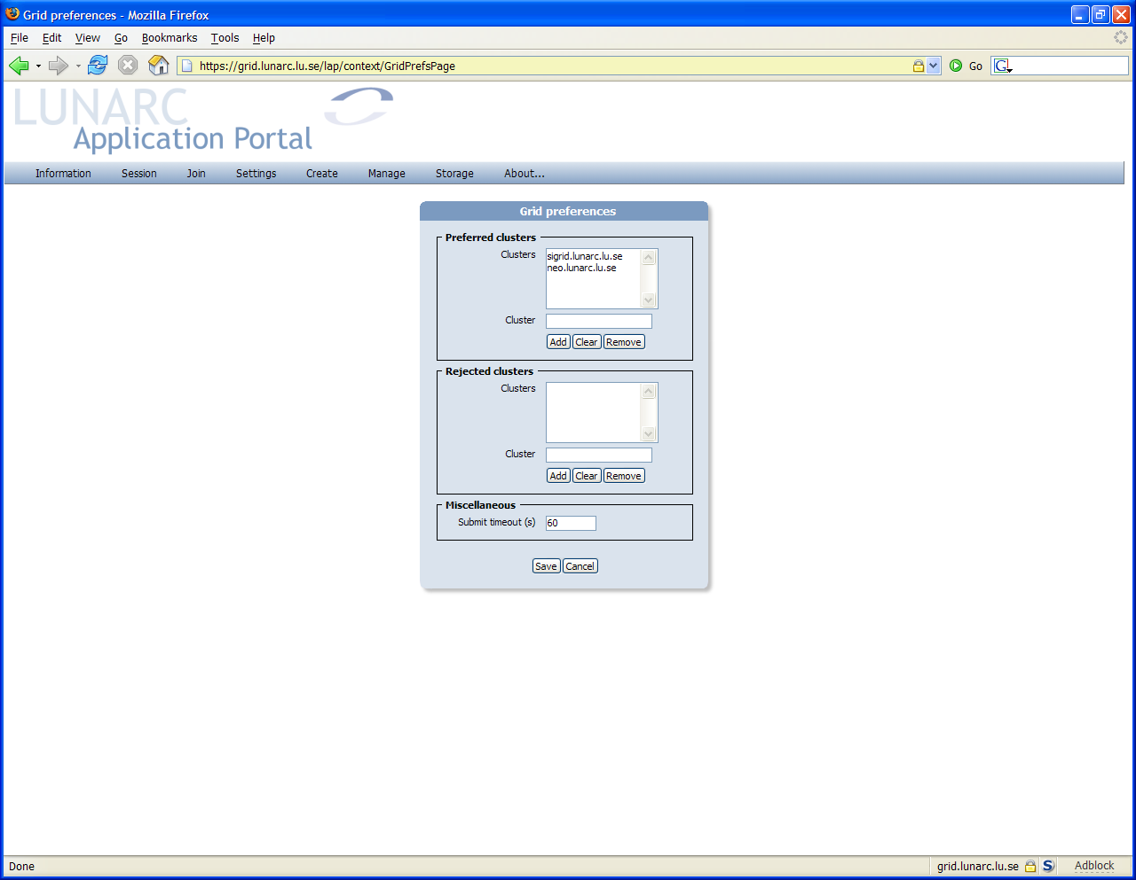
Figure 4 - Grid preferences dialog
In the preferred clusters group clusters most commonly used can be added. When clusters have been added to this list, the portal will only query these clusters during job submission. An empty list forces the portal to query for resources on a global level.
A cluster is added to the list by entering a valid hostname in the Cluster textbox and clicking on Add. The procedure is shown in Figure 5.
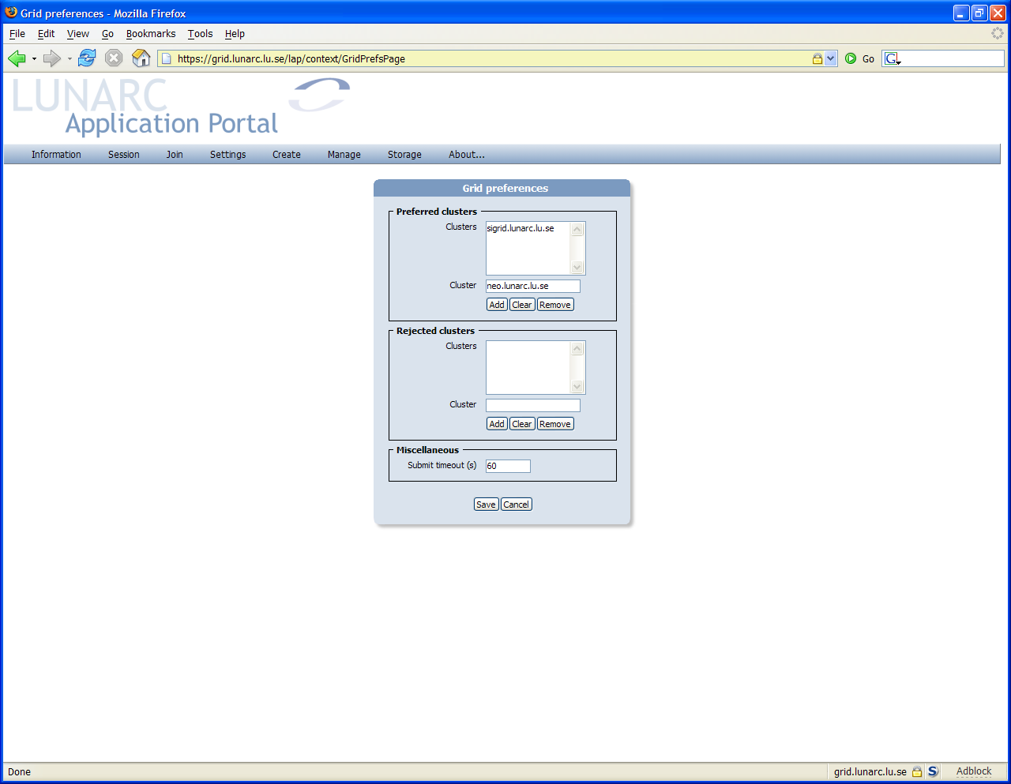
Enter hostname here
Click Add
❶
❷
Figure 5 - Adding clusters to preferred cluster list
Removing a cluster from the list, is done by first selecting the cluster from the list and then clicking on the Remove button.
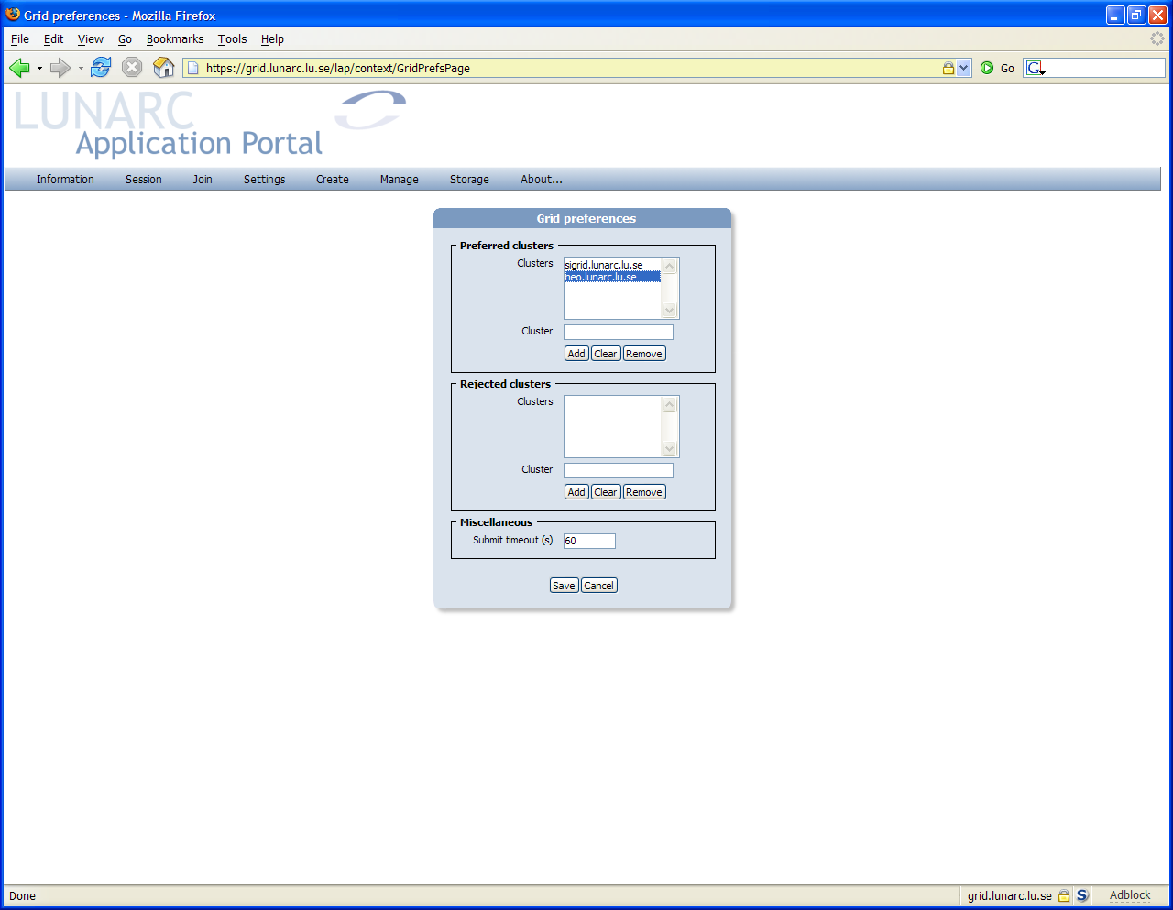
Select cluster
Click Remove
❶
❷
Figure 6 - Removing a cluster from the preferred cluster list
Removing all clusters from the preferred list is done by clicking on the Remove button.
The rejected cluster group maintains a list of clusters that should not be included in the query for resources during job submission. The list is modified in the same way as with the preferred cluster list.
The last group in this dialog box contains a timeout setting job submission. This settings determines how long the portal should query for resources before giving up. The value should be given in seconds.

Joining a virtual organization (VO)
Before any jobs can be submitted to resources on the Grid, a membership in a virtual organization (VO) is required. The normal way of joining a VO is to send an email with your distinguished name to a VO administrator requesting to be joined to the VO. To make it easier the application portal can do this on the user’s behalf. The Join menu contains the available VO that can be joined from the portal. Selecting a specific VO will bring up a dialog showing information about the VO and what information will be sent when joining.
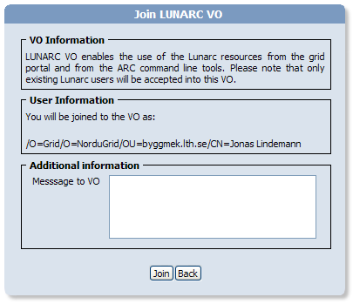
In the Message to VO text box additional information that can be of interest to the VO administrator can be added. Clicking on the Join button will send the joining request to the VO administrator.

Job definitions
The Lunarc Application Portal submits jobs to grid resources using job definitions. A job definition encapsulates all the details of job submission for a certain application type. The user provides the needed input files uploads them to the portal. The job definition is then submitted for execution on available grid resources. In the portal, all available job definitions are found in the Create menu. When the user selects a job definition a special job directory is created containing the necessary information for this job definition.
To illustrate the process of creating a job definition a simple POVRay rendering job will be created using the PoRay Parallel job job definition. When the user selects the desired job definition the portal will ask the user for a job name as shown in Figure 1Figure 7.
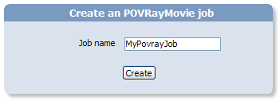
Figure 7 - Job name dialog
The job is created by clicking on the Create button. This brings up a form for editing additional job properties, as shown in
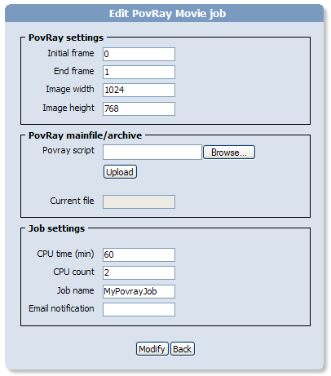
Figure 8 - Editing the PovRay Parallel job
This job will animate and render a POVRay scene generating an mpeg movie as the job result. To render an example job a simple POVRay scene is uploaded. Uploading files to a job is done using the same procedure in all job definitions. In this job, the upload is done by selecting a POVRay file using the Browse… button and then clicking on Upload to transfer the file to the portal.
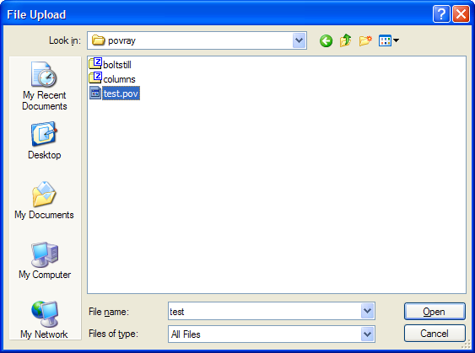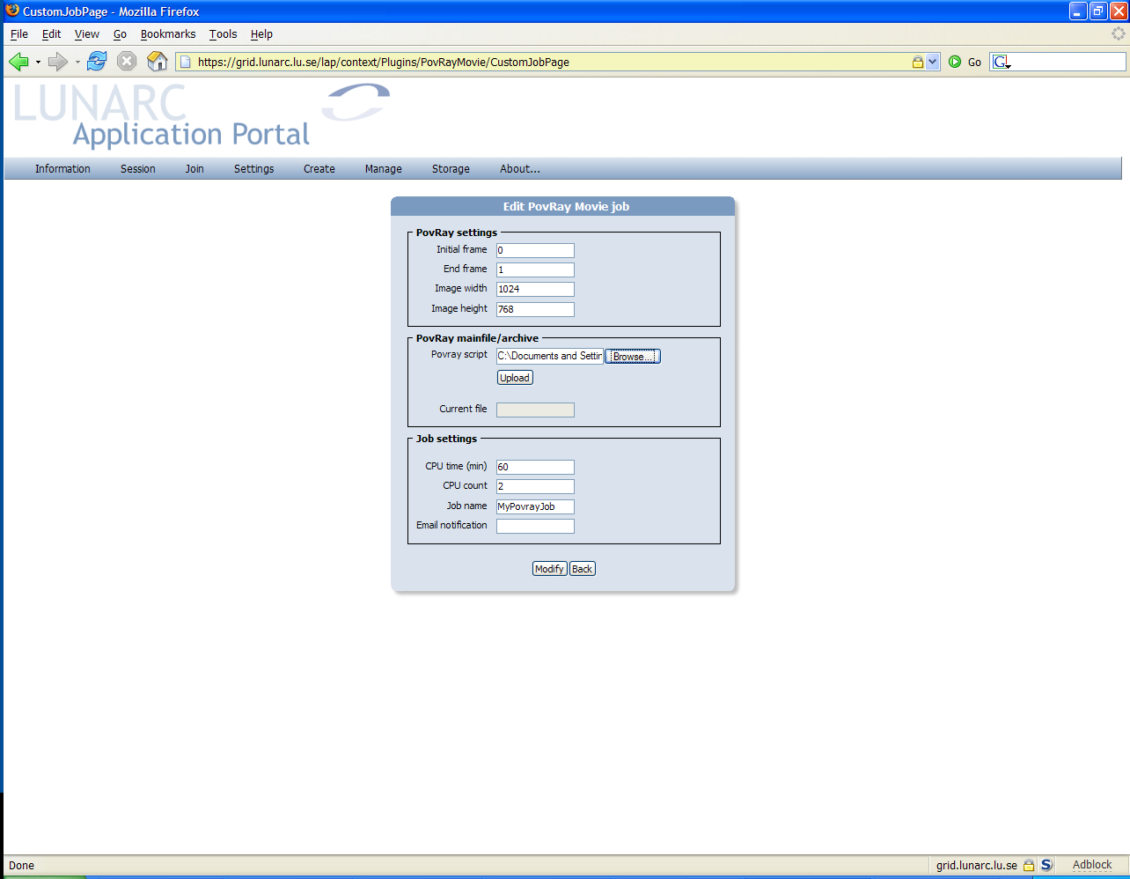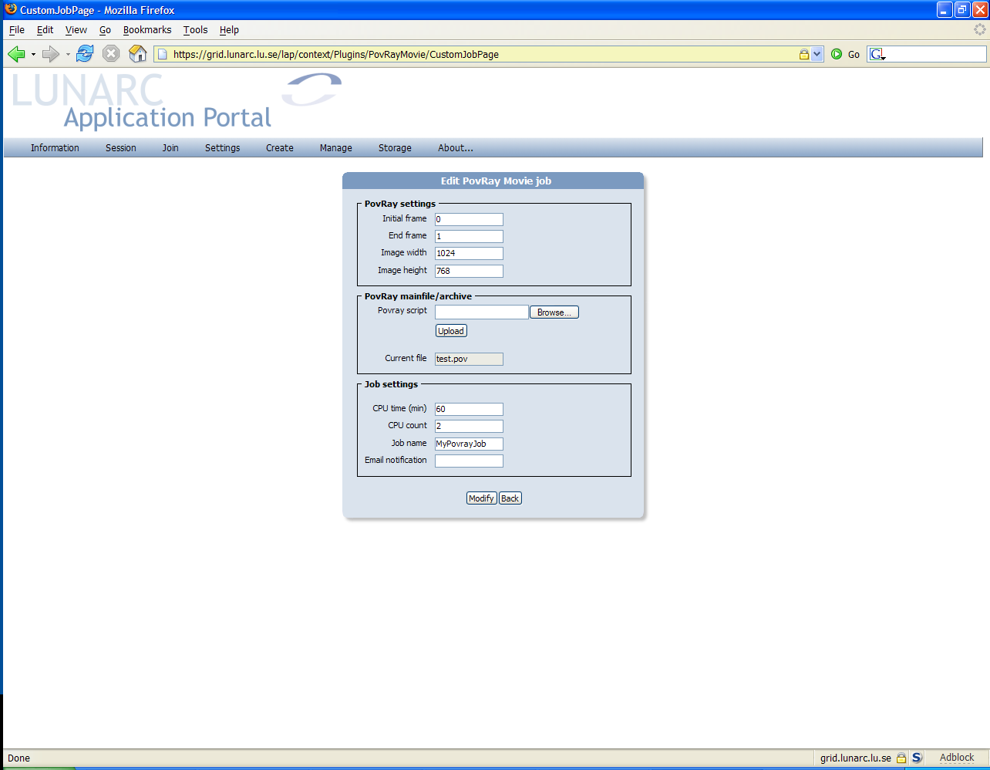
Click Browse...
❶
Select file to upload
❷
Click Upload to transfer file
❸
Figure 9 - Uploading files to job
When the file has been uploaded we set some additional parameters as shown in
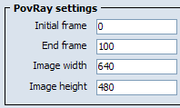
Figure 10 - Modified parameters in job
The last group Job settings is common for all jobs. In this group the CPU time, number of CPU:s, job name and email notification can be modified. For parallel jobs the CPU count parameter indicates the number of CPU:s needed for the job. In this case, we set the CPU time to 30 minutes and the count to four, see figure
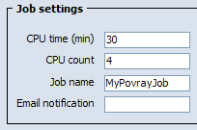
Figure 11 - Job settings
When all parameters have been modified, they are saved by clicking on the Modify. button. A information dialog appears confirming that the modifications were successful.
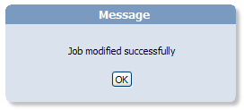
Figure 12 - Job modification confirmation
Clicking OK on this dialog brings up the form for managing job definitions, described in the next section.

Job definition management
Management of job definitions and associated result files is done through the “Manage job definitions” form. This form is accessed from the Manage/Job definitions… menu.
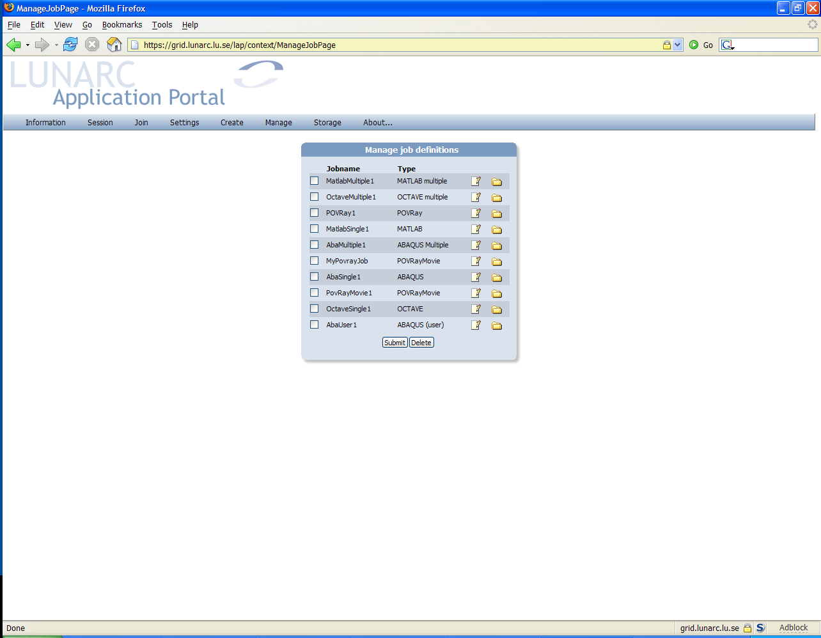
Multiple job selection used for submitting job or deleting jobs
Edit job definitions
Downloaded result files for each job
Submit selected jobs
Delete selected jobs
Figure 13 - Manage job definitions user interface
This form is the central management point of the application portal. From this user interface, the jobs can be submitted to grid resources, existing job definitions can be edited and deleted and can be examined.

Edit an existing job definition
To edit an existing job definition, click on the button on the right of the job name and type descriptions. This brings up the job definition edit-form for the selected job as shown in the previous section.

Submitting jobs
To submit on or more jobs, select the jobs using the checkboxes in the left column of the form and click Submit. The portal will query the grid information system for available resources and submit the job. Figure 14 shows how the job from the previous section is submitted to a grid resource.
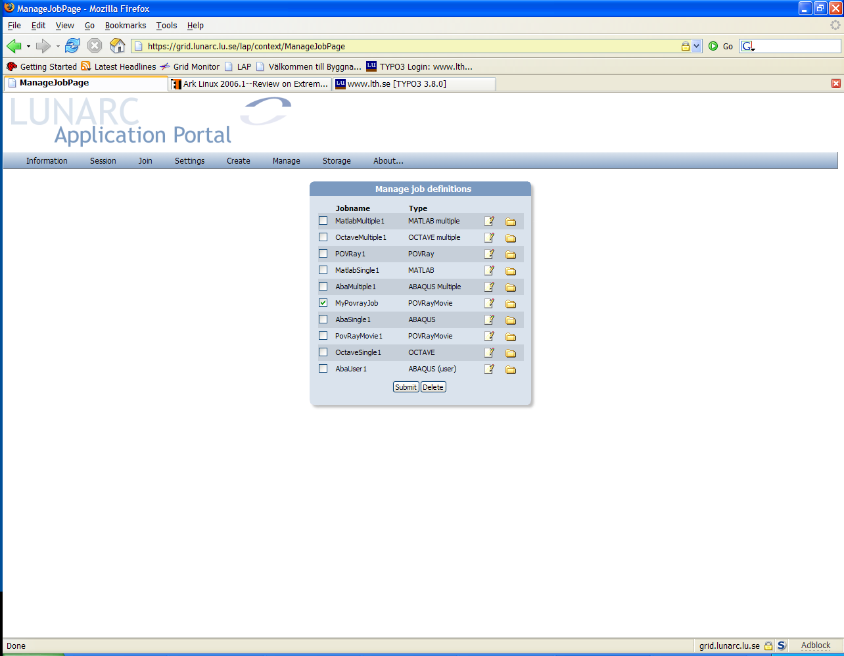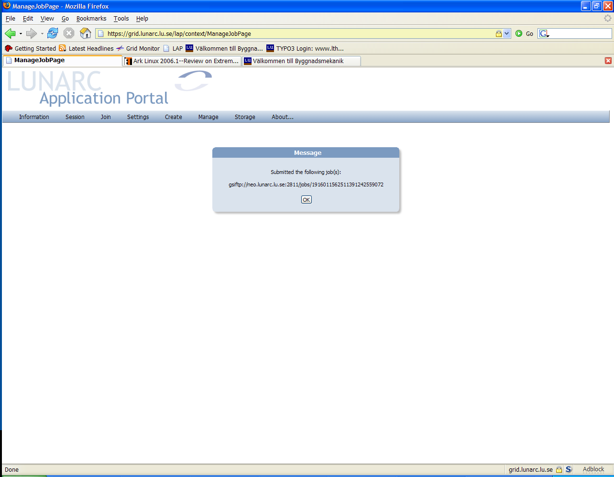
Submitting job...
Select job(s)
❶
Click Submit
❷❷
Job is submitted
❸❷
Figure 14 – Job submission procedure

Deleting a job definition
To delete an existing job definition, select the jobs using the checkboxes in the left column of the form and click Delete. A confirmation dialog is shown. Clicking on Yes will delete the job definition directory and any associated results.

Managing Grid jobs
When a job has been submitted to grid resources it is managed from the “Manage GRID jobs“ form which is found in the Manage/Running jobs… menu. The user interface layout of this form is shown in Figure 15.
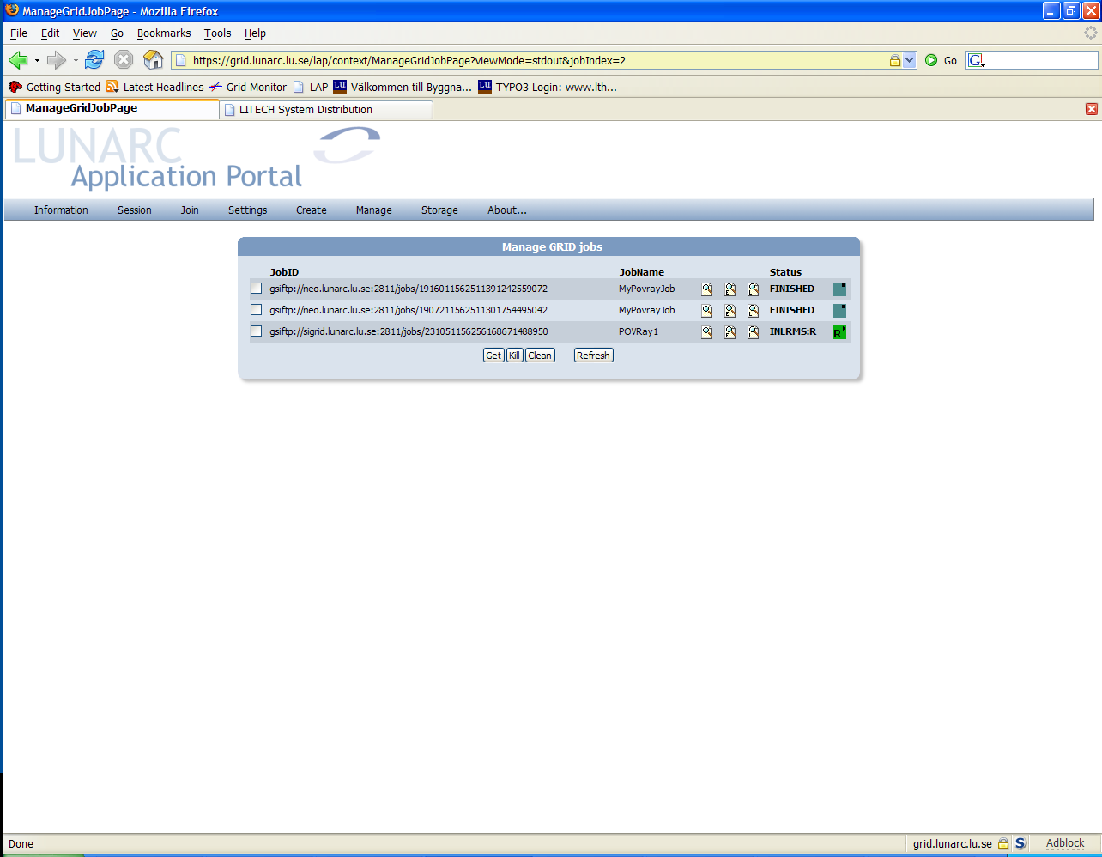
Multiple job selection used when retrieving, killing and cleaning jobs.
Buttons for viewing output and logs from jobs.
Job state information
Job control buttons
Refresh job list
Figure 15 - Manage GRID jobs user interface

Viewing output and logs from running jobs
When a job is running on grid resource, the output and logs can be viewed using the output-buttons to the left of the JobName column. The buttons are explained in Table 1.
Opens a new browser window showing the output from the job (standard output). This window is not updated automatically.
Opens a new browser window showing any error messages from the job (standard error). This window is not updated automatically.
Opens a new browser window showing the log produces by the grid middleware (gmlog). This output can be used to debug any job errors that can occur.
Table 1 - Buttons for viewing job output and status

Killing running jobs
Submitted or running jobs can be killed by selecting the jobs using the selection checkboxes left in the form and clicking on the Kill-button. This will terminate any running jobs and remove any jobs waiting in queues at any grid-resource.

Retrieving results from finished jobs
When a job has finished or failed execution at a grid resource, the results can be downloaded by selecting the jobs using the checkboxes on the left side of the form and then clicking the Get-button as shown in Figure 16. This will download the results to the respective job definition directory. The results are the accessible from the Manage Job Definitions form see section 3.5.
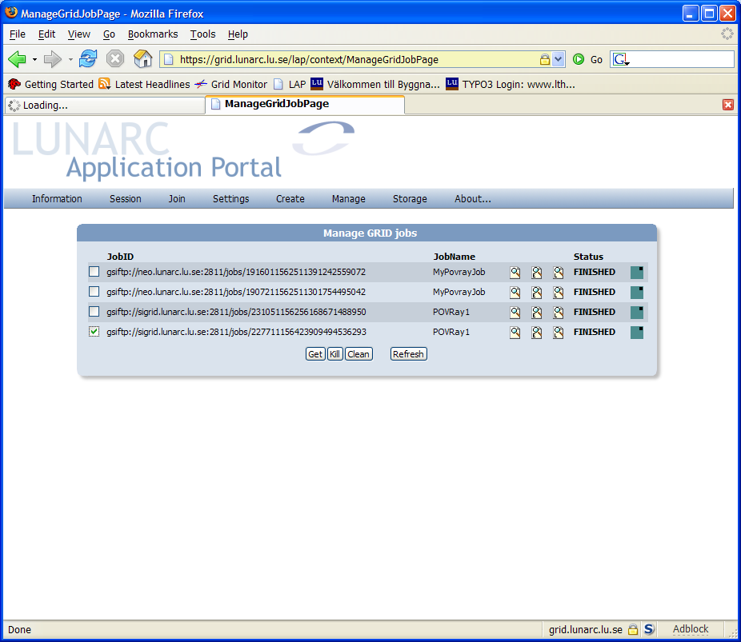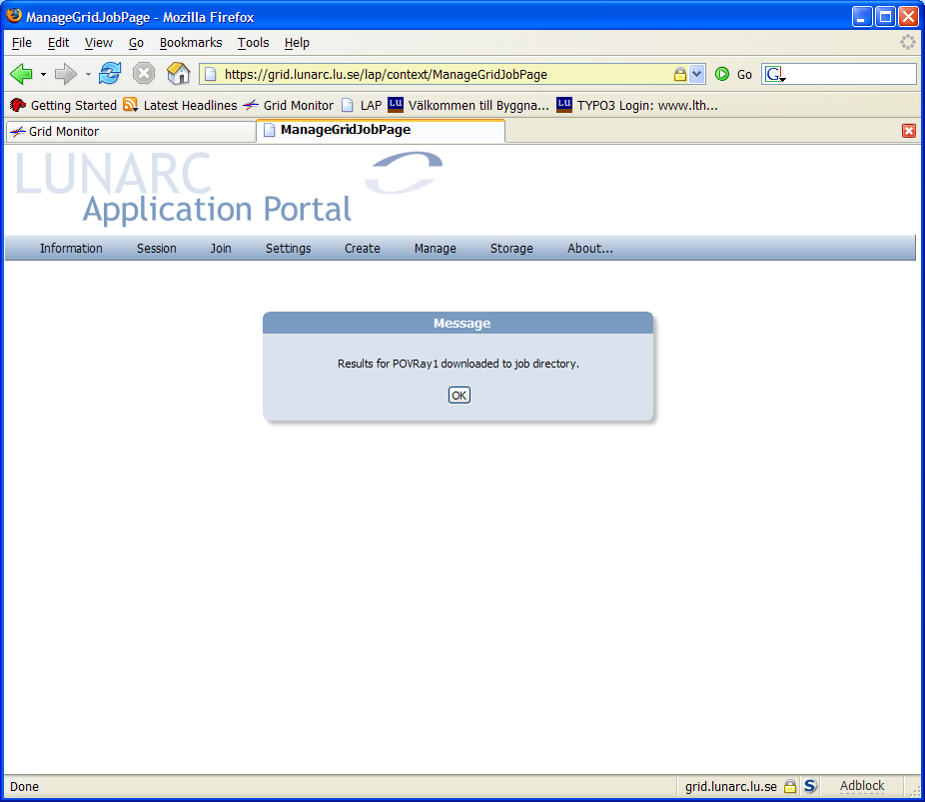
Select job(s)
❶
Click Get
❷
Downloading job...
Job is downloaded to job definition directory
❸❷
Figure 16 - Dowloading job results and output
Please note that retrieving results from a grid resource can take some time, so please be patient.

Cleaning jobs
When a job has been executed on a grid resource, the output files are stored on the resource for a limited time. After this time, the job files are automatically removed. If a job has finished, but the results are not of interest anymore, they can be removed by selecting the jobs and clicking the Clean-button as shown in Figure 17. This tells the grid resource to delete the files associated with the grid job.
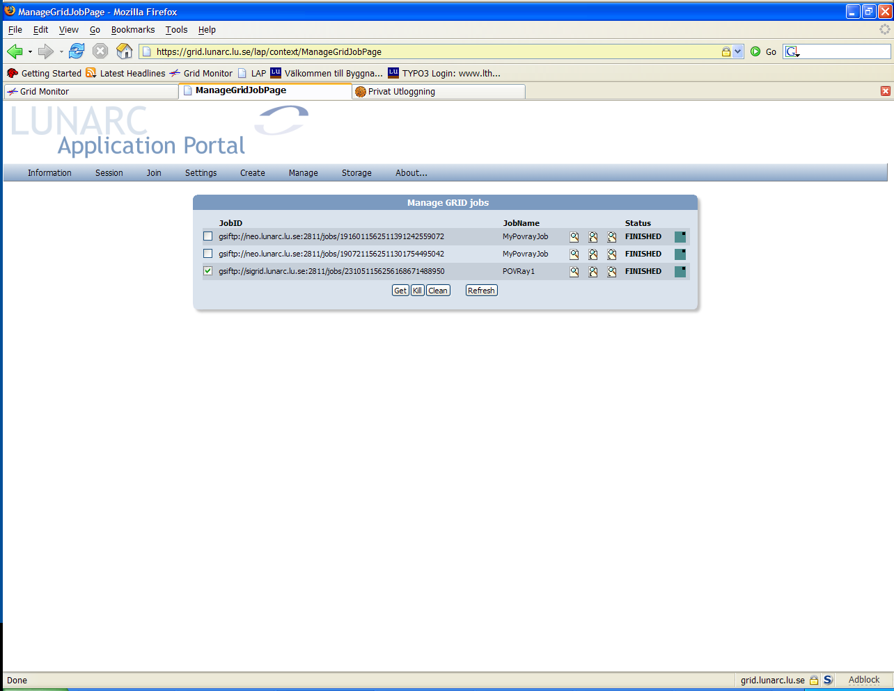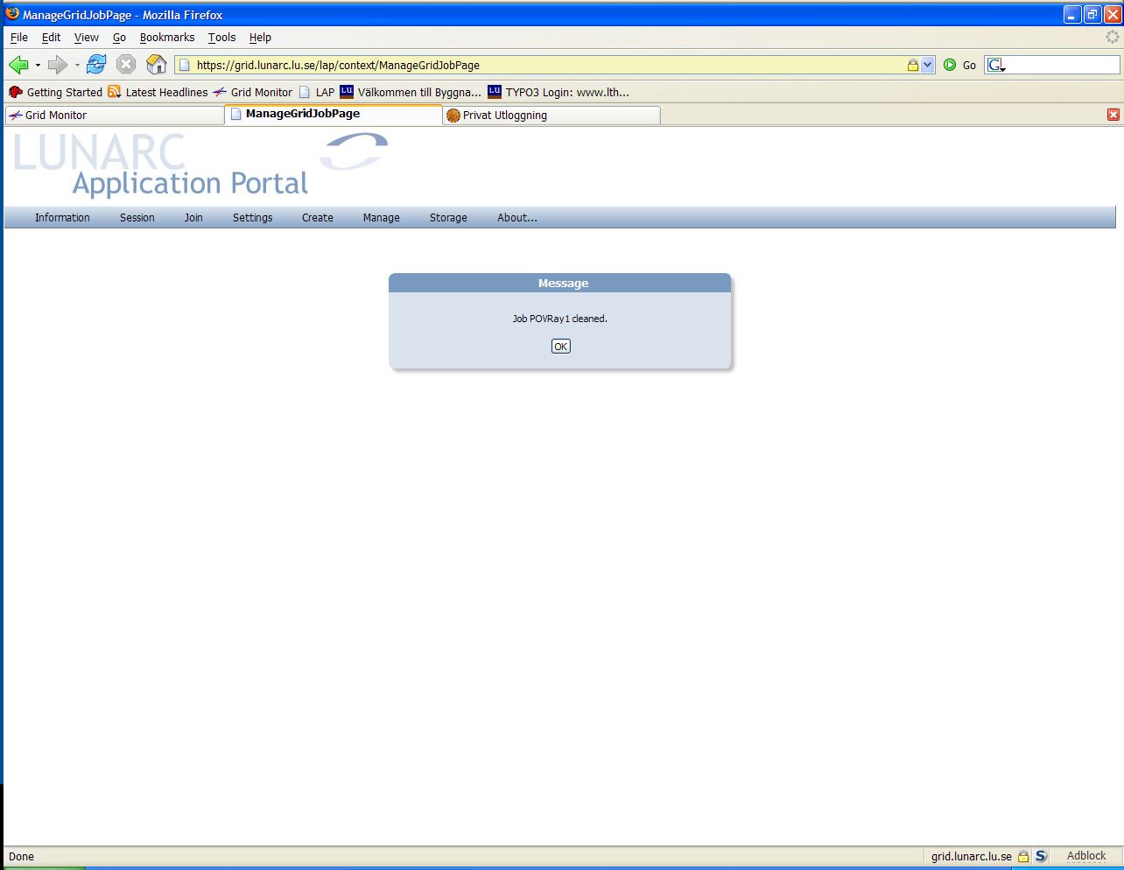
Select job(s)
❶
Click Get
❷
Cleaning job...
Job files cleaned from grid resource
❸❷
Figure 17 - Cleaning a finished grid job

Managing job output and result files
Job results are downloaded to the associated job definition directory. To view the downloaded results the Manage Job Definitions form is used from the Manage/Job definitions… menu. To view the results from a job, the folder button for the job is clicked. This displays a list of all the results downloaded for this job. A job definition can be submitted several times, so separate directories are needed to differentiate between the different downloaded results. Clicking on a directory line brings up a second form displaying the downloaded result files. The procedure is shown in
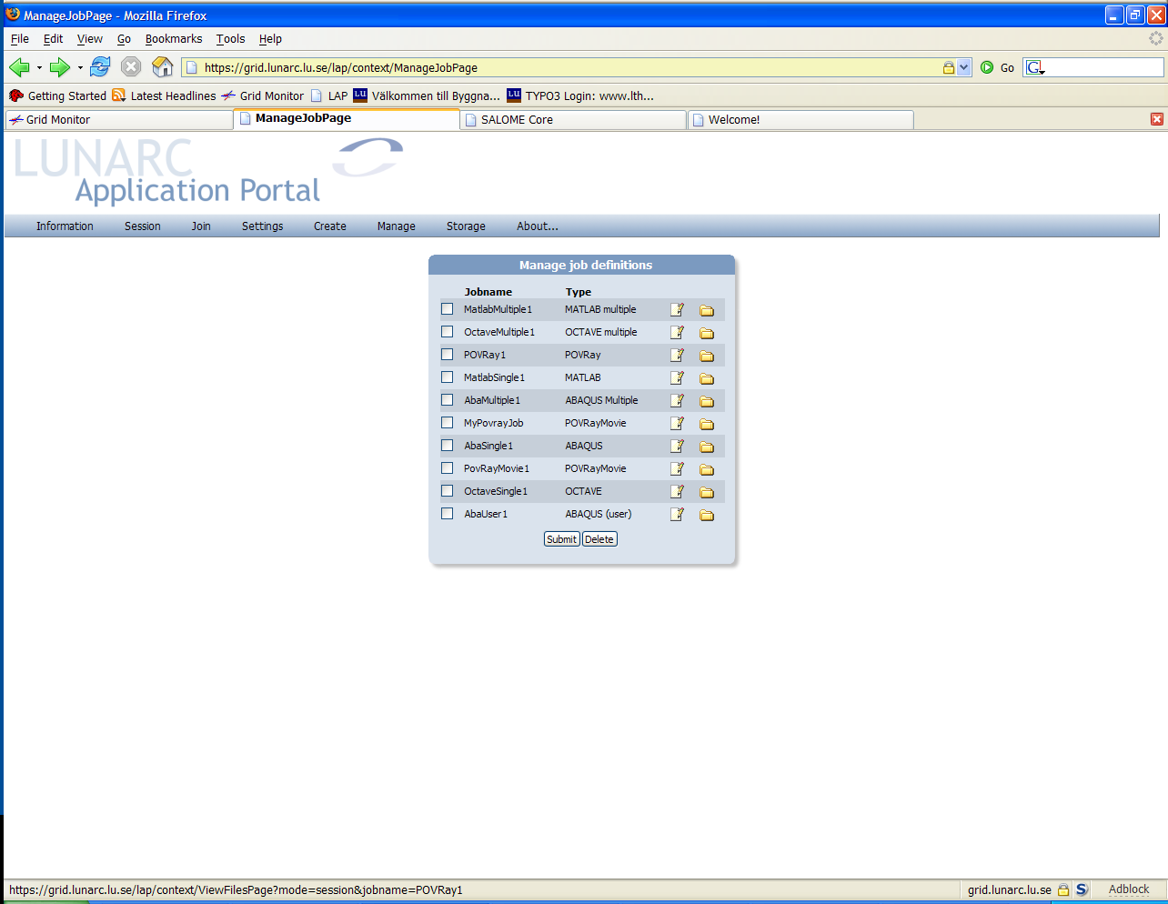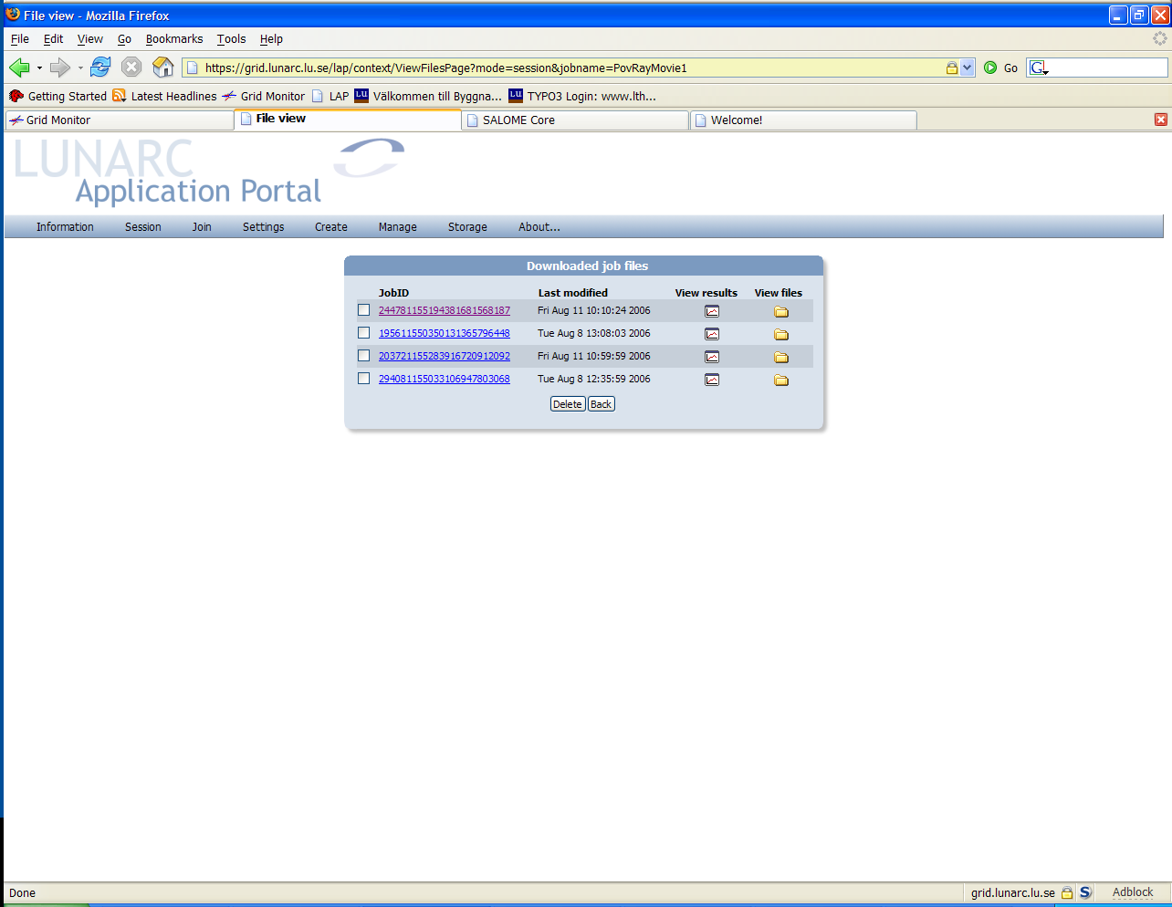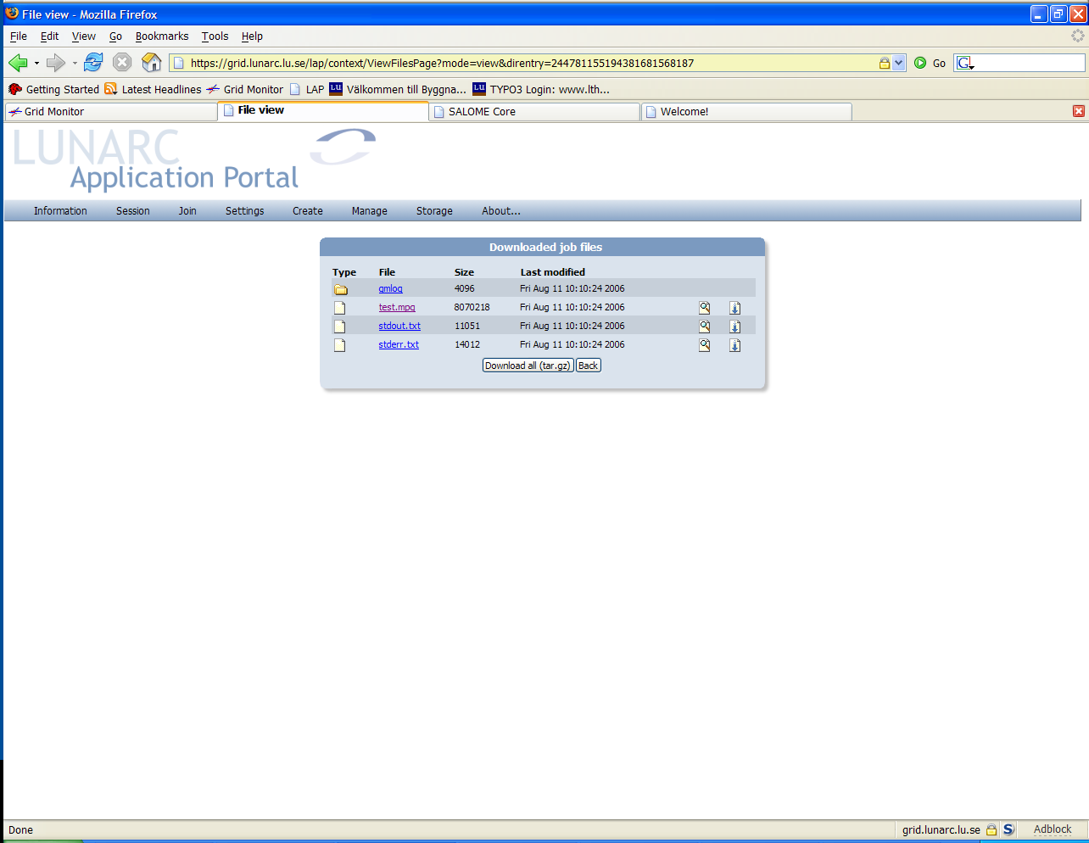
Click here
❶
Click here
❷
Figure 18 - Viewing downloaded files

The downloaded files can be viewed by clicking on the hyperlink or the button. The portal will try to guess the file type and display a window with the contents of the file. If the type cannot be guessed, the portal will initiate a file download instead.
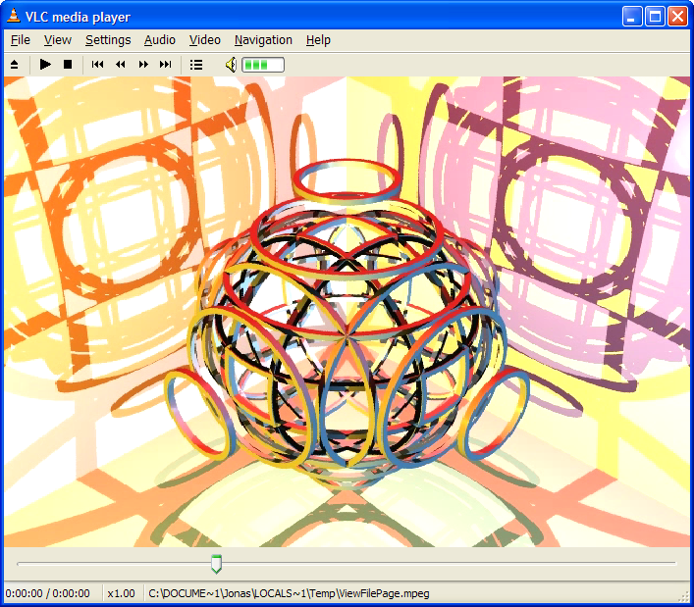
Click here
❶
Click here
❷
Figure 19 - Viewing downloaded files
To download files instead of viewing them is done using the button. This will bring up a download request for any kind of file.
The entire directory can also be downloaded by selecting the “Download all (tar.gz” button. The portal will then tar all files recursively in the current directory and initiate a download of this file.

Job definitions
Job definitions are templates for creating jobs for different kinds of applications. This chapter describes how the available job definitions are used.

ABAQUS single job
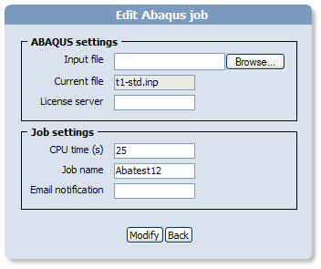
Figure 20 - ABAQUS single job definition
The “ABAQUS single job”-definition handles the creation of a single ABAQUS job. The input consists of a standard ABAQUS input file (.inp) and the hostname of the license-server used. An input file is uploaded by selecting the “Browse…” button, selecting the local input file and the clicking on the “Modify” button. This will upload the local file to the portal and the selected job. The job will use the most recent version of ABAQUS found when searching for grid resources.

ABAQUS multiple job
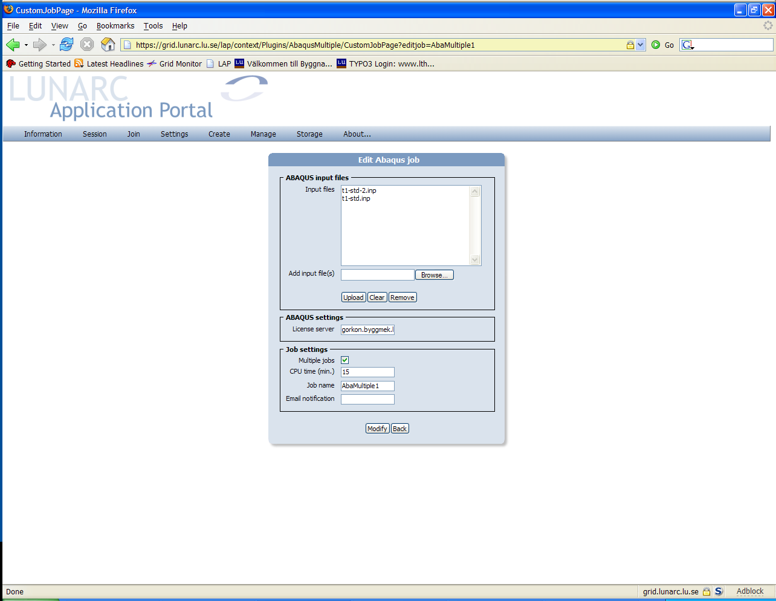
Figure 21 - ABAQUS Multiple job
The “ABAQUS multiple job”-definition handles a job that can submit multiple ABAQUS jobs either as a single job to a single processor or as multiple jobs to multiple processors.
The input files that will be submitted with the job specified in the “ABAQUS input files” group. The procedure for adding input files to the job is illustrated in Figure 1.
Click Browse...
❶
Select file to upload
❷
Click Upload to transfer file
❸
Figure 22 - Uploading ABAQUS input files
If the job should be submitted as multiple jobs the “Multiple jobs” checkbox must be checked.
Jobs submitted using the multiple option will be tagged with name of the input file, so that they can be identified when they are downloaded from grid resources.
The results from jobs submitted as a single job will be placed in separate folders in the results.

ABAQUS job (user subroutine)
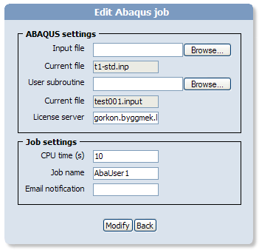
Figure 23 - ABAQUS user subroutine job
This job template sets up an ABAQUS job with an associated user subroutine. The input parameters are the same as in the single ABAQUS job described in section 4.1. The subroutine is uploaded by using the “Browse…” button, selecting the user subroutine and then uploading it by clicking on the “Modify” button.

MATLAB single job
The “MATLAB single job”-definition handles the creation of a single MATLAB job. A MATLAB job often has additional packages and files associated with the job. This plugin can handle two types of supporting files:
- Toolkit packages – zip-files or tar.gz-files containing all the necessary files for a package. The package will be uncompressed to a directory with the same name as the package (A package should not contain directories in the top level archive.) The job will automatically set the search paths to these directories for the job. (optional)
- Additional files – Extra files needed for running the job. (optional)
The job also needs a main file that is used to start the job. The method of uploading package and additional files are shown in Figure 24.
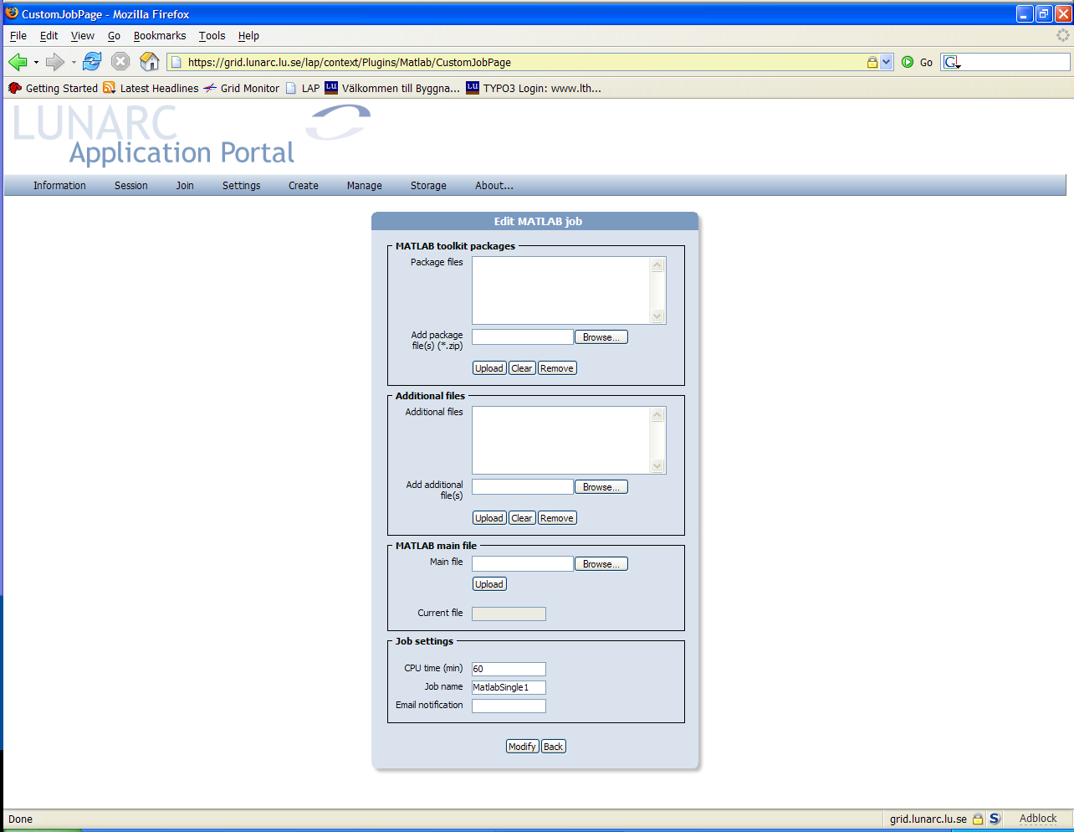
Click Browse...
❶
Select file to upload
❷
Click Upload to transfer file
❸
Figure 24 - Uploading packages and additional files to a MATLAB job
The job will use the most recent version of MATLAB found when searching for grid resources.

MATLAB multiple job
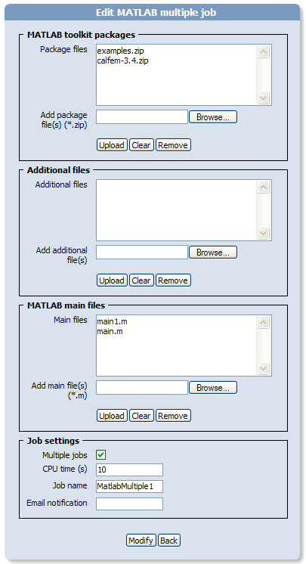
Figure 25 - MATLAB multiple job
The “MATLAB multiple job”-definition handles a job that can submit multiple ABAQUS jobs either as a single job to a single processor or as multiple jobs to multiple processors. A MATLAB job often has additional packages and files associated with the job. This plugin can handle two types of supporting files:
- Toolkit packages – zip-files or tar.gz-files containing all the necessary files for a package. The package will be uncompressed to a directory with the same name as the package (A package should not contain directories in the top level archive.) The job will automatically set the search paths to these directories for the job. (optional)
- Additional files – Extra files needed for running the job. (optional)
The job also needs a set of main files that define each separate job. The method of uploading packages, additional and main files are shown in Figure 24.
Click Browse...
❶
Select file to upload
❷
Click Upload to transfer file
❸
Figure 26 - Uploading packages and additional files to a MATLAB job
If the job should be submitted as multiple jobs the “Multiple jobs” checkbox must be checked.
Jobs submitted using the multiple option will be tagged with name of the m-file, so that they can be identified when they are downloaded from grid resources.
The results from jobs submitted as a single job will be placed in separate folders in the results.
The job will use the most recent version of MATLAB found when searching for grid resources.

OCTAVE single job
The “OCTAVE single job” corresponds to a MATLAB single job, but uses OCTAVE for job execution, see section 4.4.

OCTAVE multiple job
The “OCTAVE multiple job” corresponds to a MATLAB single job, but uses OCTAVE for job execution, see section 4.5

PovRay serial job
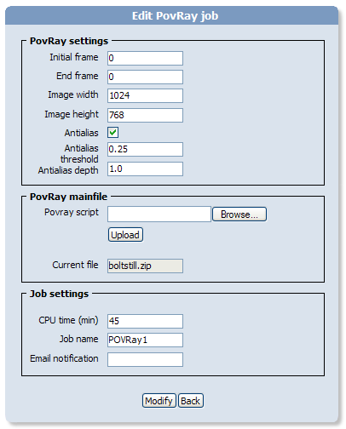
Figure 27 - PovRay job
The “PovRay serial job…” sets up a job for rendering a POVRay scene file. The scene file can be static or animated. The job renders the scene and produces a set of images. The input parameters are described in Table 2.
Parameter name | Description
Initial frame | Start frame of the rendering usually 0
End frame | End frame of the rendering. If this is a static scene accept the default value of 1.
Image width | Width of the generated image(s).
Image height | Height of the generated images(s).
Antialias | Determines if antialiasing of the image should be done.
Antialias threshold | Antialiasing parameter.
Antialias depth | Antialiasing parameter.
Table 2 - PovRay job parameters
The job definition takes as input both a single povray-script or a zip-file containing a set of povray files. The portal will use the first available .pov-file in the archive for starting the rendering.

PovRay parallel job
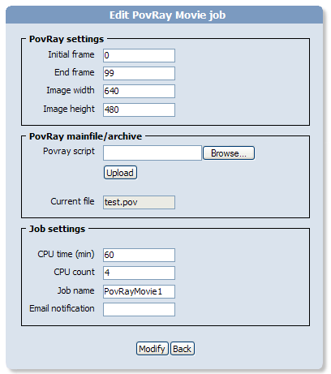
Figure 28 - PovRay Movie job
The “PovRay Movie Job” renders a POVRay scene as a mpeg-movie file. The input parameters are described in Table 2.
Parameter name | Description
Initial frame | Start frame of the rendering usually 0
End frame | End frame of the rendering. If this is a static scene accept the default value of 1.
Image width | Width of the generated image(s).
Image height | Height of the generated images(s).
Table 3 - PovRay Movie job parameters
The job definition takes as input both a single povray-script or a zip-file containing a set of povray files. The portal will use the first available .pov-file in the archive for starting the rendering.

