KIM TaeGyeong

Hong Kong Polytechnic University

Esquel Hoa Binh Vietnam

CAPS International Summer Internship

Internship summary

**Project Team**

KIM TaeGyeong HK Polytechnic University Mechanical Engineering Student

Benjamin Archangeli Asia School of Business MBA student

**About Esquel Hoa Binh Vietnam**

EHV is a cut, sew, and finishing factory located near Hanoi in Hoa Binh provinece,

Vietnam. The factory employs over 3000 workers to produce men’s cutton, button down shirts for customers all around the world.

EHV Auto pattern matching project (week 1 ~ 4)

**Background**

The process is dependent upon machine vision to view the set sequence of panels for a garment to establish matching datum points and set the final cut pattern. Paired with auto accurate cut and auto numbering, the process can eliminate several manual processes.

Automated Panel Matching

1. Job order data setup

* Input all final panel cut for job order
* Assign matching datum points relative to pattern intersections
* Determine the sequence of panels to match to each other

i.e. Back panel sets matching datum points for chest panels, chest panels set datum points for sleeves

1. Machine vision views individual panels

* Machine vision aligns final cut to bulk cut pattern based on symmetry and matching requirements of pattern
* Datum points are stored for subsequent panels to match to

1. Automated cutting performs accurate cut for each panel after matching

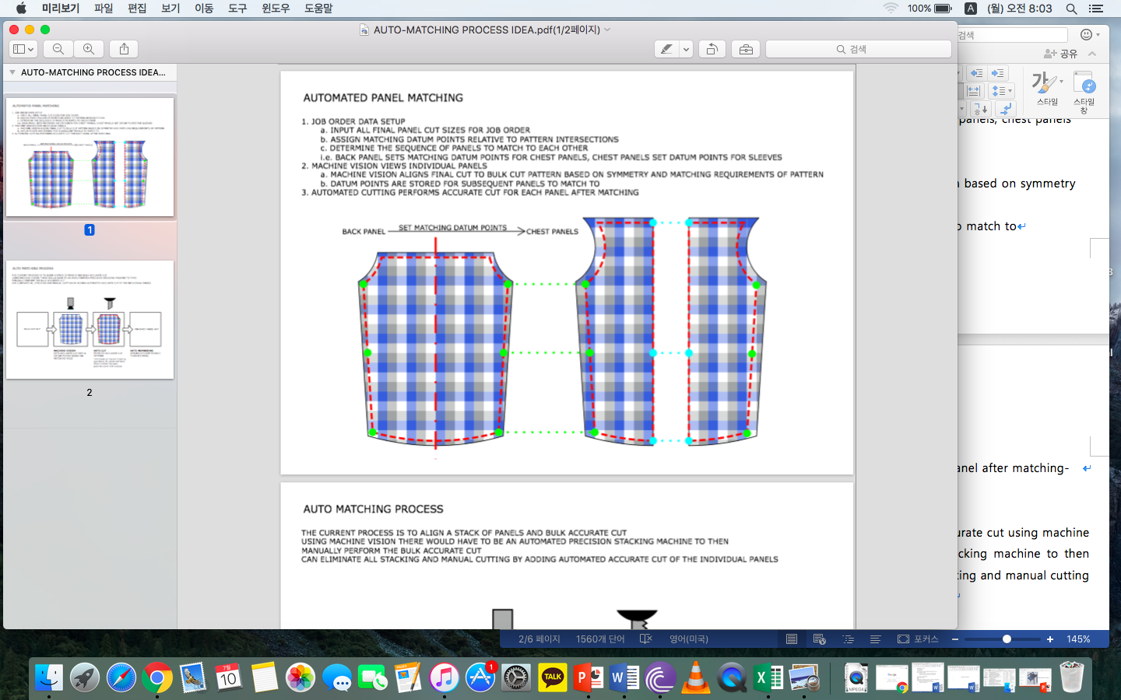

**Auto matching process**

The current process is to align a stack of panels and bulk accurate cut using machine vision. There would have to be an automated precision stacking machine to then manually perform the bulk accurate cut can eliminate all stacking and manual cutting by adding automated accurate cut of the individual panels.

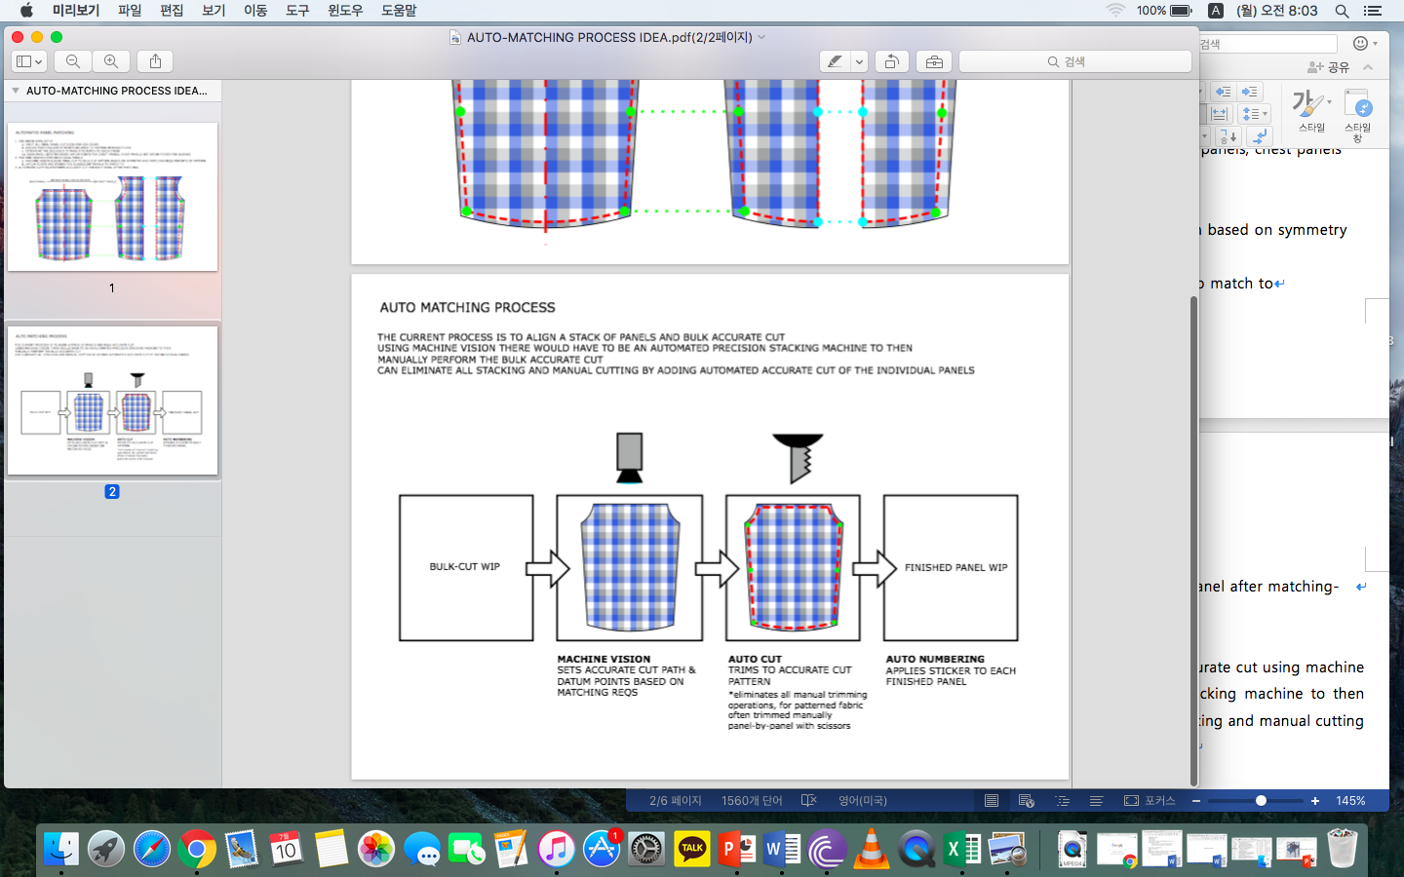

However, due to the limited research and experience with the machine vision system, the project team can no longer proceed this project. There are some limitations of lighting and fabric layout which are going to be two of the biggest barriers to getting the system functional. First, the lighting has to be such that the camera will be able to distinguish the contrasts between the colors of the pattern. This may be a unique setting for each order, based on the pattern colors and the fabric finishing (i.e. light will reflect differently off a brushed vs normal finishing). Second, the layout of the fabric has to be such that the pattern is not stretched beyond the allowed tolerances of the pattern as recognized by the camera software. For a very tight pattern, the tolerances may be so strict that the camera rejects the panel repeatedly or sets incorrect cutting path and datum points.

After 4 weeks of working on this project, our team has moved onto another project, auto fusing project, that has been introduced by assistant general manager of this factory.

EHV Auto Fusing Project (week 4~8)

**Project Team**

KIM TaeGyeong HK Polytechnic University Mechanical Engineering Student

Benjamin Archangeli Asia School of Business MBA student

Mr.Quang Esquel TED

Mr.Trung Esquel TED

**General Background**

The project focuses on cutting operations; spreading, bulk cut, matching, accurate cut, trimming, numbering, fusing, cut panel inspection, and bundling. Production lines are producing over 1,000 pieces of shirts and this factory is planning to increase the number of sewing lines. Although due to the slowness process times or delay times in cutting created the necessity for the 3 – days buffer. However, even with the buffer the process flow is not very smooth and fusing has been identified as a bottleneck that limits the throughput of the factory.

**Fusing Background**

Collars (1), collar bands (1), and cuffs (2) require fusing to an inter-lining to provide stiffness to the fabric; total 4 pieces per shirt. There are 3 types of fusing machines used for these panels; BH 600, HP-450 MS, and Spot welding machine. EHV operates five BH 600 machines, the most of any one type. The BH 600 also yields the most consistent fuse quality of the three. The daily demand per BH 600 is approximately 1,200 shirts (4,800 total pieces). The average daily throughput is 1,000 shirts.

Panels are manually matched with a lining on a moving conveyor that feeds into the BH 600. The BH600 design is intended for a single worker to place panels and linings one-by-one onto the machine conveyor. The Technical Engineering Department (TED) added a longer conveyor to extend the loading area, allowing multiple workers to place panels and linings, thereby increasing the throughput of the machine. Based on the demand and labor available, the number of workers per machine can range from 1 to 4. The most frequent arrangement is 2.5 workers, 2 loading and 1 unloading between 2 machines.

Esquel’s Technical Development Center (TDC) in China has been working on an automated pick and place machine to load panels and linings for fusing. The end effector which grabs single fabric and lining panels from stacks has limitations which is preventing it from being installed in any factories for production. Consideration should be made to make changes to the BH 600 compatible with future TDE machine designs.

TED designed and procured a functioning automatic panel collection and stacking machine for the HP-450 MS fuse machine. The concept of the machine can be redesigned for compatibility with the BH 600.

**Objective**

In line with Esquel Group’s objective to automate and deskill, the objective of this project is to automate the fusing operation. In other words, design and propose a suitable automation method for the fusing operation. The BH 600 fusing machine was selected as the target for improvement, being that an increase in machine efficiency would have the most impact to the total factory fusing capacity. To meet the daily demand, automation of the BH 600 should yield a minimum 20% increase in capacity. In addition, automation should decrease the direct labor. Implemented changes will be measured by impact to EHV’s throughput, inventory, and operation expense.

**Observations**

* Large inventory of cut panels waiting to be fused.
* Capacity of fusing operation set by the consumption rate of the fusing machines; for conveyor fed fusing machines: belt width (mm) X conveyor speed (mm/s) = fuse rate ()
* Approximate BH 600 is underutilized due to the method of loading panels and linings onto the long conveyor
* Aligning inter-linings to panels on a moving conveyor increases the process time and risk of defect (misplacement)
* Fused panels are ejected from the BH 600 conveyor into a tangled heap.
* Fused panels are manually oriented a stacked to undergo inspection and bundling before being loaded onto a cart in the Distribution Center
* The current mechanism to increase capacity of the BH 600 is to increase the direct labor but this is limited by the physical space around the conveyor and the availability of workers

**Problem statement**

The conveyor configuration limits the ability of workers to load the BH 600 to a higher capacity. The manual collecting and stacking of fused panels requires additional labor or workers to pause loading.

**Hypothesis**

By changing the conveyor configuration and adding an automated collection and stacking device, the BH 600 capacity utilization rate can theoretically increase to 70% with only one worker per BH 600. This allows for a 25% tolerance above average daily capacity and frees a total of 8 workers to increase the capacity of other cutting operation. In addition, designing and adding an automated fabric loading machine can even simplify the workers’ job and it would be more sufficient for the daily capacity. The uneven result and different laying out speed of manual work the conveyor configuration can vary due to the different types of fabric and different requirements. Therefore, the automated fabric loading machine can reduce the manual works.

**Deliverables**

* Engineering specifications to procure, install, and operate the new equipment
* Capex justification for the equipment to make the changes to the BH 600
* Production impact measurements of the new BH 600 loading and collection configuration and equipment
* Additional recommendations to modify the BH 600 and other fusing machines in the interest of product quality and safety.

**Methodology**

1. Assess the current state of the BH 600 through observation and analysis
2. Create a Value Stream Map of the current state
3. Determine what process tasks can be rearranged to increase the throughput of the BH 600
4. Develop conceptual designs and hold a design review meeting with stakeholders
5. Create a Value Stream Map for the new BH 600 configuration
6. Assess the future state of the BH 600 through analysis and assumption
7. Simulate the conceptual designs
8. Develop prototype designs and hold a design review meeting with stakeholders
9. Procure and test prototype designs
10. Develop an implementation plan
11. Determine the estimated cost for final procurement
12. Submit a capex request with justification for the design
13. Complete final design and equipment specifications
14. Submit for quotation

**Design review meeting**

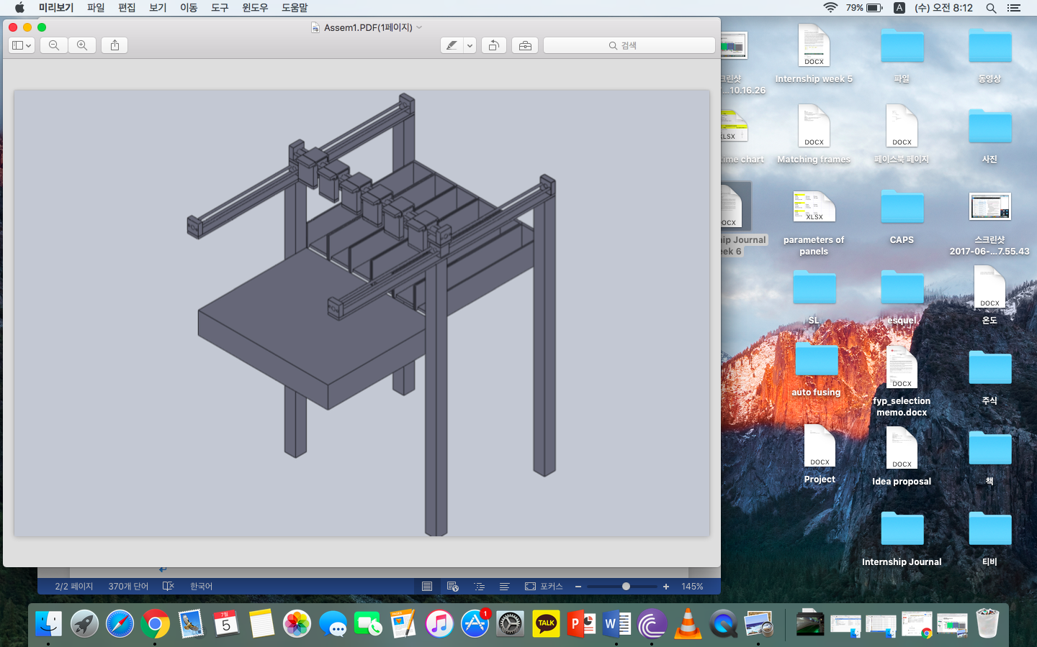

**Auto Laying out fabric**

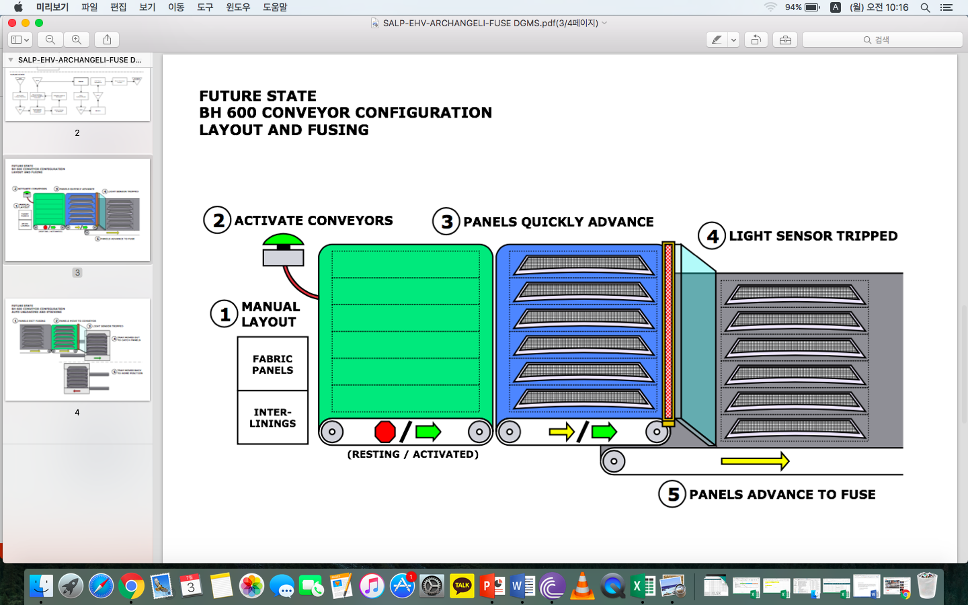

**Conveyor Configuration**

Meeting agenda

Conveyor configuration - short term

Efficiency calculation

Capacity to meet demand

Machine changes – est. cost to source or build

Quality affected

Process/simulation

Design

Auto collection – short/medium term

Adapting of TED design

Integration with conveyor

Process/Design simulation

Est. cost to build

Auto Loading – long term

Process simulation

Conceptual design

Sensors required on the stack store to detect whether there is fabric or not.

Machine capability / limitation

* The working environment – vacuum pads (14-28 degree Celsius)
* Problem with pick and place (soft fabric) – test with the sensor

Proof of concept – comparable tech

Softwear – pick and place

Grabit

Experimentation – prototyping on small scale – calculations to make prototype

Digital pressure sensor (testing out different types of fabric)

* Measures how many pads require to pick up one panel
* Testing with the vacuum pads

The conceptual design meeting went well except there are some things that need to be fixed. Re-calculations of the efficiency calculation are required. There is some misunderstanding in the assumptions that has been made to calculate the efficiency. Getting the equipment list for test prototype designs.

**Test and experiment**

Testing out whether the vacuum system pick up and pick one panel of fabric only. There are many different types of fabric so the vacuum pick-up system needs to work on every types of fabric.

**Result**

**Auto loading fabric**

Using a spot welding fusing machine in the factory, picking up a panel from a stack of fabric carried out.

1. Wind around the pads disturbs the stack of fabric
2. Trouble picking up one panel
3. Stack of fabric gets distorted
4. Cannot lay out flat (Get folded)

The results were not satisfying but some problems were noticed. Not every fabric in a stack is the same size. Due to this uneven size, when the vacuum pad picks up a panel the stack of fabric gets distorted. Also, there is inconsistency. Sometimes vacuum pick-ups cannot pick up only one panel. Maybe pick and place is not the best choice to lay out fabrics. The purchasing team has ordered vacuum pads for vinyl. This would bring a better result. An alternative ways need to be considered.

The time line for the spot welding is about 9 seconds which is a lot shorter than I have calculated for my design. Considering that my design need to travel 50 cm it would take some travel time, but even adding the travelling time still it would be shorter than the calculations so the system can focus more on picking up one layer of fabric.

For the improvements, tape mechanism idea has come up. However, there are some concerns about the tape mechanism. The tacky force needs to be considered. The stack of fabric has a lot of dust so tape needs to be changed after some period. The consistency of the machine would be the main target for this machine.

Improvement

* Using a needle mechanical system to pick up one panel

**Conveyor configuration**

The fusing machine conveyor speed cannot be changed. The test is required to get the calculations and see whether this is feasible or not. The speed of conveyor needs to be set and tested. For estimation it is set as 25cm/sec. The current fastest speed is not identified. The testing can be carried out with the fastest speed on the fusing machine which is 3.5m/min.

**Auto collection**

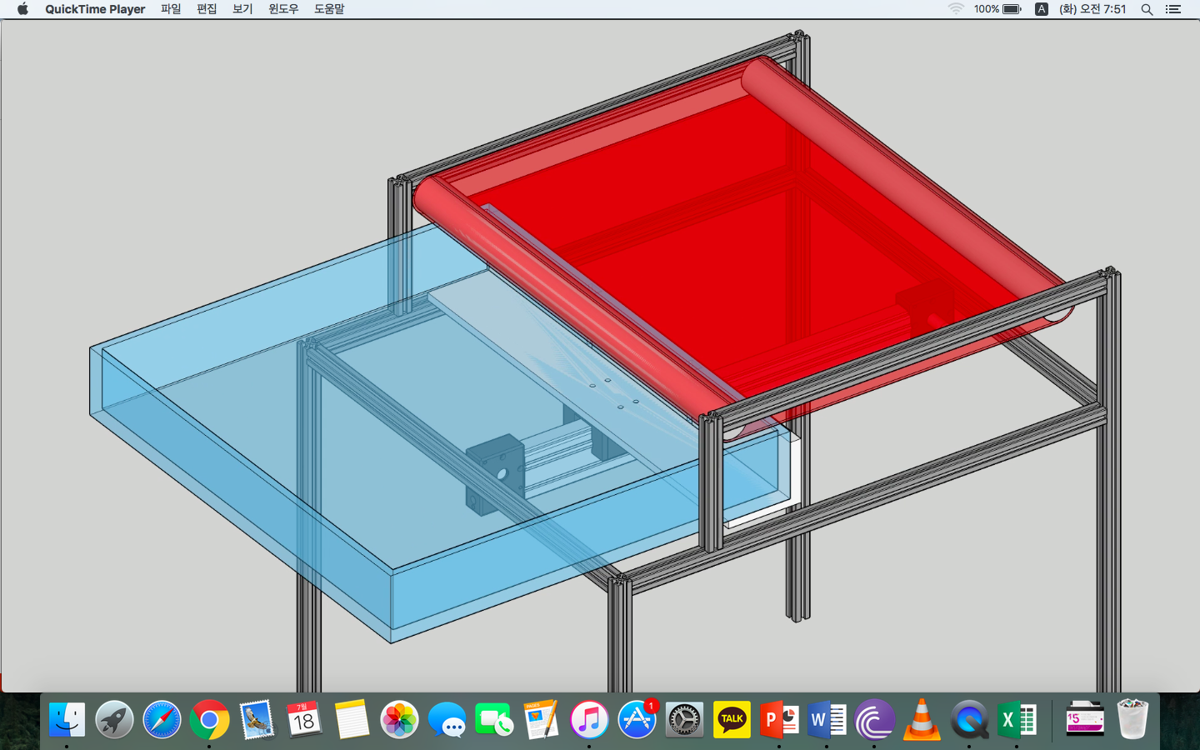

When the conveyor configuration is set, the auto collection at the exit of the BH 600 is added. This allows to collect the finished product and store in a stack so that the worker can collect it to do quality check and bundle. The Technical Engineering Department has made a similar machine for the same process attaching to a different machine. That can be modified and improve to add it to the BH 600.