Maven installation and quick commands
1)
To install download Maven from
http://maven.apache.org/download.html
Ubuntu users can install directly from apt using
sudo apt-get install maven2

and you are ready to go.
Windows users on the other hand have to follow the following looonnggg steps :
- Unzip the distribution archive, i.e. apache-maven-2.2.1-bin.zip to the directory you wish to install Maven 2.2.1. These instructions assume you chose C:\Program Files\Apache Software Foundation. The subdirectory apache-maven-2.2.1 will be created from the archive.
- Add the M2_HOME environment variable by opening up the system properties (WinKey + Pause), selecting the "Advanced" tab, and the "Environment Variables" button, then adding the M2_HOME variable in the user variables with the value C:\Program Files\Apache Software Foundation\apache-maven-2.2.1. Be sure to omit any quotation marks around the path even if it contains spaces. Note: For Maven < 2.0.9, also be sure that the M2_HOME doesn't have a '\' as last character.
- In the same dialog, add the M2 environment variable in the user variables with the value %M2_HOME%\bin.
- Optional: In the same dialog, add the MAVEN_OPTS environment variable in the user variables to specify JVM properties, e.g. the value -Xms256m -Xmx512m. This environment variable can be used to supply extra options to Maven.
- In the same dialog, update/create the Path environment variable in the user variables and prepend the value %M2% to add Maven available in the command line.
- In the same dialog, make sure that JAVA_HOME exists in your user variables or in the system variables and it is set to the location of your JDK, e.g. C:\Program Files\Java\jdk1.5.0_02 and that %JAVA_HOME%\bin is in your Path environment variable.
- Open a new command prompt (Winkey + R then type cmd) and run mvn --version to verify that it is correctly installed.

2) Go to the folder where you have cloned the lunarcodes repository (please refer to the document which selvam sent or feel free to drop a mail) and cd into the project folder. You should be able to see the pom.xml using ls/dir.
3) type “mvn install”
(this should take a long time since your jars are getting downloaded into your local machine’s repository which is ideally your <homedirectory>/.m2/repository)
Notes from the net :
~/.m2/repository/
This directory contains your local Maven repository. When you download a dependency from a remote Maven repository, Maven stores a copy of the dependency in your local repository.

Note
In Windows XP, your home directory is C:\Documents and Settings\tobrien, and in Windows Vista, your home directory is C:\Users\tobrien.

4) To add dependent libraries (as mentioned in the pom.xml) to your eclipse build path type in
mvn:eclipse eclipse
5) Open your eclipse and import the project as java project. Your classes will still give a problem saying that it could not find the libraries. Go to Project-Properties-BuildPath-Libraries- Add variable and add M2_REPO as Name and your <homedirectory>/.m2/repository as value

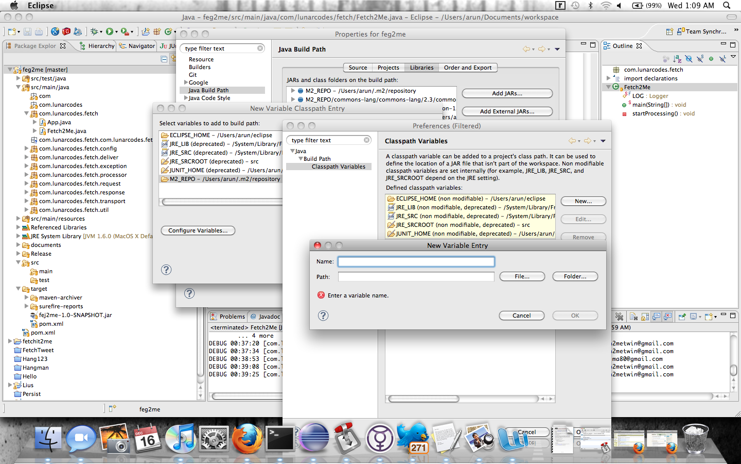

detailed guide is available at :
http://maven.apache.org/guides/getting-started/index.html

