=== **Javascript Exercise 1 - Vanilla JS process URL Query String.**

=== @ Bin Jiang, 10 June, 2015

**Run on URL:**

<http://lunarcy.comze.com/view/vanilla_js.html?buy=icecream&color=white&type=vanilla&price=6>

**Output:**

{"buy":"icecream","color":"white","type":"vanilla","price":"6"}

**Cookie:**

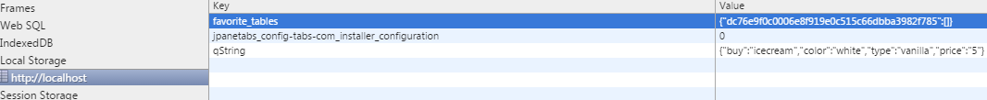

**LocalStorage:**

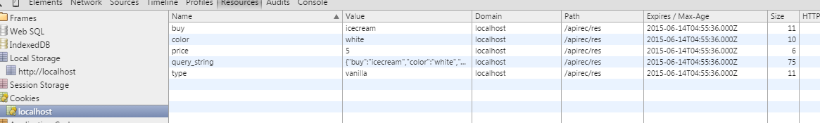

**Notes!! (if you run the html file as local file, not hosted web page.)**



=== **Javascript Exercise 2 - AngularJS - Directives.**

=== @ Bin Jiang, 10 June, 2015

**Run on URL:**

<http://lunarcy.comze.com/view/angular_form.html>

**Result:**

