Specific Requirements

Functionality
3.1.1 Department management
- Description:
Department management allows admin to view/insert/update/delete department' information.
  - Insert: create department and its information.
  - Update: update department's information.
  - Delete: delete department.
  - View: view department's information.
Only admin can use these functions.

No. | Field name | Remarks
1 | Department ID | Each department has a unique identification number
2 | Name | Department’s name
3 | Phone | Department’s contact phone number
4 | Employee Number | Total employees in department
5 | Email | Email support
Table 1: List of department field

- Use-case model:

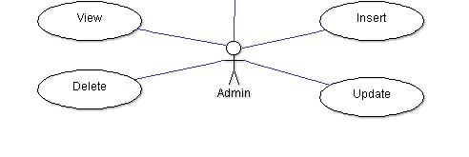
Figure 3.1-1: Admin use-case in department management

Use Case Name | Insert department use case
Actors | Admin
Description | Insert department
Requirement | Fields/Attributes must have validations on it
Pre-conditions | User must log in with role “Admin”
Post-conditions | New department is added to database
Basic Flow | Actor Actions:  1. Click “Add department” (link)  3. Admin types required attributes  4. Click "Submit" button  [Alternative Flow 1] | System Response:  2. Display a form and request to enter the attributes that will be processed.  Form includes:  - Name: String, Textbox (Required)  - Phone: String, Textbox (Required)  - Employee Number: Integer. Textbox (Required)  - Email support: String, Textbox (Required)  5. Data will be checked then saved to database.
Alternative Flow 1 | Actor actions:  1. Click “Cancel” button  3. Click "Yes"  [Alternative Flow 2] | System Response:  2. Message box confirms "Do you want to leave this page?"  4. Return to main page
Alternative Flow 2 | Actor Actions:  1. Click "No" button | System Response:  2. Stay at current page.
Exception Flow | N/A
Use case 3.1-1: Insert department

Use Case Name | View/Update/Delete Department use case
Actors | Admin
Description | View/Update/Delete Department
Requirement | Fields/Attributes must have validations on it
Pre-conditions | User must log in with role “Admin”
Post-conditions | Department is modified or marked as deleted in database
Basic Flow | Actor Actions:  1. Click on Modify Department (link)  2. Type Department’s name (Textbox)  3. Click “Search” button  5. Click on a department name (Link)  7. Click "Update" button  [Alternative Flow 1]  9. Enter needed attributes  10. Click “Submit” button.  [Alternative Flow 3] | System Response:  4. Display department list.  6. Department information will be shown  8. Display a form and let admin to re-enter attributes of department information  - Name: String, Textbox (Required)  - Phone: String, Textbox (Required)  - Employee Number: Integer. Textbox (Required)  - Email support: String, Textbox (Required)  - Submit/Cancel button  11. System will check data and save to database
Alternative Flow 1 | Actor Actions:  1. Click "Delete" button  3. Click "Yes" button  [Alternative Flow 2] | System Response:  2. Confirmed message box displays.  Message box include:  - Message: “Do you want to delete this department”  - Yes/No button.  4. System sets de-active department
Alternative Flow 2 | Actor Actions:  1. Click “No” button | System Response:  2. Return to department’s information page.
Alternative Flow 3 | Actor Actions:  1. Click “Cancel” button  3. Click "Yes" button  [Alternative Flow 4] | System Response:  2. Message box confirms "Do you want to leave this page?"  4. Return to main page
Alternative Flow 4 | Actor Actions:  1. Click "No" button | System Response:  2. Stay at current page.
Exception Flow | N/A
Use case 3.1-2: View/Update/Delete department
3.1.2 Employee management
- Description:
Employee management allows admin to view, insert, update, delete employees ' information. Employees' information may include their positions, their salaries, roles, e-mail......
Employees can only view information of other employees in company.
Inserting employees can be added manually by using form or from excel file (with self-format template).

No. | Field name | Remarks
1 | Employee ID | Each employee has a unique identification number
2 | First Name | Employee’s first name
3 | Last Name | Employee’s last name
4 | Address | Employee's address
5 | Phone | Phone to contact
6 | Account ID | Account ID uses in department
7 | Division | Employee's Division
8 | Department ID | Which department employee belongs
9 | Department Name | Name of department which employee belongs to
10 | Email | Email uses in department
11 | Division Group | Group in division
Table 2: List of Employee field
- Use-case model:
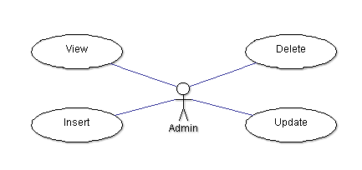
Figure 3.1-2: Admin use-case in employee management


Figure 3.1.2.2: Employee use-case in employee management

Use Case Name | Insert Employee use case
Actors | Admin
Description | Insert Employee
Requirement | Fields/Attributes must have validations on it
Pre-conditions | User must log in with role “Admin”
Post-conditions | New employee is added to database
Basic Flow | Actor Actions:  1. Click “Insert Employee” (link)  3. Enter needed attributes  4. Click "Submit" button  [Alternative Flow 2] | System Response:  2. Display a form and request to enter the attributes that will be process.  Form includes:  - First name: String, Textbox  - Last name: String, Textbox  - Address: String, Textbox  - Phone: String, Textbox  - Account ID: String, Textbox  - Department name: String, Drop down list  - Email: String, Textbox  - Division group: String, Textbox  - Submit/Cancel button  5. Data will be checked then saved to database.
Alternative Flow 1 | Actor Actions:  1. Click “Insert Employee by Excel” (link)  2. Upload an excel file that have employee information (excel will be self-formatted).  3. Click "Upload" | System Response:  4. Data will be checked then saved to database.
Alternative Flow 2 | Actor Actions:  1. Click “Cancel” button  3. Click "Yes" button  [Alternative Flow 3] | System Response:  2. Message box confirms "Do you want to leave this page?"  4. Return to main page
Alternative Flow 3 | Actor Actions:  1. Click "No" button | System Response:  2. Stay at current page.
Exception Flow | N/A
Use case 3.1-2: Insert Employee

Use Case Name | Update/Delete Employee use case
Actors | Admin
Description | View/Update/Delete Employee information
Requirement | Fields/Attributes must have validations on it
Pre-conditions | User must log in with role “Admin”
Post-conditions | Employee is modified or marked as deleted in database
Basic Flow | Actor Actions:  1. Click on Modify Employee (link)  2. Type Name/Account ID then click “Search” button  4. Click on Account ID/Name (link)  6. Click "Update" button  [Alternative Flow 1]  8. Admin modifies  9. Click "Submit" button  [Alternative Flow 2] | System Response:  3. Display Employee list.  5. Employee information will be shown  7. Display Employee information form and let admin modifies info.  Form includes:  - First name: String, Textbox  - Last name: String, Textbox  - Address: String, Textbox  - Phone: String, Textbox  - Account ID: String, Textbox (cannot be modified)  - Department name: String, Drop down list  - Email: String, Textbox  - Division group: String, Textbox  - Submit/Cancel button  10. Data will be checked then saved into database.
Alternative Flow 1 | Actor Actions:  1. Click "Delete" button  3. Click "Yes" button  [Alternative Flow 3] | System Response:  2. Display message box to confirm  Message box include:  - Message: “Do you want to delete this Employee”  - Yes/No button.  4. Set de-active employee
Alternative Flow 2 | Actor Actions:  1. Click “Cancel” button  3. Click "Yes" button  [Alternative Flow 4] | System Response:  2. Message box confirms "Do you want to leave this page?"  4. Return to main page
Alternative Flow 3 | Actor Actions:  1. Click “No” button | System response:  2. Return to employee information page
Alternative Flow 4 | Actor Actions:  1. Click "No" button | System Response:  2. Stay at current page.
Exception Flow | N/A
Use case 3.1-3: Update/Delete Employee for Admin

Use Case Name | View Employee use case
Actors | Admin/Manager/Employee
Description | View Employee information
Requirement | Roles must be defined clearly
Pre-conditions | User must log in
Post-conditions | None
Basic Flow | Actor Actions:  [User role “Admin”]  1. Click on Modify Employee (link)  2. Type Name/Account ID then click “Search”  4. Click on Account ID/Name | System Response:  3. Display Employee list.  5. Employee information will be shown
Alternative Flow | Actor Actions:  [User role “Employee”]  1. User click “My information” | System Response:  2. Employee information will be shown
Exception Flow | N/A
Use case 3.1-4: View information for Employee

3.1.3 Project management
- Description:
Project management allows:
  - Admin: add new projects, assign managers to the projects.
  - Managers: add employees into projects, assign tasks, define checkpoint and give evaluation mark.
  - Employees: view projects information.

No. | Field name | Remarks
1 | Project ID | Each project has a unique identification number
2 | Project Name | Project Name
3 | Team Name | Team name
4 | Total Employee | Total employee in the project
5 | Scope | Scope of the project
6 | Rank | Rank of the project
7 | Check Point | Define checkpoint time
8 | Evaluation mark | Give mark to each employee
9 | Employee ID | Employee ID
10 | Employee Name | Include first name and last name
11 | Manager | Manage who manage the project
Table 3: List of Project field

- Use-case model:
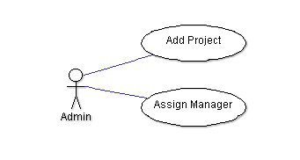
Figure 3.1-3: Admin use-case in project management

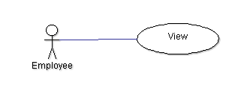
Figure 3.1-4: Employee use-case in project management

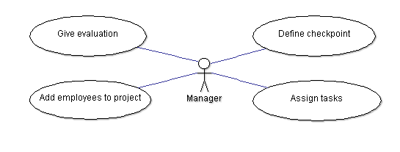
Figure 3.1-5: Manager use-case in project management

Use Case Name | Define checkpoint Use Case
Actors | Manager
Description | Define checkpoint
Requirement | Fields/Attributes must be filled with correct format
Pre-conditions | User must log in with role “Manager”
Post-conditions | Checkpoint(s) for selected project is(are) defined
Basic Flow | Actor Actions:  1. Click “Define check point” (link)  3. Click "Submit" (button)  [Alternative Flow 1] | System Response:  2. Display a form and request to enter necessary items needed for a checkpoint.  Form may contain:  - Date (Calendar, date)  - Reason for defining checkpoint (Textbox, String)  - Project's name (Drop down list, String)  - Submit/Cancel button.  4. Data will be checked then save into database.  5. Before the checkpoint's time 1 week, system will send an email notification to members in project.  Email content:  - Remind to give evaluation
Alternative Flow 1 | Actor Actions:  1. Click "Cancel" button  3. Click "Yes" button  [Alternative Flow 2] | System Response:  2. Message box confirms "Do you want to leave this page?"  4. Return to main page
Alternative Flow 2 | Actor Actions:  1. Click "No" button | System Response:  2. Stay at current page.
Exception Flow | N/A
Use case 3.1-5: Define checkpoint

Use Case Name | Define checkpoint Use Case
Actors | System
Description | Define checkpoint
Requirement
Pre-conditions | User must log in with role “Manager”  Manager does not define any checkpoint
Post-conditions | Checkpoint(s) for selected project is(are) defined
Basic Flow | Actor Actions: | System Response:  1. System will automatically define a checkpoint at the end of the project.  2. Before the project ends 1 week, system will send an email notification to members in project.  Email content:  - Remind to give evaluation
Alternative Flow | N/A
Exception Flow | N/A

Use Case Name | Assign Tasks Use Case
Actors | Manager
Description | Assign Tasks
Requirement | Manager has already been set on a specific project by admin.  Employees have already been added into project
Pre-conditions | User must log in with role “Manager”
Post-conditions | Tasks for members in project are assigned
Basic Flow | Actor Actions:  1. Click “Assign Tasks” (link)  3. Choose Employees and Tasks  4. Click "Assign" button | System Response:  2. Display a screen that allows manager to assign work to members in project.  Screen includes:  - List of employees in the project. (String, Drop down list)  - List of tasks (String, Drop down list)  - Assign button  5. An email notification will be sent to Employees’ mails.
Alternative Flow | N/A
Exception Flow | N/A
Use case 3.1-6: Assign tasks

Use Case Name | Give Evaluation Use Case
Actors | Manager
Description | Give Evaluation
Requirement | Manager has already been set on a specific project by admin.
Pre-conditions | User must log in with role “Manager”
Post-conditions | Evaluation for selected employee is given
Basic Flow | Actor Actions:  1. Click “Give Evaluation” (link)  3. Click "Submit" button  [Alternative Flow 1] | System Response:  2. Display a screen that allows manager to Give Evaluation to members in project.  Screen include:  - Criterions for evaluation (radio button with marks as: “Always: 10; Almost:8; Sometimes:5; Rarely:3; Almost not: 1”)  - Description field (String, Textbox)  4. System will save the result.
Alternative Flow 1 | Actor Actions:  1. Click "Cancel" button  3. Click "Yes" button  [Alternative Flow 2] | System Response:  2. Message box confirms "Do you want to leave this page?"  4. Return to main page
Alternative Flow 2 | Actor Actions:  1. Click "No" button | System Response:  2. Stay at current page.
Exception Flow | N/A
Use case 3.1-7: Give evaluation

Use Case Name | Add employee to project Use Case
Actors | Manager
Description | Add employee to project
Requirement | Manager has already been set on a specific project by admin.
Pre-conditions | User must log in with role “Manager”
Post-conditions | Employee is added to project
Basic Flow | Actor Actions:  1. Manager type name/ Account ID of employee  2. Click “Search”  4. Click on employee name  5. Add employee into project by clicking “Add”  [Alternative Flow 1]  6.Click "Submit" button  [Alternative Flow 2] | System Response:  3. Display Form Employee list and project list:  Form include:  - List of employee  - List of project  - Add/Remove button  - Submit/Cancel button  7. Data will be checked then saved into database
Alternative Flow 1 | Actor Actions:  1. Click on employee name  2. Remove employee from project by clicking "Remove"  3.Click "Submit" button  [Alternative Flow 2] | System Response:  4. Data will be checked then saved into database
Alternative Flow 2 | Actor Actions:  1. Click "No" button | System Response:  2. Stay at current page.
Exception Flow | N/A
Use case 3.1-8: Add employee to project

3.1.4 Performance Rating
a. Description
This function will help the manager in rating the employee’s performance on the project after a limit checkpoint (always 1 main Check Point at the end of the project, and somewhat that will be defined by manager depends on project’s specific situation) by re-evaluating their self-assessment, which will be submitted by the employee near the deadline of checkpoint. All result of rating process based on 12 default standard criteria that were followed by the company’s policies about how to asses one employee’s performance.
The final result will be calculated automatically by the system considered followed an aspect ratio created by the system administrator at the initial stage of the performance rating process and will be saved to database.
- System administrator: Configure ratio between the manager’s points and employee’s one for final calculation, and view all the final result
- Project manager: Re-evaluate employee’s performance based on checkpoint and company’s default standard criteria.
- Employee: Fulfill their own self-assessment for the result and view the final result of their own
- System automatically calculate the final result with the ratio that was configured by the admin and display
- Here is the list of evaluation criteria:
No | Attribute name | Description
1 | Attendance | The frequency with which an employee is present
2 | Support teammates | How well an employee support his/ her teammates
3 | Deadline commitment | How well an employee meet the planning schedule
4 | Adaptability | The ability to change to fit in new environment
5 | Learning ability | The ability to study new technologies, or skills
6 | Communication | The ability to communicate and express thoughts
7 | Problem Solving Ability | The ability to solve problems
8 | Managing and measuring work | The ability to manage and divide work
9 | Project Contribution | The contribution level to project
10 | Self-fulfilled ability | The ability to complete the task independently
11 | Attitude at work | Employee's behavior and characteristics at work
12 | Company Activities | How often an employee attends company’s activities
Table 4: Employee evaluation criteria
b. Use case model

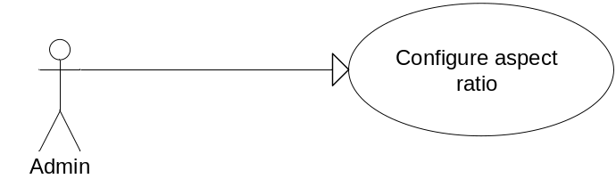
Figure 3.1-6: Administrator configures aspect ratio

User Case ID | UC_3.1.4.1
Name | Configure Performance Rating Ration Use Case
Goal | Configure the aspect ratio for performance rating
Actors | Administrator
Requirements | None
Pre-conditions | User must log in with role “Admin”
Post-conditions | New performance ratio is saved to database
Basic Flow | Actor Actions:  1. Click “Configure performance ratio”  2. Depending on the company’s policy, admin will add the specific ratio ( the ratio range will be from 0 – 40% )  3. Click “Save”  [Alternative Flow] | System Response:  2. System will display a textbox for user input ratio value ( number data-type , range : 0 – 40 )  4. System validates the input value  5. System saves and store in database
Alternative Flow | Actor Actions:  - Click “Reset” button | - System will reset the value of data and will be ready for user input new data.
Exception Flow | Actor Actions:  - Click “save” button after input the value | - System will automatically validate the input value  - If the input value is out of range, system will reset the value in textbox and display an error message box: “Error! Invalid value. Please try again”.
Use case 3.1-9: Administrator configures ratio use case

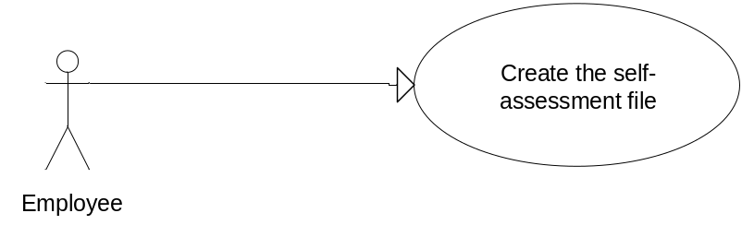
Figure 3.1-7: Employee self-assess

User Case ID | UC_3.1.4.2
Name | Performance Rating Employee self-assess Use Case
Goal | Employee finish the self-assessment template
Actors | Employee
Requirements | System has sent a notification email about checkpoint to employee
Pre-conditions | User must log in with role “Employee”
Post-conditions | Employee fulfills all necessary information in self-assessment file.
Basic Flow | Actor Actions:  1. Click “Download Self-assessment template”  - Employee manually fills in their own results. | System Response:  - Display a template excel file with 12 default standard criteria for employee :  - Attendance  - Support teammate  - Deadline commitment  - Adaptability  - Learning ability  - Communication  - Problem solving ability  - Manage and measuring work  - Project contribution  - Self-fulfilled ability  - Attitude at work  - Company activities  with the corresponding default evaluate point stored in combo-box for user to choose :  - 10 : Always/Great  - 8: Almost/Good  - 5:Sometimes/Normal  - 3:Rarely/Weak  - 1:Almost not/Bad
Alternative Flow | N/A |  | N/A
Exception Flow | N/A |  | N/A
Use case 3.1-10: Employee self-assessment use case

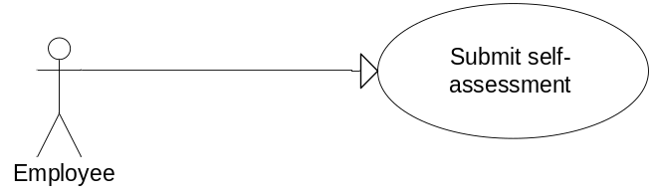
Figure 3.1-8: Employee self-assessment use case 2

User Case ID | UC_3.1.4.3
Name | Performance Rating Employee self-assess Use Case
Goal | Employee finished uploading self-assessment file into system
Actors | Employee
Requirements | Employee finished creating the self-assessment file
Pre-conditions | User must log in with role “Employee”
Post-conditions | Employee’s self-assessment is saved to database
Basic Flow | Actor Actions:  1. Click on the latest checkpoint time on system  - Click “Browse file” button and choose the template file  - Click “Upload this file”  - Employee manually fill in their own results. | System Response:  2. Deliver user to upload page  - System will save the file on the Temporary folder on system for parsing to database.  - System will validate the template and then parse to the database
Alternative Flow | N/A | N/A
Exception Flow 1 | Actor Actions:  - Click “Upload this file” | System Response:  - If the upload file is neither on the Temporary folder nor the Upload process has finished , system will display an error message:  “Error! Please choose to file to upload again.”
Exception Flow 2 | Actor Actions :  - Click “Upload this file” | System Response:  - System saves file in Temporary folder for parsing.  - System validates whether the uploaded file is on the right formatted template. If not , an error message will be displayed :  “Error! The file is in wrong format. Please upload another one.”
Use case 3.1-12: Employee self-assessment use case 2

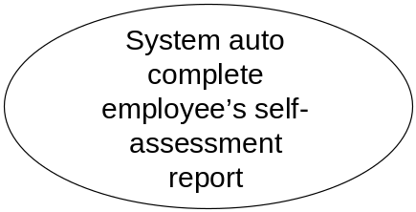
Figure 3.1-9: System auto function 1

User Case ID | UC_3.1.4.4
Name | Performance Rating auto functioning 1
Goal | System automatically
Actors | System
Requirements | System has sent a notification email about checkpoint to employee
Pre-conditions | At the checkpoint, the employee still hasn’t finished uploading the self-assessment file to the system.
Post-conditions | Default value of employee’s self-assessment will be auto completed by system
Basic Flow | Actor Actions:  N/A | System Auto Actions:  1. At checkpoint, in case the employee hasn’t uploaded anything to system , it will automatically fill in the table’s fields the default value of 3 for all criteria .
Alternative Flow | N/A | N/A
Exception Flow | N/A | N/A

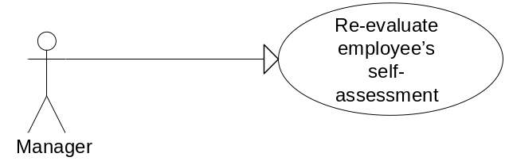
Figure 3.1-10: Manager re-evaluates employee performance

User Case ID | UC_3.1.4.5
Name | Performance Rating Manager re-evaluate Use Case
Goal | Manager re-evaluate the employee’s self-assessment
Actors | Manager
Requirements | Employee finished creating and uploading self-assessment file on system’s database
Pre-conditions | User must log in with role “Manager”
Post-conditions | Manager’s evaluation for employee is saved to database
Basic Flow | Actor Actions:  1. Click on Employee Name  2. Choose “Evaluate” options.  4. Manager fulfills all necessary information.  5. Click “Submit” button.  [Alternative Flow] | System Response:  - System will display a web-form with file with 12 default standard criteria for employee :  - Attendance, Support teammate, Deadline commitment, Adaptability, Learning ability, Communication, Problem solving ability, Manage and measuring work, Project contribution, Self-fulfilled ability, Attitude at work, Company activities  with the corresponding default evaluate point stored in combo-box for user to choose :  - 10 : Always/Great  - 8: Almost/Good  - 5:Sometimes/Normal  - 3:Rarely/Weak  - 1:Almost not/Bad  And together with a “Remarks” textbox for each of criteria for managers to write their opinion or comment  6. System will automatically save the manager’s result into database.
Alternative Flow | Actor Actions:  - Click “Reset” button | System Response:  - System resets all the fields for user re-enter again.
Exception Flow 1 | Actor Actions:  - Click “Submit” button | System Response:  - System validates all the fields.  - When encountering any abnormal or missing field, system will display a message: “Error! Some fields are missing. Please fill in all necessary information.”
Exception Flow 2 | - Click “Submit” button | - System validates all the fields.  - When system can’t connect to database or the data can’t be updated into database: “Error! Database connecting failed. Please try again later.”
Use case 3.1-11: Manager Re-evaluation use case

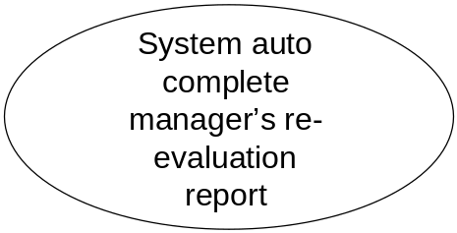
Figure 3.1-11: System auto function 2

User Case ID | UC_3.1.4.6
Name | Performance Rating auto functioning 2
Goal | System automatically
Actors | System
Requirements | System has sent a notification email about checkpoint to employee
Pre-conditions | At the checkpoint, the manager still hasn’t finished completed the re-evaluation process on the system.
Post-conditions | Default value of manager’s re-evaluation result will be auto completed by system
Basic Flow | Actor Actions:  N/A | System Auto Actions:  1. At checkpoint, in case the manager hasn’t finished submitted anything on the system. It will automatically fill in the table’s fields the default value of 3 for all criteria.
Alternative Flow | N/A | N/A
Exception Flow | N/A | N/A

User Case ID | UC_3.1.4.7
Name | Performance Rating Processing
Goal | Calculate the final result based on the initial ratio and the evaluation point from employee and manager
Actors | System
Requirements | Employee’s and Manager’s evaluation result must exist in system’s database.
Pre-conditions | None
Post-conditions | Final result of each employee will be calculated and saved into database.
Basic Flow | Actor Actions: | System Response:  - After all required necessary data has been on the system’s database , the system will automatically calculate the result of each of 12 standard criteria based on the formula :  Each criteria mark =  (employee mark*ratio) +  (manager mark*(1-ratio))  And the final result will be the average value of 12 criteria’s result.  - System will insert these final values into database.
Alternative Flow | N/A
Exception Flow | N/A

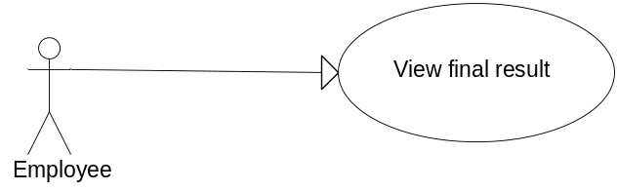
Figure 3.1-11: Employee view result

User Case ID | UC_3.1.4.8
Name | Performance Rating Employee view result Use Case
Goal | View the final result that was calculated automatically by system
Actors | Employee
Requirements | System calculated the final result after collecting all necessary information.
Pre-conditions | User must log in with role “Employee”
Post-conditions | None
Main Flow | Actor Actions:  - Click “View final result” | System Response:  - System connects to database and retrieve the final result according and only restricted to the current employee id is using the function.  - Display the final result in the employee’s screen.
Alternative Flow | N/A |  | N/A
Exception Flow | Actor Actions:  - Click “View final result” |  | System Response:  - System failed to connect to database and will display and error message: “Error! Database connection has broken. Please try again”
Use case 3.1-12: Employee view result use case
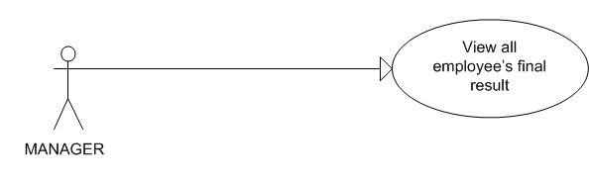
Figure 3.1-12: Manager views result

User Case ID | UC_3.1.4.9
Name | Performance Rating Manager view result Use Case
Goal | View the final result that was calculated automatically by system
Actors | Manager
Requirements | System calculated the final result after collecting all necessary information.
Pre-conditions | User must log in with role “Manager”
Post-conditions | None
Basic Flow | - Click “Display final results” | 2. System connects to database and retrieve the final result value of all employees.  - Display the final results in the table form of a name-list , consists of these columns of all employees:  - ID ( hyperlink )  - Name ( hyperlink )  - Project ( hyperlink )  - Final result ( text box )
Alternative Flow | N/A | N/A
Exception Flow | N/A | N/A
Use case 3.1-13: Manager views result use case.

3.1.5 View Report
- Description
The view report function allows managers to view reports based on their request. For example: when a manager chose to view which employee is good at Learning Ability and Adaptability they just need to choose these two attributes and click the view report button. A report will be shown based on their request.
Here is the list of attributes that can be chosen to view report
No | Attribute name | Description
1 | Attendance | The frequency with which an employee is present
2 | Support teammates | How well an employee support his/ her teammates
3 | Deadline commitment | How well an employee meet the planning schedule
4 | Adaptability | The ability to change to fit in new environment
5 | Learning ability | The ability to study new technologies, or skills
6 | Communication | The ability to communicate and express thoughts
7 | Problem Solving Ability | The ability to solve problems
8 | Managing and measuring work | The ability to manage and divide work
9 | Project Contribution | The contribution level to project
10 | Self-fulfilled ability | The ability to complete the task independently
11 | Attitude at work | Employee's behavior and characteristics at work
12 | Company Activities | How often an employee attends company’s activities
Table 5: List of attributes that can be view in reports
Here is the list of scope that can be chosen when viewing report
No | Name | Description
1 | Department | Show all employees of that department
2 | Project | Show all employees of that project
3 | Company | Show all employees of that company
Table 6: List of scope

- Use-case Model
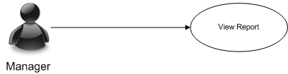
Figure 3.1-8: Manager Views Report

Use Case Name | View Report Use Case
Actors | Manager
Description | This function provide the view report ability for Manager
Pre-conditions | User must log in with role “Manager”
Post-conditions | Success: a report with requested attributes are rendered  Fail: N/A
Basic Flow | Actor Actions:  - Click “Report” link  3. Choose attributes  4. Click “View”  [Alternative Flow 1] | System Response:  2. Display a form with Attendance, Support Teammate, Deadline Commitment, Adaptability, Learning Ability, Communication, Problem Solving Ability, Managing and Measuring Work, Project Contribution, Self-Fulfilled Ability, Attitude At Work, Company Activities attributes as checkbox, three scopes: Project, Department, Company as group of combo box  5. A report with the chosen attributes as output data will be shown.  [Exception 1]
Alternative Flow | [Alternative Flow 1]  4. Click Cancel | 5. Reset form to default
Exception Flow | N/A | [Exception 1]  5. A message “Do Not Have Data” will be shown
Use case 3.1-14: Manager Views Report Use case

