

[Project]
SOFTWARE DESIGN SPECIFICATION

Project Code:
Document Code: <Project code>-DD – v<Version>

<Location, issued date of the Document>
Record of change
*A - Added M - Modified D – Deleted
Effective Date | Changed Items | A*  M, D | Change Description | New Version

SIGNATURE PAGE

ORIGINATOR: <Name> <Date>
<Position>

REVIEWERS: <Name> <Date>
<Position>

<Name, if it’s needed> <Date>
<Position>

APPROVAL: <Name> <Date>
<Position>

TABLE OF CONTENTS
1 Introduction 6
1.1 Purpose 6
1.2 Definitions, Acronyms and Abbreviations 6
1.3 References 7
1.4 Overview 7
2 SYSTEM Architecture 8
3 screen Flow 9
4 COMMON package and mechanism 10
4.1 Common package 10
4.1.1 Class diagram 10
4.1.2 XXX class 10
4.2 Error, exception handling 11
4.2.1 Class Diagram 11
4.2.2 Usage mechanism 11
4.3 Log, trace and debug 11
4.4 Performance optimizing mechanism 11
4.5 Multilingual processing 11
5 Diagrams 12
5.1 Customer management 12
5.1.1 Add customer 12
5.1.2 Update customer 13
6 Packages 14
6.1 xxx Package 14
6.1.1 Class diagram 14
6.1.2 External interface 14
6.1.3 XXX class 14
6.2 ...... 15
7 Database 16
7.1 ERDs 16
7.2 XXX table 16
8 Other considerations 18
9 Appendix 19

Introduction

Purpose
This part will give general description of the document including:
- Purpose of document.
- What are contained in the doc
- Reader of document
- Other description about scope of document, limitation,...
Ex.
XXX class design document contains descriptions of all classes of the YYYY system including:
Class diagrams that describe the static relation of all classes in the system
Dynamic diagrams such as collaboration diagram, sequence diagram, activities diagram
Description of class in detail
Common mechanism in implementing is also defined in this document
Developer and tester will base on this design to implement classes and unit test.

Definitions, Acronyms and Abbreviations

Abbreviations | Description | Comment
TBD | To be decided | It means “not decided yet”
Windows DDK | Windows Device Development Kit | Development Kit from Microsoft to develop device driver for Windows 2000/XP/Server 2003 OS
ESC/P | Escape Printing command | A page description language used on Epson ink jet printers

References
List all the reference document such as: other document of the system, or the technical article,...
Document Number | Title
01 | Data design document

Overview
General overview of the detail design such as what is the structure of the document

SYSTEM Architecture
[This section describes what software architecture is for the current system, and how it is represented]

screen Flow
<Screen structure or transition between screens. It should be in diagram>
<List of screen>
No | Screen Name | Description

COMMON package and mechanism

Common package

Class diagram
<Class diagram>
No | Class Name | Description
01 | <Name of class> | <Brief description about class ex. One sentence to tell what the class is for, what does it encapsulate>

XXX class
<Class description>

Attributes
No | Attribute | Type | Default | Note | Description
01 | <Attribute name> | int |  | Public/ Static | <Description of attribute>

Methods
No | Method | Description
01 | <method name> | <brief description of method. can be one sentence tell what the method does>

xxxx method
<Method declaration>
<method description, it must be compliance with the brief description in the upper class list>

Parameters & return
No | Parameter | Type | In/out | Default | Description
01 | parameter name | int |  |  | <Description of parameter, special criteria such as boundary should be stated>
 | <return >

Implementation
How to implement the method, it can be in pseudo code or activity diagram or just words

Error, exception handling

Class Diagram
Describe class like in common package

Usage mechanism
Common mechanism of exception handling

Log, trace and debug

Performance optimizing mechanism

Multilingual processing

Diagrams
Describe diagrams in system such as collaboration diagram, sequence diagram, activities diagram and state chart for some functionalities of the system
Example

Customer management

Add customer
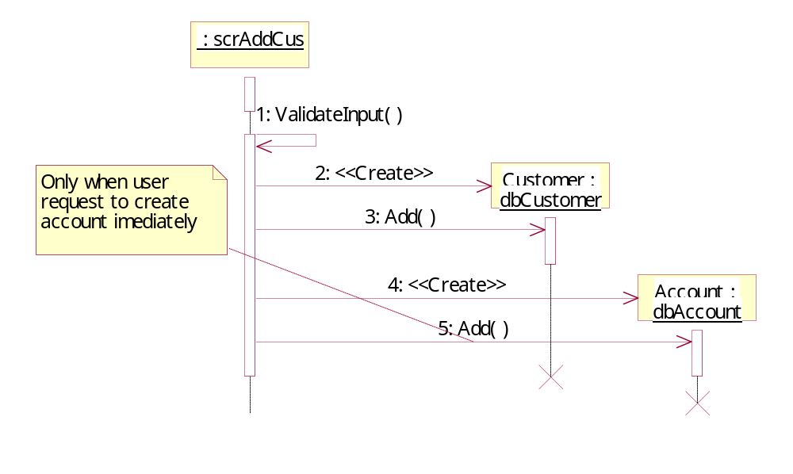
Figure 1 Add Customer sequence diagram
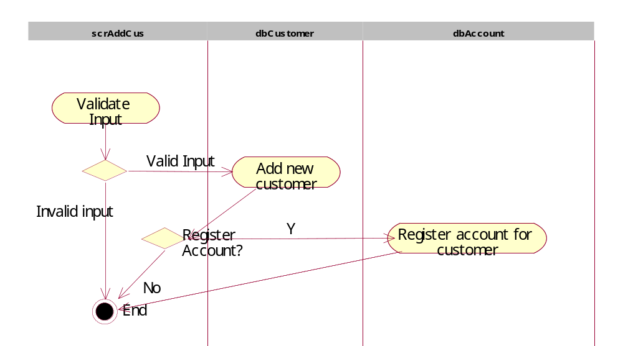

Update customer
.....

Packages
No | Package | Language | Description
01 | <package name> | C++, Java | <brief description of package; can be one sentence tell what the method does>

xxx Package

Class diagram
<Class diagram figure>
No | Class Name | Description
01 | <Name of class> | <Brief description about class ex. One sentence to tell what the class is for, what does it encapsulate>

External interface
Describe the external interface of the package (exported classes, methods).

XXX class
<Class description>

Attributes
No | Attribute | Type | Default | Note | Description
01 | <Attribute name> | int |  | Public/ Static | <Description of attribute>

Methods
No | Method | Description
01 | <method name> | <brief description of method. can be one sentence tell what the method does>

xxxx method
<Method declaration>
<method description, it must be compliance with the brief description in the upper class list>

Parameters & return
No | Parameter | Type | in/out | Default | Description
01 | <parameter name> | int |  |  | <Description of parameter, the special criteria such as boundary should be stated>
 | <return >

Implementation
<How to implement the method, it can be in pseudo code or activity diagram or just words>

......

Database

ERDs
<Entity relation ship diagrams>
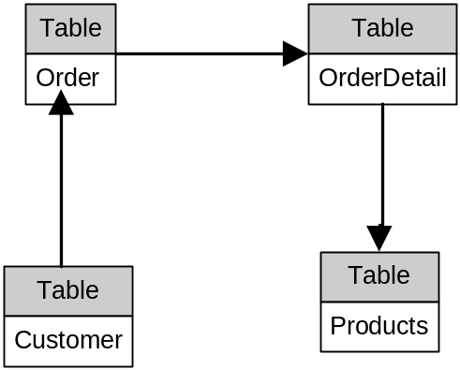
<List of tables and brief description>
No | Table Name | Description
 | CustomerMaster
 | Order | Order made by customer to buy one or more products
 | OrderDetail | Detail information of each products in order
 | ProductMaster | Contains all products of the store

XXX table
No | Field Name | Type | Length | Size | Null | Unique | P/F Key | Default | Description
01 | xxxCode | int | 4 |  |  | x | P |  | Code of xxx, Auto number
02 | yyyCode | int | 4 |  | x |  | F |  | Code of yyy.

Other considerations
<[This section provides a description of other design elements that were considered as alternatives in selection process for the above class design, i.e. a brief explanation of advantages and disadvantages of the selected package relationships and/or class implementation in comparison with others. It should be a clear answer to the question why the above class design is selected for this system, not the others.>

Appendix

