- Use-case model:

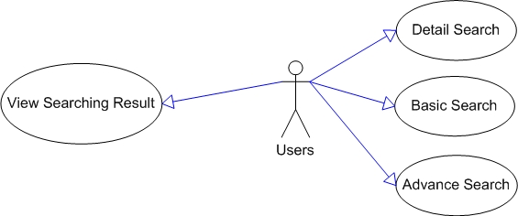
Figure 3.1-1: Admin use-case in department management

Use Case Name | Book Basic Search Use Case
Actors | Librarian/Admin/Normal users
Description
Requirement | For authorized users only
Pre-conditions | User must log in the system
Post-conditions
Basic Flow | Actor Actions:  1. Click “Search for books” (button)  3. User types required attributes  4. Click "Search" button  [Alternative Flow 1] | System Response:  2. Display a form and request to enter the attributes that will be processed.  Form includes:  - Title: String, Textbox (Required)  - Author: String, Textbox (Required)  - Publisher: String. Textbox (Required)  5. Data will be checked then show searching result
Alternative Flow 1 | Actor actions:  1. Click “Reset” button  3. Click "Yes"  [Alternative Flow 2] | System Response:  2. Message box confirms "Do you want to reset your searching data?"  4. Erase data in textboxes
Alternative Flow 2 | Actor Actions:  1. Click "No" button | System Response:  2. Stay at current state.
Exception Flow | N/A
Use case 3.1-1: Insert department

Use Case Name | Book Detail Search Use Case
Actors | Librarian/Admin/Normal users
Description
Requirement | For authorized users only
Pre-conditions | User must log in the system
Post-conditions
Basic Flow | Actor Actions:  1. Click “Search for books” (button)  3. User types required attributes  4. Click "Search" button  [Alternative Flow 1] | System Response:  2. Display a form and request to enter the attributes that will be processed.  Form includes:  - Title: String, Textbox (Required)  - Author: String, Textbox (Required)  - Publisher: String. Textbox (Required)  5. Data will be checked then show searching result
Alternative Flow 1 | Actor actions:  1. Click “Reset” button  3. Click "Yes"  [Alternative Flow 2] | System Response:  2. Message box confirms "Do you want to reset your searching data?"  4. Erase data in textboxes
Exception Flow | N/A
Use case 3.1-2: Detail Search department

Use Case Name | Book Advance Search Use Case
Actors | Librarian/Admin/Normal users
Description
Requirement | For authorized users only
Pre-conditions | User must log in the system
Post-conditions
Basic Flow | Actor Actions:  1. Click “Search for books” (button)  3. User types required attributes  4. Click "Search" button  [Alternative Flow 1] | System Response:  2. Display a form and request to enter the attributes that will be processed.  Form includes:  - Title: String, Textbox (Required)  - Author: String, Textbox (Required)  - Publisher: String. Textbox (Required)  5. Data will be checked then show searching result
Alternative Flow 1 | Actor actions:  1. Click “Reset” button  3. Click "Yes"  [Alternative Flow 2] | System Response:  2. Message box confirms "Do you want to reset your searching data?"  4. Erase data in textboxes
Exception Flow | N/A
Use case 3.1-3: Advance Search department

