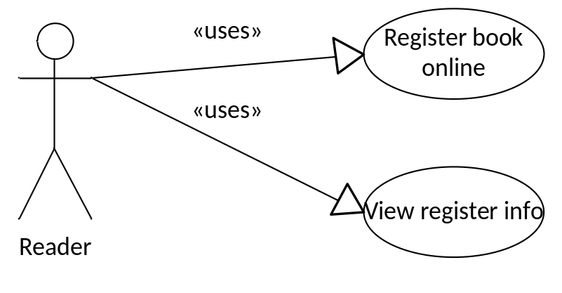
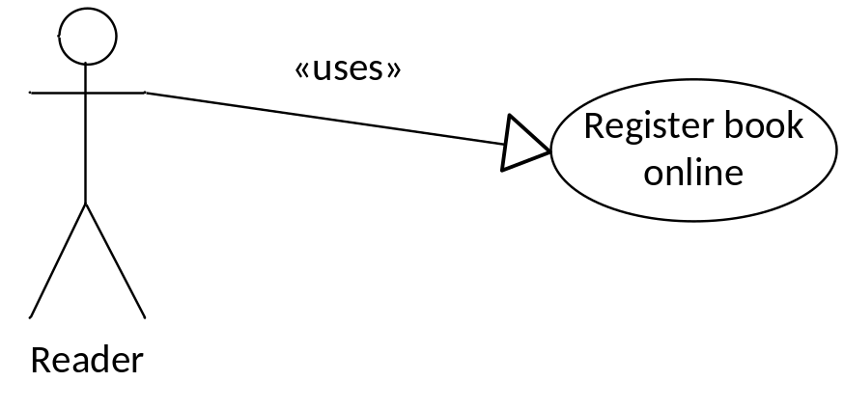

Use Case Name | Register book online
Actors | Reader
Description | Register book online
Requirement | User is available to borrow book
Pre-conditions | User must log in as a reader
Post-conditions | New register record is inserted into database
Basic Flow | Actor Actions:  1. Click Register icon on a book  4. Click OK  [Alternative Flow 1] | System Response:  3. Display confirm message  5. Save register info to database.  6. Display info message  7. Back to book list page
Alternative Flow 1 | Actor actions:  1. Click “Cancel” | System Response:  2. Back to book list page
Exception Flow | N/A
Use case 3.1-1: Register for book borrowing

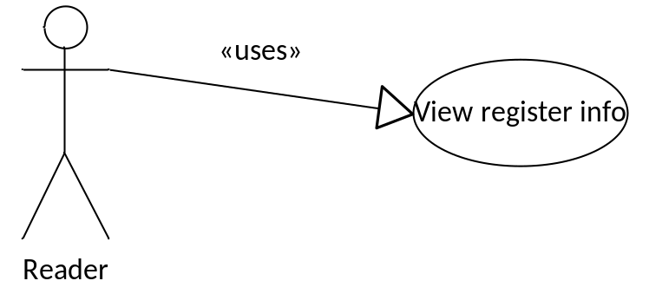
Use Case Name | View register info
Actors | Reader
Description | View register info
Requirement | N/A
Pre-conditions | User must log in as a reader
Post-conditions | Register info is displayed
Basic Flow | Actor Actions:  1. Click “View Register Info” | System Response:  2. Display all register of the logged in user
Exception Flow | N/A
Use case 3.1-2: View/Update/Delete department

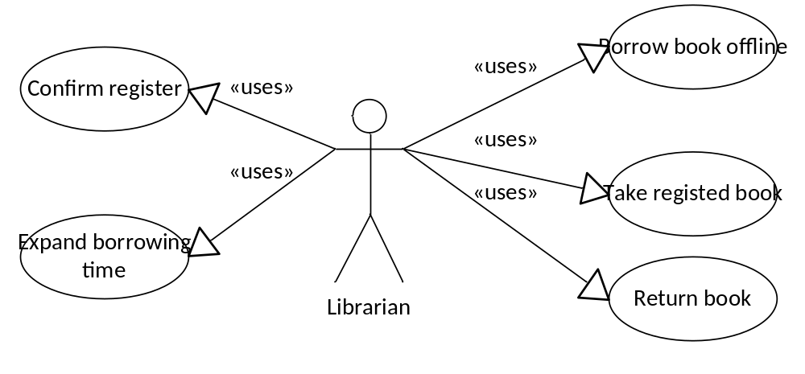
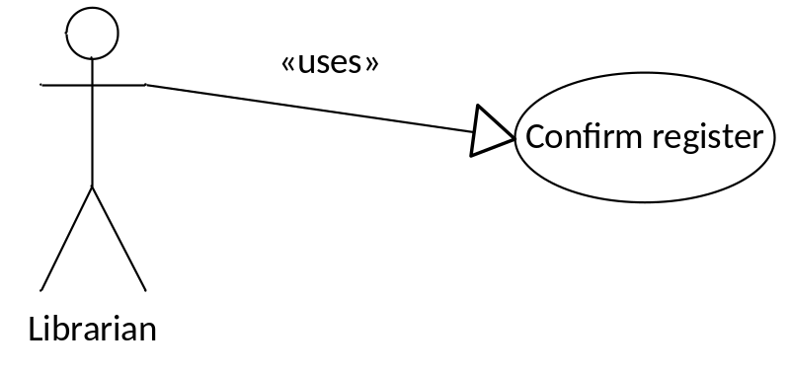
Use Case Name | Confirm register
Actors | Librarian
Description | Confirm register
Requirement | N/A
Pre-conditions | User must log in as a librarian
Post-conditions | New borrowing record is inserted into database
Basic Flow | Actor Actions:  1. Click “View Register”  3. Select a register  4. Click “Confirm”  [Alternative Flow 1]  6. Click “OK”  [Alternative Flow 2] | System Response:  2. Display all available registers  5. Display confirm message box  7. Update register info  8. Back to register list page
Alternative Flow 1 | Actor actions:  1. Click “Deny”  3. Click “OK”  [Alternative Flow 2] | System Response:  2. Display confirm message box  4. Update register info  5. Back to register list page
Alternative Flow 2 | Actor actions:  1. Click “Cancel” | System Response:  2. Back to register list page
Exception Flow | N/A

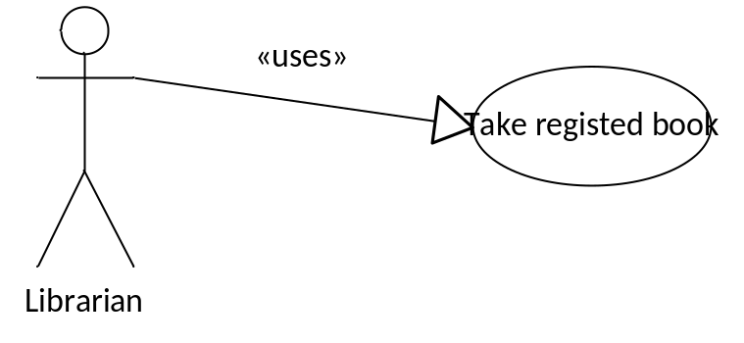

Use Case Name | Take registered book
Actors | Librarian
Description | Reader takes registered book
Requirement | Reader info is available
Pre-conditions | User must log in as a librarian
Post-conditions | New borrowing record is inserted into database  Register record is updated
Basic Flow | Actor Actions:  1. User input Reader ID  3. Click “Take Book” button  5. Select the required book  6. Click “Take”  8. Click “OK”  [Alternative Flow 1] | System Response:  2. Display reader info  4. Display a list of registered book  7. Display confirm message  9. Save borrowing info to database  10. Update register info  11. Display info message
Alternative Flow 1 | Actor actions:  1. Click “Cancel” | System Response:  2. Back to list book page
Exception Flow | N/A

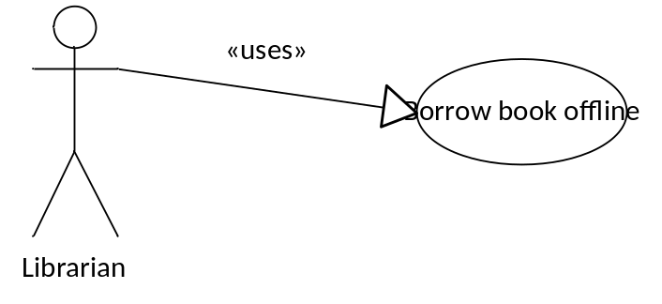
Use Case Name | Borrow book offline
Actors | Librarian
Description | Borrow book offline
Requirement | Reader info is available
Pre-conditions | User must log in as a librarian
Post-conditions | New borrowing record is inserted into database
Basic Flow | Actor Actions:  1. User input Reader ID  3. Click “Borrow Book” button  5. Select the required book  6. Click “Borrow”  8. Click “OK”  [Alternative Flow 1] | System Response:  2. Display reader info  4. Display list book page  7. Display confirm message  9. Save borrowing info to database  10. Display info message
Alternative Flow 1 | Actor actions:  1. Click “Cancel” | System Response:  2. Return to list book page
Exception Flow | N/A

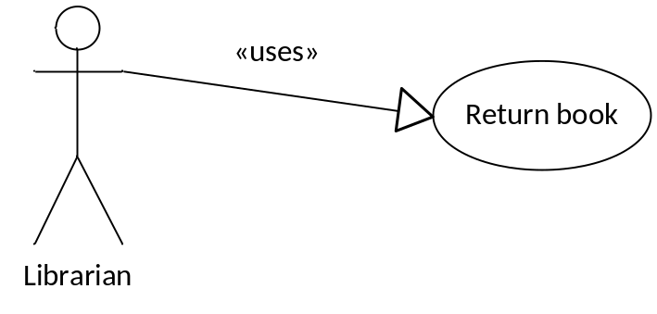
Use Case Name | Return book
Actors | Librarian
Description | Reader returns book
Requirement | Reader info is available
Pre-conditions | User must log in as a librarian
Post-conditions | Borrowing record is updated
Basic Flow | Actor Actions:  1. User input Reader ID  3. Click “Return Book” button  5. Select the required book  6. Click “Return”  8. Click “OK”  [Alternative Flow 1] | System Response:  2. Display reader info  4. Display list of currently borrowed books  7. Display confirm message  9. Save borrowing info to database
Alternative Flow 1 | Actor actions:  1. Click “Cancel” | System Response:  2. Return to list book page
Exception Flow | N/A

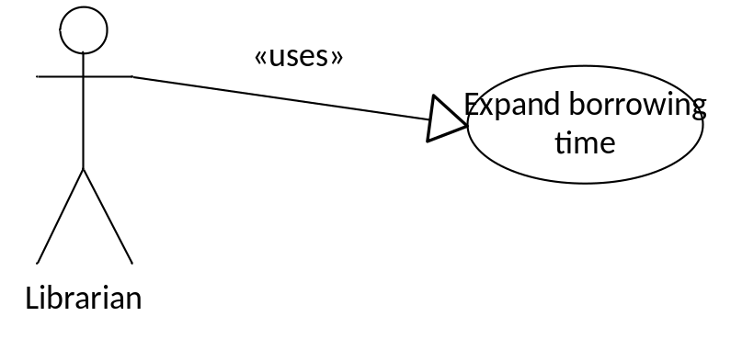
Use Case Name | Expand borrowing time
Actors | Librarian
Description | Expand borrowing time
Requirement | Reader info is available
Pre-conditions | User must log in as a librarian
Post-conditions | Borrowing record is updated
Basic Flow | Actor Actions:  1. User input Reader ID  2. Click “Expand time”  3. Select a borrowing record  5. Choose a date to expand to  6. Click “OK”  [Alternative Flow 1] | System Response:  3. Display list of borrowing records  4. Display a form and let user modify its info  Form includes:  - Date to expand to  7. Save borrowing info to database  8. Display info message
Alternative Flow 1 | Actor actions:  1. Click “Cancel” | System Response:  2. Return to borrowing records list
Exception Flow | N/A

