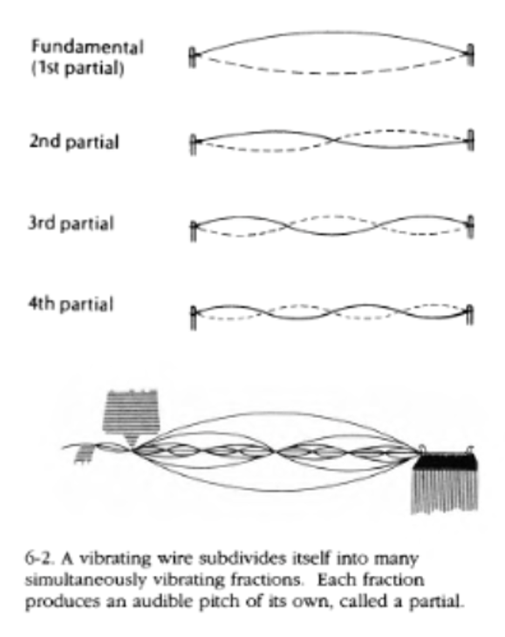
钢琴调音步骤
1. 概念：
a. 钢琴一个弦不止发出一个音，在完美情况 (perfectly harmonic) 下，。但实际上，琴弦两端和中间松紧不一，partial之间比例不完美 (inharmonicty)，其中存在偏差音系数(inharmonicity constant) ，使

b. A half-step or semitone is the smallest division of notes. For example, C to C# is a half-step. An octave is 12 half-steps.

c. Beat rate: Given two different perfect frequencies, they will create constructive and destructive interference that results in a pulsating effect called a beat. (This is likely a poor explanation)

d. An interval is a difference in pitch between two sounds. Some important intervals we will consider:
Unison (1:1), Pure (Perfect) octave (2:1), Perfect fifth (3:2), Perfect fourth(4:3), Major third(5:4), Minor third(6:5).
Below is a table and diagram you can refer to:
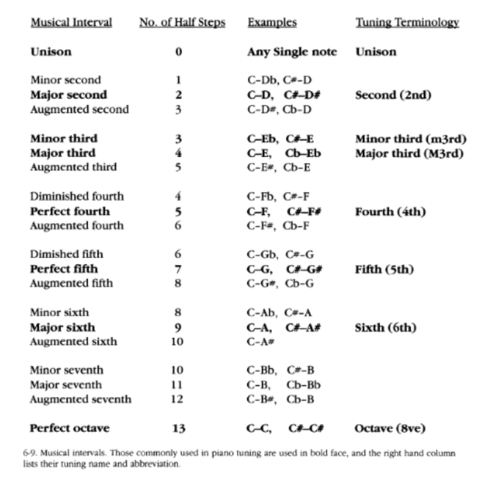
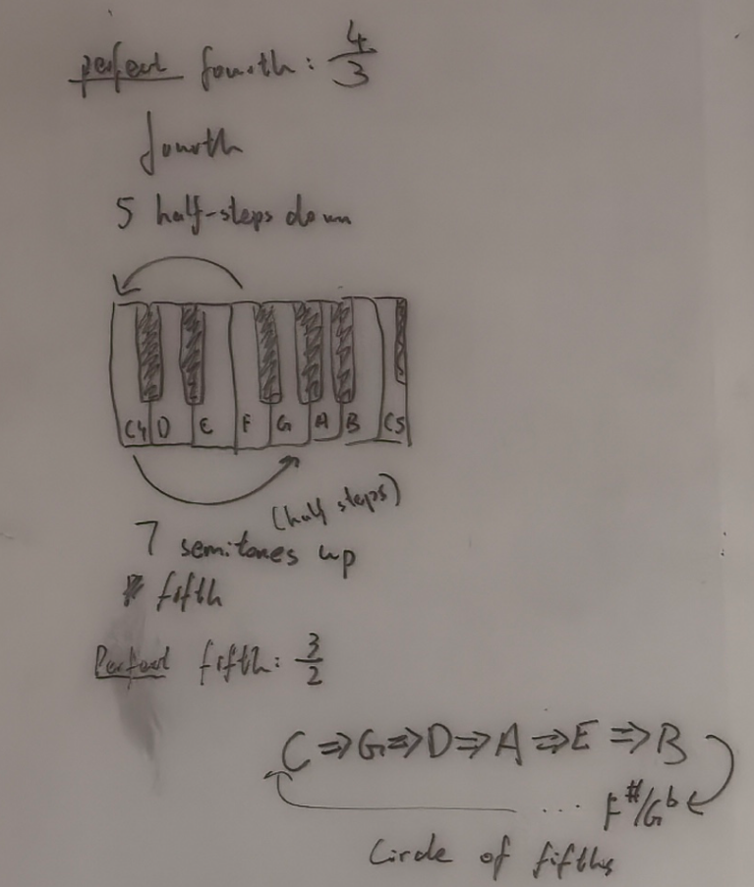
We can consider the Perfect fifth, with a ratio of (3:2) and 7 half-steps, starting from A4:
The relationships between the fundamentals will be:

Or we can think of it as:

The same logic can be applied to all other intervals. The most important intervals, that must be correct, are the unison and perfect octave. This means that the fundamental of a note should always have half the frequency of the fundamental of a note one full octave above it.
e. Apart from the two intervals mentioned above, the next most important interval is the perfect fifth. Pythagorean was first to mathematically express the 3:2 ratio of this interval. However, starting from C, going up 12 fifths, we arrive at a C of a higher octave (Circle of fifths). However, the fundamental frequency calculated differs from that of calculated from the perfect octave. This dilemma is known as Pythagorean’s comma.

f. Since we wish for the perfect octave to be always perfect, we only need to determine the relationship between the notes of a single octave. This octave is known as the temperament. Note that for our purposes, the temperament can be wider than an octave.

g. There are many ways to distribute the temperament. For my sanity, all that is relevant is the modern system, 12-Tune Equal Temperament (12-TET). In a perfect harmonic piano, the ratio of fundamentals between adjacent notes is the 12th root of 2, .

2. Steps for tuning:
a. Analyze the values of :
We can easily measure the fundamental and the first few partials of a string with a microphone and FFTs. We can then calculate an average of for that string.

With a few of these samples, we can use a best fit curve to predict B for all strings across the piano.

b. Determine the targets for octaves
Our starting point is . We can then calculate the fundamentals of all As across the piano, following this pattern:
For A5:
For A3:

…

c. Determine the temperament
This is the hard part. To roughly achieve 12-TET, we would like to minimize the difference in beat rate between the intervals:
Perfect fifth (3:2)
Perfect fourth(4:3)
Major third(5:4)
Minor third(6:5)
compared to the “perfect” piano mentioned in 1g, across all notes. Our only knowns are the notes we calculated in 2b. An error function should be created and a numerial method like least-squares fit should be implied.
这个怎么算出来是现在面对的问题...

d. Propagate the temperament following a similar method used in b across the piano.

