- Goal: make sure the final code and files are 1) meeting the requirement in nr-software-policy-Chen et al; 2) clearly structured, easily reproducible, and ready to upload to public GitHub as it is.
- Folder sturcutre:
    - Src
    - Data
    - Results
    - Plots
- Organize the code in DataProcessing.ipynb, Controled_Learning.ipynb and Plots.ipynb
    - Reorganize the code split into py script
    - Ensure the dependencies are correct and efficient
    - Remove unused/redudent pieces of codes
    - Improve the code efficiency, especially the below part for both high and median
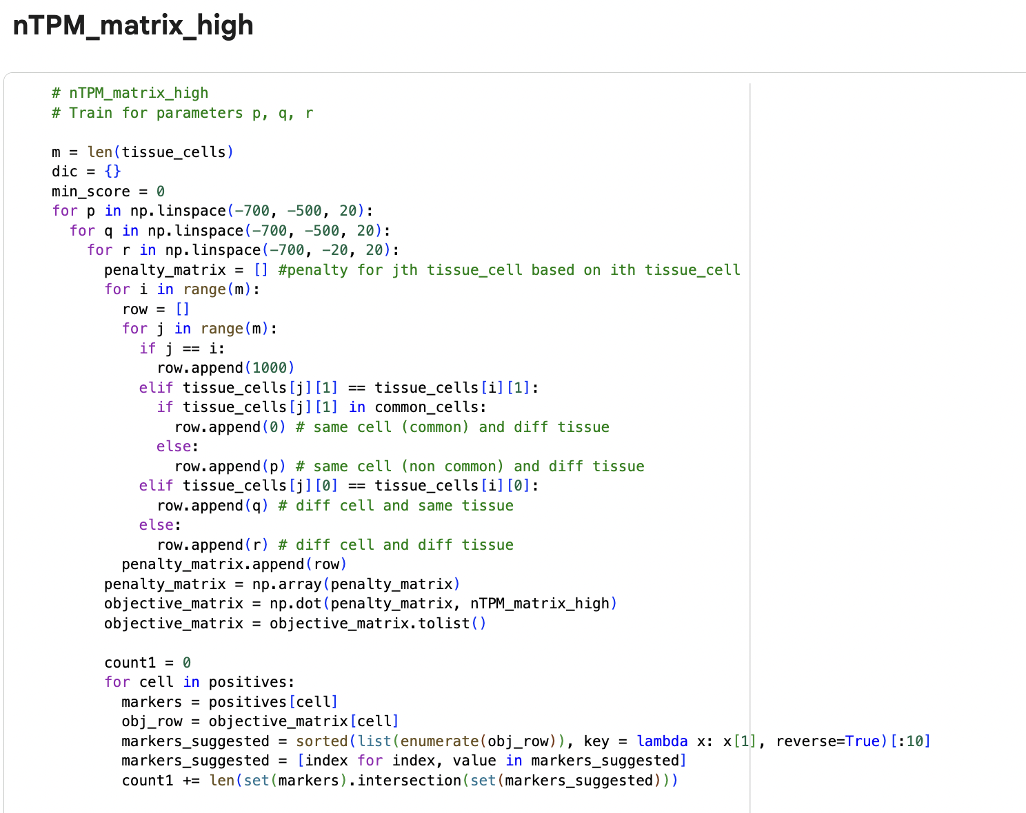

  - Expand the range from (-700, -500, 20) to wider, eg: (-1000, -1000, 20), to ensure the params are not hitting the edge
    - Save the original raw data into src folder
    - Save the after organized py scripts into src folder
    - Save all the intermediate output files into results folder
    - Save the plots into plots folder

4. Write a readme for people to follow and reproduce
5. Replace the files on website folder

Replace the organ.json by organ_high.json and organ_median.json, corresponding to the two different modes.
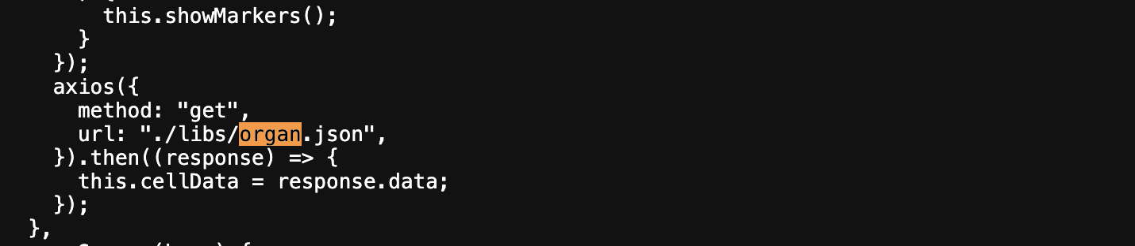
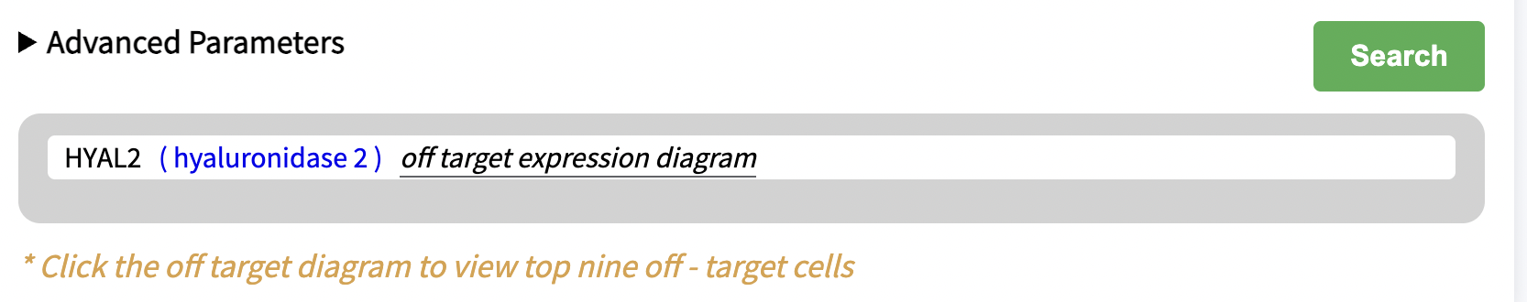
Which means now the off target expression diagram will vary by mode.

