Unipi for Jeedom

What you need

You need 2 things :
- a Jeedom installed and ready for your home automation (this can be any platform that Jeedom is supporting : Pi or other computer board, VM, x86 server and of course Jeedom box)
- a working Unipi with Evok installed (refer to https://github.com/UniPiTechnology/evok for installation guide)

Installation of Unipi plugin

Go on the Plugin page and open the market

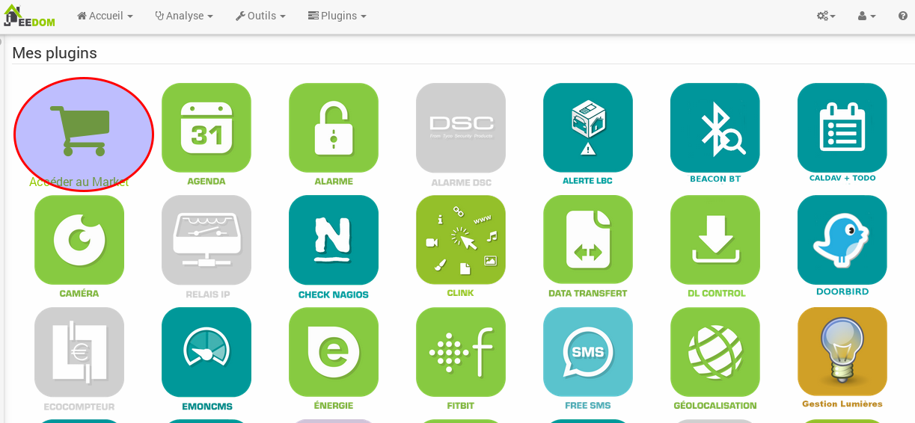
In the market, you will find Unipi in the automation protocol section

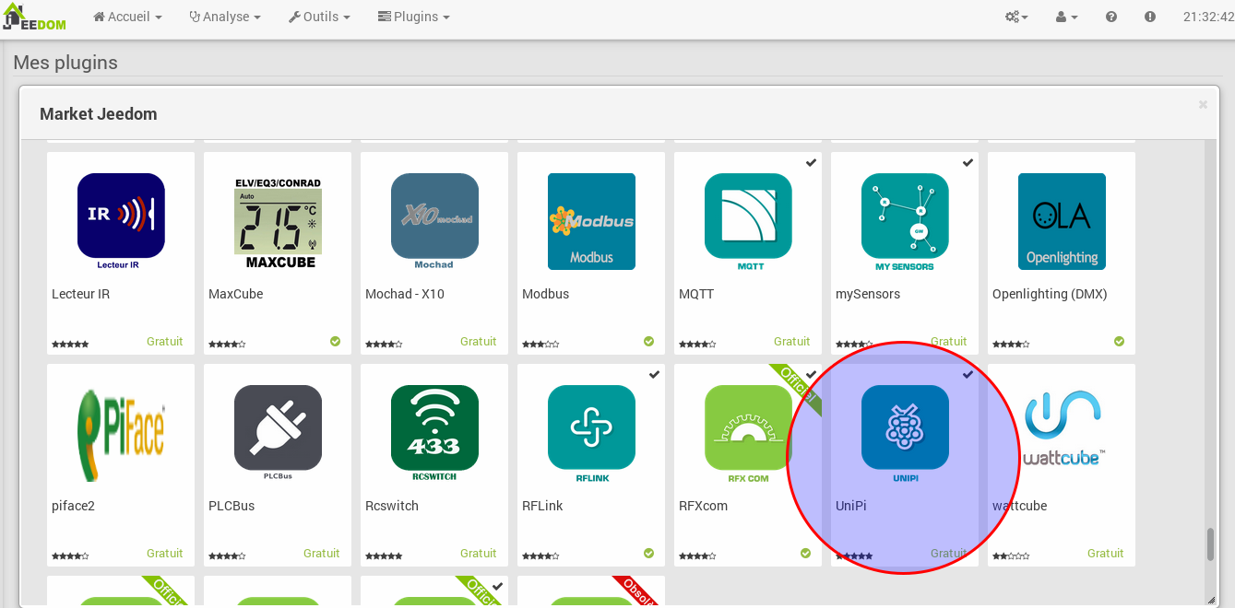
Once done, you will redirected to the plugin page, you need to activate it

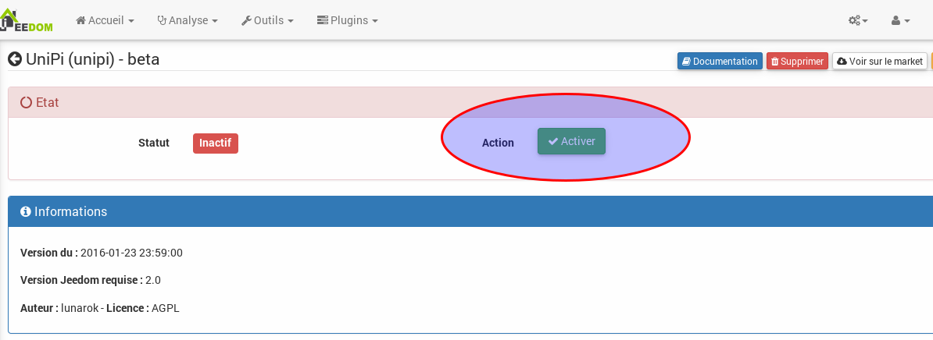
Once activated, you will see the status of dependencies and service.

Dependencies will be installed alone if missing (a python package for websocket)
And service will reflect the status of your Unipi connexion (listening to websocket for changes)

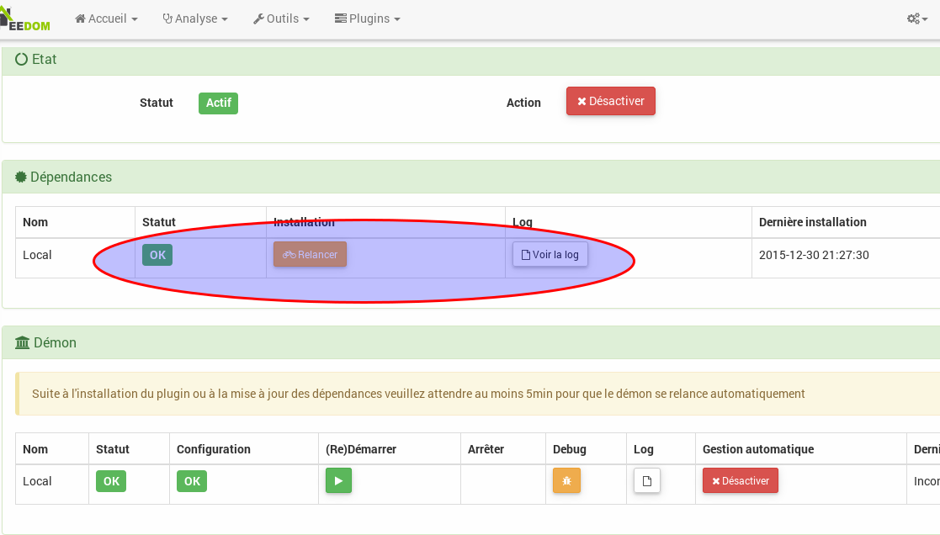
Once the plugin is active, we must create the Unpi.
This can be done on the Unipi page under home automation protocoles.

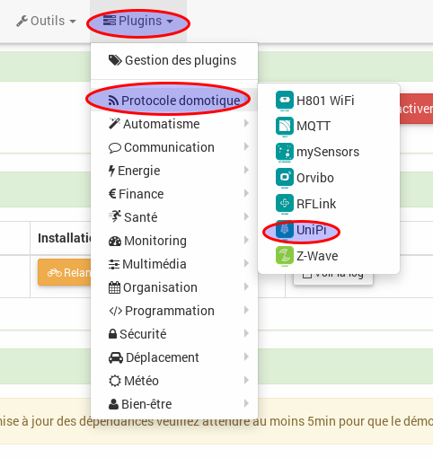

There you have a blank page where you can add an equipment

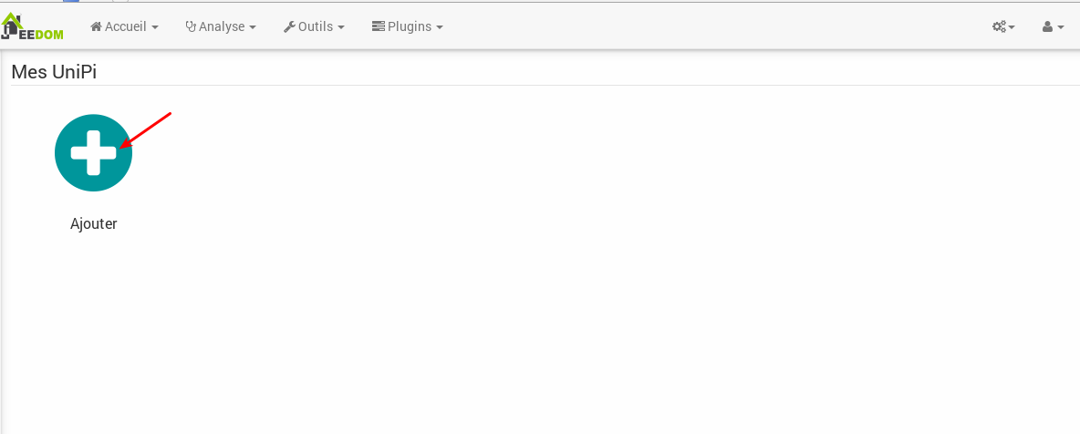
On the device page, you must give it a name, choose a jeedom object where you want to store it and select activate and visible. Of course, you must enter the IP address of the Unipi

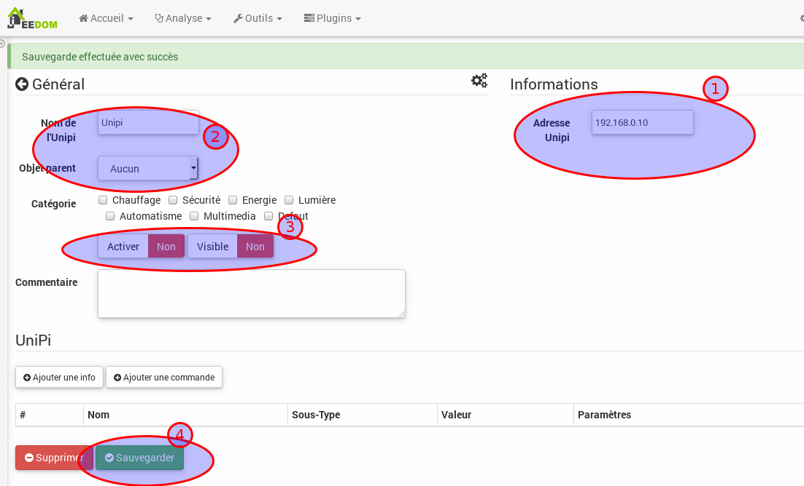
Once this is done, you press save button. The commands will be created. You will have actions to activate output and informations for status of output and input.

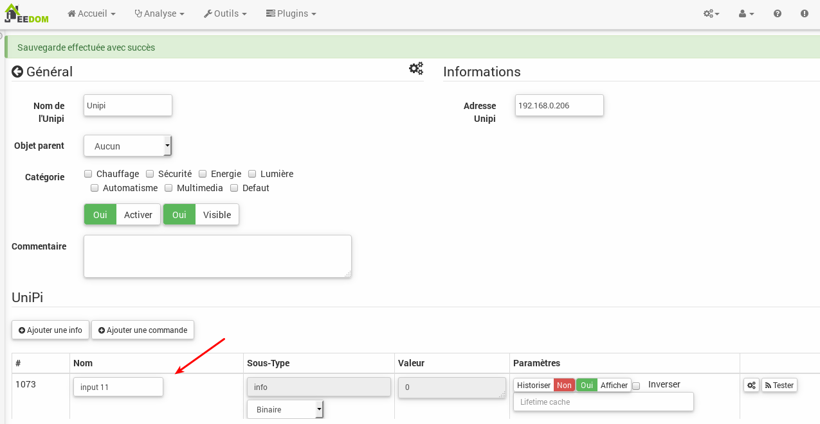
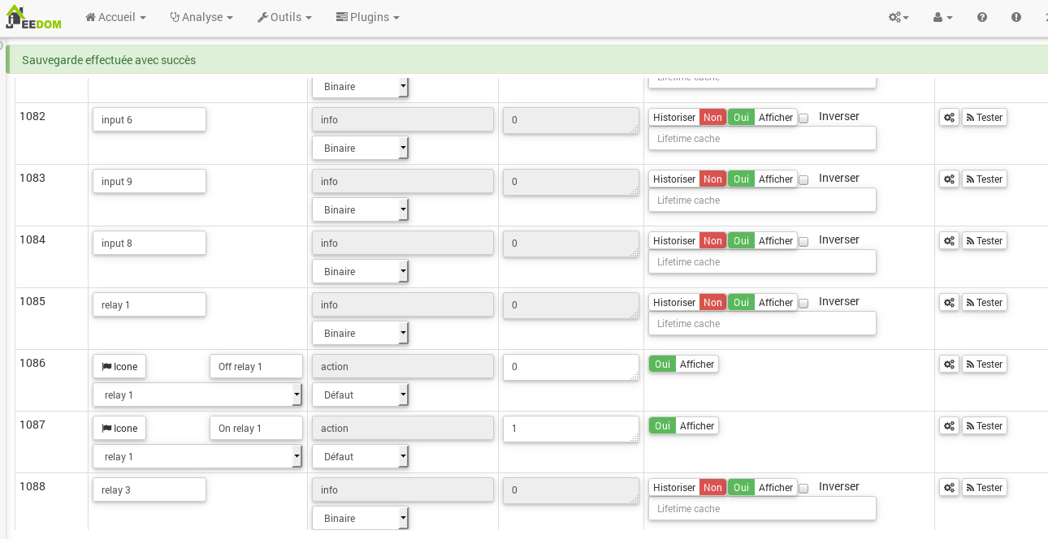

The status of inputs/outputs are updated through a service listening to websocket of Unipi. And there is also a protection by refreshing every 5mn the status in case of a message was lost.

Here you can see what the Unipi look by default on the Jeedom dashboard.

