homework3.r

Luna

2020-02-10

Frequency <- c(0.6,0.3,0.4,0.4,0.2,0.6,0.3,0.4,0.9,0.2)  
BP <- c(103,87,32,42,59, 109, 78, 205, 135, 176)  
First <- c(1,1,1,1,0,0,0,0,NA,1)  
Second <- c(0,0,1,1,0,0,1,1,1,1)  
FinalDecision <- c(0,1,0,1,0,1,0,1,1,1)  
  
patients <- data.frame(Frequency, BP, First, Second, FinalDecision)  
  
boxplot(patients$BP)

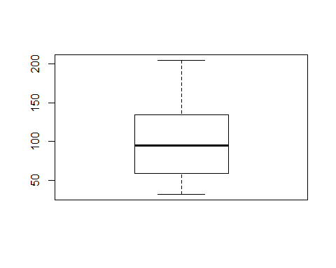

boxplot(patients$FinalDecision)

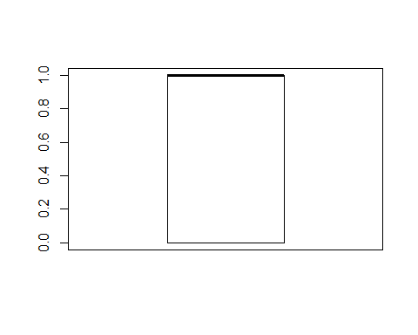

hist(patients$BP)

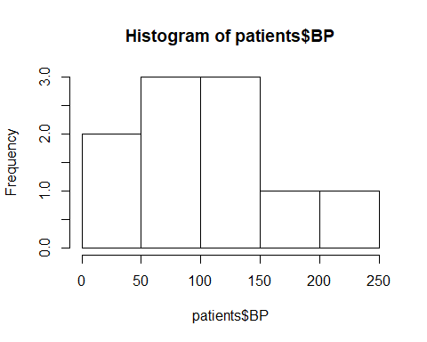

hist(patients$First)

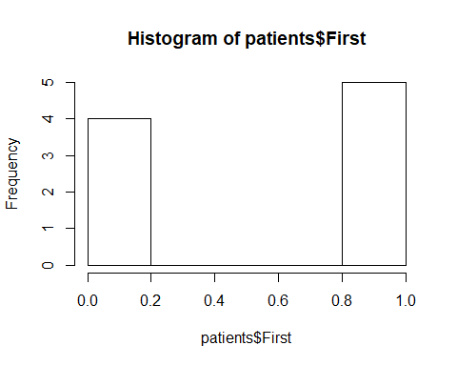

hist(patients$Second)

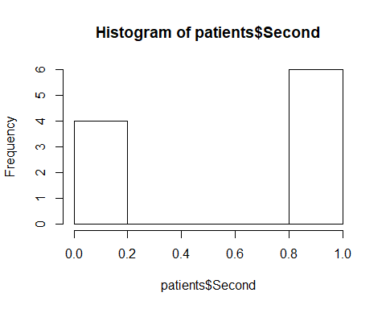

hist(patients$FinalDecision)

