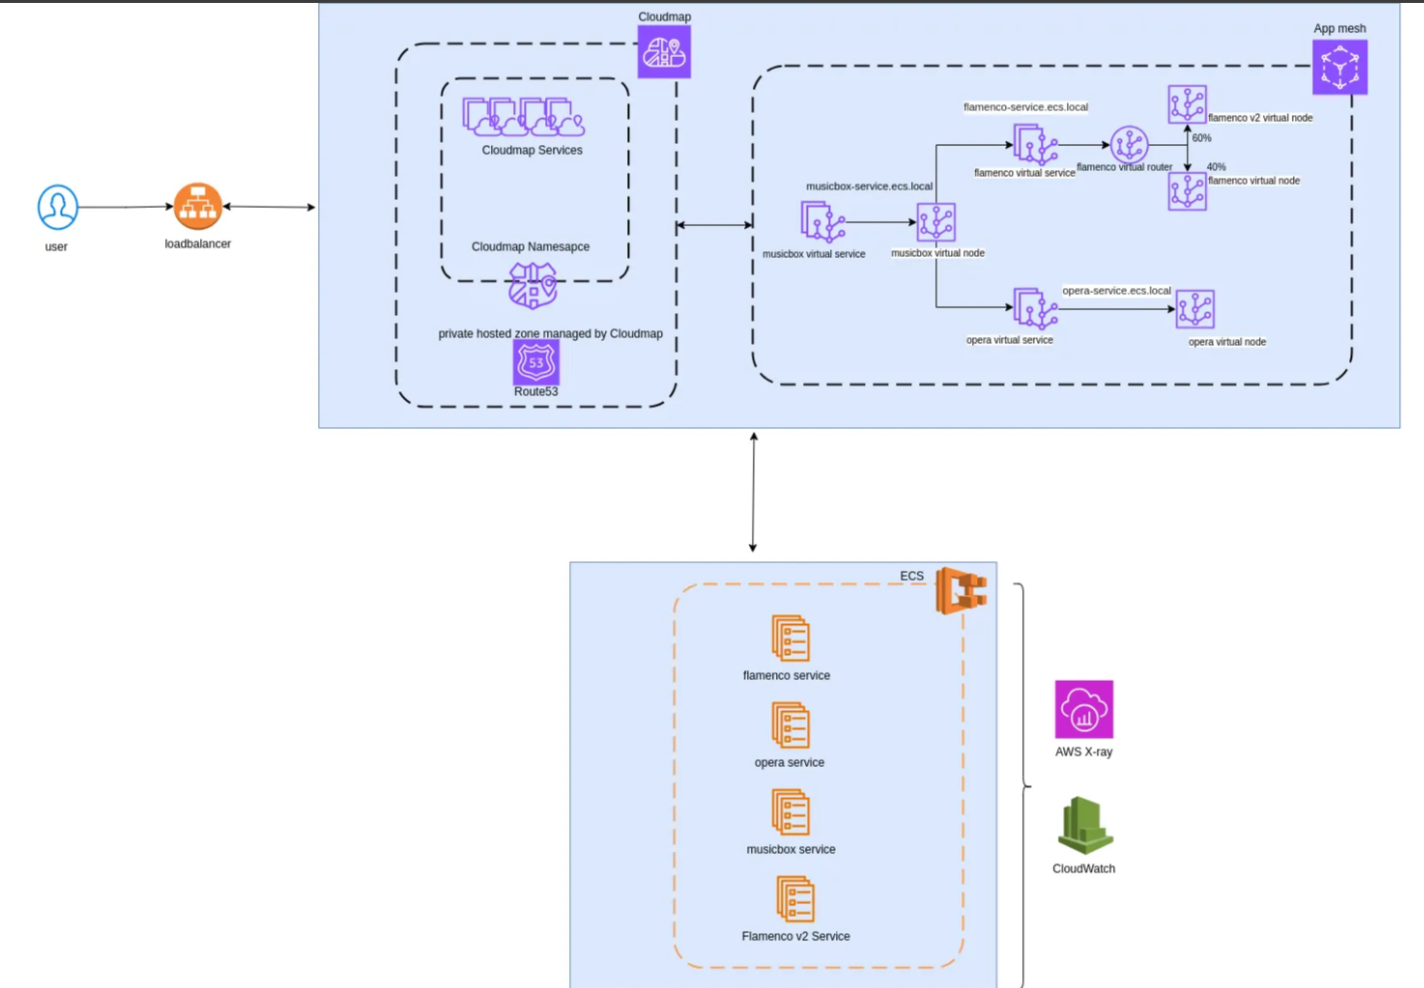

- App mesh: service mesh allows to monitor and control communication between applications -> service discovery, load balencing, traffic management

- App cloud map: automatic service discovery and dynamic DNS registration

- X-Ray: analyze and visualize requests

1. Network stack:

cidr: 10.0.0.0/16

public: 10.0.0.0/24; 10.0.1.0/24

private: 10.0.2.0/24; 10.0.3.0/24

1. ECS cluster:

Name: cluster-ec2 within public subnet,

launch configuration: "Container Instance"

Task definition: musicbox, flameco, Opera