Prototype Simple Traditional Chatbot Project

Trey Williams
University of the Cumberlands
MSAI-631-A01: Human-Computer Interaction.
Dr. Alan Dennis
September 13, 2026

Prototype Simple Traditional Chatbot Project
Chatbots are a growing form of human-computer interaction. This project required creating a simple, traditional chatbot rather than one based on a large language model. Rule-based systems follow explicit instructions, while examples-based systems learn from examples (Kore, 2022). The chatbot created for this project was named MovieMatch, a Python-based movie recommendation chatbot. The purpose of MovieMatch was to provide simple movie recommendations, respond to various user prompts, and handle unsupported or malformed inputs. This created a foundation that could be expanded later with additional capabilities. Traditional chatbots use explicit rules rather than learning from large amounts of data. This project demonstrated the chatbot development lifecycle by planning, implementing, testing, troubleshooting, and evaluating a simple rule-based movie recommendation chatbot.
Planning and Prototype Development
This prototype was developed as a small-scale model rather than a production-level recommendation engine. The goal was to create a functional version that could be tested quickly and improved. Prototyping allows developers to test concepts before making significant investments of time and resources (Kore, 2022). It can reduce development risk, identify usability problems, and provide opportunities to receive feedback before additional resources are committed. MovieMatch was therefore created as a simple usability prototype that could demonstrate the core interaction before additional functionality was added.
Chatbot Design and Development
Python was appropriate for this project because it supports straightforward, rule-based logic and keeps the chatbot code simple and readable. The program structure was intentionally basic. First, a “chatbot()” function was used to contain the main interaction logic. A continuous while loop allowed the chatbot to continue accepting input until the user chose to exit. The input() function was used to accept user responses. To normalize the input, .lower() converted the text to lowercase and .strip() removed leading and trailing whitespace. Finally, if/elif/else statements were used to identify keywords and select the appropriate responses.
After this, the project required developing the chatbot’s supported capabilities. Because MovieMatch was not an LLM-based system, its capabilities had to be explicitly programmed. Several film genres were selected, the help function was coded, and exit commands were added. To make the chatbot easier to use, synonym handling was also included. For example, the word “funny” was mapped to “comedy.” Because MovieMatch was rule-based, the program could not learn from user input, no model training was required, and responses were determined by explicitly programmed conditions. Rule-based AI follows predefined instructions that specify the actions a computer should take (Kore, 2022). This differs from modern generative systems because MovieMatch does not use deep learning, large language models, or generative AI.
Human-Computer Interaction and Usability
Chatbot development is not only about making the code execute correctly; users must also understand the system’s limitations, how to phrase requests, and what happens when the chatbot does not understand a prompt. The help function is a good example of this. MovieMatch begins each interaction with a greeting and instructs the user to type help. The help command sets expectations by listing the supported movie categories. This reduces the risk of creating false expectations about what the chatbot can do. The design also supports key usability principles by clearly communicating the chatbot’s capabilities, providing relevant responses, and handling unsupported input predictably.
Usability and relevance are important objectives when evaluating a prototype because they help identify confusion and determine whether the system provides useful results (Kore, 2022). MovieMatch supports these principles through a simple help function, synonym recognition, fallback responses, and clear exit commands. The chatbot does not maintain deep conversational context, and each user response is evaluated primarily on its own. A future version could improve the user experience by adding limited contextual memory.
Testing and Challenges
The next part of the project involved testing the chatbot. This was conducted by manually entering prompts to determine whether the expected responses were produced. Examples included typing “help,” “I want an action movie,” “something scary,” and “drama.” I also tested the chatbot’s ability to handle invalid input by entering malformed or misspelled text and by pressing the Enter key without providing any input. Finally, I tested the chatbot’s exit functionality by typing “bye.” These tests included both valid and invalid or unsupported inputs.
The chatbot successfully returned predefined recommendations for recognized categories, while unsupported text prompted the user to enter a valid request. This was important because the system needed to remain usable even when the input was incorrect. Testing is especially important during prototyping because it helps identify points of confusion and failure before additional development occurs. Usability testing can evaluate whether users successfully complete tasks and can reveal failure points or confusion (Kore, 2022). One challenge was deciding which keywords users would be most likely to enter and, therefore, which terms should be added to the supported phrases. An example was using the word “funny” as a synonym for “comedy.” Another challenge was ensuring that when the user pressed Enter without entering any text, the chatbot responded by prompting the user to provide valid input.
What I Learned
This project showed me how much functionality can be created with relatively simple logic. Originally, I built a more complex web-based version that used JavaScript for the interface, Flask for the backend, and a dictionary-based structure to support responses. After reviewing the assignment prompt and rubric more closely, I realized that a much simpler Python implementation using if/elif logic could accomplish the same basic objective. This allowed me to build a deterministic, rule-based chatbot rather than a machine-learning-based system. The result was predictable, easy to test, and easier to understand because each response was tied to explicitly programmed conditions. The chatbot could only recognize the specific words and phrases included in its rules. Adding more supported phrases improved flexibility, but it also increased the amount of logic that had to be maintained.
I also learned that usability is just as important as basic functionality. A chatbot may technically work, but still provide a poor user experience if users do not understand its capabilities. I have seen this with many help chatbots, where users are not given enough information about what the system can and cannot do. Recommendation systems are designed to suggest content to users and are commonly associated with platforms such as Netflix, Spotify, and Amazon (Kore, 2022). MovieMatch implements a much simpler version of this capability by using deterministic rules to select recommendations rather than a trained recommendation model. This helped demonstrate the difference between a basic rule-based recommendation system and more advanced AI-supported recommendation approaches.
A more complex chatbot does not necessarily provide a better solution for the user. The first version I created for this project used a web interface, JavaScript, Flask, and more elaborate logic. This was more complex than what the assignment required. Because the goal was to demonstrate the mechanics of a traditional chatbot, a production-ready application was unnecessary. The simplified product made the logic easier to explain, test, and document. This reinforced the importance of understanding the project's statement of work before choosing tools and architecture. Prototypes are intended to test ideas quickly and at low risk before investing more time and resources (Kore, 2022). Prototyping should therefore focus on learning and validation rather than unnecessary complexity.
Future Development
MovieMatch could eventually be expanded beyond its current traditional rule-based architecture. Several future improvements could be implemented in the program. One limitation is the small number of supported genres. Additional genres and movie titles could be added, potentially by connecting the chatbot to a larger external movie database. Another improvement would be to implement a ranking system that supports multiple recommendations within each category. This could include parameters such as decade, ratings, director, or actor. Limited conversational context could also be added to help the chatbot retain information from earlier exchanges and reduce the need for users to repeat their preferences.
If the chatbot were to become more advanced, it could incorporate artificial intelligence through natural language processing (NLP). This could improve the chatbot’s ability to interpret varied user language and potentially support additional languages. This would reduce the number of fallback responses caused by wording that the bot does not recognize. NLP could also make the chatbot feel less rigid and more natural to use. Natural language processing is commonly used in chatbots and virtual assistants, making it a logical capability to consider for a future version of MovieMatch (Kore, 2022). Supporting more varied forms of language and additional languages could improve accessibility and make the chatbot usable for a broader range of users. An external AI service could also be added in a future version to support these capabilities.
MovieMatch does not currently include artificial intelligence as a service (AIaaS), but AIaaS could be incorporated into a future iteration of the chatbot. This integration could provide advanced capabilities without requiring an organization to build and maintain all of the supporting AI infrastructure internally. External AI boundary resources, such as APIs and SDKs, allow organizations to integrate AI capabilities into existing systems (Zapadka et al., 2020). AIaaS can also provide access to capabilities such as NLP, analytics, and recommendation services without requiring all infrastructure to be developed internally (Lins et al., 2021). These benefits must be balanced against concerns such as security, trust, cost, and dependence on external service providers. AIaaS adoption should also be tied to actual organizational or user value rather than implemented simply because the technology is available (Hajipour et al., 2023). A future version of MovieMatch could therefore preserve the Python interface while replacing or supplementing the current keyword rules with an external NLP or recommendation service.
Conclusion
This project was developed to demonstrate the functionality of a traditional rule-based chatbot. MovieMatch successfully met this objective by using a simple Python program to collect user input, perform keyword matching, provide movie recommendations, and handle unsupported or invalid responses. The project also demonstrated the importance of usability considerations during chatbot development. It helped illustrate the difference between a traditional rule-based chatbot and a modern generative AI system, such as a large language model. The simplicity of MovieMatch was useful because it exposed the underlying mechanics of chatbot interaction in a way that was easy to understand, test, and implement way. Although the prototype could be expanded with additional functionality in the future, the current version successfully meets the goal of demonstrating traditional chatbot development.

Figures
Figure 1
Python/Colab source code for MovieMatch
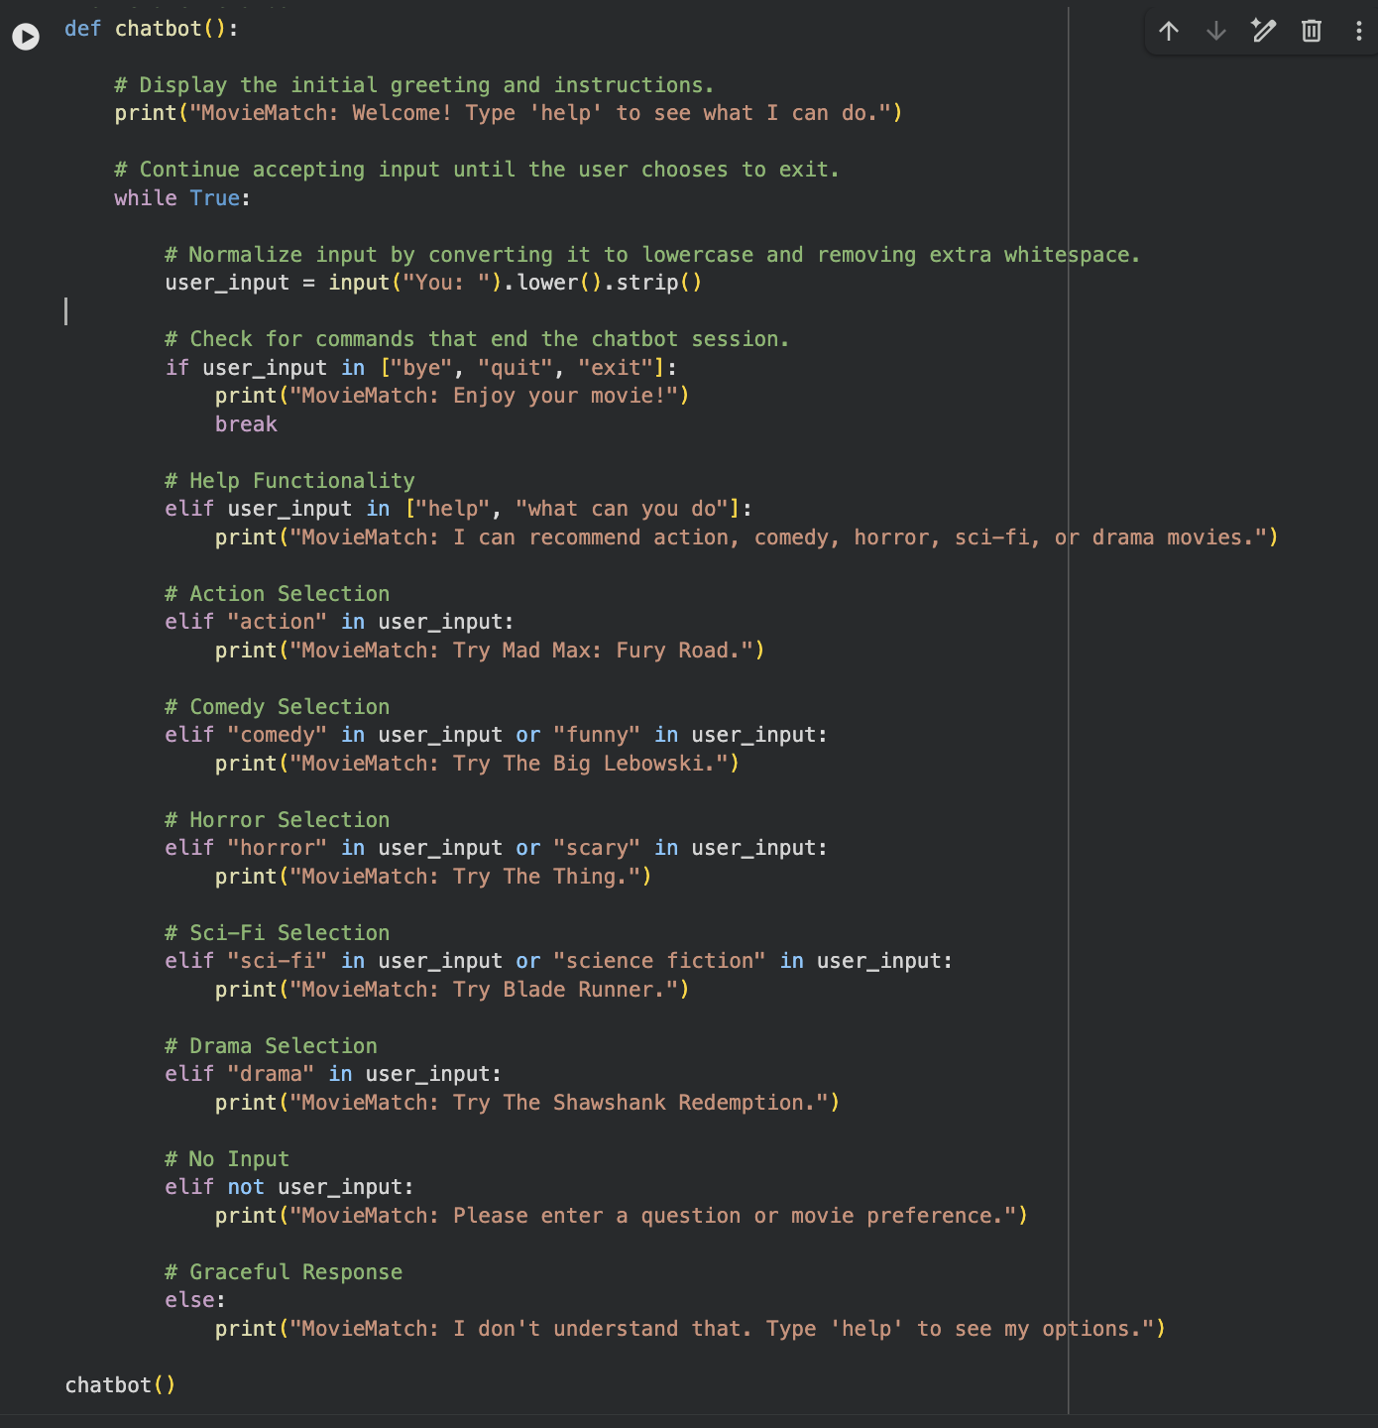

Figure 2
Help command showing the chatbot's capabilities
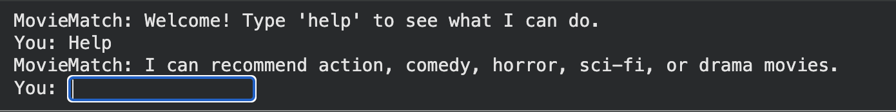
Figure 3
Successful conversation showing two or three recommendations
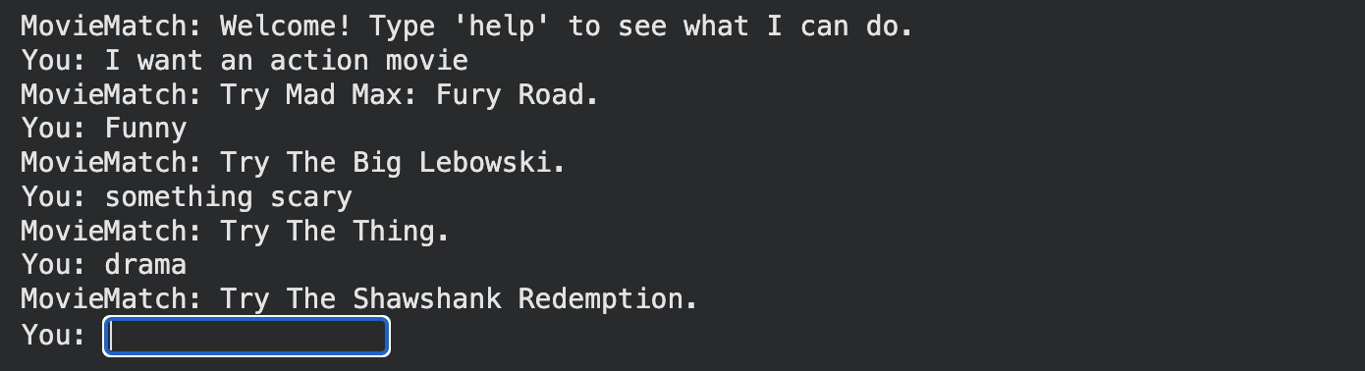
Figure 4
Invalid or malformed input showing graceful fallback handling
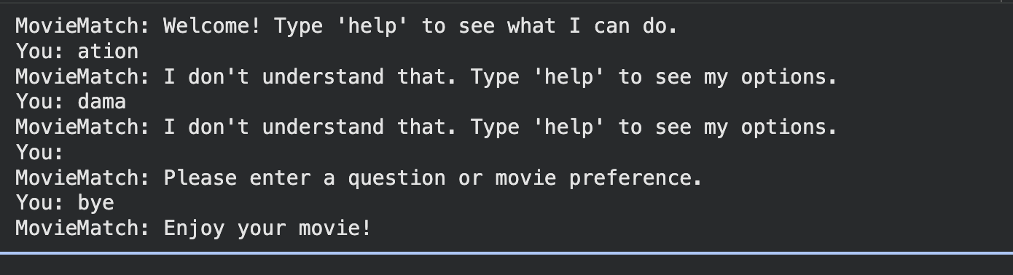

AI Tools and Project Repository Disclosure
I used ChatGPT and Grammarly to support coding, brainstorming, and grammar revision.
I reviewed, verified, and revised all AI-assisted content and accept responsibility for the final submitted work.
Project repository: lunchtrey84/MSAI_631_REPO

References
Hajipour, V., Hekmat, S., & Amini, M. (2023). A value-oriented artificial intelligence-as-a-service business plan using integrated tools and services. Decision Analytics Journal, 8, 100302. https://doi.org/10.1016/j.dajour.2023.100302
Kore, A. (2022). Designing human-centric AI experiences. Springer Nature. https://reader2.yuzu.com/books/9781484280881
Lins, S., Pandl, K. D., Teigeler, H., Thiebes, S., Bayer, C., & Sunyaev, A. (2021). Artificial intelligence as a service: Classification and research directions. Business & Information Systems Engineering, 63, 441–456. https://doi.org/10.1007/s12599-021-00708-w
Zapadka, P., Hanelt, A., Firk, S., & Oehmichen, J. (2020). Leveraging “AI-as-a-service”–Antecedents and consequences of using artificial intelligence boundary resources. Proceedings of the International Conference on Information Systems (ICIS 2020). https://aisel.aisnet.org/icis2020/governance_is/governance_is/6/

