GitHub Report

Trey Williams
University of the Cumberlands
MSAI-631-A01: Human-Computer Interaction
Dr. Alan Dennis
August 30, 2026

GitHub Report
GitHub is a repository hosting platform commonly used for software development and artificial intelligence projects. The purpose of this exercise was to create a private GitHub repository, initialize it, add the instructor as a collaborator, and document the process in a report. I have used GitHub many times over the years, so creating a repository was easy. The exercise was technically straightforward, but in my experience with GitHub, I have found the platform less effective from a user-experience perspective. I prefer other development environments that I find more intuitive and better integrated with AI-assisted development tools. AI products should be designed to benefit the people who use them and that human-centered design is necessary to support user needs, trust, and effective interaction (Kore, 2022).
Creating the Repository
To begin the assignment, I created a new private repository for MSAI 631 and named it MSAI_631_REPO. I confirmed that the repository was configured as private, which limited access to authorized users and reduced the risk of unintentionally exposing project material. This was important because the repository will be used to store coursework and development files that are intended for the instructor rather than for public access. Kore (2022) explains that human-centered AI design should emphasize control, trust, and the ability of users to make informed choices about how systems affect them. Ensuring that the repository was private supported those principles by giving me greater control over who could access the project.
Figure 1
Establishment of Repository
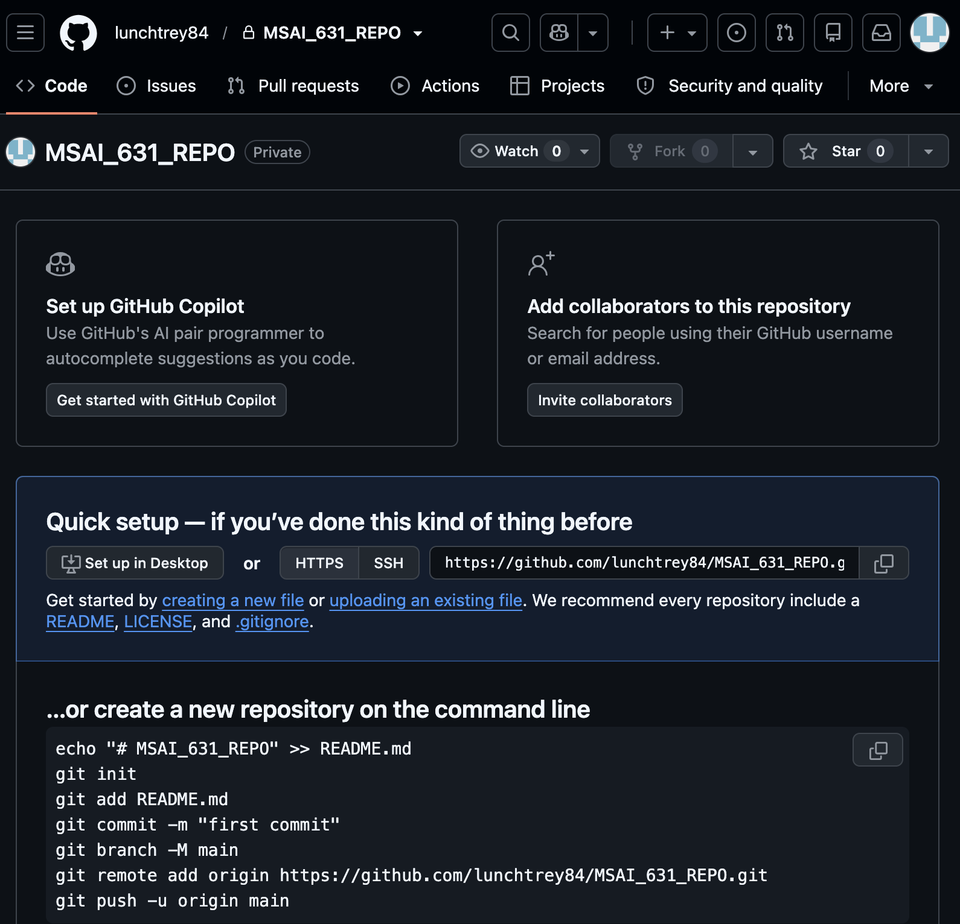
Adding the Professor as a Collaborator
Once the repository was created, I added the instructor as a collaborator. I opened the repository settings, navigated to the access controls, and entered the instructor’s GitHub username. The main challenge was locating the correct username because I could not initially find it in the course announcements. I eventually located it in one of the professor’s YouTube videos, and later I noticed that the same username was also shown in Figure 8 of the assignment instructions. This experience reinforced the importance of clear communication and accessible information when users are expected to complete a technical task. Effective collaboration depends on reducing barriers, improving communication, and helping users and team members understand what is needed to accomplish a shared goal (Kore, 2022).
Figure 2
Inviting the Instructor
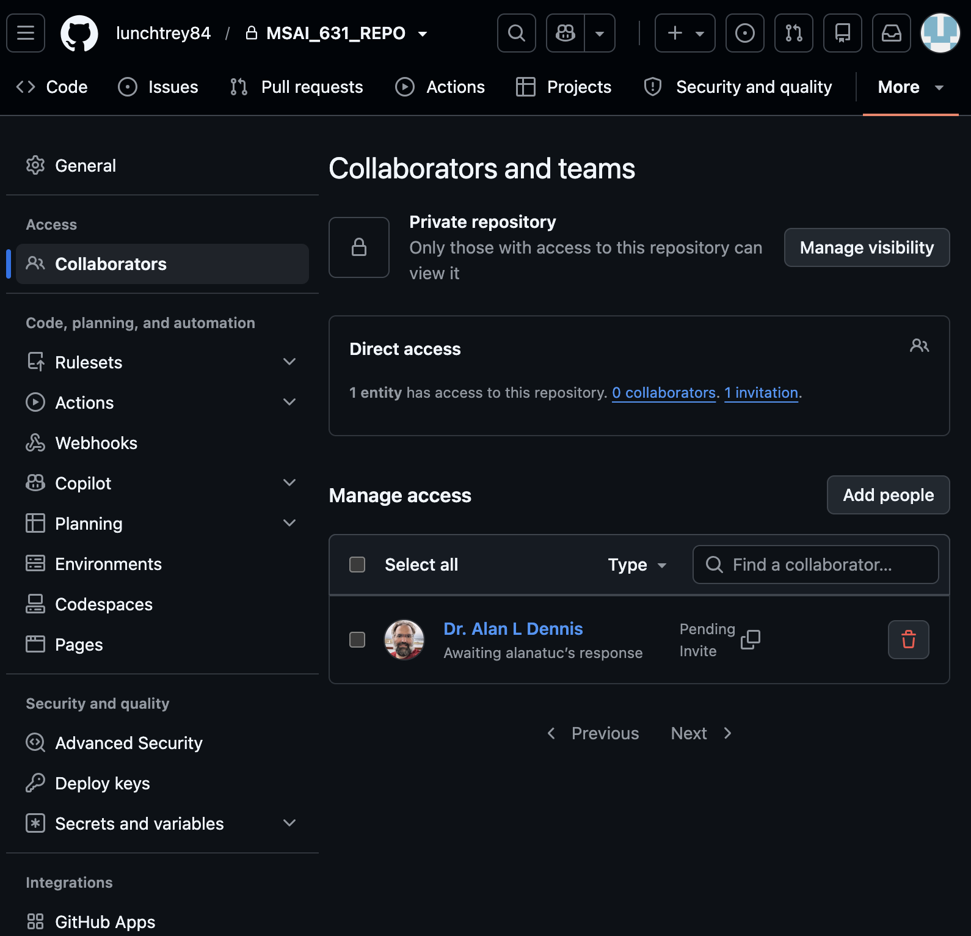
Initializing the Repository and README
After the repository was established and the instructor was added as a collaborator, I created a README.md file to initialize the repository and explain its purpose. I used the main branch and included a brief description stating that the repository would be used for MSAI 631 projects and to support the group project later in the course. README files are useful because they communicate the purpose of a project, orient collaborators, and provide context before someone begins reviewing the source files. Kore (2022) emphasizes that effective AI development depends on collaboration, communication, and helping team members develop a shared understanding of the product and its goals. Creating the README supported those principles by making the purpose and intended use of the repository clear to anyone with access.
Figure 3
README.md File
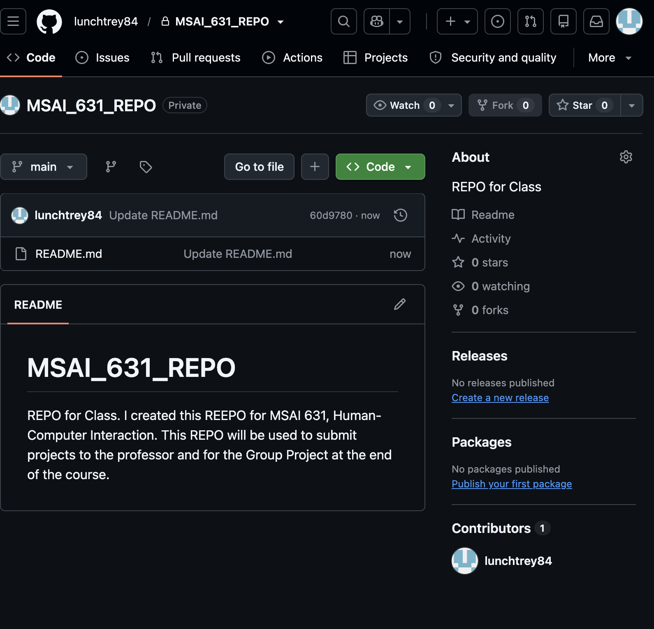
Previous Experience and Opinion of GitHub
I have used GitHub in the past and have found the platform less intuitive than other development tools I use. Repository permissions, branches, commits, collaborator access, and deployment functions can require navigating several different areas of the interface, which can make the workflow feel more complicated than necessary. I am also concerned about the possibility of unintentionally exposing project material if repository permissions or visibility settings are configured incorrectly. From a human-centered perspective, development tools should support clear workflows, reduce unnecessary barriers, and help users understand system limitations and potential errors. Misunderstandings, frustration, and mistakes are inevitable in technical systems, making it important to design workflows that help users recognize and manage those risks (Kore, 2022).
Comparison With Google's Antigravity IDE
I prefer to use Google’s Antigravity IDE as a development environment because I find it easier to use and better integrated with the AI tools that support my workflow. The platform provides direct access to Google Gemini and agent-based development tools, which makes it easier for me to move between planning, coding, testing, and deployment. I also find its integration with Google’s cloud environment more efficient for deploying projects. This preference reflects the importance of designing tools around the needs and workflows of the people using them. User-centered development requires teams to understand user needs, workflows, limitations, and errors so that products can better support the people who interact with them (Kore, 2022).
Conclusion
This exercise required me to create a private GitHub repository, add the instructor as a collaborator, initialize the repository with a README file, and document the process. Although I do not prefer GitHub as my primary development environment, completing the exercise reinforced the importance of version control, repository management, access control, documentation, and collaboration. It also demonstrated that Human-Computer Interaction applies not only to consumer-facing AI systems but also to the tools developers use to create and manage those systems. Kore (2022) emphasizes that effective AI products depend on collaboration, user-centered choices, and an understanding of the needs of the people interacting with the technology. The effectiveness of a technical system, therefore, depends not only on what it can do but also on how effectively users can understand, control, and use it.
AI Tools and Project Repository Disclosure
I used ChatGPT and Grammarly to support brainstorming and grammar revision.
I reviewed, verified, and revised all AI-assisted content and accept responsibility for the final submitted work.
Project repository: lunchtrey84/MSAI_631_REPO

References
Kore, A. (2022). Designing human-centric AI experiences. Springer Nature. https://reader2.yuzu.com/books/9781484280881

