# Compensation AI Framework: Strategic Implementation for Generative AI Excellence

## Current Architecture Limitations

Amazon's compensation analytics infrastructure operates through fragmented systems that prevent the organization from realizing the full potential of generative AI capabilities. Today's architecture relies on SAML-federated Redshift access with QuickSight dashboards, creating significant bottlenecks that limit business users' ability to leverage AI for dynamic compensation analysis, policy interpretation, and strategic decision support.

The current state presents multiple governance and operational challenges. Compensation data exists in isolated silos across Redshift, WorkDocs, internal wikis, and various vendor platforms, with no unified mechanism for AI systems to access and correlate this information safely. Business Intelligence Engineers and Data Engineers build point solutions that often become "orphaned" when team members transition to new roles, leaving critical AI systems without proper ownership or maintenance. Meanwhile, compensation analysts and product managers lack direct access to AI capabilities, forcing them to rely on static reports rather than dynamic, contextual analysis that generative AI enables.

This fragmentation creates substantial risks. Without proper governance, AI systems operate with inconsistent accuracy standards, potentially perpetuating bias or making recommendations based on outdated information. The lack of centralized oversight means that different teams implement varying validation protocols, creating compliance gaps and reducing confidence in AI-driven compensation decisions. Additionally, the absence of systematic knowledge management prevents AI agents from accessing critical context about compensation philosophy, regulatory requirements, and market dynamics that are essential for accurate recommendations.

## Required Generative AI Infrastructure

Transforming compensation systems to leverage generative AI requires establishing a comprehensive technical and governance framework that enables safe democratization of AI capabilities while maintaining the highest standards of accuracy and compliance.

The foundation requires implementing a unified AI governance platform that serves as the central nervous system for all compensation-related artificial intelligence. This platform will enforce a mandatory 95% confidence threshold across all AI-powered tools, ensuring that every recommendation meets established accuracy standards before reaching decision-makers. The governance framework will implement dual ownership models where each AI system has both a designated business owner from the compensation team and a technical owner responsible for maintenance and updates.

Knowledge integration represents a critical component of the modernized architecture. The system will implement Amazon Kendra as the primary knowledge indexing service, automatically ingesting and processing content from WorkDocs, internal wikis, compensation policies, regulatory databases, and market survey data. This knowledge base will be continuously updated through automated pipelines that extract information from diverse sources, transform it into AI-readable formats, and index it for rapid retrieval. The Model Context Protocol (MCP) will govern how AI agents access and utilize this knowledge, ensuring that all recommendations are grounded in current, accurate information.

The technical stack will leverage Kiro IDE and other agentic development tools to enable BIEs and Data Engineers to rapidly build and deploy AI agents while maintaining governance compliance. These agents will operate through standardized interfaces that provide business users with conversational access to complex analytical capabilities, from market benchmarking to pay equity analysis, without requiring direct technical expertise.

## AI Integration Architecture

The generative AI framework implements a layered architecture designed to balance accessibility with governance, enabling sophisticated AI capabilities while maintaining strict oversight and control mechanisms.

The foundation layer consists of Amazon's large language models, fine-tuned specifically for compensation domain knowledge and integrated with the comprehensive knowledge base through MCP protocols. These models understand compensation concepts including job leveling frameworks, geographic pay differentials, equity methodologies, and regulatory compliance requirements. The models are continuously updated with anonymized historical compensation decisions, market trends, and best practices, enabling them to provide contextually relevant recommendations while maintaining privacy and confidentiality.

An intelligent routing and validation engine sits above the foundation models, implementing business logic specific to Amazon's compensation philosophy and practices. This engine understands the nuances of different employee populations, organizational structures, and compensation strategies. It validates all AI recommendations against established parameters, business rules, and compliance requirements before presenting them to users. The engine maintains detailed audit logs of all decisions and recommendations, enabling complete traceability and accountability.

The application layer provides multiple access points tailored to different user personas and use cases. Product managers access AI capabilities through Pippin integration, enabling them to ask natural language questions about compensation trends, perform scenario modeling for new initiatives, and generate comprehensive analysis reports. Compensation analysts interact with specialized AI agents that can perform complex statistical analysis, identify pay equity issues, and recommend corrective actions. Business leaders access executive dashboards that provide AI-generated insights on compensation competitiveness, budget implications, and strategic recommendations.

Agentic computing capabilities enable the creation of sophisticated workflows where multiple AI agents collaborate to complete complex tasks. For example, a compensation review process might involve one agent extracting relevant market data, another agent analyzing internal equity patterns, and a third agent generating comprehensive recommendations that consider both external competitiveness and internal fairness. These agent chains operate under strict governance protocols, with each step logged and validated against accuracy thresholds.

## Security and Governance Framework

The implementation of generative AI in compensation management requires unprecedented security and governance controls that address both technical vulnerabilities and business risks associated with AI-driven decision-making in sensitive domains.

Access control mechanisms implement attribute-based access control (ABAC) systems that dynamically determine AI system access based on multiple factors including user role, data sensitivity, query type, and intended use of results. Every interaction with AI systems is logged in comprehensive audit trails that capture user identity, query content, data accessed, AI recommendations provided, and final decisions made. These logs support both compliance reporting and continuous improvement of AI system performance.

The governance framework establishes mandatory ownership structures for all AI systems, eliminating the "orphaned AI" problem through clear accountability chains. Each AI system has a designated business owner from the compensation team who understands the domain context and a technical owner responsible for system maintenance and updates. Ownership assignments are tracked in a centralized registry with automated alerts when ownership transitions occur.

Model governance includes comprehensive testing frameworks that continuously validate AI recommendations against known compensation scenarios, regulatory requirements, and fairness criteria. Automated bias detection systems monitor AI outputs across protected demographic categories, alerting governance teams when statistical anomalies suggest potential discriminatory impacts. Human oversight mechanisms require manual review for high-impact decisions, with clear escalation paths when AI confidence levels fall below established thresholds.

Privacy protection operates through multiple defensive layers including data anonymization for model training, differential privacy techniques for sensitive analysis, and secure multi-party computation when cross-functional data correlation is required. All AI processing occurs within Amazon's secure infrastructure with comprehensive monitoring and alerting for unusual access patterns or potential security breaches.

## Integration with Existing Amazon Tools

The generative AI framework seamlessly integrates with Amazon's existing tool ecosystem while enhancing rather than replacing current analytical capabilities and workflows.

Pippin integration enables product managers to access AI-powered compensation insights directly within their existing development and analysis workflows. Natural language interfaces allow users to ask questions like "What would be the budget impact of increasing L6 engineer salaries by 8% in high-cost locations?" and receive comprehensive analysis that considers market data, internal equity impacts, and budget constraints. These capabilities operate through standardized APIs that maintain consistency with existing Pippin functionality while adding powerful AI-driven analysis.

Kiro IDE integration allows BIEs and Data Engineers to rapidly prototype and deploy new AI agents using familiar development environments. Pre-built templates and governance-compliant frameworks accelerate development while ensuring all new AI systems meet established standards. The integration includes automated testing capabilities that validate AI agent behavior against governance requirements before deployment.

QuickSight dashboards are enhanced with AI-generated insights that provide contextual intelligence alongside traditional visualizations. Business users see not only what the data shows but also AI-generated explanations of trends, recommendations for action, and predictive analysis of potential outcomes. These enhancements maintain existing dashboard functionality while adding sophisticated analytical capabilities.

The framework establishes standardized APIs that enable AI capabilities to be embedded across Amazon's internal tools and systems. Whether accessed through Workdocs for policy analysis, internal wikis for knowledge verification, or specialized compensation planning tools, AI capabilities provide consistent, governed intelligence that enhances decision-making across all touchpoints.

## Operational Excellence Framework

The governance framework establishes operational processes that ensure AI systems maintain high performance standards while enabling continuous improvement and adaptation to changing business needs.

Bi-weekly governance audits provide systematic review of all AI systems, assessing performance against the 95% confidence threshold, reviewing recent decisions for accuracy and bias, and identifying opportunities for improvement. These audits follow standardized protocols that ensure consistent evaluation across all systems while capturing lessons learned that inform future enhancements.

Real-time monitoring systems track AI performance metrics, user satisfaction scores, and business impact measurements. Automated alerts notify governance teams when systems approach performance thresholds, enabling proactive intervention before issues impact business operations. Performance trending analysis identifies gradual degradation patterns that might not trigger immediate alerts but require attention over time.

The framework includes comprehensive training programs that ensure all stakeholders understand their roles within the governance structure. Business owners receive training on AI system oversight, validation techniques, and escalation procedures. Technical owners learn governance requirements, documentation standards, and monitoring protocols. End users understand appropriate AI usage, limitation recognition, and when to seek human oversight.

Continuous improvement processes capture feedback from all stakeholders and translate insights into system enhancements. Regular retrospectives identify friction points in AI interactions, accuracy improvement opportunities, and new use cases that could benefit from AI capabilities. These insights drive the evolution of both individual AI systems and the overall governance framework.

## Implementation Roadmap

The transformation to a comprehensive generative AI framework follows a carefully sequenced implementation plan that minimizes operational disruption while progressively building advanced capabilities.

**Phase One: Foundation (Months 1-3)** establishes core governance infrastructure including the AI Governance Council, system registry, and basic monitoring capabilities. This phase implements the knowledge base infrastructure using Amazon Kendra, beginning with critical compensation policies and market data. Initial AI agents focus on low-risk use cases like policy lookup and basic market analysis, providing immediate value while validating governance processes.

**Phase Two: Core Capabilities (Months 4-9)** deploys the primary AI reasoning engines and implements comprehensive bias detection and monitoring systems. This phase introduces sophisticated AI agents capable of pay equity analysis, market benchmarking, and scenario modeling. The Model Context Protocol implementation enables complex agent interactions while maintaining governance oversight. Integration with existing tools like Pippin and QuickSight provides business users with AI-enhanced analytical capabilities.

**Phase Three: Advanced Intelligence (Months 10-12)** implements agentic computing workflows that enable multiple AI systems to collaborate on complex analyses. Advanced predictive capabilities provide forward-looking insights on market trends, retention risks, and compensation strategy optimization. The framework achieves full integration across Amazon's tool ecosystem, with AI capabilities seamlessly available wherever compensation decisions are made.

Throughout all phases, the implementation maintains operational continuity by building alongside existing systems rather than replacing them. Each milestone includes comprehensive validation against accuracy thresholds and governance requirements, ensuring that new capabilities enhance rather than compromise decision-making quality.

## The complete implementation, targeted for completion by December 31, 2026, will position Amazon's compensation organization with industry-leading AI capabilities that enable more accurate, fair, and strategic compensation decisions while maintaining the highest standards of governance and compliance. This framework provides the foundation for continued innovation in compensation practices while ensuring that AI augments rather than replaces human judgment in critical people decisions.

## Appendices

### Appendix A: Visual Architecture Overview

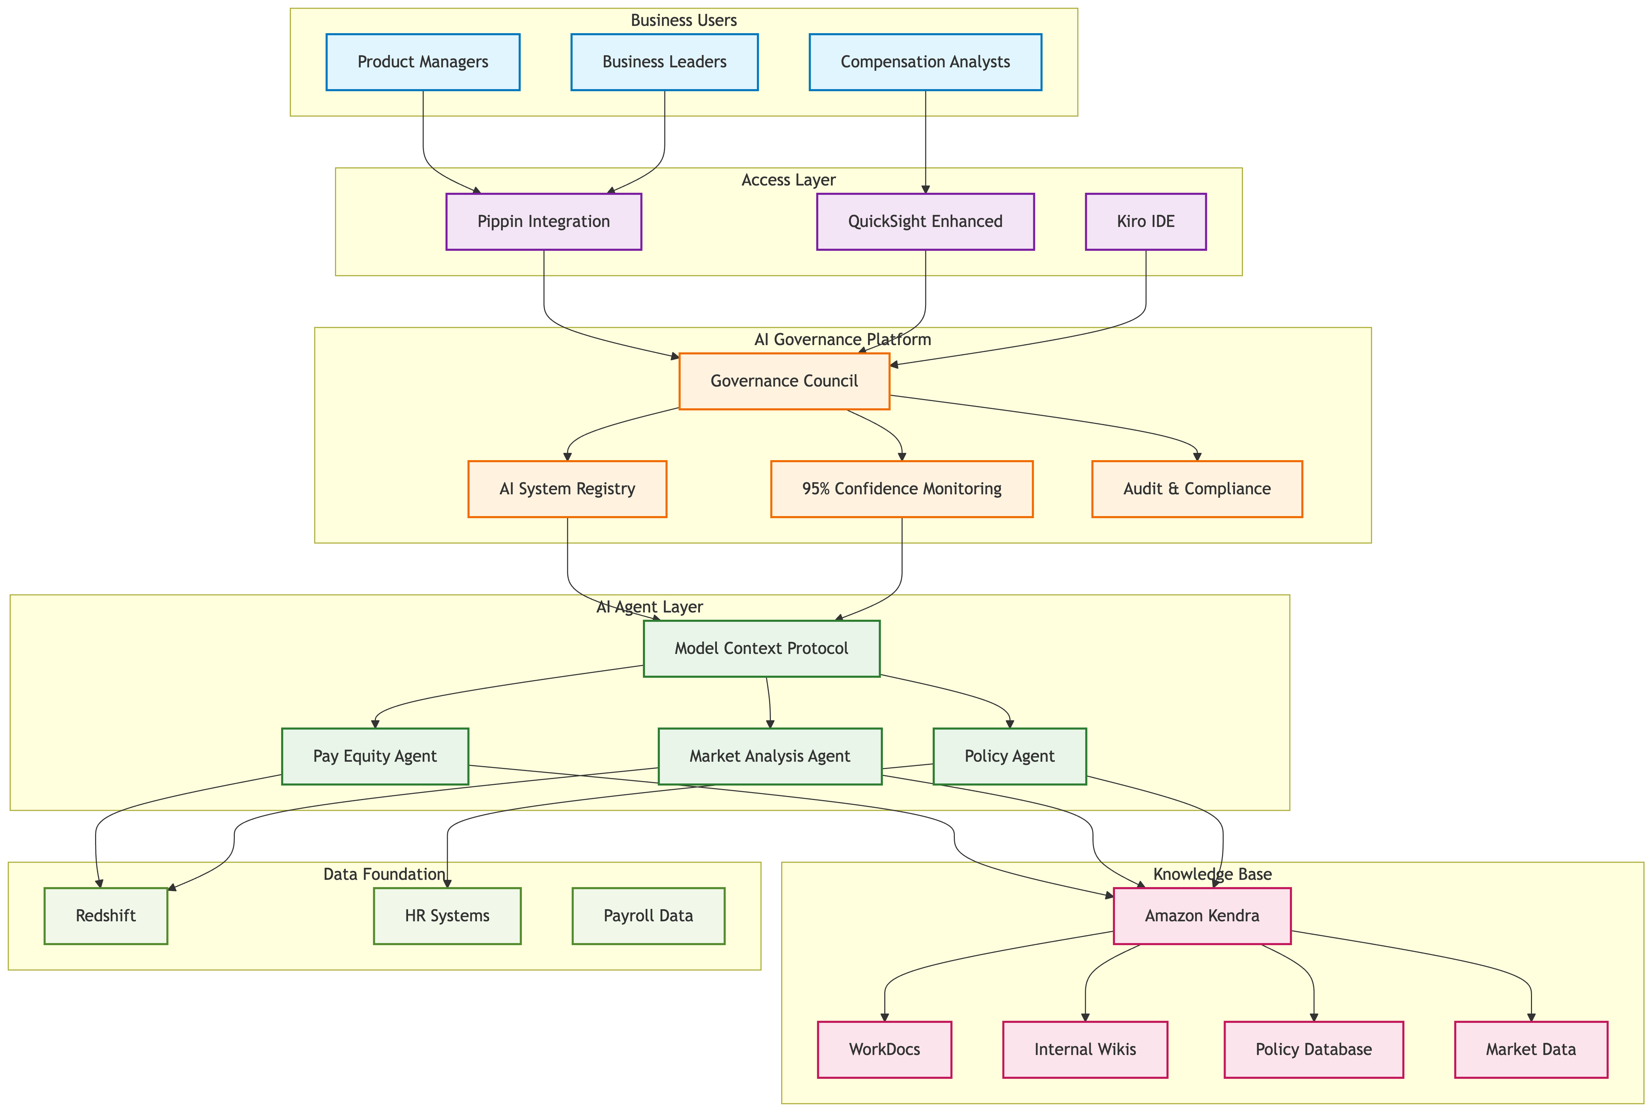

### Appendix B: Compensation AI Training Data Examples

**What "Training on Compensation Data" Actually Means:**

**Example 1: Market Benchmarking Intelligence**

Training Input: "L6 Software Engineer in Seattle typically earns $180K-$220K base salary according to Radford survey data from Q2 2024. Internal Amazon data shows our L6 engineers in Seattle average $195K base. Market movement shows 8% increase year-over-year."

AI Learning: The model learns to correlate job levels, locations, market data sources, and trend analysis to provide contextually relevant recommendations.

Resulting AI Capability: When asked "What should we pay a new L6 engineer in Seattle?", the AI responds with market-informed recommendations that consider both external competitiveness and internal equity.

**Example 2: Pay Equity Pattern Recognition**

Training Input: Historical analysis showing that engineers hired in Q1 2023 received offers 12% higher than those hired in Q4 2022, with no corresponding change in job requirements or market conditions.

AI Learning: The model identifies patterns that might indicate inequitable compensation practices.

Resulting AI Capability: The AI can flag potential equity issues in real-time during compensation reviews, asking "This salary increase is 15% above the typical range for similar promotions. Should we review for equity implications?"

**Example 3: Policy Application Intelligence**

Training Input: "Amazon's promotion policy states that L4 to L5 promotions typically include 15-25% base salary increases, but geographic cost-of-living differences may warrant adjustments. High-cost locations may exceed the 25% threshold when justified by market data."

AI Learning: The model understands policy nuances and contextual applications rather than just rigid rules.

Resulting AI Capability: When processing a promotion from L4 to L5 in San Francisco with a 28% increase, the AI validates this against policy and market data rather than flagging it as an error.

### Appendix C: Sample AI Agent Workflows

**Workflow 1: Weekly Compensation Review Process**

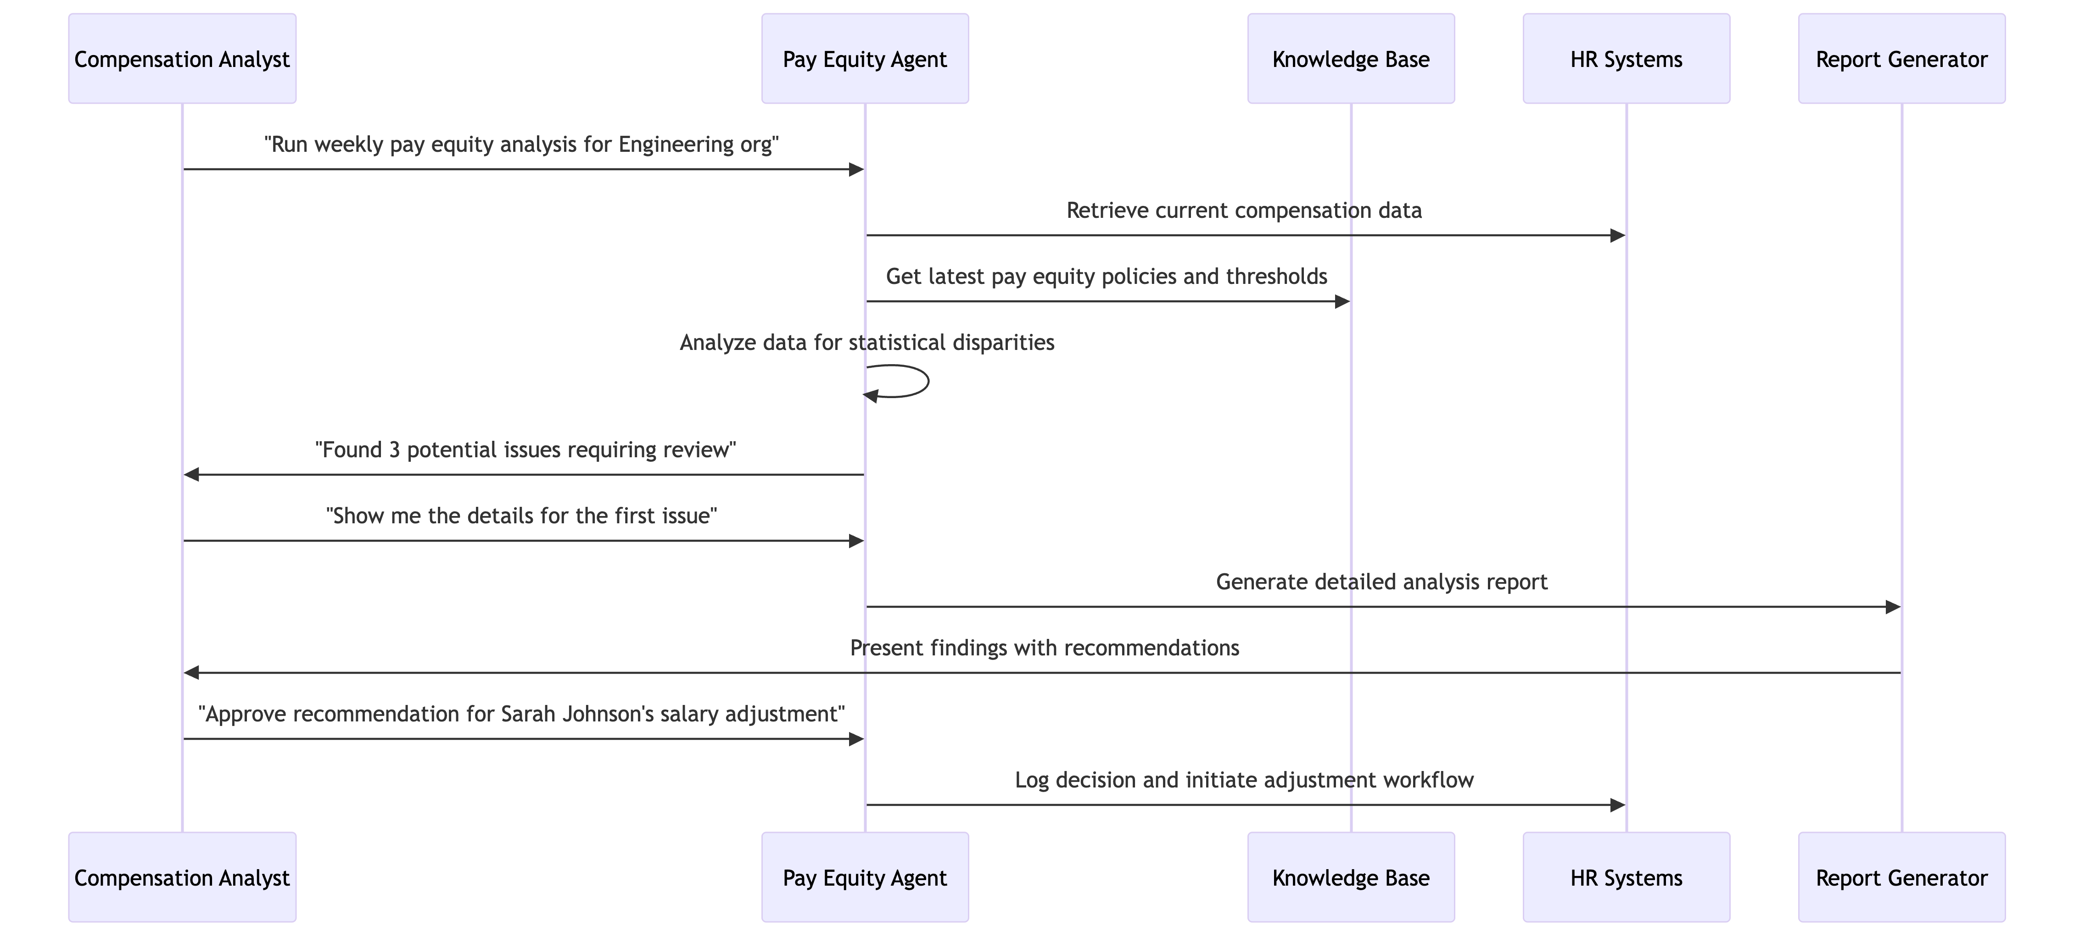

**Workflow 2: Market Analysis for New Role Creation**

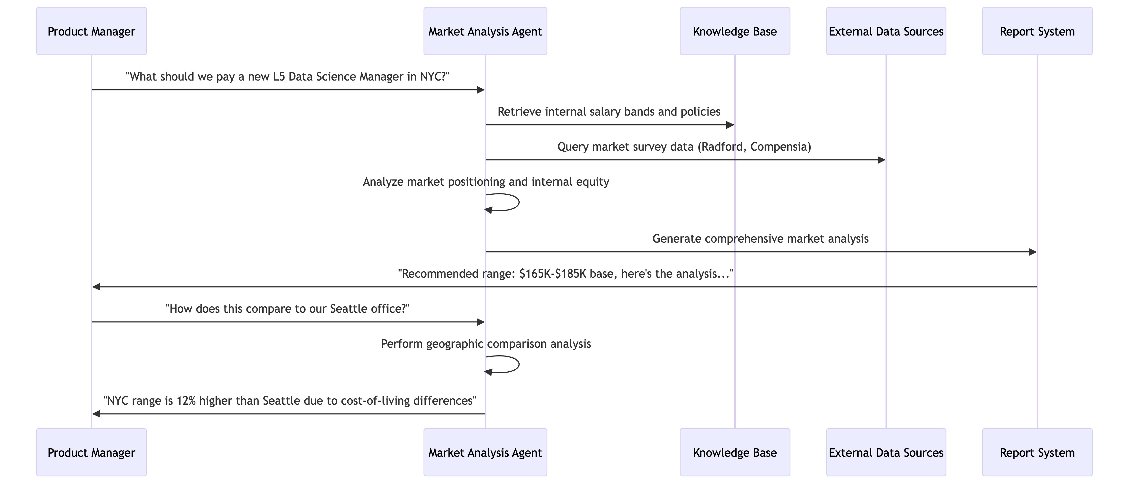

### Appendix D: Governance in Action - Real Scenarios

**Scenario 1: Preventing Biased Recommendations**

*Without Governance:* AI agent recommends lower salary offers for candidates with non-traditional backgrounds based on historical hiring patterns.

*With Governance:*

* Bias detection algorithms flag the statistical disparity
* Human review is triggered automatically
* Compensation team investigates and adjusts recommendation
* AI model is retrained to eliminate biased patterns
* All decisions are logged for compliance reporting

**Scenario 2: Handling Outdated Market Data**

*Without Governance:* AI continues using 2023 market data in 2025, leading to non-competitive offers.

*With Governance:*

* Data freshness monitoring detects outdated information
* System automatically flags recommendations as "low confidence"
* Knowledge base refresh is triggered
* Updated market data is validated before use
* Users are notified of the data refresh and improved confidence scores

**Scenario 3: Managing "Orphaned" AI Systems**

*Without Governance:* BIE builds compensation analysis agent, then leaves team. Agent continues running with degrading performance.

*With Governance:*

* Dual ownership model ensures continuity (business + technical owners)
* Automated monitoring detects performance degradation
* Ownership transition protocols activate when team member leaves
* New technical owner is assigned before system issues arise
* Business owner validates continued relevance and accuracy

### Appendix E: Technology Glossary

|  |  |  |
| --- | --- | --- |
| **Term** | **Definition** | **Compensation Context** |
| Model Context Protocol (MCP) | Standardized way for AI agents to access and use relevant information when making decisions | Ensures AI agents have access to current compensation policies, market data, and regulatory requirements when making recommendations |
| Agentic Computing | AI systems that can autonomously perform complex tasks by coordinating multiple specialized agents | Multiple AI agents work together - one pulls market data, another analyzes internal equity, a third generates recommendations |
| 95% Confidence Threshold | Minimum acceptable accuracy rate for AI recommendations before they can be presented to users | AI recommendation for salary adjustment must be 95% confident based on available data and validation checks |
| Dual Ownership Model | Each AI system has both a business owner (understands the domain) and technical owner (maintains the system) | Compensation analyst owns business logic for pay equity agent; BIE owns technical maintenance and updates |
| Amazon Kendra | AI-powered search service that can extract insights from unstructured documents | Automatically indexes compensation policies, market surveys, and regulatory documents for AI agent access |
| Pippin Integration | Connects AI capabilities with existing product management workflows | Product managers can ask compensation questions directly in their existing tools |

### Appendix F: Implementation Phases Detail

**Phase 1: Foundation (Months 1-3)**

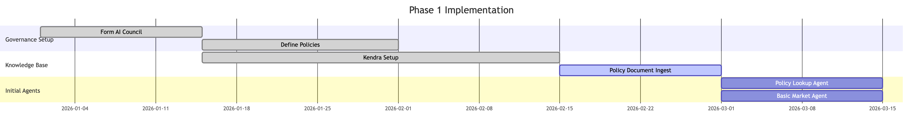

**Phase 2: Core Capabilities (Months 4-9)**

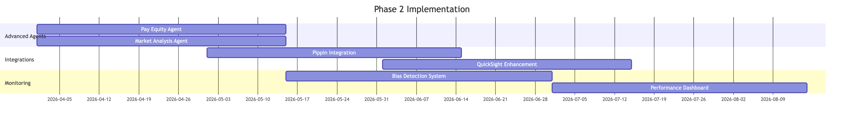

**Phase 3: Advanced Intelligence (Months 10-12)**

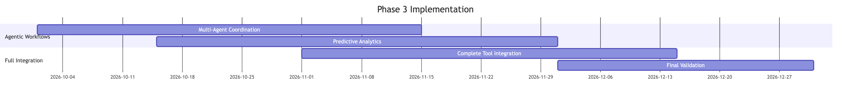

### Appendix G: Business Impact Projections

**Efficiency Gains:**

* 60% reduction in time spent on routine market analysis
* 75% faster response time for compensation policy questions
* 40% improvement in pay equity issue identification and resolution time

**Quality Improvements:**

* 95% confidence threshold ensures higher accuracy than manual analysis
* Elimination of human error in data lookup and basic calculations
* Consistent application of compensation policies across all decisions

**Risk Reduction:**

* Proactive bias detection prevents discriminatory compensation practices
* Automated compliance monitoring reduces regulatory exposure
* Complete audit trails support legal defense and compliance reporting

**Strategic Value:**

* Real-time market intelligence enables more competitive compensation strategies
* Predictive analytics help anticipate retention risks and market changes
* Data-driven insights support more effective budget planning and resource allocation

### Appendix H: Change Management Strategy

**Addressing Common Concerns:**

|  |  |  |
| --- | --- | --- |
| **Stakeholder Concern** | **Response Strategy** | **Supporting Evidence** |
| "AI will replace compensation analysts" | Position AI as augmentation, not replacement. Show how AI handles routine tasks so analysts can focus on strategic work | Include examples of enhanced analytical capabilities that require human interpretation |
| "AI recommendations might be biased" | Demonstrate comprehensive bias detection and human oversight mechanisms | Reference bias detection framework and audit processes |
| "The technology is too complex" | Provide simple, intuitive interfaces and comprehensive training | Show Pippin integration examples that use natural language |
| "What if the AI makes mistakes?" | Explain confidence thresholds, human review processes, and audit trails | Detail the 95% confidence requirement and escalation procedures |
| "This will be expensive to implement" | Present clear ROI analysis and phased implementation approach | Include cost-benefit projections and efficiency gains |

This strategic framework transforms Amazon's compensation capabilities through intelligent automation while maintaining human oversight and control, positioning the organization for competitive advantage in talent management and retention.