# Compensation AI Framework: Strategic Implementation for Generative AI Excellence

## For Hourly Workforce (L1-L3)

## Current Architecture Limitations

Amazon's hourly workforce compensation analytics infrastructure operates through fragmented systems that prevent the organization from realizing the full potential of generative AI capabilities. Today's architecture relies on SAML-federated Redshift access with QuickSight dashboards, creating significant bottlenecks that limit business users' ability to leverage AI for dynamic hourly compensation analysis, policy interpretation, and strategic decision support.

The current state presents multiple governance and operational challenges. Hourly compensation data exists in isolated silos across Redshift, WorkDocs, internal wikis, and various workforce management platforms, with no unified mechanism for AI systems to access and correlate this information safely. Business Intelligence Engineers and Data Engineers build point solutions that often become "orphaned" when team members transition to new roles, leaving critical AI systems without proper ownership or maintenance. Meanwhile, hourly compensation analysts and operations managers lack direct access to AI capabilities, forcing them to rely on static reports rather than dynamic, contextual analysis that generative AI enables.

This fragmentation creates substantial risks in the hourly workforce domain. Without proper governance, AI systems operate with inconsistent accuracy standards, potentially perpetuating bias or making recommendations based on outdated information about minimum wage requirements, shift differentials, or local labor market conditions. The lack of centralized oversight means that different teams implement varying validation protocols, creating compliance gaps and reducing confidence in AI-driven hourly compensation decisions. Additionally, the absence of systematic knowledge management prevents AI agents from accessing critical context about state-specific wage laws, overtime regulations, and local market dynamics that are essential for accurate recommendations.

## Required Generative AI Infrastructure

Transforming hourly workforce compensation systems to leverage generative AI requires establishing a comprehensive technical and governance framework that enables safe democratization of AI capabilities while maintaining the highest standards of accuracy and compliance.

The foundation requires implementing a unified AI governance platform that serves as the central nervous system for all hourly compensation-related artificial intelligence. This platform will enforce a mandatory 95% confidence threshold across all AI-powered tools, ensuring that every recommendation meets established accuracy standards before reaching decision-makers. The governance framework will implement dual ownership models where each AI system has both a designated business owner from the hourly compensation team and a technical owner responsible for maintenance and updates.

Knowledge integration represents a critical component of the modernized architecture. The system will implement Amazon Kendra as the primary knowledge indexing service, automatically ingesting and processing content from WorkDocs, internal wikis, hourly workforce policies, state and local wage regulations, and labor market data. This knowledge base will be continuously updated through automated pipelines that extract information from diverse sources, transform it into AI-readable formats, and index it for rapid retrieval. The Model Context Protocol (MCP) will govern how AI agents access and utilize this knowledge, ensuring that all recommendations are grounded in current, accurate information on hourly wage requirements and local labor conditions.

The technical stack will leverage Kiro IDE and other agentic development tools to enable BIEs and Data Engineers to rapidly build and deploy AI agents while maintaining governance compliance. These agents will operate through standardized interfaces that provide business users with conversational access to complex analytical capabilities, from local labor market analysis to shift differential optimization, without requiring direct technical expertise.

## AI Integration Architecture

The generative AI framework implements a layered architecture designed to balance accessibility with governance, enabling sophisticated AI capabilities while maintaining strict oversight and control mechanisms for hourly workforce compensation management.

The foundation layer consists of Amazon's large language models, fine-tuned specifically for hourly workforce compensation domain knowledge and integrated with the comprehensive knowledge base through MCP protocols. These models understand hourly compensation concepts including state and local minimum wage laws, shift differential calculations, overtime rules, seasonal workforce planning, and compliance with federal and state regulations. The models are continuously updated with anonymized historical hourly compensation decisions, local labor market trends, and best practices, enabling them to provide contextually relevant recommendations while maintaining privacy and confidentiality.

An intelligent routing and validation engine sits above the foundation models, implementing business logic specific to Amazon's hourly workforce compensation philosophy and practices. This engine understands the nuances of different hourly roles, facility types, geographic wage variations, and seasonal workforce planning. It validates all AI recommendations against established parameters, business rules, and compliance requirements before presenting them to users. The engine maintains detailed audit logs of all decisions and recommendations, enabling complete traceability and accountability.

The application layer provides multiple access points tailored to different user personas and use cases. Operations managers access AI capabilities through Pippin integration, enabling them to ask natural language questions about hourly wage competitiveness, perform scenario modeling for seasonal hiring initiatives, and generate comprehensive analysis reports. Hourly compensation analysts interact with specialized AI agents that can perform complex labor cost analysis, identify compliance issues with state wage laws, and recommend adjustments to maintain market competitiveness. Workforce leadership access executive dashboards that provide AI-generated insights on hourly labor costs, retention metrics, and strategic recommendations for different geographic regions.

Agentic computing capabilities enable the creation of sophisticated workflows where multiple AI agents collaborate to complete complex tasks. For example, a seasonal wage adjustment process might involve one agent extracting relevant local market data, another agent analyzing internal pay equity patterns across facilities, and a third agent generating comprehensive recommendations that consider both external competitiveness and internal fairness. These agent chains operate under strict governance protocols, with each step logged and validated against accuracy thresholds.

## Security and Governance Framework

The implementation of generative AI in hourly workforce compensation management requires unprecedented security and governance controls that address both technical vulnerabilities and business risks associated with AI-driven decision-making in sensitive domains.

Access control mechanisms implement attribute-based access control (ABAC) systems that dynamically determine AI system access based on multiple factors including user role, data sensitivity, query type, and intended use of results. Every interaction with AI systems is logged in comprehensive audit trails that capture user identity, query content, data accessed, AI recommendations provided, and final decisions made. These logs support both compliance reporting and continuous improvement of AI system performance.

The governance framework establishes mandatory ownership structures for all AI systems, eliminating the "orphaned AI" problem through clear accountability chains. Each AI system has a designated business owner from the hourly compensation team who understands the domain context and a technical owner responsible for system maintenance and updates. Ownership assignments are tracked in a centralized registry with automated alerts when ownership transitions occur.

Model governance includes comprehensive testing frameworks that continuously validate AI recommendations against known hourly compensation scenarios, regulatory requirements, and fairness criteria. Automated bias detection systems monitor AI outputs across protected demographic categories, alerting governance teams when statistical anomalies suggest potential discriminatory impacts. Human oversight mechanisms require manual review for high-impact decisions, with clear escalation paths when AI confidence levels fall below established thresholds.

Privacy protection operates through multiple defensive layers including data anonymization for model training, differential privacy techniques for sensitive analysis, and secure multi-party computation when cross-functional data correlation is required. All AI processing occurs within Amazon's secure infrastructure with comprehensive monitoring and alerting for unusual access patterns or potential security breaches.

## Integration with Existing Amazon Tools

The generative AI framework seamlessly integrates with Amazon's existing tool ecosystem while enhancing rather than replacing current analytical capabilities and workflows for hourly workforce management.

Pippin integration enables operations managers to access AI-powered hourly compensation insights directly within their existing development and analysis workflows. Natural language interfaces allow users to ask questions like "What would be the labor cost impact of increasing Grocery Associate wages by $1.50 in Chicago to maintain market competitiveness?" and receive comprehensive analysis that considers local labor data, internal equity impacts, and budget constraints. These capabilities operate through standardized APIs that maintain consistency with existing Pippin functionality while adding powerful AI-driven analysis.

Kiro IDE integration allows BIEs and Data Engineers to rapidly prototype and deploy new AI agents using familiar development environments. Pre-built templates and governance-compliant frameworks accelerate development while ensuring all new AI systems meet established standards. The integration includes automated testing capabilities that validate AI agent behavior against governance requirements before deployment.

QuickSight dashboards are enhanced with AI-generated insights that provide contextual intelligence alongside traditional visualizations. Business users see not only what the hourly workforce data shows but also AI-generated explanations of trends, recommendations for action, and predictive analysis of potential outcomes. These enhancements maintain existing dashboard functionality while adding sophisticated analytical capabilities.

The framework establishes standardized APIs that enable AI capabilities to be embedded across Amazon's internal tools and systems. Whether accessed through Workdocs for policy analysis, internal wikis for knowledge verification, or specialized workforce planning tools, AI capabilities provide consistent, governed intelligence that enhances decision-making across all touchpoints.

## Operational Excellence Framework

The governance framework establishes operational processes that ensure AI systems maintain high performance standards while enabling continuous improvement and adaptation to changing business needs in hourly workforce management.

Bi-weekly governance audits provide systematic review of all AI systems, assessing performance against the 95% confidence threshold, reviewing recent decisions for accuracy and bias, and identifying opportunities for improvement. These audits follow standardized protocols that ensure consistent evaluation across all systems while capturing lessons learned that inform future enhancements.

Real-time monitoring systems track AI performance metrics, user satisfaction scores, and business impact measurements. Automated alerts notify governance teams when systems approach performance thresholds, enabling proactive intervention before issues impact business operations. Performance trending analysis identifies gradual degradation patterns that might not trigger immediate alerts but require attention over time.

The framework includes comprehensive training programs that ensure all stakeholders understand their roles within the governance structure. Business owners receive training on AI system oversight, validation techniques, and escalation procedures. Technical owners learn governance requirements, documentation standards, and monitoring protocols. End users understand appropriate AI usage, limitation recognition, and when to seek human oversight.

Continuous improvement processes capture feedback from all stakeholders and translate insights into system enhancements. Regular retrospectives identify friction points in AI interactions, accuracy improvement opportunities, and new use cases that could benefit from AI capabilities. These insights drive the evolution of both individual AI systems and the overall governance framework.

## Implementation Roadmap

The transformation to a comprehensive generative AI framework follows a carefully sequenced implementation plan that minimizes operational disruption while progressively building advanced capabilities for hourly workforce compensation management.

**Phase One: Foundation (Months 1-3)** establishes core governance infrastructure including the AI Governance Council, system registry, and basic monitoring capabilities. This phase implements the knowledge base infrastructure using Amazon Kendra, beginning with critical hourly compensation policies and state/local wage regulations. Initial AI agents focus on low-risk use cases like policy lookup and basic local market analysis, providing immediate value while validating governance processes.

**Phase Two: Core Capabilities (Months 4-9)** deploys the primary AI reasoning engines and implements comprehensive bias detection and monitoring systems. This phase introduces sophisticated AI agents capable of wage compliance analysis, local market benchmarking, and shift differential optimization. The Model Context Protocol implementation enables complex agent interactions while maintaining governance oversight. Integration with existing tools like Pippin and QuickSight provides business users with AI-enhanced analytical capabilities for hourly workforce planning.

**Phase Three: Advanced Intelligence (Months 10-12)** implements agentic computing workflows that enable multiple AI systems to collaborate on complex analyses. Advanced predictive capabilities provide forward-looking insights on local labor market trends, retention risks, and hourly workforce strategy optimization. The framework achieves full integration across Amazon's tool ecosystem, with AI capabilities seamlessly available wherever hourly compensation decisions are made.

Throughout all phases, the implementation maintains operational continuity by building alongside existing systems rather than replacing them. Each milestone includes comprehensive validation against accuracy thresholds and governance requirements, ensuring that new capabilities enhance rather than compromise decision-making quality.

## The complete implementation, targeted for completion by December 31, 2026, will position Amazon's hourly workforce compensation organization with industry-leading AI capabilities that enable more accurate, fair, and strategic compensation decisions while maintaining the highest standards of governance and compliance. This framework provides the foundation for continued innovation in hourly compensation practices while ensuring that AI augments rather than replaces human judgment in critical people decisions.

## Appendices

### Appendix A: Visual Architecture Overview

#### A1: Three-Layer Architecture - Core Components

This simplified diagram shows how the AI Governance Framework is structured in three clear layers:

flowchart TD

subgraph "Layer 1: Business Users"

BU[Business Users<br>Operations Managers<br>Compensation Analysts<br>Workforce Planners]

end

subgraph "Layer 2: Governance Controls"

GC[Governance Controls<br>95% Confidence Threshold<br>Ownership Registry<br>Audit & Logging]

end

subgraph "Layer 3: AI Infrastructure"

AI[AI Infrastructure<br>Knowledge Base<br>Agent Framework<br>Data Sources]

end

BU <-->|Request & Receive<br>AI Insights| GC

GC <-->|Validate & Monitor<br>All AI Actions| AI

classDef users fill:#e1f5fe,stroke:#0277bd,stroke-width:2px;

classDef gov fill:#fff3e0,stroke:#ef6c00,stroke-width:2px;

classDef infra fill:#e8f5e8,stroke:#2e7d32,stroke-width:2px;

class BU users;

class GC gov;

class AI infra;

#### A2: How Hourly Workforce Users Access AI Capabilities

This diagram illustrates how different hourly workforce stakeholders interact with AI capabilities through familiar tools:

flowchart LR

OM[Operations<br>Manager] -->|Uses| PIP[Pippin]

CA[Compensation<br>Analyst] -->|Uses| QS[QuickSight]

BIE[BIE/DE] -->|Uses| KIRO[Kiro IDE]

PIP -->|"Asks: What should FC<br>Associates earn in Phoenix?"| GOV[AI Governance<br>Layer]

QS -->|"Asks: Show market trends<br>for Grocery Associates"| GOV

KIRO -->|"Creates: Shift differential<br>optimization agent"| GOV

GOV -->|Validates Request<br>Checks Permissions<br>Logs Interaction| AI[AI Agent<br>Layer]

AI -->|"Provides: $19.25-$21.50<br>recommended range<br>with 95% confidence"| PIP

AI -->|"Provides: Interactive<br>market trend visualization<br>with AI insights"| QS

AI -->|"Registers: New agent in<br>governance system with<br>dual ownership"| KIRO

classDef users fill:#e1f5fe,stroke:#0277bd,stroke-width:2px;

classDef tools fill:#f3e5f5,stroke:#7b1fa2,stroke-width:2px;

classDef gov fill:#fff3e0,stroke:#ef6c00,stroke-width:2px;

classDef ai fill:#e8f5e8,stroke:#2e7d32,stroke-width:2px;

class OM,CA,BIE users;

class PIP,QS,KIRO tools;

class GOV gov;

class AI ai;

#### A3: Knowledge Integration for Hourly Workforce Insights

This diagram shows how the knowledge base integrates information from multiple sources to provide accurate hourly compensation insights:

flowchart TD

subgraph "Knowledge Sources"

WD[WorkDocs<br>Hourly Policies]

WIKI[Internal Wikis<br>Best Practices]

REG[Regulatory Database<br>Minimum Wage Laws]

MKT[Market Survey Data<br>Local Wage Rates]

end

subgraph "Knowledge Processing"

KEN[Amazon Kendra]

EXT[Extraction<br>Pipeline]

VAL[Validation<br>Layer]

end

subgraph "AI Agents"

MCP[Model Context Protocol]

WRA[Wage Regulation<br>Agent]

MLA[Market Analysis<br>Agent]

SDA[Shift Differential<br>Agent]

end

WD --> EXT

WIKI --> EXT

REG --> EXT

MKT --> EXT

EXT --> VAL

VAL --> KEN

KEN --> MCP

MCP --> WRA

MCP --> MLA

MCP --> SDA

classDef sources fill:#fce4ec,stroke:#c2185b,stroke-width:2px;

classDef process fill:#e0f2f1,stroke:#00796b,stroke-width:2px;

classDef agents fill:#e8f5e8,stroke:#2e7d32,stroke-width:2px;

class WD,WIKI,REG,MKT sources;

class KEN,EXT,VAL process;

class MCP,WRA,MLA,SDA agents;

### Appendix B: Hourly Compensation AI Training Data Examples

**What "Training on Hourly Compensation Data" Actually Means:**

**Example 1: Local Market Wage Intelligence**

Training Input: "FC Associate 1 in Chicago typically earns $18.50-$22.00 per hour according to labor market surveys from Q2 2024. Internal Amazon data shows our FC Associates in Chicago average $19.75 per hour. Local market movement shows 5% increase year-over-year due to competition from other warehousing operations."

AI Learning: The model learns to correlate job levels, locations, labor market data sources, and trend analysis to provide contextually relevant recommendations for hourly workers.

Resulting AI Capability: When asked "What should we pay new FC Associates in Chicago?", the AI responds with market-informed recommendations that consider both external competitiveness and internal equity across facilities in the region.

**Example 2: Shift Differential Pattern Recognition**

Training Input: Historical analysis showing that night shift differentials in Phoenix facilities increased from $1.50 to $2.00 in Q1 2023 due to retention challenges, resulting in 15% lower attrition compared to facilities that maintained the $1.50 differential.

AI Learning: The model identifies patterns showing effectiveness of different shift differential strategies across regions and facility types.

Resulting AI Capability: The AI can recommend shift differential adjustments based on local conditions, stating "Current night shift differential of $1.50 in Detroit facilities shows 23% higher attrition than similar facilities. Consider evaluating an increase to $2.00 based on successful outcomes in comparable markets."

**Example 3: Compliance Policy Application Intelligence**

Training Input: "California wage laws require overtime pay of 1.5x regular rate for hours over 8 in a day and 40 in a week, and 2x regular rate for hours over 12 in a day. Amazon's policy is to comply with all state regulations and ensure all payroll systems accurately calculate these requirements."

AI Learning: The model understands state-specific wage compliance requirements and how they vary across different jurisdictions.

Resulting AI Capability: When analyzing staffing plans for a new facility in California, the AI automatically flags potential compliance issues, noting "This staffing plan includes multiple 12-hour shifts which will trigger double-time pay requirements under California law. Estimated additional labor cost is $34,500 per month versus standard overtime calculations."

### Appendix C: Sample AI Agent Workflows

**Workflow 1: Minimum Wage Compliance Review Process**

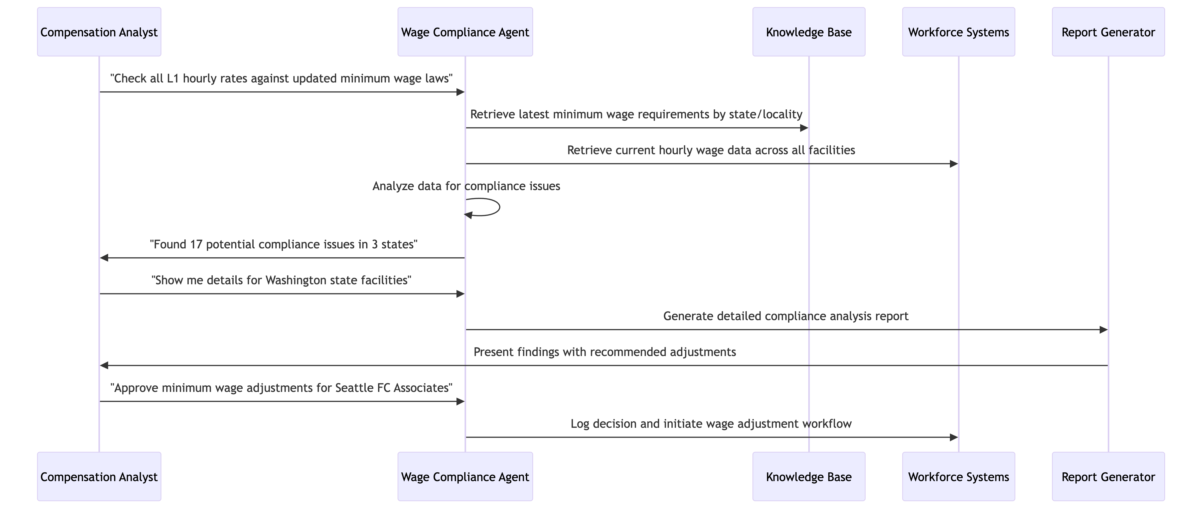

**Workflow 2: Seasonal Hiring Rate Analysis**

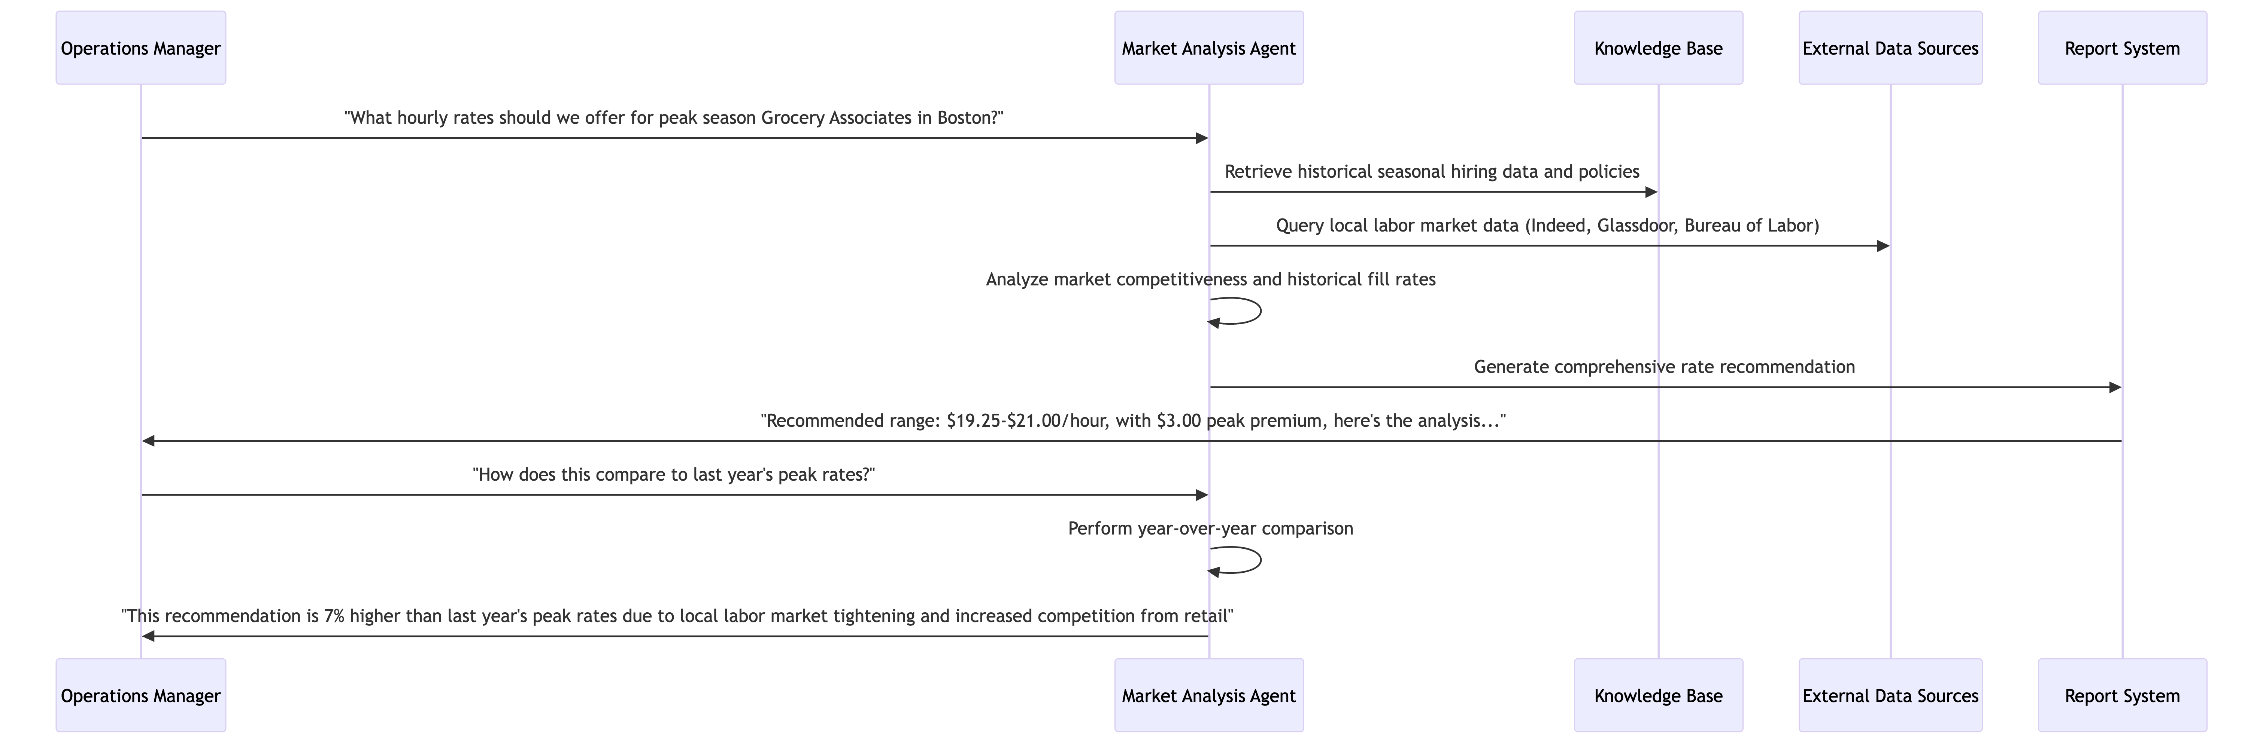

### Appendix D: Governance in Action - Real Scenarios

**Scenario 1: Preventing Geographic Wage Bias**

*Without Governance:* AI agent recommends lower starting wages for facilities in areas with similar cost of living but different demographic compositions, inadvertently perpetuating geographic wage disparities.

*With Governance:*

* Bias detection algorithms flag the statistical disparity in wage recommendations
* Human review is triggered automatically
* Hourly compensation team investigates and adjusts recommendation
* AI model is retrained with additional fairness constraints
* All decisions are logged for compliance reporting and trend analysis

**Scenario 2: Handling Outdated Minimum Wage Data**

*Without Governance:* AI continues using outdated minimum wage requirements from 2023 after multiple states implemented increases in 2025, leading to compliance risks.

*With Governance:*

* Data freshness monitoring detects outdated wage regulations
* System automatically flags recommendations as "low confidence"
* Knowledge base refresh is triggered from authoritative sources
* Updated wage requirements are validated by legal team before use
* Users are notified of the data refresh and improved confidence scores

**Scenario 3: Managing "Orphaned" Shift Optimization AI**

*Without Governance:* BIE builds shift differential optimization agent, then leaves team. Agent continues running with outdated assumptions about labor availability.

*With Governance:*

* Dual ownership model ensures continuity (business + technical owners)
* Automated monitoring detects increasing variance between recommendations and actual labor market response
* Ownership transition protocols activate when team member leaves
* New technical owner updates the model with current labor market dynamics
* Business owner validates continued relevance and accuracy of recommendations

### Appendix E: Technology Glossary

|  |  |  |
| --- | --- | --- |
| **Term** | **Definition** | **Hourly Compensation Context** |
| Model Context Protocol (MCP) | Standardized way for AI agents to access and use relevant information when making decisions | Ensures AI agents have access to current minimum wage laws, shift premium policies, and local market data when making recommendations |
| Agentic Computing | AI systems that can autonomously perform complex tasks by coordinating multiple specialized agents | Multiple AI agents work together - one checks compliance with wage laws, another analyzes local market data, a third generates recommendations |
| 95% Confidence Threshold | Minimum acceptable accuracy rate for AI recommendations before they can be presented to users | AI recommendation for hourly rate adjustment must be 95% confident based on available data and validation checks |
| Dual Ownership Model | Each AI system has both a business owner (understands the domain) and technical owner (maintains the system) | Hourly compensation analyst owns business logic for wage compliance agent; BIE owns technical maintenance and updates |
| Amazon Kendra | AI-powered search service that can extract insights from unstructured documents | Automatically indexes wage policies, state regulations, and labor market surveys for AI agent access |
| Pippin Integration | Connects AI capabilities with existing product management workflows | Operations managers can ask hourly workforce questions directly in their existing tools |

### Appendix F: Implementation Phases Detail

**Phase 1: Foundation (Months 1-3)**

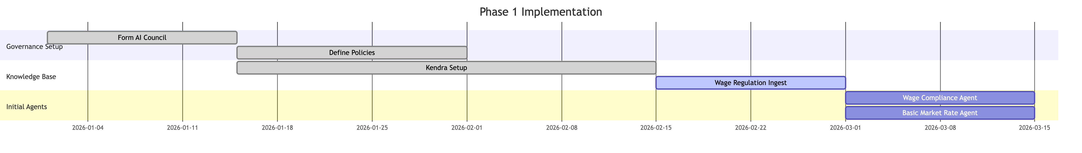

**Phase 2: Core Capabilities (Months 4-9)**

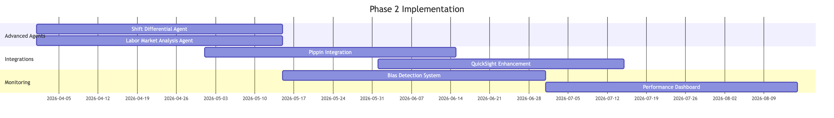

**Phase 3: Advanced Intelligence (Months 10-12)**

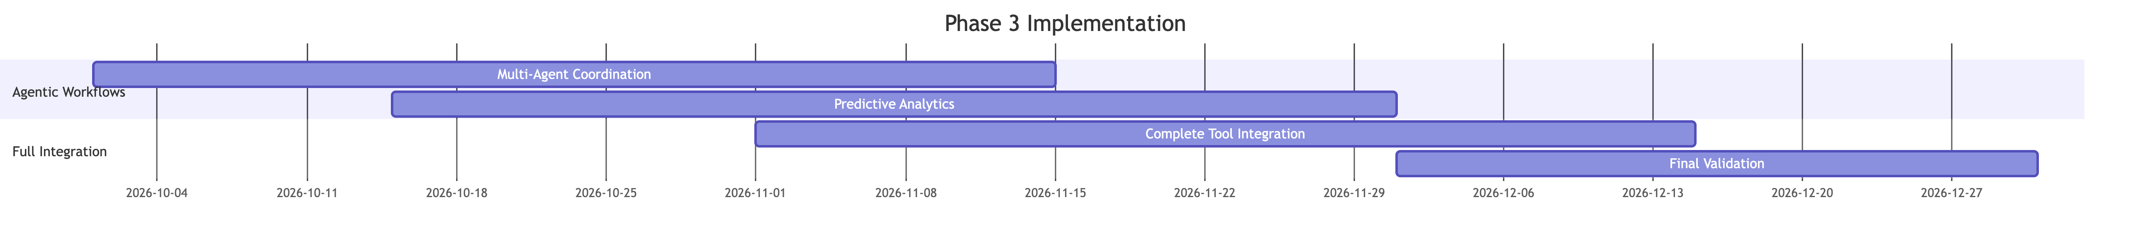

### Appendix G: Business Impact Projections

**Efficiency Gains:**

* 65% reduction in time spent on wage compliance verification
* 80% faster response time for local market rate questions
* 45% improvement in seasonal staffing plan optimization time

**Quality Improvements:**

* 95% confidence threshold ensures higher accuracy than manual analysis
* Elimination of human error in minimum wage compliance calculations
* Consistent application of wage policies across all facilities and jurisdictions

**Risk Reduction:**

* Proactive compliance monitoring prevents wage law violations
* Automated market analysis ensures competitive hourly wages to reduce attrition
* Complete audit trails support legal defense and compliance reporting

**Strategic Value:**

* Real-time local market intelligence enables more competitive wage strategies
* Predictive analytics help anticipate turnover risks and labor market changes
* Data-driven insights support more effective labor budget planning and workforce allocation

### Appendix H: Change Management Strategy

**Addressing Common Concerns:**

|  |  |  |
| --- | --- | --- |
| **Stakeholder Concern** | **Response Strategy** | **Supporting Evidence** |
| "AI will replace hourly workforce planners" | Position AI as augmentation, not replacement. Show how AI handles routine tasks so analysts can focus on strategic work | Include examples of enhanced workforce planning capabilities that require human judgment |
| "AI recommendations might disadvantage certain areas" | Demonstrate comprehensive bias detection and human oversight mechanisms | Reference geographic equity framework and compliance audit processes |
| "The technology is too complex for our operations" | Provide simple, intuitive interfaces and comprehensive training | Show Pippin integration examples that use natural language |
| "What if the AI misinterprets wage requirements?" | Explain confidence thresholds, human review processes, and audit trails | Detail the 95% confidence requirement and legal validation procedures |
| "This will be expensive to implement for hourly roles" | Present clear ROI analysis and phased implementation approach | Include labor cost optimization projections and compliance risk reduction |

This strategic framework transforms Amazon's hourly workforce compensation capabilities through intelligent automation while maintaining human oversight and control, positioning the organization for competitive advantage in hourly talent management and retention.