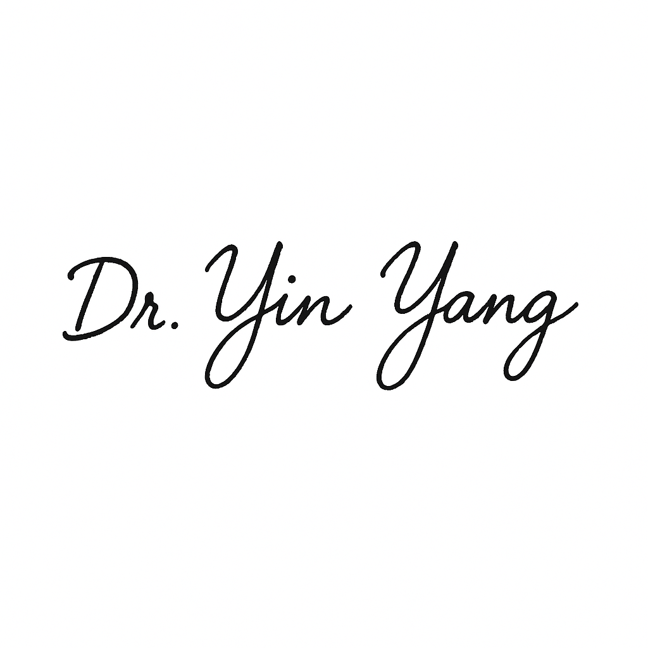
Yin Yang, M.D. for
Ash Judd, D.O., or Designee
Medical Director

