**1.Hello World from HTML, JS, React  
  
1.1 Hello world from html  
  
  
1.2 From JS  
  
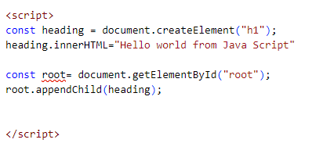  
  
1.3 From React  
  
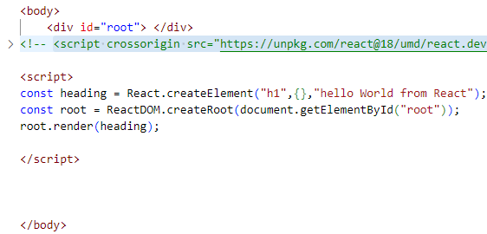  
  
  
  
  
  
  
  
  
  
  
  
  
  
JSX and ReactCreate Element  
  
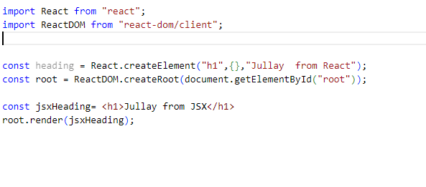  
  
  
React element is nothing but JSX.  
  
Components-   
1. Class based component and Funtional component  
  
  
  
  
  
  
  
  
  
1. Surveyor**