**Team Members:**

The only prerequisite for joining our team was that we were taking the COSC345 Software Engineering paper, there was no scouting process. We formed a team through discord, having all missed the initial in-person group formation events (hence, it was matter of being in the right place at the right time). With that being said, each of our team members have skills that will be useful for our project.

**Sam Hansard** is a third-year Computer Science major, he has commercial work experience in software development and has previously completed software project management (INFO310) which will help with organising the project.

**Eliot Luna** is a third-year student studying Computer Science. He has experience working in a group to create a game through the Cosc360 game design paper. This involved using the Agile approach to software development method as well as Gitlab for version control. He also has experience in programming, particularly with Java which is similar to Kotlin - the language we will be using for our app.

**Denzel Lozano**, along with the others, is a third-year Computer Science major and has also completed a minor in Japanese which ties well into the concept of our app which is intended to aide in language learning. He has experience in managerial positions and sales and can provide an outlook as to how to outline the critical questions, both sales-specific and project-specific. Denzel has adequate experience in programming although not android.

**Corey Skvor** is a Data Science major. He has a high-level understanding of neural-networks and other related statistical methods. He has some limited practical experience in using TensorFlow from INFO204.

**What we are going to Build:**

With our app – ImageLingo - we aim to produce a language supplement tool which incorporates image classification to identify a pre-set object, and return a translated, grammatically correct sentence incorporating said object.

With this app, you will have the option to select a language for which you want the translation. You will then use your phone to take a picture of an object in the classroom or home setting, where the app will then use our own neural network to identify and object and use a database to find the associated translated phrase.

The fundamental purpose of this app is to promote the incorporation of other languages into people’s everyday vocabulary, with the image classification ensuring real-life practicality with the word choices.

We have elected to select the languages of Māori, Samoan, and Japanese. The choice of Te Reo Māori and Sāmoan tie in deeply with our interpretation of diversity in the New Zealand environment, whilst understanding our current time limitations. These communities are an integral part of NZ culture, and we believe actively incorporating their language promotes unity and inclusion. From the New Zealand Principals’ Federation Conference 2022, “The Refresh will be shaped around the learner – their voice, needs, and aspirations. It will enable the curriculum to have a stronger focus on wellbeing, identity, language, and culture.” - in reference to the renewed curriculum starting this year. Samoan, being the most prevalent of the spoken Pacifica languages [1], offers the largest consumer base. Our addition of Japanese stems through embracing and exploiting the diverse team skillset (as Denzel has proficiency in the language).

The framework of the app will allow for long-term developments involving other languages, better trained image classification, and more in-depth teaching prompts.

**How we are going to build it:**

We are going to collect the images for our objects by going through the University buildings and taking photos (with permission). We will label these images using ImgLab - a free online tool. Using these labelled images and Google Colab we will train a TensorFlow Lite model.

We will create the UI for our Android app using Kotlin and integrate our TensorFlow Lite model to our App for object detection using the TensorFlow Lite Task Library.

We will use the Kotlin Storage class, to store the translation for our objects as well as several commonly used and useful phrases associated with the object classified as strings. Upon identifying the object in the image, we will prompt the user with buttons displaying the associated strings and if pressed, these will access the storage class and display the associated object data.

We will use GitHub for version control.

**What already exists, and how will it differ from that:**

Our app isn’t intended to combat apps like [Duolingo](https://www.duolingo.com/) and [Rosetta Stone](https://www.rosettastone.com/), with there being a clear disparity between what our app sets out to achieve. These language-learning tools aim to teach you a new language, whilst our app merely wants to promote incorporation of other languages into everyday English conversation. To this end, our app can be defined as a supplement, rather than a fully developed education tool. Hence, our app may be used in union with Duolingo and Rosetta Stone but aims to promote diversifying your everyday English vocabulary.

[Google Lens](https://lens.google/howlensworks/) is an app which, among other things, can use a photo to return a web result of similar objects. This is quite impressive, especially with their other feature of language translation through real-time images. This app does not define the object taken, and will return specific, rather than generic, results. The language translation and image classification are also independent features, making it inconvenient to translate a defined image. Whilst not as technologically advanced, our app offers a simplistic, convenient, and safe tool optimized for our target audience – teachers and older students.

According to further research, the app with the greatest parallel to ours is called [Kupu](https://www.healthnavigator.org.nz/apps/k/kupu-app/). This app, which is run through a child organization of Spark, uses image classification to identify an image, and return the Māori translation with synonyms. Unlike Kupu (which we conclude runs Google’s network), we wish to build our own neural network. This will address much of the criticism faced by the app, through allowing us to: select the items we will classify, meaning that there will be no need for arbitrary censorship; define generic objects rather than be unhelpfully specific; provide a human-translated sentence incorporating the word (allowing better language acquisition). The initial addition of two other languages also helps diversify the user’s daily conversation, whilst the simplistic nature of the network promotes safe user interaction.

**Target Market:**

Our main target market is teachers and independent language learners. Our app is meant for Teachers as a tool to assist students in expanding their Māori, Samoan, or Japanese, language knowledge. For independent language learners (Self Study) - In compliance with the ethics approval, this will be directed towards people over the age of 18.

There is also the possibility of expanding our target market to school children learning a language in future if we were able to get ethical approval

Our market also includes anybody who wants to add some foreign words for common objects into their vocabulary.

**Evidence our target market is Interested:**

The government has set a goal of raising Māori language fluency to include 1 million basic speakers by 2040, in service of this, resources are being allocated to increase Māori language education availability and quality.  
As our app is intended to be used primarily by teachers in a classroom setting, this increased resource availability for the subject will create higher demand for educational assistance tools.

The article below[2] explains the positive correlation between learning a second language and reducing the effects of cognitive decline due to ageing. Our app can be used as a tool to help assist in the language learning process in medical settings such as rest homes to aid in reducing cognitive decline, or within individual settings to achieve the same result.

Evidence of interest in self-learning a second language digitally through apps and websites has skyrocketed within the past few years with Duolingo now having 40 million monthly active users.

**Milestones:**

As this assignment has three major releases: alpha, beta, and final release, we will be breaking our goals down accordingly.

For our alpha release we do not expect to have fully implemented object recognition. Instead, we aim to have the neural network functioning in TensorFlow, being able to identify a restricted list of our objects (four). We should have 250 photos of each of our listed objects taken and labelled and have all the translated sentences for each object stored. The main objective of our alpha release is to have a cosmetic version of the app which shows the user interface and a pre-programmed demonstration of the intended user experience, having all other aspects running/existing independently of the app.

Our beta release should have the neural network and stored translated sentences fully implemented into the app. The neural network will now be trained on all listed objects (see above), with room for addition. The user should be able to select a language, take a photo of an object, and be returned the identified [listed] object with the correlated translated sentence, with the choice of saving this overlayed image to their photo-log.

The final release will offer a smooth implementation of the app. We will now expect that the hyperparameters of the neural network will be optimized, such that our classification rate will be above 85%.

**Potential Improvements:**

If our App proves to be successful, how we would improve it is to:

* Expand our image recognition to include more objects, potentially by using an organisation such as Google’s image recognition tools.
* Expand the list of languages - potentially by using an organisation such as Google’s translation tools instead of our prebuilt database of translations.
* Option to save the image with translation to your camera roll. (Useful ‘Photo Diary’)
* Have our App be available as a learning resource for school students (cannot have school students as our target audience currently do to the need for ethical approval for underage people)

**Single vs Multiple Object Detection**

We investigated whether we wanted to have our image recognition be able to detect a single object in an image or multiple objects, and we decided we would only detect one object per image. It would not be difficult to add the ability to detect multiple objects per photo, however we decided that it might be confusing to the user if we gave translations for multiple objects at a time. We may reconsider this point when it comes to user testing depending on the feedback we are given. This leaves the user responsible for ensuring that the object that they want translated is the most prominent object in the photo.

**Proposed Timeline**

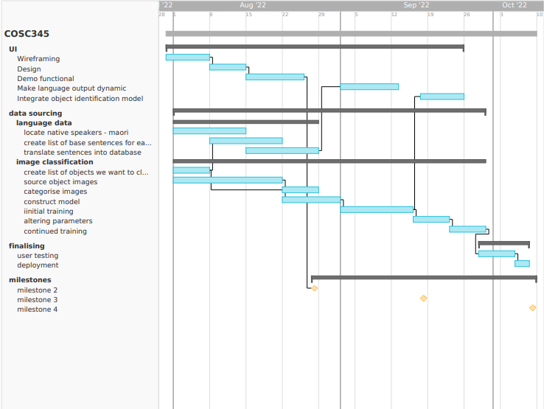

1. https://pasifika.tki.org.nz/LEAP/Pasifika-in-New-Zealand/Pasifika-languages-in-New-Zealand#:~:text=While%20the%20language%20shift%20to,still%20speak%20the%20Niue%20language.
2. [Bubbico, G., Chiacchiareta, P., Parenti, M., di Marco, M., Panara, V., Sepede, G., Feretti, A., Perucci, M. G. (2019). Effects of Second Language Learning on the Plastic Aging Brain: Functional Connectivity, Cognitive Decline, and Reorganization.](https://www.frontiersin.org/articles/10.3389/fnins.2019.00423/full)