**Outline Testing strategy**:

* Verify the Content screen content
* Verify the Home screen content
* Verify the Library screen content
* Verify the Search screen content
* Verify that the **Switch** button is working in the Reading screen
* Verify that the **OutlinedTextField** search is working in the Search screen
* Verify that the **toggleReadingMode** is working in the Reading app view model
* Navigating to the Library screen by clicking the **go to library** button from the Home screen
* Navigating to the Contents screen by clicking the **Table of Contents** button from the Library screen
* Navigating to the Reading screen by clicking on one of the books in the Library screen
* Navigating to the Reading screen by clicking the **Read** button from the Library screen

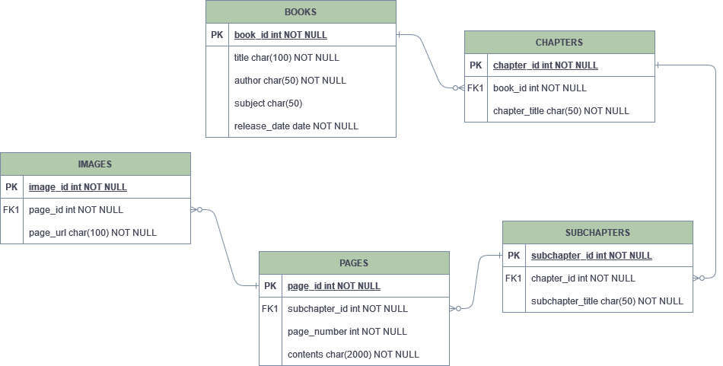

In our database, we will have a table to store the general book information such as the title, author, subject, and release date. This information will be displayed in the library screen. When a book is clicked, the app will make a query to the database to find that book’s chapters and subchapters, and it will display them in the table of contents screen. When a subchapter is pressed, the app will make a query to the database to find that subchapter’s pages and contents, and any images contained in that page.

Examples of queries:

SELECT * FROM Books;

SELECT * FROM Chapters WHERE book_id = 1;

SELECT * FROM Pages WHERE subchapter_id = 3;