**DATA GATHERING DOCUMENTATION**

**FIRST INTERVIEW**

* DECEMBER 9, 2022
  + MR. MANNY SEVILLA
    - Land Transportation Office

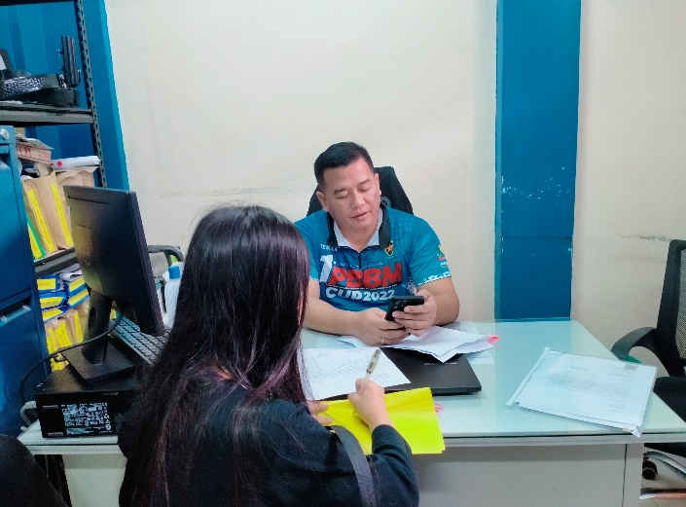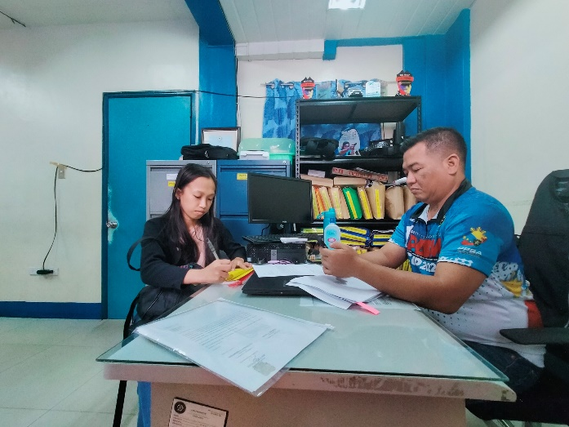

**SECOND INTERVIEW**

* DECEMBER 20, 2022
  + MR. DENNIS PACA and MA’AM GRACE CAPUYAN
    - 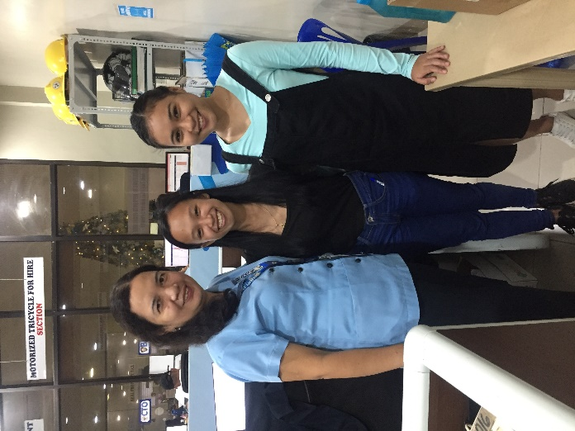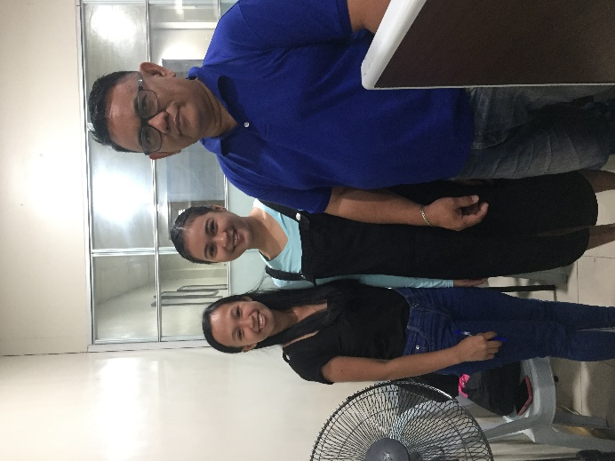Business Permit and Licensing Office