**Game Design Document**

**200K JPacman**

Concept

200K JPacman is the Maze 2D adventure game.

Story

Pacman is the treasure hunter. He knew there is a treasure somewhere on earth. But in the end, he learns that the treasure he is looking for does not exist. But the real treasure is to explore the beautiful world.

Target Group

People of all ages who love Pacman games and love adventure, challenge the difficulty of Pacman games.

Game Structure

There are 5 stages: sky, forest, rock cave. ice cave and lava pond respectively Players must complete levels in each order in the difficulty that the player chooses himself (easy, normal, hard).

The game supports 1 player, playing by pressing the arrows on the keyboard to control the Pacman character, collecting pellets all over the map and dodging the ghosts that are blocking us. Once you've collected it, you'll travel to the next area.

Graphic & Sound

There is a top view with cartoon art graphics without cut scenes to tell the story, when the game is opened, it can be played at all. Pacman has animation, opens his mouth to walk and eats pellets, ghosts also have walking animation with no background music.

Development System

????????????????????????????????????????????????????????????????????????????????????????

Game Play

Character : Pacman

Story : Pacman is a famous treasure hunter. He has hunted treasures countless

times. One day, someone

Tell him that there is one of the greatest treasures in the world that no one has discovered, and that Pacman, who accidentally heard it, was interested and traveled the world to find that precious treasure. But along the way, there are many obstacles, including a maze and a group of treasure hunters named Ghost that keep him away. The battle and escape for the treasure lasted a long time, fighting in the sky, in the great forest, in a dangerous rock cave, in cold ice caves or even sweltering lava ponds. Eventually, Pacman manages to break free from the ghost treasure hunters. And at the end of the journey, at the edge of the cliff overlooking the far horizon. He learns the truth, that the greatest treasure in the world is nothing. But it was an experience he had during his travels. But in the end, he realized that the journey, despite its difficulties, was happy, and that he would never forget the experience.

Objective : Collect all the pellets in all 5 levels to win at that difficulty level. If hit by

ghost, it is considered a loss immediately.

Level Design : There are 3 difficulty levels: easy, medium, hard, and there are 5 levels:

sky, forest, rock cave, ice cave and lava pond.

Enemy : There are 4 ghosts in total, and each of them has a different walk:

* Walk after players.
* Walk trap the player from a possible path.
* Random walks across the map.
* Walk follow the pattern.

Game Flow :

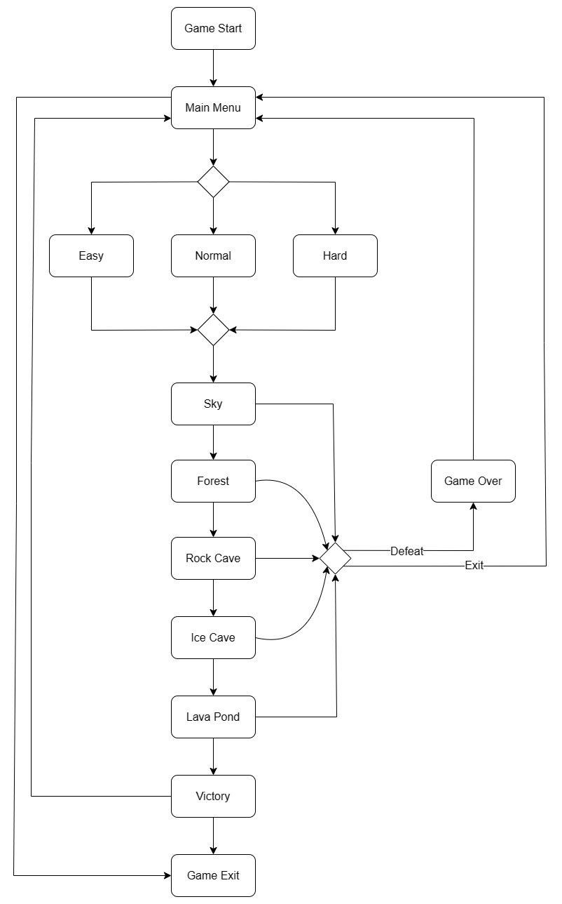

UI Flow : <https://www.figma.com/file/Od3uLFHgFcfGS2OJRuoWRk/Untitled?node-id=0%3A1&t=ldvTnEi454bFQgXf-1>

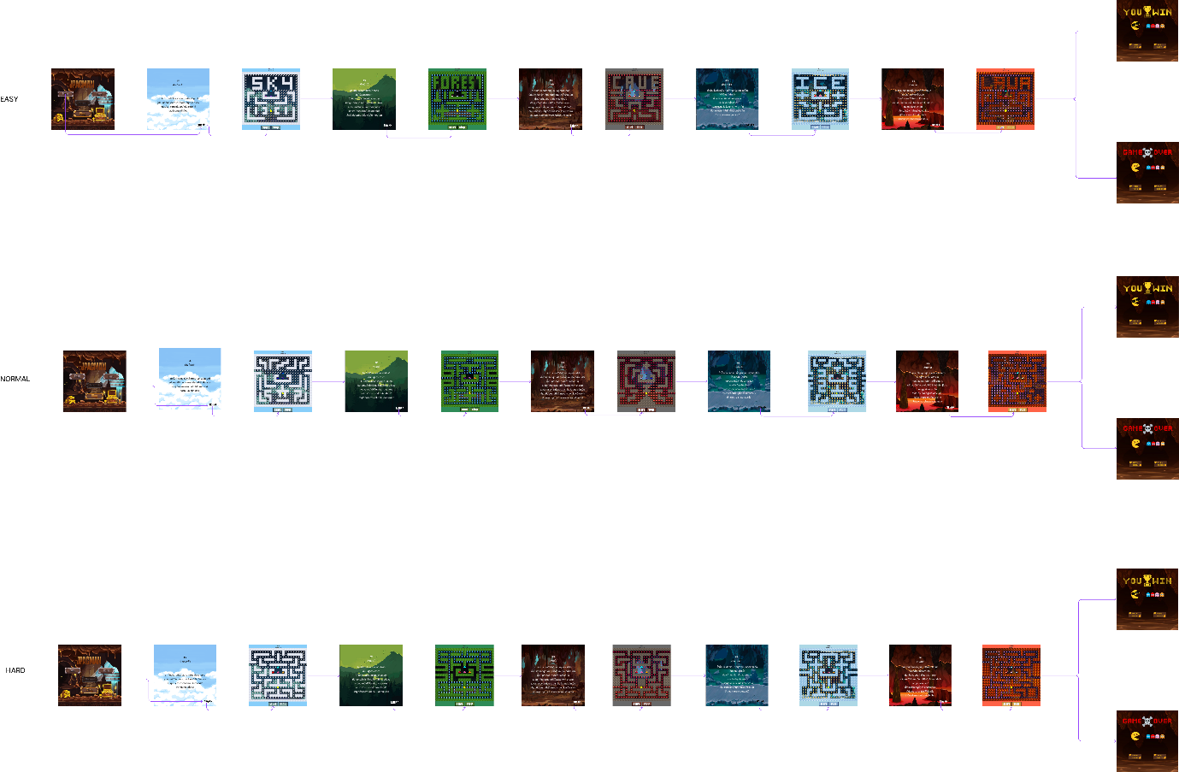

Team member : นางสาวสินีนาฏ เทียกมูล

นายกล้ายุทธ พิชัยเชิด

นางสาวช่อปทุม อุดมชาติ

นายชวัชร์ชัย ไชยโสดารัชต์

นายธีรธัช ชาวระนอง

นายพันธ์ศักดิ์สมภาค

นายอัจฉริยะ สร้อยอุดม

Time :

Start Date: Mar 2, 2023

Complete Game Design: Mar 16, 2023

Milestone 1 - Add 5 pacman map and sorting map order. Can finish all map in new JPacman: Mar 4, 2023

Milestone 2 - Fix bugs changing level**.**: Mar 4, 2023

Milestone 3 - add wall and pellet theme: Mar 5, 2023

Milestone 4 - add MainUI with background image: Mar 5, 2023

Milestone 5 - add image button of Menu UI: Mar 5, 2023

Milestone 6 - Deleted class MainUI and add MainUI in method void to PacManUI: Mar 6, 2023

Milestone 7 - Fixed an issue using while loops.: Mar 7, 2023

Milestone 8 - chance imagebutton filename: Mar 7, 2023

Milestone 9 - add startstopStart() in LevelTest and create DirectionTest class: Mar 7, 2023

Milestone 10 - Rename the forestt board and Test the button play: Mar 8, 2023

Milestone 11 - add board level won test.: Mar 8, 2023

Milestone 12 - create ResourceTest and edit GhostMapParser.: Mar 9, 2023

Milestone 13 - add PelletScoreTest and add test display name: Mar 9, 2023

Milestone 14 - create FindUnitInBoardTest and GhostMoveTest.: Mar 9, 2023

Milestone 15 - add CollisionWallTest and add PelletScoreTest.: Mar 9, 2023

Milestone 16 - create FindUnitInBoardTest and GhostMoveTest.: Mar 9, 2023

Milestone 17 - Add PelletChanceMapTest and change BG image, Pellet image, Wall image.: Mar 9, 2023

Milestone 18 - Change all ghost picture.: Mar 9, 2023

Milestone 19 - test button doclick.: Mar 10, 2023

Milestone 20 - Add stage change display: Mar 10, 2023

Milestone 21 - Add stage change display 2nd.: Mar 10, 2023

Milestone 22 - chance dispaly name.: Mar 10, 2023

Milestone 23 - Rename DisplayName.: Mar 10, 2023

Milestone 24 - Rename DisplayName no2.: Mar 10, 2023

Milestone 25 - Rename DisplayName no3.: Mar 10, 2023

Milestone 26 - Rename DisplayName no4.: Mar 10, 2023

Milestone 27 - Update Game Document: Mar 16, 2023

Milestone 28 - Add Sprint backlog and test report: Mar 16, 2023

Milestone 29 - make Game Difficulty Level function and add new file board: Mar 17, 2023

Milestone 30 - Add Cut Scense resources and and Cut Scense UI to the game.: Mar 17, 2023

Milestone 31 - Add new main ui: Mar 17, 2023

Milestone 32 - Add main ui image and bottom image: Mar 17, 2023

Milestone 33 - add level mode and link button in MainUI: Mar 18, 2023

Milestone 34 - add deadscense and victoryscense and merge with main menu: Mar 19, 2023

Milestone 35 - add ImageButton start stop and colors theme, add new ghost: Mar 19, 2023

Milestone 36 - set up Test: Mar 19, 2023

Milestone 37 - fix bug: Mar 19, 2023

Milestone 38 - modify test and add ModeTest class.: Mar 19, 2023

Milestone 39 - Add Cutscense test: Mar 19, 2023

Milestone 40 - fix bug changing level upon death: Mar 20, 2023

Milestone 41 - fix bug Test CutScenseTest: Mar 20, 2023

Milestone 42 - add test gemauitest: Mar 20, 2023

Milestone 43 - add test VicetoryUI_Test and DeadCcenseTest: Mar 20, 2023

Milestone 44 - Add Board Test for each level Easy, normal, Hard.: Mar 20, 2023

Milestone 45 - add GhostSpeedSkyTest, GhostSpeedForestTest: Mar 20, 2023

Milestone 46 - modify smokeTest, CollisionWellTest and PelletScoreTest: Mar 21, 2023

Milestone 47 - add GhostSpeesCaveTest,GhostSpeesLavaTest,GhostSpeedIceTest and MainUITest: Mar 21, 2023

End of Project: Mar 23, 2023