CLASSROOM HANDOUT
Nmap Hands-On Activities
Six lab exercises for teaching network scanning and reconnaissance with Nmap on Kali Linux
These activities give students hands-on practice with Nmap, progressing from simple network discovery to scripted vulnerability enumeration and a capture-the-flag style challenge. Each uses safe, legal, purpose-built targets so students can practice freely without any legal risk.

1. Home Network Discovery Sweep
Students scan their own home network (or a lab VLAN) to build a live inventory of connected devices.
- Run nmap -sn 192.168.1.0/24 to find every live device on their network
- Identify each device (router, phone, laptop, smart TV, etc.) and document its IP address and MAC vendor
Deliverable: A simple network diagram or table listing every discovered host.

2. Metasploitable 2 Port & Service Enumeration
Using the intentionally vulnerable Metasploitable 2 VM (free download, isolated VM only).
- Run nmap -sV -p- <target> against the VM
- List every open port, the service, and the version Nmap detected
- Research one CVE tied to an outdated service they found (e.g. vsftpd 2.3.4)
Deliverable: A short enumeration report mapping ports → services → potential risk.
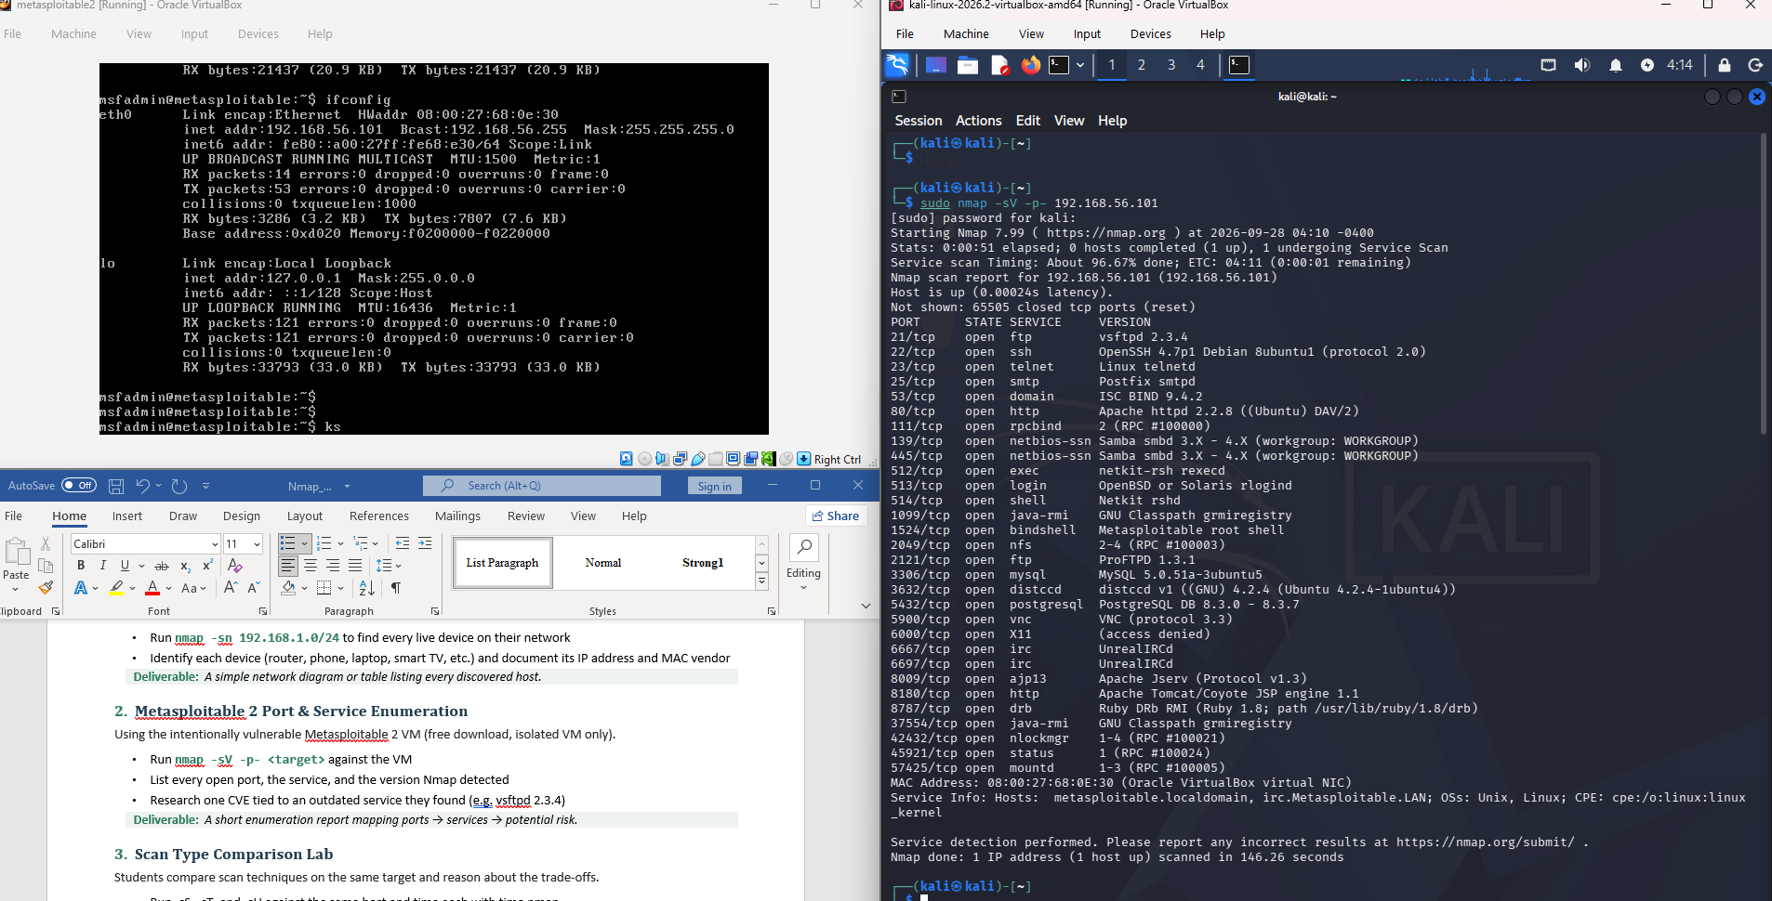

3. Scan Type Comparison Lab
Students compare scan techniques on the same target and reason about the trade-offs.
- Run -sS, -sT, and -sU against the same host and time each with time nmap ...
- Capture the traffic in Wireshark alongside each scan
Deliverable: A short write-up comparing the speed, packet behavior, and stealth of each scan type.
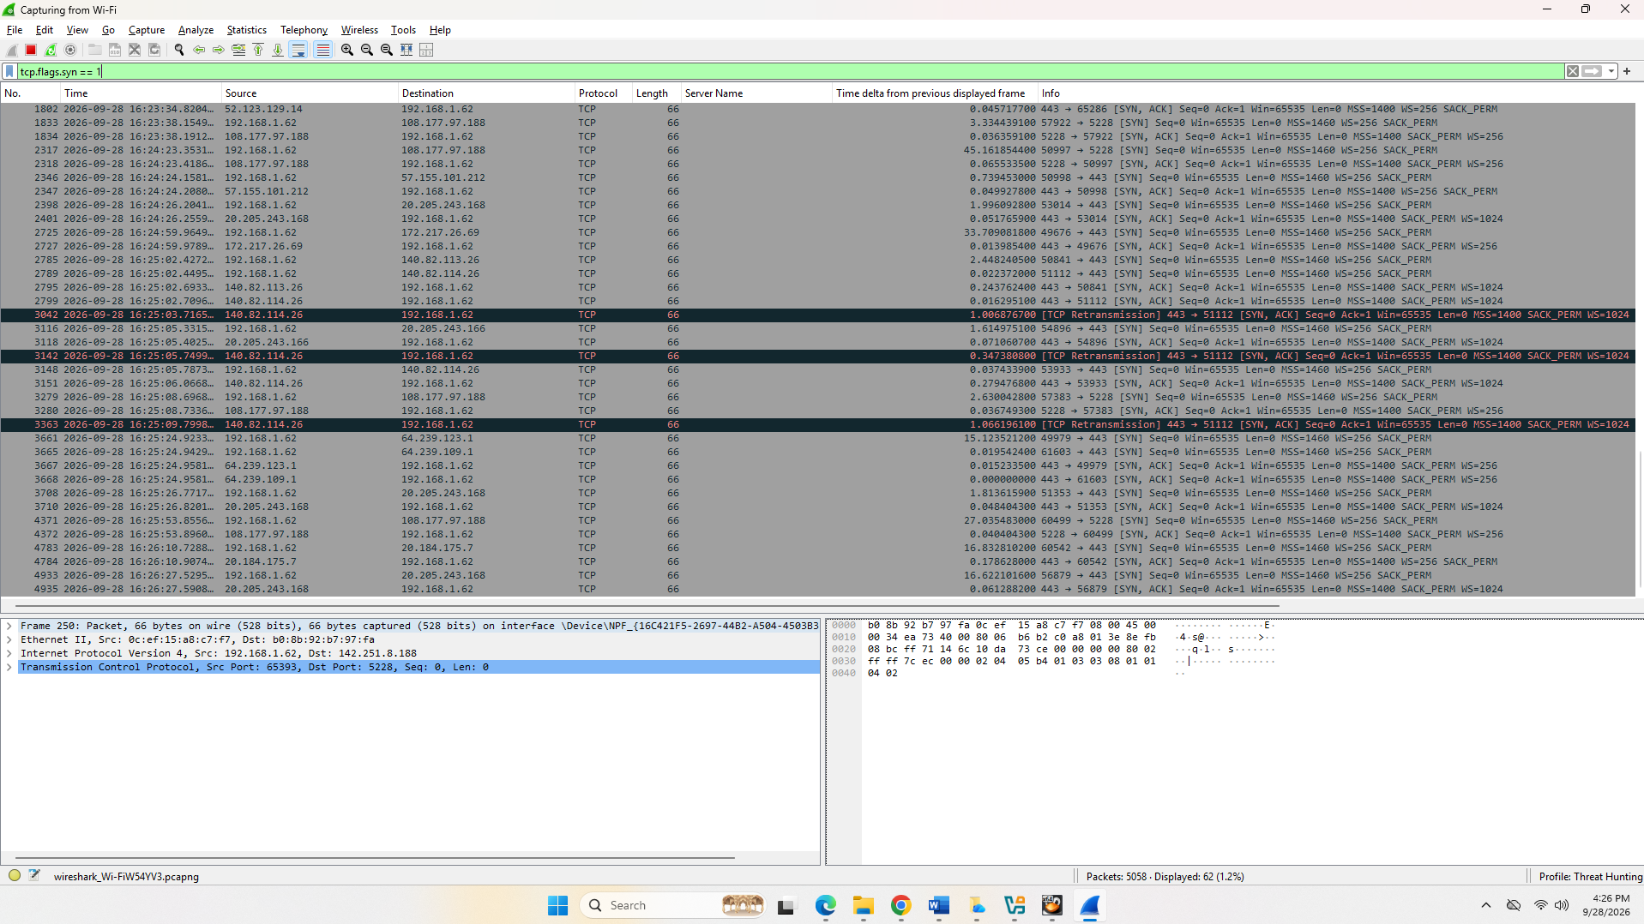

4. NSE Scripting Scavenger Hunt
Introduces the Nmap Scripting Engine (NSE) through guided discovery.
- Assign each student or group a different NSE script category (vuln, discovery, safe, auth)
- Run nmap --script=<category> <target> against Metasploitable and record findings
Deliverable: A 5-minute lightning talk on what their script category revealed
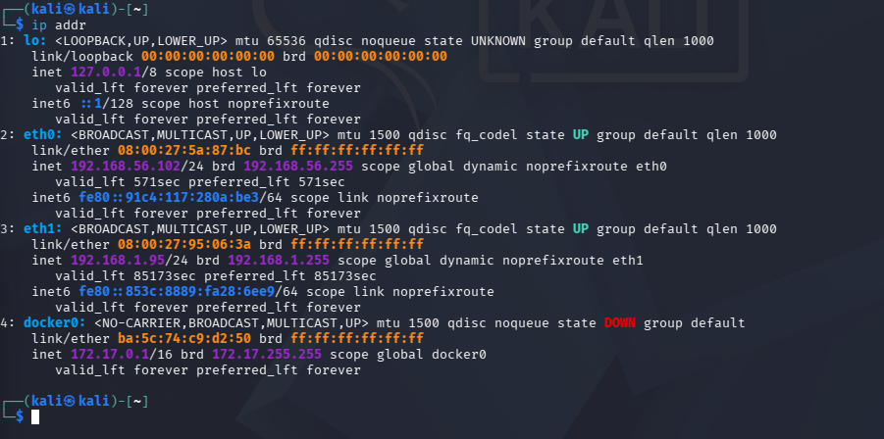step 1
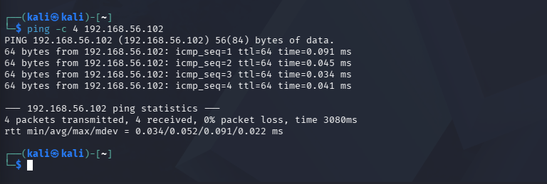step 2
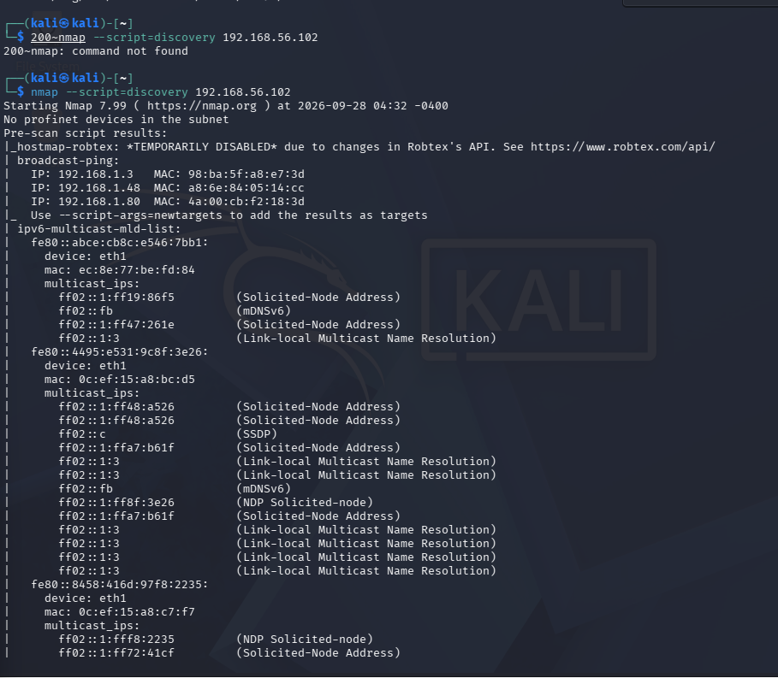step3
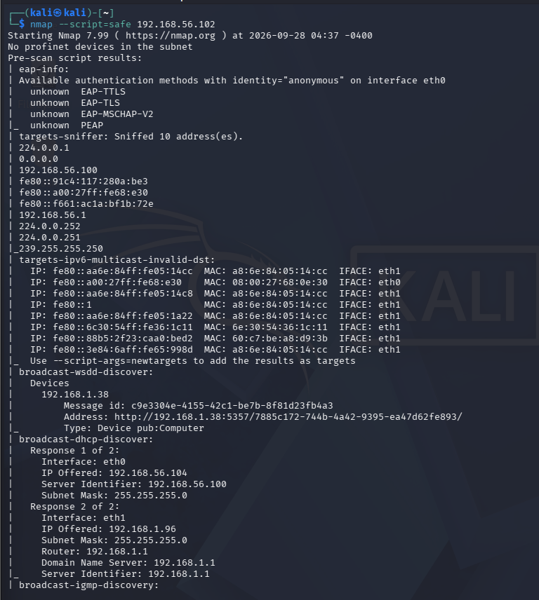
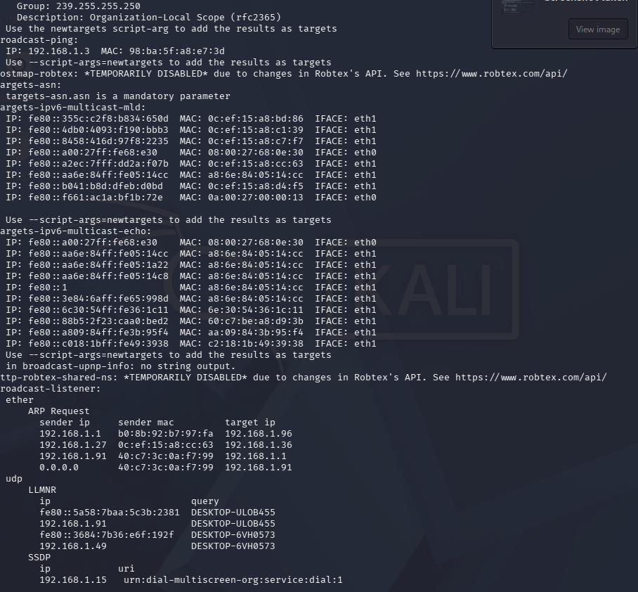4
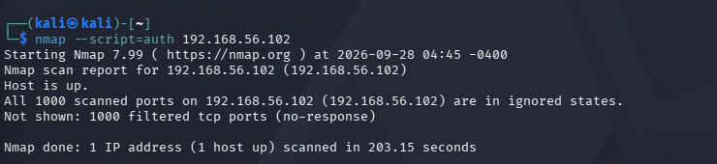
5
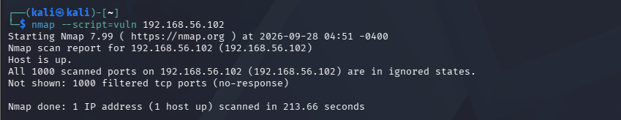

5. TryHackMe / HackTheBox Guided Room
Students complete a beginner Nmap-focused room on a legal, structured training platform.
- TryHackMe's “Nmap” room (part of the free “Pre Security” or “Jr Penetration Tester” path) walks through flags step by step
- Students submit screenshots or flag answers as proof of completion
Deliverable: Completed room plus a reflection paragraph on one new flag they learned.

6. Bonus: Capture the Port (CTF-style)
A timed, competitive exercise to reinforce enumeration skills.
- Set up 2–3 Metasploitable/DVWA VMs on an isolated lab network, each with a different open service
- Students race to find and report a hidden “flag” service/port on each machine using only Nmap
Deliverable: First team to correctly report all open ports and services wins.
⚠ A NOTE ON SAFE & LEGAL USE
All of these activities should run inside an isolated lab network or a host-only VM setup (VirtualBox/VMware). Never point Nmap at production networks, other students' devices, or the open internet without explicit written authorization. Metasploitable and DVWA are free, purpose-built vulnerable VMs designed exactly for this kind of exercise.

Quick Reference: Activities at a Glance
# | Activity | Core Command | Focus Skill
1 | Home Network Discovery | nmap -sn | Host discovery
2 | Metasploitable Enumeration | nmap -sV -p- | Service & version scanning
3 | Scan Type Comparison | -sS / -sT / -sU | Scan technique trade-offs
4 | NSE Scavenger Hunt | --script=<category> | Scripting engine (NSE)
5 | Guided Online Room | Guided walkthrough | Structured self-paced learning
6 | Capture the Port (CTF) | Full enumeration | Applied / competitive review

