UniSplit — Threat Model

1. What Are We Working On?
UniSplit is a web application that helps college students track and split shared expenses. The system consists of four main components: a browser-based frontend (HTML/JavaScript), a Flask REST API backend, a MySQL/SQLite database, and optional third-party payment integration (Venmo/Zelle).

System Components
Component | Description | Trust Level | Data Handled
User (Browser) | College student accessing via web browser | External / Untrusted | Credentials, expense inputs
Frontend (HTML/JS) | Static HTML pages with JS fetch calls to the API | Low trust | Rendered expense data, tokens
Flask API Backend | REST API for auth, groups, expenses, balances | Trusted | All user and financial data
Database (MySQL/SQLite) | Persistent storage for all application data | Highly trusted | Users, groups, expenses, hashed passwords
Payment Service | Venmo/Zelle for settling debts (planned) | External / Untrusted | Settlement amounts

Data Flow Diagram (DFD)
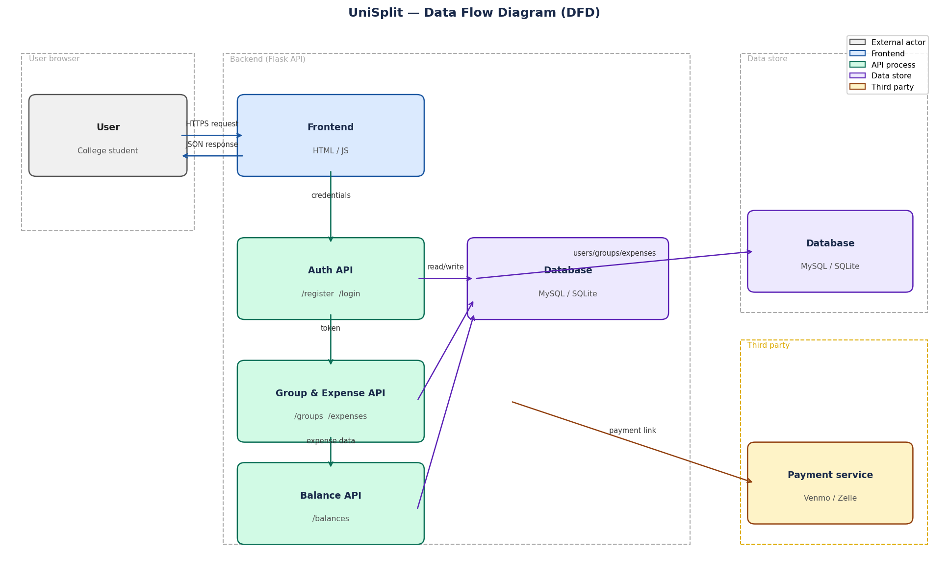
Figure 1: UniSplit Data Flow Diagram showing trust boundaries and data flows between components.

Trust Boundaries
- Browser boundary: User input is untrusted; all data must be validated server-side.
- Frontend/Backend boundary: Network boundary; all API calls must be authenticated.
- Backend/Database boundary: Trusted but protected from SQL injection via ORM.
- Backend/Payment Service boundary: External third-party; all communication is untrusted.

2. What Can Go Wrong? (STRIDE Analysis)
The following table identifies 12 threats across all six STRIDE categories. Each threat is mapped to a specific component and describes the actor, attack vector, and potential impact.

# | Category | Component | Threat | Actor | Attack | Impact
1 | Spoofing | Auth API | Credential spoofing | Attacker | Submits forged email/password to /api/login | Gains unauthorized access to another user's account
2 | Spoofing | Frontend | Session hijacking | Attacker | Steals localStorage token via XSS attack | Impersonates a legitimate user
3 | Tampering | Expense API | Expense data tampering | Malicious user | Modifies amount or paid_by field in POST body | Falsifies expense records
4 | Tampering | Database | Direct DB manipulation | Insider | Directly edits rows in the expenses table | Corrupts financial records
5 | Repudiation | Activity Log | Denial of actions | Dishonest user | Claims they never added an expense | Disputes cannot be resolved without audit log
6 | Repudiation | Auth API | Fake registration | Attacker | Registers with someone else's email address | Victim cannot register; attacker controls account
7 | Info Disclosure | Database | Password leak | Attacker | Reads database file if server is compromised | Exposes user credentials
8 | Info Disclosure | API Response | Over-fetching data | Attacker | Calls /api/groups/<id> for groups they don't belong to | Views other users' financial data
9 | Info Disclosure | Frontend | Sensitive data in JS | Attacker | Inspects localStorage or JS source code | Exposes user ID or session token
10 | Denial of Service | Flask API | Request flooding | Attacker | Sends thousands of POST /api/register requests | Server overloaded; legitimate users cannot access app
11 | Denial of Service | Database | Large payload injection | Attacker | Sends very large description field to /api/expenses | Exhausts DB storage or causes timeouts
12 | Elevation of Privilege | Group API | Unauthorized admin action | Regular member | Calls admin-only endpoint without role check | Gains admin control over a group

3. What Are We Going to Do About It?
The following mitigations address each identified threat. Status reflects the current implementation state.

# | Threat | Mitigation | Status
1 | Credential spoofing | Implement rate limiting on /api/login. Lock account after 5 failed attempts. Consider CAPTCHA for suspicious IPs. | Planned
2 | Session hijacking | Use HTTP-only cookies instead of localStorage for session tokens. Implement Content Security Policy (CSP) headers. | Planned
3 | Expense data tampering | Add server-side validation for all input fields. Verify user is a group member before writing any expense data. | Partially done
4 | Direct DB manipulation | Restrict database access to the API process only. Enable audit logging at the database server level. | Planned
5 | Denial of actions | activity_log table already records all actions with user_id and timestamp. Restrict DELETE access to prevent log tampering. | Implemented
6 | Fake registration | Send email verification link before activating an account. Only allow login after email is verified. | Planned
7 | Password leak | Passwords are hashed with bcrypt (already implemented). Restrict DB file permissions. Consider field-level encryption for PII. | Implemented
8 | Over-fetching data | Add authorization check on every API endpoint: verify the requesting user is a member of the target group. | Planned
9 | Sensitive data in JS | Move session tokens to HTTP-only cookies. Never store sensitive data in localStorage. | Planned
10 | Request flooding | Add Flask-Limiter middleware for rate limiting. Deploy behind a reverse proxy (nginx) with request throttling. | Planned
11 | Large payload injection | Enforce max field length in API validation (e.g., description <= 255 chars). Already enforced at DB schema level. | Partially done
12 | Unauthorized admin action | Check user role from group_members table before processing any admin-level API call (e.g., remove member). | Planned

4. Did We Do a Good Job?
Self-review using the threat modeling checklist provided in the assignment.

"What are we working on?" review
Question | Answer
Can we see where all the data goes and who uses it? | Yes. The DFD shows all data flows between User, Frontend, API processes, Database, and Payment Service.
Do we see the processes that move data from one data store to another? | Yes. Auth, Group/Expense, and Balance API processes are shown with read/write flows to the database.
Does the diagram show all trust boundaries? | Yes. Four trust boundaries are marked: User browser, Backend API, Data store, and Third-party payment.
Can we see where the software makes a security decision? | Yes. Security decisions occur at the Auth API and at each API endpoint where authorization is enforced.
Does the diagram reflect current or planned reality? | Yes. It reflects the current implemented state plus the planned Venmo/Zelle payment integration.

"What can go wrong?" review
Question | Answer
Have we looked at each element of the diagram? | Yes. All five components were analyzed: User, Frontend, Auth API, Group/Expense API, Balance API, Database, and Payment Service.
Have we looked for each of the STRIDE threats? | Yes. All six categories covered: Spoofing (2), Tampering (2), Repudiation (2), Info Disclosure (3), DoS (2), Elevation of Privilege (1).
For each threat, can we describe the actor, attack, and impact? | Yes. Each of the 12 threats in the table identifies the actor, attack vector, and impact.

"What are we going to do about it?" review
Question | Answer
Is there a proposed/planned/implemented mitigation for each threat? | Yes. All 12 threats have a mitigation. 2 are implemented (bcrypt, activity_log), 2 are partially done, and 8 are planned.
Are there test cases we should write? | Yes: login rate limiting, authorization checks on group endpoints, input length validation, and role-based access control for admin actions.

