Chapter 1 Introduction of Chemistry and Matter (Bonding & Crystalline Q&A)

- Which of the following has eight valence electrons?
A) Ti⁴⁺
B) Kr
C) Cl⁻
D) Na⁺
E) all of the above

- Which of the following does not have eight valence electrons?
A) Ca⁺
B) Rb⁺
C) Xe
D) Br⁻
E) All of the above have eight valence electrons.

- Lattice energy is ________.
A) the energy required to convert a mole of ionic solid into its constituent ions in the gas phase
B) the energy given off when gaseous ions combine to form one mole of an ionic solid
C) the energy required to produce one mole of an ionic compound from its constituent elements in their standard states
D) the sum of ionization energies of the components in an ionic solid
E) the sum of electron affinities of the components in an ionic solid

- In ionic bond formation, the lattice energy of ions ________ as the magnitude of the ion charges _______ and the radii ________.
A) increases, decrease, increase
B) increases, increase, increase
C) decreases, increase, increase
D) increases, increase, decrease
E) increases, decrease, decrease

- The ability of an atom in a molecule to attract electrons is best quantified by the ________.
A) paramagnetism
B) diamagnetism
C) electronegativity
D) electron charge-to-mass ratio
E) first ionization potential

- In the nitrite ion (NO₂), ________.
A) both bonds are single bonds
B) both bonds are double bonds
C) one bond is a double bond and the other is a single bond
D) both bonds are the same
E) there are 20 valence electrons

- The oxidation number of iron in Fe₂O₃ is ________.
A) -2
B) +1
C) +3
D) +2
E) -3
- The Lewis structure of the CO32- ion is ________.
A)
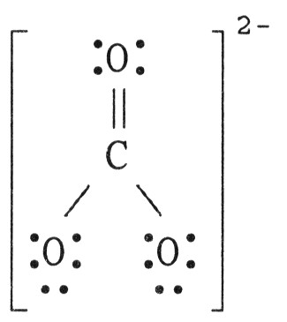
B)
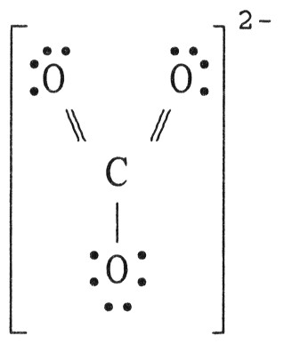

C)
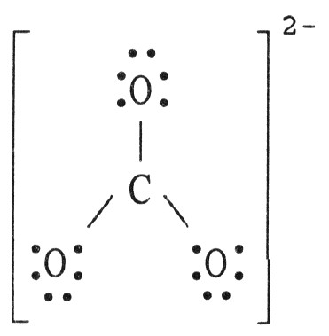
D)
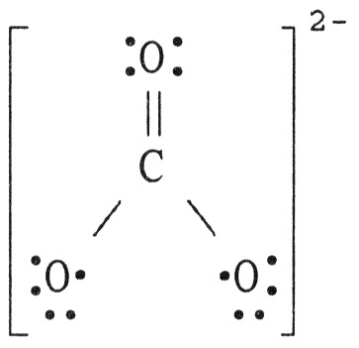
E)
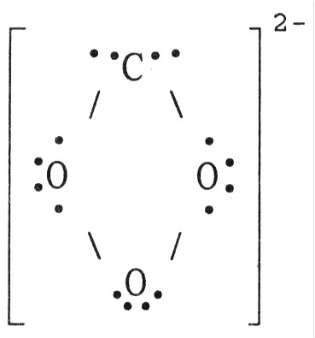

- Bond enthalpy is ________.
A) always positive
B) always negative
C) sometimes positive, sometimes negative
D) always zero
E) unpredictable

- Of the bonds C-C, C=C, and C≡C, the C-C bond is ________.
A) strongest/shortest
B) strongest/longest
C) weakest/longest
D) weakest/shortest
E) intermediate in both strength and length

- As the number of covalent bonds between two atoms increases, the distance between the atoms ________ and the strength of the bond between them ________.
A) increases, increases
B) decreases, decreases
C) increases, decreases
D) decreases, increases
E) is unpredictable

- Based on the octet rule, magnesium most likely forms a ________ ion.
A) Mg²⁺
B) Mg²⁻
C) Mg⁶⁻
D) Mg⁶⁺
E) Mg⁻

- Based on the octet rule, aluminum most likely forms an ________ ion.
A) Al³⁺
B) Al⁴⁺
C) Al⁴⁻
D) Al⁺
E) Al⁻

- For a given arrangement of ions, the lattice energy increases as ionic radius ________ and as ionic charge ________.
A) decreases, increases
B) increases, decreases
C) increases, increases
D) decreases, decreases
E) This cannot be predicted.

- Elements from opposite sides of the periodic table tend to form ________.
A) covalent compounds
B) ionic compounds
C) compounds that are gaseous at room temperature
D) homonuclear diatomic compounds
E) covalent compounds that are gaseous at room temperature

- A ________ covalent bond between the same two atoms is the longest.
A) single
B) double
C) triple
D) strong
E) They are all the same length.
- A double bond consists of ________ pairs of electrons shared between two atoms.
A) 1
B) 2
C) 3
D) 4
E) 6

- What is the maximum number of double bonds that a hydrogen atom can form?
A) 0
B) 1
C) 2
D) 3
E) 4

- Electronegativity ________ from left to right within a period and ________ from top to bottom within a group.
A) decreases, increases
B) increases, increases
C) increases, decreases
D) stays the same, increases
E) increases, stays the same

- The formal charge on carbon in the molecule below is ________.
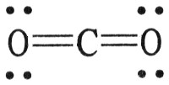
A) 0
B) +1
C) +2
D) +3
E) -1

- There are ________ unpaired electrons in the Lewis symbol for an oxygen atom.
A) 0
B) 1
C) 2
D) 4
E) 3

- The oxide of which of the following metals should have the greatest lattice energy?
A) calcium
B) strontium
C) magnesium
D) beryllium
E) barium

- How many single covalent bonds must a chlorine atom form to have a complete octet in its valence shell?
A) 0
B) 1
C) 2
D) 3
E) 4

- Of the atoms below, ________ is the most electronegative.
A) Ba
B) Sr
C) Ca
D) Mg
E) Be

- The oxidation number of phosphorus in PF₅ is ________.
A) +5
B) +3
C) +1
D) -5
E) 0

- The basis of the VSEPR model of molecular bonding is ________.
A) regions of electron density on an atom will organize themselves so as to maximize s-character
B) regions of electron density in the valence shell of an atom will arrange themselves so as to maximize overlap
C) atomic orbitals of the bonding atoms must overlap for a bond to form
D) electron domains in the valence shell of an atom will arrange themselves so as to minimize repulsions
E) hybrid orbitals will form as necessary to, as closely as possible, achieve spherical symmetry

- An electron domain consists of ________.
a) a nonbonding pair of electrons
b) a single bond
c) a multiple bond
A) a only
B) b only
C) c only
D) a, b, and c
E) b and c

- The molecular geometry consists of ________.
a) a nonbonding pair of electrons
b) a single bond
c) a multiple bond
A) a only
B) b only
C) c only
D) a, b, and c
E) b and c

- A molecule has the formula AB₃ and the central atom is in a different plane from the surrounding three atoms. Its molecular shape is ________.
A) tetrahedral
B) trigonal pyramidal
C) linear
D) T-shaped
E) bent

- The molecular geometry of the PF₃ molecule is ________, and this molecule is ________.
A) trigonal planar, polar
B) trigonal planar, nonpolar
C) trigonal pyramidal, polar
D) trigonal pyramidal, nonpolar
E) tetrahedral, unipolar

- For molecules with only one central atom, how many lone pairs on the central atom guarantees molecular polarity?
A) 1
B) 2
C) 1 or 2
D) 3
E) 1 or 3

- The sp² atomic hybrid orbital set accommodates ________ electron domains.
A) 2
B) 3
C) 4
D) 5
E) 6

- The hybridization scheme for BeF₂ is ________.
A) sp
B) sp²
C) sp³
D) sp³d
E) sp³d²

- When four atomic orbitals are mixed to form hybrid orbitals, how many hybrid orbitals are formed?
A) one
B) six
C) three
D) four
E) five

- Valence bond theory does not address the issue of ________.
A) excited states of molecules
B) molecular shape
C) covalent bonding
D) hybridization
E) multiple bonds

- A typical double bond ________.
A) is stronger and shorter than a single bond
B) consists of one σ bond and one π bond
C) imparts rigidity to a molecule
D) consists of two shared electron pairs
E) All of the above answers are correct.

- Electrons in ________ bonds remain localized between two atoms. Electrons in ________ bonds can become delocalized between more than two atoms.
A) pi, sigma
B) sigma, pi
C) pi, pi
D) sigma, sigma
E) ionic, sigma

- The bond order of any molecule containing equal numbers of bonding and antibonding electrons is ________.
A) 0
B) 1
C) 2
D) 3
E) 1/2
- In comparing the same two atoms bonded together, the ________ the bond order, the ________ the bond length, and the ________ the bond energy.
A) greater, shorter, greater
B) greater, greater, greater
C) greater, longer, greater
D) smaller, longer, smaller
E) smaller, greater, greater

- Based on molecular orbital theory, there is/are ________ unpaired electron(s) in the OF⁺ ion.
A) 0
B) 3
C) 1
D) 2
E) 1/2

- For a molecule with the formula AB₂, the molecular shape is ________.
A) linear or bent
B) linear or trigonal planar
C) linear or T-shaped
D) T-shaped
E) trigonal planar

- The molecular geometry of the CHCl₃ molecule is ________.
A) bent
B) trigonal planar
C) trigonal pyramidal
D) tetrahedral
E) T-shaped

- The O-S-O bond angle in SO₂ is slightly less than ________.
A) 90°
B) 109.5°
C) 120°
D) 180°
E) 60°

- The hybridization of orbitals on the central atom in a molecule is sp. The electron-domain geometry around this central atom is ________.
A) octahedral
B) linear
C) trigonal planar
D) trigonal bipyramidal
E) tetrahedral
- ClF₃ has "T-shaped" geometry. There is/are ________ non-bonding domain(s) in this molecule.
A) 4
B) 2
C) 3
D) 1
E) 0

- The H-C-H bond angle in the CH₄ ion is approximately ________.
A) 180°
B) 120°
C) 109.5°
D) 60°
E) 90°

- The central atom in the ICl₄⁻ ion has ________ nonbonded electron pair(s) and ________ bonded electron pair(s) in its valence shell.
A) 4, 2
B) 0, 4
C) 2, 4
D) 2, 2
E) 6, 0

- The central atom in the O₃ molecule has ________ nonbonded electron pair(s) and ________ bonded electron pair(s) in its valence shell.
A) 6, 2
B) 1, 3
C) 2, 2
D) 3, 1
E) 3, 2
- According to VSEPR theory, if there are three electron domains in the valence shell of an atom, they will be arranged in a(n) ________ geometry.
A) tetrahedral
B) octahedral
C) linear
D) square planar
E) bent
- Using the VSEPR model, the electron-domain geometry of the central atom in XeF₄ is ________.
A) linear
B) trigonal planar
C) tetrahedral
D) trigonal bipyramidal
E) octahedral

- Crystalline solids ________.
A) have their particles arranged randomly
B) have highly ordered structures
C) are usually very soft
D) exist only at high temperatures
E) exist only at very low temperatures

- In liquids, the attractive intermolecular forces are ________.
A) very weak compared with kinetic energies of the molecules
B) strong enough to hold molecules relatively close together
C) strong enough to keep the molecules confined to vibrating about their fixed lattice points
D) not strong enough to keep molecules from moving past each other
E) strong enough to hold molecules relatively close together but not strong enough to keep molecules from moving past each other

- A gas is ________ and assumes ________ of its container, whereas a liquid is ________ and assumes ________ of its container.
A) compressible, the volume and shape, not compressible, the shape of a portion
B) compressible, the shape, not compressible, the volume and shape
C) compressible, the volume and shape, compressible, the volume
D) condensed, the volume and shape, condensed, the volume and shape
E) condensed, the shape, compressible, the volume and shape

- Which statement is true about liquids but not true about solids?
A) They flow and are highly ordered.
B) They are highly ordered and not compressible.
C) They flow and are compressible.
D) They assume both the volume and the shape of their containers.
E) They flow and are not compressible.

- The ease with which the charge distribution in a molecule can be distorted by an external electrical field is called the ________.
A) electronegativity
B) hydrogen bonding
C) polarizability
D) volatility
E) viscosity

- Hydrogen bonding is a special case of ________.
A) London-dispersion forces
B) ion-dipole attraction
C) dipole-dipole attractions
D) ion-ion interactions
E) none of the above

- What intermolecular force is responsible for the fact that ice is less dense than liquid water?
A) London dispersion forces
B) dipole-dipole forces
C) ion-dipole forces
D) hydrogen bonding
E) ionic bonding

- Which statements about viscosity are true?
(i) Viscosity increases as temperature decreases.
(ii) Viscosity increases as molecular weight increases.
(iii) Viscosity increases as intermolecular forces increase.
A) (i) only
B) (ii) and (iii)
C) (i) and (iii)
D) none
E) all

- Viscosity is ________.
A) the "skin" on a liquid surface caused by intermolecular attraction
B) the resistance to flow
C) the same as density
D) inversely proportional to molar mass
E) unaffected by temperature

- Large intermolecular forces in a substance are manifested by ________.
A) low vapor pressure
B) high boiling point
C) high heats of fusion and vaporization
D) high critical temperatures and pressures
E) all of the above

- Of the following, ________ is an exothermic process.
A) melting
B) subliming
C) freezing
D) boiling
E) All of the above are exothermic.

- A volatile liquid is one that ________.
A) is highly flammable
B) is highly viscous
C) is highly hydrogen-bonded
D) is highly cohesive
E) readily evaporates

- In general, the vapor pressure of a substance increases as ________ increases.
A) surface tension
B) molecular weight
C) hydrogen bonding
D) viscosity
E) temperature

- Volatility and vapor pressure are ________.
A) inversely proportional to one another
B) directly proportional to one another
C) not related
D) the same thing
E) both independent of temperature

- Which one of the following should have the lowest boiling point?
A) CH₄
B) PCl₃
C) C₂H₅COOH
D) LiCl
E) Cl₂S

- Of the following substances, ________ has the highest boiling point.
A) H₂O
B) SiH₄
C) Ar
D) Cl₂
E) BF₃

- What is the predominant intermolecular force in HCN?
A) dipole-dipole attraction
B) ion-dipole attraction
C) ionic bonding
D) hydrogen bonding
E) London dispersion forces

- Ethanol melts at -114 °C and boils at 78 °C at a constant pressure of 1 atm. What state of matter must a sample of ethanol be in at 0 °C and 1 atm?
A) liquid
B) gas
C) solid
D) solid and liquid in equilibrium
E) liquid and gas in equilibrium

- Of the following, ________ is the least volatile.
A) CI₄
B) CF₄
C) CBr₄
D) CCl₄
E) CH₄

- A solid has a very high melting point, great hardness, and poor electrical conduction. This is a(n) ________ solid.
A) ionic
B) molecular
C) metallic
D) covalent network
E) metallic and covalent network

- Which of the following is not a type of solid?
A) ionic
B) molecular
C) supercritical
D) metallic
E) covalent network

- Crystalline solids differ from amorphous solids in that crystalline solids have ________.
A) appreciable intermolecular attractive forces
B) a long-range repeating pattern of atoms, molecules, or ions
C) atoms, molecules, or ions that are close together
D) much larger atoms, molecules, or ions
E) no orderly structure

- The unit cell with all sides the same length and all angles equal to 90° that has lattice points only at the corners is called ________.
A) monoclinic
B) body-centered cubic
C) primitive cubic
D) face-centered cubic
E) spherical cubic

- What fraction of the volume of each corner atom is actually within the volume of a face-centered cubic unit cell?
A) 1
B) 1/2
C) 1/4
D) 1/8
E) 1/16

- What portion of the volume of each atom or ion on the face of a unit cell is actually within the unit cell?
A) 1/2
B) 1/4
C) 3/4
D) all of it
E) none of it

- An alloy is a
A) heterogeneous mixture of two metals.
B) pure metal.
C) metallic material that is composed of two or more elements.
D) nonmetal with some properties of a metal.
E) mineral containing two or more metals.

- Which one of the following is a property of most metals?
A) low melting point
B) brittleness
C) high electronegativity
D) thermal conductivity
E) acidic oxides

- Which statement about steel is false?
A) It is a polymer.
B) It is an alloy of iron.
C) It can have different percentages of carbon.
D) It can be made so it resists rust.
E) none of the above

- What is the typical effect of the addition of an interstitial element on the properties of a metal?
A) increase in malleability and corrosion resistance
B) increase in hardness and strength, decrease in ductility
C) decrease in melting point and increase in ductility
D) decrease in conductivity and increase in brittleness
E) increased surface luster

- Alloys generally differ from compounds in that
A) the former always contain some carbon.
B) the former always contain some iron.
C) the former always have semiconductor properties.
D) the atomic ratios of the constituent elements in the former are not fixed and may vary over a wide range.
E) the former never contain a transition element.

- Metallic solids do not exhibit ________.
A) excellent thermal conductivity
B) excellent electrical conductivity
C) variable hardness
D) extreme brittleness
E) variable melting point

- Which of the following is not a natural polymer?
A) silk
B) starch
C) protein
D) cellulose
E) nylon

- As a polymer becomes more crystalline, ________.
A) its melting point decreases
B) its density decreases
C) its stiffness decreases
D) its yield stress decreases
E) None of the above is correct.

- ________ solids consist of atoms or molecules held together by dipole-dipole forces, London dispersion forces, and/or hydrogen bonds.
A) Ionic
B) Molecular
C) Metallic
D) Covalent-network
E) Metallic and covalent-network

- Blue LEDs are usually made of ________.
A) GaAs
B) GaP
C) GaO
D) GaS
E) GaN

- CsCl crystallizes in a unit cell that contains a Cs⁺ ion at the center of a cube and a Cl⁻ ion at each corner. The unit cell of CsCl is ________.
A) close packed
B) body-centered cubic
C) face-centered cubic
D) amorphous
E) primitive cubic

- The ________ lattice is one of the five two-dimensional lattices in which the lattice vectors a and b are equal and the γ angle between them is 90°.
A) square
B) rectangular
C) hexagonal
D) rhombic
E) oblique

- The ________ lattice is one of the seven primitive three-dimensional lattices in which the relationship between the lattice vectors a, b, and c can be written as: a ≠ b ≠ c
A) monoclinic
B) hexagonal
C) rhombohedral
D) tetragonal
E) cubic

- Which of the following is not an alloy?
A) elemental gold
B) sterling silver
C) 18-karat gold
D) dental amalgam
E) bronze

- Of the following, only ________ is not a polymer.
A) dental amalgam
B) cellulose
C) Teflon
D) plastic
E) protein

- The correct abbreviation for the polymer low-density polyethylene is ________.
A) LDPE
B) PP
C) P
D) PETE
E) HDPE

- Which element is typically not added to steel to modify its properties?
A) carbon
B) vanadium
C) chromium
D) nitrogen
E) nickel

- Which property of metals cannot be explained with the electron-sea model?
A) shine
B) high thermal conductivity
C) high electric conductivity
D) malleability and ductility
E) trends in melting points

- NaCl crystallizes in a face-centered cubic cell. What is the total number of ions (Na⁺ ions and Cl⁻ ions) that lie within a unit cell of NaCl?
A) 2
B) 4
C) 8
D) 6
E) 5

- An ionic solid, NaCl (s), dissolves in water because of the ________.
A) relatively low lattice energy due to small charges of Na⁺ and Cl⁻ ions
B) simple face-centered cubic unit cell type it forms
C) 1:1 ratio of ions in the unit cell
D) strong coulombic interactions between oppositely charged ions
E) relatively low melting point

- CsCl crystallizes in a unit cell that contains the Cs⁺ ion at the center of a cube that has a Cl⁻ at each corner. Each unit cell contains ________ Cs⁺ ion(s) and ________ Cl⁻ ion(s), respectively.
A) 1 and 8
B) 2 and 1
C) 1 and 1
D) 2 and 2
E) 2 and 4

- Inorganic compounds that are semiconductors have an average of ________ valence electrons.
A) 1
B) 2
C) 3
D) 4
E) 5

- An elastomer will fail to regain its original dimensions following a distortion beyond its ________.
A) glass transition
B) phase boundary
C) London force
D) crystallinity
E) elastic limit

- The formation of a condensation polymer generally involves ________.
A) the addition of a plasticizer
B) the mixing of sulfur with an addition polymer
C) the elimination of a small molecule
D) the vaporization of a plasticizer
E) the formation of significant crosslinking

- The properties of graphene include ________.
A) high strength
B) low thermal conductivity
C) a zero energy gap
D) A and C
E) A, B and C

