Chapter 2 Thermodynamics (Questions)

- Objects can possess energy as ________.
(a) endothermic energy
(b) potential energy
(c) kinetic energy
A) a only
B) b only
C) c only
D) a and c
E) b and c

- The internal energy of a system is always increased by ________.
A) adding heat to the system
B) having the system do work on the surroundings
C) withdrawing heat from the system
D) adding heat to the system and having the system do work on the surroundings
E) a volume compression

- The internal energy of a system ________.
A) is the sum of the kinetic energy of all of its components
B) is the sum of the rotational, vibrational, and translational energies of all of its components
C) refers only to the energies of the nuclei of the atoms of the component molecules
D) is the sum of the potential and kinetic energies of the components
E) none of the above

- Which one of the following conditions would always result in an increase in the internal energy of a system?
A) The system loses heat and does work on the surroundings.
B) The system gains heat and does work on the surroundings.
C) The system loses heat and has work done on it by the surroundings.
D) The system gains heat and has work done on it by the surroundings.
E) None of the above is correct.

- When a system ________, ΔE is always negative.
A) absorbs heat and does work
B) gives off heat and does work
C) absorbs heat and has work done on it
D) gives off heat and has work done on it
E) None of the above is always negative.

- Which one of the following is an endothermic process?
A) ice melting
B) water freezing
C) boiling soup
D) Hydrochloric acid and barium hydroxide are mixed at 25 °C: the temperature increases.
E) Both A and C

- Which one of the following is an exothermic process?
A) ice melting
B) water evaporating
C) boiling soup
D) condensation of water vapor
E) Ammonium thiocyanate and barium hydroxide are mixed at 25 °C: the temperature drops.

- Which of the following is a statement of the first law of thermodynamics?
A) Ek = 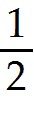m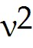
B) A negative ΔH corresponds to an exothermic process.
C) ΔE = Efinal - Einitial
D) Energy lost by the system must be gained by the surroundings.
E) 1 cal = 4.184 J (exactly)

- A ________ ΔH corresponds to an ________ process.
A) negative, endothermic
B) negative, exothermic
C) positive, exothermic
D) zero, exothermic
E) zero, endothermic

- ΔH for an endothermic process is ________ while ΔH for an exothermic process is ________.
A) zero, positive
B) zero, negative
C) positive, zero
D) negative, positive
E) positive, negative

- A chemical reaction that absorbs heat from the surroundings is said to be ________ and has a ________ ΔH at constant pressure.
A) endothermic, positive
B) endothermic, negative
C) exothermic, negative
D) exothermic, positive
E) exothermic, neutral

- The reaction
4Al (s) + 3O2 (g) → 2Al2O3 (s) ΔH° = -3351 kJ
is ________, and therefore heat is ________ by the reaction.
A) endothermic, released
B) endothermic, absorbed
C) exothermic, released
D) exothermic, absorbed
E) thermoneutral, neither released nor absorbed

- Under what condition(s) is the enthalpy change of a process equal to the amount of heat transferred into or out of the system?
(a) temperature is constant
(b) pressure is constant
(c) volume is constant
A) a only
B) b only
C) c only
D) a and b
E) b and c

- Which of the following is a statement of Hess's law?
A) If a reaction is carried out in a series of steps, the ΔH for the reaction will equal the sum of the enthalpy changes for the individual steps.
B) If a reaction is carried out in a series of steps, the ΔH for the reaction will equal the product of the enthalpy changes for the individual steps.
C) The ΔH for a process in the forward direction is equal in magnitude and opposite in sign to the ΔH for the process in the reverse direction.
D) The ΔH for a process in the forward direction is equal to the ΔH for the process in the reverse direction.
E) The ΔH of a reaction depends on the physical states of the reactants and products.

- Consider the following two reactions:
A → 2B ΔH°rxn = 456.7 kJ/mol
A → C ΔH°rxn = -22.1 kJ/mol
Determine the enthalpy change for the process:
2B → C
A) -478.8 kJ/mol
B) -434.6 kJ/mol
C) 434.6 kJ/mol
D) 478.8 kJ/mol
E) More information is needed to solve the problem.

- With reference to enthalpy changes, the term standard conditions means ________.
(a) P = 1 atm
(b) some common temperature, usually 298 K
(c) V = 1 L
A) a only
B) b only
C) c only
D) a and c
E) a and b

- The ΔE of a system that releases 12.4 J of heat and does 4.2 J of work on the surroundings is ________ J.
A) 16.6
B) 12.4
C) 4.2
D) -16.6
E) -8.2
- The enthalpy change for the following reaction is -483.6 kJ:
2H2 (g) + O2 (g) → 2H2O (g)
Therefore, the enthalpy change for the following reaction is ________ kJ.
4H2 (g) + 2O2 (g) → 4H2O (g)
A) -483.6
B) -967.2
C) 2.34 × 105
D) 483.6
E) 967.2

- ΔH for the reaction
IF5 (g) → IF3 (g) + F2 (g)
is ________ kJ, give the data below.
IF (g) + F2 (g) → IF3 (g) ΔH = -390 kJ
IF (g) + 2F2 (g) → IF5 (g) ΔH = -745 kJ
A) +355
B) -1135
C) +1135
D) +35
E) -35

- Given the following reactions
Fe2O3 (s) + 3CO (s) → 2Fe (s) + 3CO2 (g) ΔH = -28.0 kJ
3Fe (s) + 4CO2 (s) → 4CO (g) + Fe3O4 (s) ΔH = +12.5 kJ
the enthalpy of the reaction of Fe2O3 with CO
3Fe2O3 (s) + CO (g) → CO2 (g) + 2 Fe3O4 (s)
is ________ kJ.
A) -59.0
B) 40.5
C) -15.5
D) -109
E) +109
- Given the following reactions
N2 (g) + 2O2 (g) → 2NO2 (g) ΔH = 66.4 kJ
2NO (g) + O2 (g) → 2NO2 (g) ΔH = -114.2 kJ
the enthalpy of the reaction of the nitrogen to produce nitric oxide
N2 (g) + O2 (g) → 2NO (g)
is ________ kJ.
A) 180.6
B) -47.8
C) 47.8
D) 90.3
E) -180.6

- The value of ΔH° for the following reaction is -3351 kJ:
2Al (s) + 3O2 (g) → 2Al2O3 (s)
The value of ΔH°f for Al2O3 (s) is ________ kJ.
A) -3351
B) -1676
C) -32.86
D) -16.43
E) +3351

- When work is done on a system, w will be a ________ value.
A) positive
B) negative
C) very large
D) very small
E) There is not enough information given to determine the answer.

- The value of ΔE for a system that performs 139 kJ of work on its surroundings and gains 54kJ of heat is ________ kJ.
A) -85
B) 193
C) 7506
D) 85
E) -193

- The temperature of a 24.3 g sample of gold increases from 23.7 °C to 31.5 °C. If the specific heat of gold is 0.129 J/g-K, how many joules of heat are absorbed?
A) 24.5 J
B) 0.0414 J
C) -24.5 J
D) 0.293 J
E) 1.01 J

- The first law of thermodynamics can be given as ________.
A) ΔE = q + w
B) Δ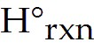 = 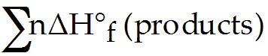 - 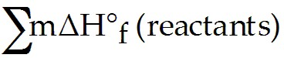
C) for any spontaneous process, the entropy of the universe increases
D) the entropy of a pure crystalline substance at absolute zero is zero
E) ΔS = qrev/T at constant temperature

- A reaction that is spontaneous as written ________.
A) is very rapid
B) will proceed without outside intervention
C) is also spontaneous in the reverse direction
D) has an equilibrium position that lies far to the left
E) is very slow

- When a system is at equilibrium, ________.
A) the reverse process is spontaneous but the forward process is not
B) the forward and the reverse processes are both spontaneous
C) the forward process is spontaneous but the reverse process is not
D) the process is not spontaneous in either direction
E) both forward and reverse processes have stopped

- A reversible process is one that ________.
A) can be reversed with no net change in either system or surroundings
B) happens spontaneously
C) is spontaneous in both directions
D) must be carried out at low temperature
E) must be carried out at high temperature

- Which of the following statements is true?
A) Processes that are spontaneous in one direction are spontaneous in the opposite direction.
B) Processes are spontaneous because they occur at an observable rate.
C) Spontaneity can depend on the temperature.
D) All of the statements are true.

- The thermodynamic quantity that expresses the extent of randomness in a system is ________.
A) enthalpy
B) internal energy
C) bond energy
D) entropy
E) heat flow

- The entropy of the universe is ________.
A) constant
B) continually decreasing
C) continually increasing
D) zero
E) the same as the energy, E

- The second law of thermodynamics states that ________.
A) ΔE = q + w
B) ΔH°rxn = Σ nΔH°f (products) - Σ mΔH°f (reactants)
C) for any spontaneous process, the entropy of the universe increases
D) the entropy of a pure crystalline substance is zero at absolute zero
E) ΔS = qrev/T at constant temperature

- Which one of the following processes produces a decrease of the entropy of the system?
A) dissolving sodium chloride in water
B) sublimation of naphthalene
C) dissolving oxygen in water
D) boiling of alcohol
E) explosion of nitroglycerine

- Consider a pure crystalline solid that is heated from absolute zero to a temperature above the boiling point of the liquid. Which of the following processes produces the greatest increase in the entropy of the substance?
A) melting the solid
B) heating the liquid
C) heating the gas
D) heating the solid
E) vaporizing the liquid

- ΔS is positive for the reaction ________.
A) CaO (s) + CO2 (g) → CaCO3 (s)
B) N2 (g) + 3H2 (g) → 2NH3 (g)
C) 2SO3 (g) → 2SO2 (g) + O2 (g)
D) Ag+ (aq) + Cl- (aq) → AgCl (s)
E) H2O (l) → H2O (s)

- Which reaction produces a decrease in the entropy of the system?
A) CaCO3 (s) → CaO (s) + CO2 (g)
B) 2C (s) + O2 (g) → 2CO (g)
C) CO2 (s) → CO2 (g)
D) 2H2 (g) + O2 (g) → 2H2O (l)
E) H2O (l) → H2O (g)

- Which reaction produces an increase in the entropy of the system?
A) Ag+ (aq) + Cl- (aq) → AgCl (s)
B) CO2 (s) → CO2 (g)
C) H2 (g) + Cl2 (g) → 2 HCl (g)
D) N2 (g) + 3 H2 (g) → 2 NH3 (g)
E) H2O (l) → H2O (s)
- The equilibrium position corresponds to which letter on the graph of G vs. f (course of reaction) below?
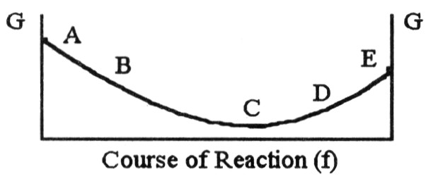
A) A
B) B
C) C
D) D
E) E

- For the reaction
C2H6 (g) → C2H4 (g) + H2 (g)
ΔH° is +137 kJ/mol and ΔS° is +120 J/K ∙ mol. This reaction is ________.
A) spontaneous at all temperatures
B) spontaneous only at high temperature
C) spontaneous only at low temperature
D) nonspontaneous at all temperatures

- For the reaction
2 C4H10 (g) + 13 O2 (g) → 8 CO2 (g) + 10 H2O (g)
ΔH° is -125 kJ/mol and ΔS° is +253 J/K ∙ mol. This reaction is ________.
A) spontaneous at all temperatures
B) spontaneous only at high temperature
C) spontaneous only at low temperature
D) nonspontaneous at all temperatures
E) unable to determine without more information

- A reaction that is not spontaneous at low temperature can become spontaneous at high temperature if ΔH is ________ and ΔS is ________.
A) +, +
B) -, -
C) +, -
D) -, +
E) +, 0

- Given the following table of thermodynamic data,
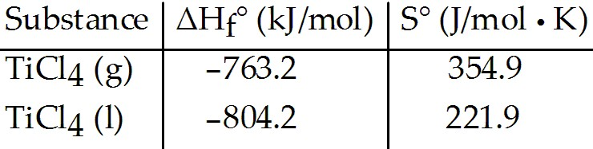
complete the following sentence. The vaporization of TiCl4 is ________.
A) spontaneous at all temperatures
B) spontaneous at low temperature and nonspontaneous at high temperature
C) nonspontaneous at low temperature and spontaneous at high temperature
D) nonspontaneous at all temperatures
E) not enough information given to draw a conclusion

- With thermodynamics, one cannot determine ________.
A) the speed of a reaction
B) the direction of a spontaneous reaction
C) the extent of a reaction
D) the value of the equilibrium constant
E) the temperature at which a reaction will be spontaneous

- Which one of the following statements is true about the equilibrium constant for a reaction if ΔG° for the reaction is negative?
A) K = 0
B) K = 1
C) K > 1
D) K < 1
E) More information is needed.

- Which one of the following processes produces a decrease in the entropy of the system?
A) freezing of Fe(l) into Fe(s)
B) evaporation of liquid ethanol into gaseous ethanol
C) dissolution of LiOH(s) in water
D) melting ice to form water
E) mixing of two gases into one container

- Of the following, the entropy of ________ is the largest.
A) B2F4 (g)
B) BF3 (g)
C) B2H6 (g)
D) BCl3 (l)
E) B2O3 (s)

- The standard Gibbs free energy of formation of ________ is zero.
(a) H2O (l)
(b) Fe (s)
(c) I2 (s)
A) (a) only
B) (b) only
C) (c) only
D) (b) and (c)
E) (a), (b), and (c)

- Given the thermodynamic data in the table below, calculate the equilibrium constant (at 298 K) for the reaction:
2 SO2 (g) + O2 (g) 2 SO3 (g)
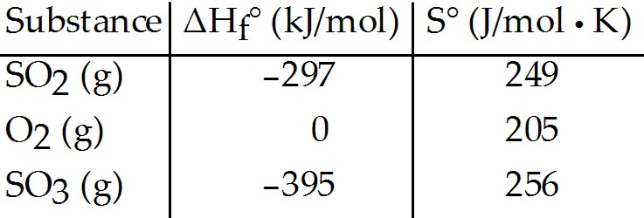
A) 2.40 × 1024
B) 1.06
C) 1.95
D) 3.82 × 1023
E) More data are needed.

- For a given reaction, ΔH = +22.2 kJ/mol and ΔS = +81.1 J/K-mol. The reaction is spontaneous ________. Assume that ΔH and ΔS do not vary with temperature.
A) at T < 274 K
B) at T > 274 K
C) at T > 298 K
D) at T < 298 K
E) at all temperatures

