Brand Product Matching Assignment

Objective
The objective of this assignment is to parse the brand from all the Products and sort all the Products by brand.

Input
One XML file named “ProductDetail.xml”, which contains all the raw information of the Products. For example:
“brand” attribute means the brand of this product.

Output
There should be three output files.
- One txt file which contains all the parsed brands. For example:
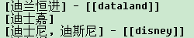
- One txt file which contains all the products sorted by brand. For example:
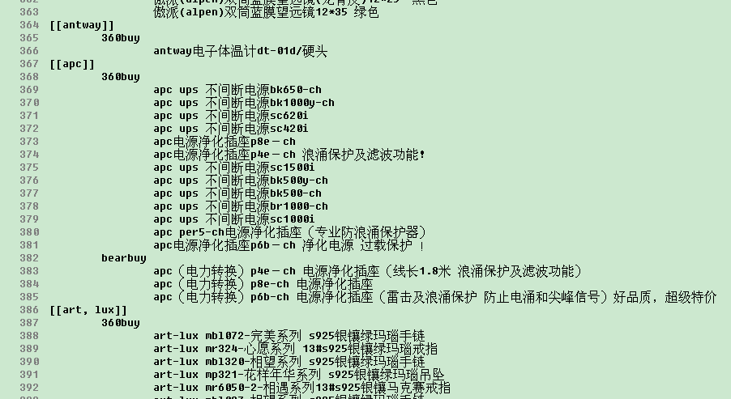
- One txt file which contains all the products which can’t be matched to one brand. For example:
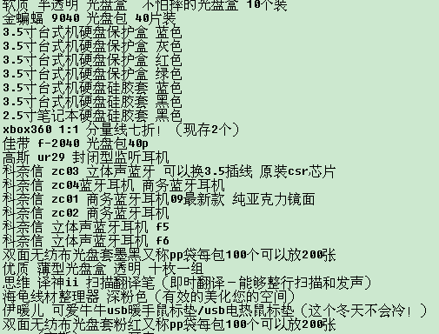

Report
There should be one report file describing the main logic for parsing the brand and matching the product with brand.

The source code should have one “README.txt” describing the usage of the code.

Tips
- There might be different translation for English brand. For example:
- There might be typo for brands. For example:
- Not every product has “brand” attribute. For example:
- The idea is to make brand-parsing as accurate as possible, and minimize the number of products which can’t be match to one brand.

