Simple with color and back color.  
**Bold + underline**

**backline text1.** backline text2.

Left this text.

Center this text.

Right this text.

Fonts face only.

Fonts face and size.

|  |  |  |
| --- | --- | --- |
| **No.** | **Title1** | **Title2** |
| 1 | All grown-ups were once children |  |
| 2 | there is no harm in putting off a piece of work until another day. |  |
| 3 | But when it is a matter of baobabs, that always means a catastrophe. |  |
| 4 | watch out for the baobabs! | END |

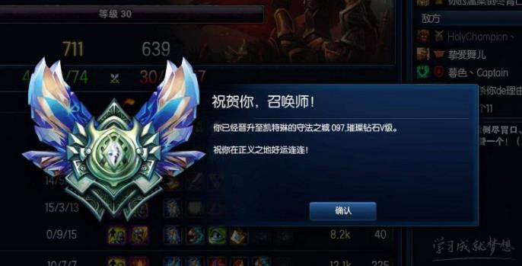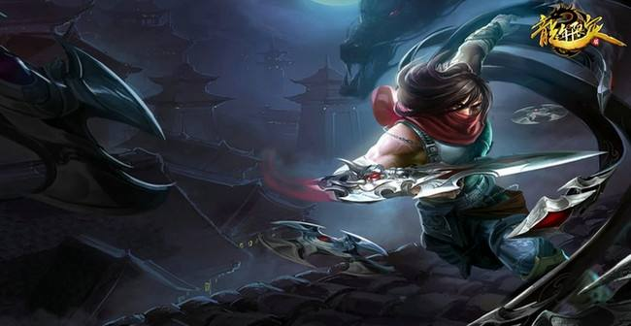

numList1.

numList2.

* dotlist1.
* dotlist2.