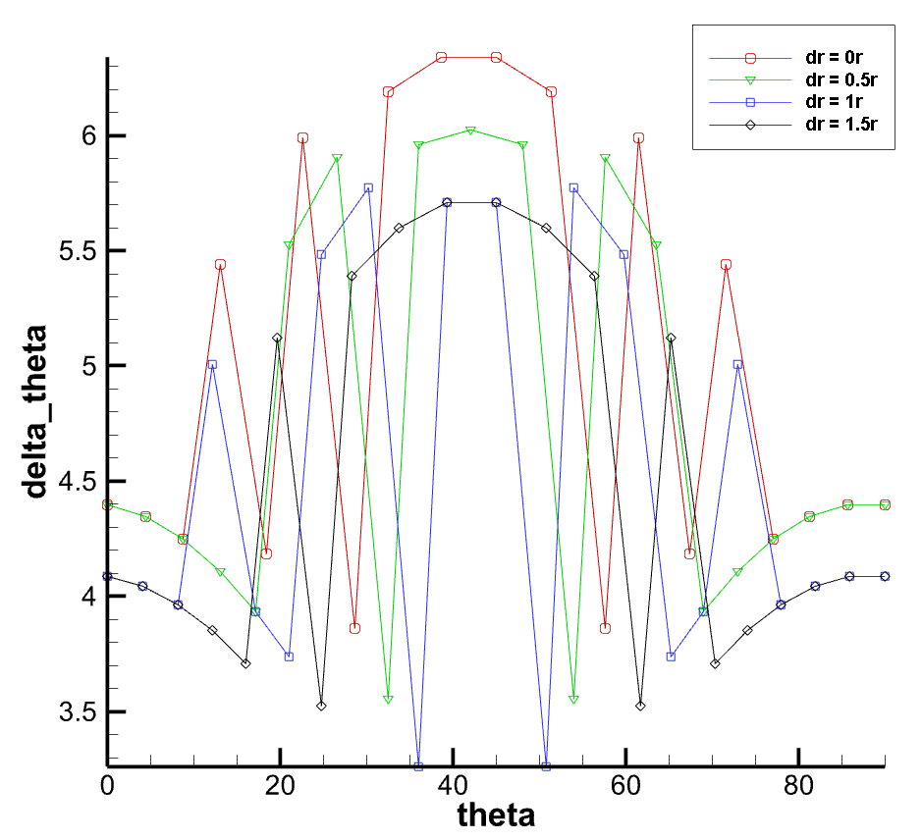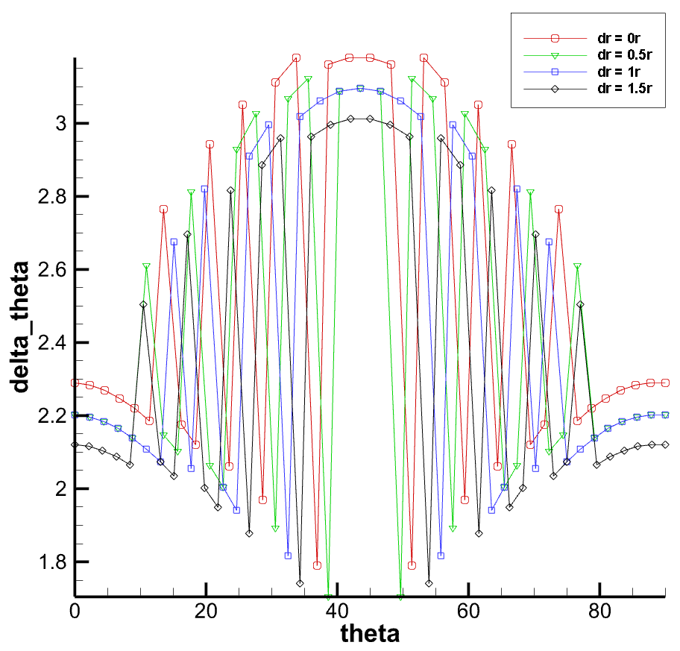

50X50 100X100

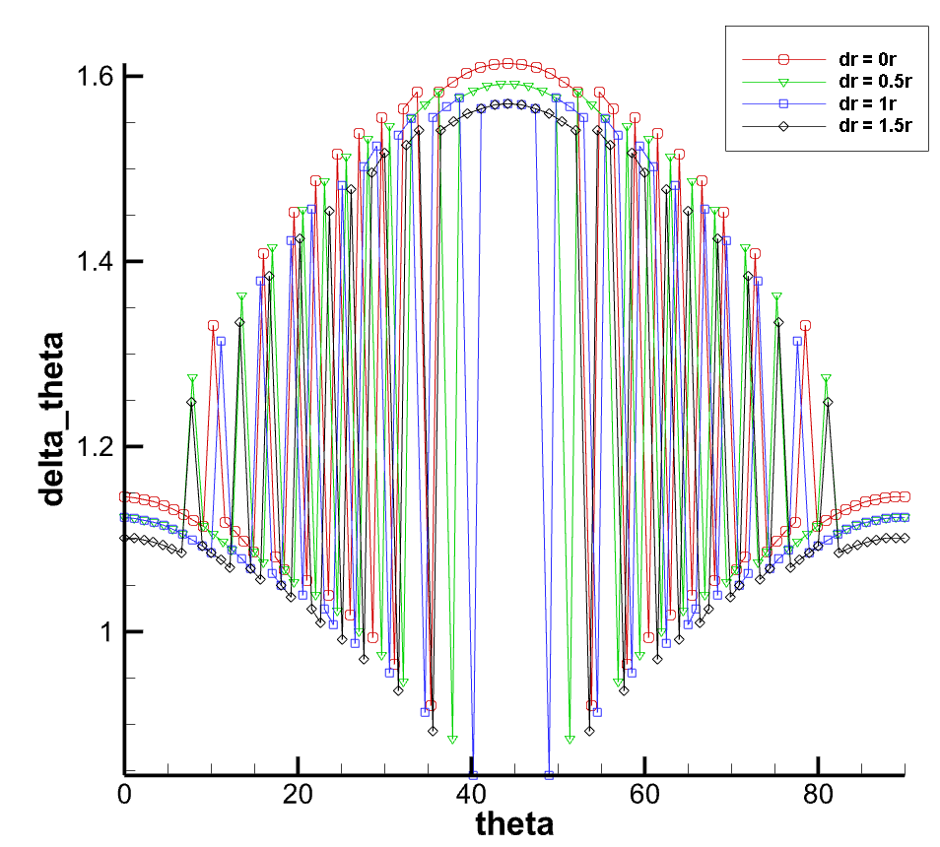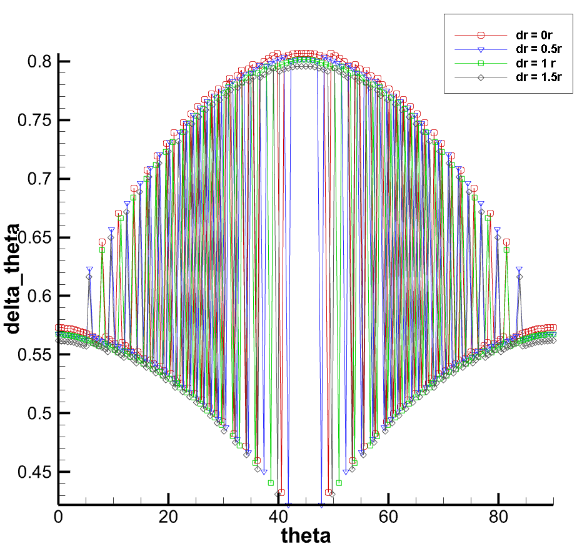

200X200 400X400

dr=r时delta_r最大最小值

|  |  |  |
| --- | --- | --- |
| 网格量 | 最大值 | 最小值 |
| 50X50 | 3.86073 | 6.34019 |
| 100X100 | 1.78991 | 3.17983 |
| 200X200 | 0.920786 | 1.61386 |
| 400X400 | 0.432585 | 0.806929 |

dr=0时delta_d最大最小值

|  |  |  |
| --- | --- | --- |
| 网格量 | 最大值 | 最小值 |
| 50X50 | 0.0299641dx | 0.841664dx |
| 100X100 | 4.33681e-15dx | 0.70992dx |
| 200X200 | 0.009999dx | 1dx |
| 400X400 | 6.61246e-13dx | 1dx |

dr=0.5dx时delta_d最大最小值

|  |  |  |
| --- | --- | --- |
| 网格量 | 最大值 | 最小值 |
| 50X50 | 0.538405dx | 1.5dx |
| 100X100 | 0.553865dx | 1.4764dx |
| 200X200 | 0.537115dx | 1.47815dx |
| 400X400 | 0.568385dx | 1.49384dx |

dr=1dx时delta_d最大最小值

|  |  |  |
| --- | --- | --- |
| 网格量 | 最大值 | 最小值 |
| 50X50 | 1.10147dx | 1.81782dx |
| 100X100 | 1dx | 1.92582dx |
| 200X200 | 1.0098dx | 2dx |
| 400X400 | 1dx | 2dx |

dr=1.5dx时delta_d最大最小值

|  |  |  |
| --- | --- | --- |
| 网格量 | 最大值 | 最小值 |
| 50X50 | 1.53567dx | 2.5dx |
| 100X100 | 1.57066dx | 2.45906dx |
| 200X200 | 1.5461dx | 2.46904dx |
| 400X400 | 1.51355dx | 2.48902dx |