Coordinate system M ranges:
- Xmin = -10, Xmax= 10,
- Ymin = -10, Ymax= 10.

Sta-ge | Augmented matrix | System of equations | Points, lines | Visualization
1 | 2x−3y=1  3x+2y=21 | 2 ,-3|1  3,2|21 | (5,3) | 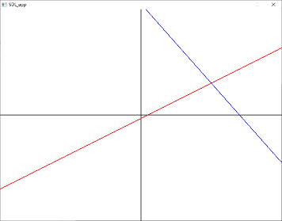
2 | 2x−3y=1  13/2 y=39/2 | 2,-3|1  0,13/2|39/2 | (5,3) | 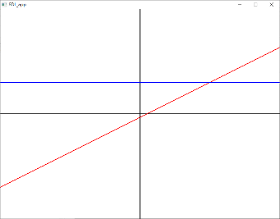
3 | 2x−3y=1  y=3 | 2,-3|1  0,1|3 | (5,3) | 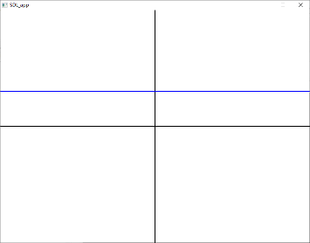
4 | x=5  y=3 | 1,0|5  0,1|3 | (5,3) | 