**LAB1: Caesar_Cipher**

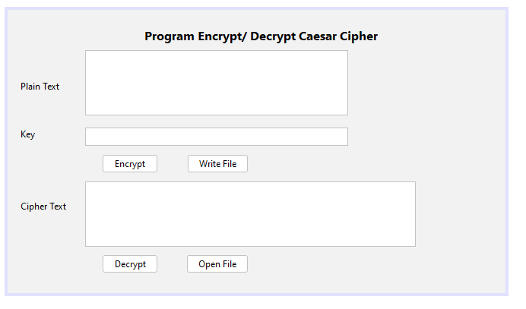

package lab1;

import java.io.BufferedReader;

import java.io.BufferedWriter;

import java.io.FileReader;

import java.io.FileWriter;

import java.io.IOException;

import javax.swing.JOptionPane;

import java.util.logging.*;

public class Caesar_Cipher extends javax.swing.JFrame {

public Caesar_Cipher() {

initComponents();

}

private void btnEncryptActionPerformed(java.awt.event.ActionEvent evt) {

// TODO add your handling code here:

int k = Integer.valueOf(this.txtKhoa.getText());

String br = this.txtVanBan.getText();

this.txtMaHoa.setText(EncryptCaesarCipher(br, k));

}

private void btnWriteFileActionPerformed(java.awt.event.ActionEvent evt) {

// TODO add your handling code here:

try

{

BufferedWriter bw = null;

String fileName = "D:\\Lab1.txt";

String s = txtMaHoa.getText();

bw = new BufferedWriter(new FileWriter(fileName));

bw.write(s);

bw.close();

JOptionPane.showMessageDialog(null, "Wrote File Success!!!");

}

catch (IOException ex)

{

Logger.getLogger(Caesar_Cipher.class.getName()).log(Level.SEVERE, null,ex);

}

}

private void btnDecryptActionPerformed(java.awt.event.ActionEvent evt) {

// TODO add your handling code here:

int k = Integer.valueOf(this.txtKhoa.getText());

String br = this.txtMaHoa.getText();

this.txtVanBan.setText(EncryptCaesarCipher(br, -k));

}

private void btnOpenFileActionPerformed(java.awt.event.ActionEvent evt) {

// TODO add your handling code here:

try

{

BufferedReader br = null;

String fileName = "D:\\Lab1.txt";

br = new BufferedReader(new FileReader(fileName));

StringBuffer sb = new StringBuffer();

JOptionPane.showMessageDialog(null, "Opened File Success!!!");

char[] ca = new char[5];

while(br.ready())

{

int len = br.read(ca);

sb.append(ca,0,len);

}

br.close();

System.out.println("Data: " + sb);

String chuoi = sb.toString();

this.txtVanBan.setText(chuoi);

}

catch (IOException ex)

{

Logger.getLogger(Caesar_Cipher.class.getName()).log(Level.SEVERE, null,ex);

}

}

char Caesarcipher(char c, int k){

if(!Character.isLetter(c))

return c;

return (char) ((((Character.toUpperCase(c) - 'A') + k) %26 + 26) %26 + 'A');

}

private String EncryptCaesarCipher(String br, int k){

String kq = "";

int n = br.length();

for(int i = 0; i < n; i++){

kq += Caesarcipher(br.charAt(i), k);

}

return kq;

}

}

**LAB2_1: Rail_Fence**

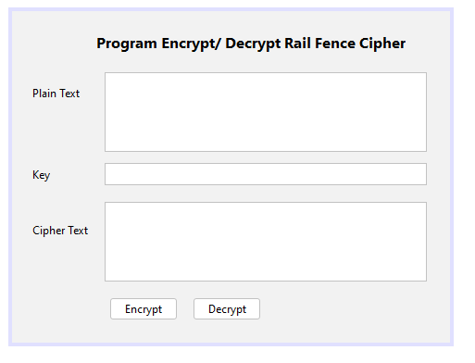

package lab2;

public class Rail_Fence extends javax.swing.JFrame {

public Rail_Fence() {

initComponents();

}

private void btnEncryptActionPerformed(java.awt.event.ActionEvent evt) {

// TODO add your handling code here:

int k = Integer.valueOf(this.txtKey.getText());

String s = this.txtPlain.getText();

int n = s.length();

int sd, sc;

sd = k;

sc = n / sd + 1;

char hr[][] = new char[sd][sc];

int c,d;

c = 0;

d = 0;

int sodu = n % sd;

for(int i = 0; i < n; i++)

{

hr[d][c] = s.charAt(i);

d++;

if(d == k)

{

c++;

d = 0;

}

}

String kq = "";

int sokytu = sc;

for(int i = 0; i < sd; i++)

{

if (i>= sodu)

sokytu = sc - 1;

for(int j = 0; j < sokytu; j++)

kq = kq + hr[i][j];

}

this.txtCipher.setText(kq);

}

private void btnDecryptActionPerformed(java.awt.event.ActionEvent evt) {

// TODO add your handling code here:

int k = Integer.valueOf(this.txtKey.getText());

String s = this.txtCipher.getText();

int n = s.length();

int sd, sc;

sd = k;

sc = n / sd + 1;

int sodu = n % sd;

int sokytu = sc;

int t = 0;

String kq = "";

char hr[][] = new char[sd][sc];

for(int i = 0; i < sd; i++)

{

if(i >= sodu)

sokytu = sc - 1;

for(int j = 0; j < sokytu; j++){

hr[i][j] = s.charAt(t);

t++;

}

}

int c,d;

c = 0;

d = 0;

for(int i = 0; i < n; i++)

{

kq += hr[d][c];

d++;

if (d == k)

{

c++;

d = 0;

}

}

this.txtPlain.setText(kq);

}

}

**LAB2_2: Vigenere_Cipher**

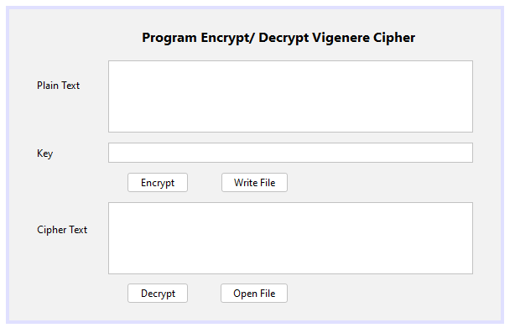

package lab2;

import java.io.BufferedReader;

import java.io.BufferedWriter;

import java.io.FileReader;

import java.io.FileWriter;

import java.io.IOException;

import javax.swing.JOptionPane;

import java.util.logging.*;

public class Vigenere_Cipher extends javax.swing.JFrame {

int Vig[][];

public Vigenere_Cipher() {

initComponents();

Vig = new int[26][26];

for (int i = 0; i < 26; i++)

for (int j = 0; j < 26; j++)

Vig[i][j] =(i + j) % 26;

}

private String Encryption(String plainText, String key)

{

int n = plainText.length();

String CipherText = "";

int k = 0;

for(int i = 0; i < n; i++){

if(Character.isLetter(plainText.charAt(i)))

{

CipherText += Encrypt(plainText.charAt(i), key.charAt(k));

k++;

k = k%key.length();

}

else{

CipherText += plainText.charAt(i);

}

}

return CipherText;

}

char Encrypt(char x, char k){

int xn = Character.toUpperCase(x) - 'A';

int kn = Character.toUpperCase(k) - 'A';

int yn = Vig[kn][xn];

return (char) (yn + 'A');

}

private void btnEncryptActionPerformed(java.awt.event.ActionEvent evt) {

// TODO add your handling code here:

String plainText = this.txtPlain.getText();

String k = this.txtKey.getText();

String CipherText = Encryption(plainText, k);

this.txtCipher.setText(CipherText);

}

private void btnWriteFileActionPerformed(java.awt.event.ActionEvent evt) {

// TODO add your handling code here:

try

{

BufferedWriter bw = null;

String fileName = "D:\\Lab2.txt";

String s = txtPlain.getText();

bw = new BufferedWriter(new FileWriter(fileName));

bw.write(s);

bw.close();

JOptionPane.showMessageDialog(null, "Wrote File Success!!!");

}

catch (IOException ex)

{

Logger.getLogger(Vigenere_Cipher.class.getName()).log(Level.SEVERE, null,ex);

}

}

private void btnOpenFileActionPerformed(java.awt.event.ActionEvent evt) {

// TODO add your handling code here:

try

{

BufferedReader br = null;

String fileName = "D:\\Lab2.txt";

br = new BufferedReader(new FileReader(fileName));

StringBuffer sb = new StringBuffer();

JOptionPane.showMessageDialog(null, "Opened File Success!!!");

char[] ca = new char[5];

while(br.ready())

{

int len = br.read(ca);

sb.append(ca,0,len);

}

br.close();

System.out.println("Data: " + sb);

String chuoi = sb.toString();

txtPlain.setText(chuoi);

}

catch (IOException ex)

{

Logger.getLogger(Vigenere_Cipher.class.getName()).log(Level.SEVERE, null,ex);

}

}

private void btnDecryptActionPerformed(java.awt.event.ActionEvent evt) {

// TODO add your handling code here:

String CipherText = this.txtPlain.getText();

String k = this.txtKey.getText();

String kt1 = "";

int kn = k.length();

for(int i = 0; i < kn; i++)

{

kt1 += (char)(((26-(Character.toUpperCase(k.charAt(i)) - 'A')) % 26) + 'A');

}

this.txtKey.setText(kt1);

String PlainText = Encryption(CipherText, kt1);

this.txtPlain.setText(PlainText);

}

}

**LAB3_1: PlayFail_Cipher**

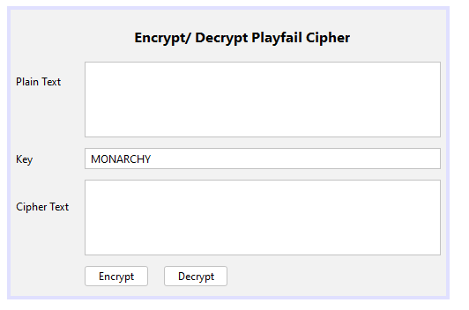

package lab3;

public class PlayFail_Cipher extends javax.swing.JFrame {

char pf[][] = {{'M','O','N','A','R'},

{'C','H','Y','B','D'},

{'E','F','G','I','K'},

{'L','P','Q','S','T'},

{'U','V','W','X','Z'}

};

public PlayFail_Cipher() {

initComponents();

this.txtKey.disable();

}

private String Encrypt(String banro){

int n = banro.length();

int i = 0;

String banma = "";

char a,b;

while (i < n){

if (i == n - 1){

a = banro.charAt(i);

b = 'X';

i++;

}

else{

a = banro.charAt(i);

b = banro.charAt(i+1);

if(a == b){

b = 'X';

i++;

}

else

i += 2;

}

banma += Replace(a,b);

}

return banma;

}

String Replace(char a, char b)

{

String vta = FindLoacation(a);

String vtb = FindLoacation(b);

char x,y;

if (vta.charAt(0) == vtb.charAt(0)){

x = pf[vta.charAt(0) - '0'][((vta.charAt(1) - '0') + 1) % 5];

y = pf[(vtb.charAt(0) - '0')][((vtb.charAt(1) - '0') + 1) % 5];

return x + "" + y;

}

if (vta.charAt(1) == vtb.charAt(1)){

x = pf[((vta.charAt(0) - '0') + 1) % 5][(vta.charAt(1) - '0')];

y = pf[((vtb.charAt(0) - '0') + 1) % 5][(vtb.charAt(1) - '0')];

return x + "" + y;

}

x = pf[(vta.charAt(0) - '0')][(vtb.charAt(1) - '0')];

y = pf[(vtb.charAt(0) - '0')][(vta.charAt(1) - '0')];

return x + "" + y;

}

private String FindLoacation(char a)

{

for (int i = 0; i < 5; i ++){

for (int j = 0; j <5; j++){

if (pf[i][j] == a){

return i + "" + j;

}

}

}

return "";

}

private String Decrypt(String banma)

{

int n = banma.length();

String banro = "";

char a,b;

for(int i = 0; i < n; i += 2){

a = banma.charAt(i);

b = banma.charAt(i+1);

banro += ReverseReplace(a, b);

}

return banro;

}

String ReverseReplace(char a, char b){

String vta = FindLoacation(a);

String vtb = FindLoacation(b);

char x,y;

if (vta.charAt(0) == vtb.charAt(0)){

x = pf[vta.charAt(0) - '0'][((vta.charAt(1) - '0') - 1 + 5) % 5];

y = pf[(vtb.charAt(0) - '0')][((vtb.charAt(1) - '0') - 1 + 5) % 5];

return x + "" + y;

}

if (vta.charAt(1) == vtb.charAt(1)){

x = pf[((vta.charAt(0) - '0') - 1 + 5) % 5][(vta.charAt(1) - '0')];

y = pf[((vtb.charAt(0) - '0') - 1 + 5) % 5][(vtb.charAt(1) - '0')];

return x + "" + y;

}

x = pf[(vta.charAt(0) - '0')][(vtb.charAt(1) - '0')];

y = pf[(vtb.charAt(0) - '0')][(vta.charAt(1) - '0')];

return x + "" + y;

}

private void btnEncryptActionPerformed(java.awt.event.ActionEvent evt) {

// TODO add your handling code here:

String banro = this.txtPlainText.getText();

banro = banro.toUpperCase();

banro = banro.replace('J', 'I');

String banma = Encrypt(banro);

this.txtCipherText.setText(banma);

}

private void btnDecryptActionPerformed(java.awt.event.ActionEvent evt) {

// TODO add your handling code here:

String banma = this.txtCipherText.getText();

String banro = Decrypt(banma);

int n = banro.length();

String br = "";

for(int i = 0; i < n - 2; i += 2){

if(banro.charAt(i) == banro.charAt(i+2)){

br += banro.charAt(i);

}

else{

br += banro.charAt(i) + "" + banro.charAt(i+1);

}

}

if( banro.charAt(n-1) == 'X'){

br += banro.charAt(n-2);

}

else{

br += banro.charAt(n-2);

br += banro.charAt(n-1);

}

this.txtPlainText.setText(br);

}

}

**LAB3_2: Transposition_Cipher**

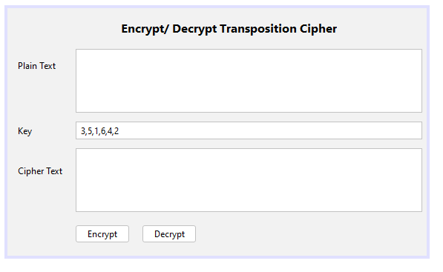

package lab3;

public class Transposition_Cipher extends javax.swing.JFrame {

public Transposition_Cipher() {

initComponents();

}

private void btnEncryptActionPerformed(java.awt.event.ActionEvent evt) {

// TODO add your handling code here:

String k = this.txtKey.getText();

String ks[] = new String[6];

ks = k.split(",");

int key[] = new int[6];

for(int i = 0; i < 6; i ++){

key[i] = Integer.valueOf(ks[i]) - 1;

}

String sa = this.txtPlainText.getText();

String kq = "";

int na = sa.length();

int d = 0;

int c;

String s = "";

int thieu = 6 - na%6;

for(int i = 0; i < thieu; i++){

sa = sa + " ";

}

while(d < na){

c = d + 6;

s = sa.substring(d,c);

for(int i = 0; i < 6; i++){

kq = kq + s.charAt(key[i]);

}

d = d + 6;

}

this.txtCipherText.setText(kq);

}

private void btnDecryptActionPerformed(java.awt.event.ActionEvent evt) {

// TODO add your handling code here:

String k = this.txtKey.getText();

String ks[] = new String[6];

ks = k.split(",");

int key[] = new int[6];

for(int i = 0; i < 6; i ++){

key[i] = Integer.valueOf(ks[i]) - 1;

}

int key1[] = new int[6];

for(int i = 0; i < 6; i ++){

key1[key[i]] = i;

}

String sa = this.txtCipherText.getText();

String kq = "";

int na = sa.length();

int d = 0;

int c;

String s = "";

while(d < na){

c = d + 6;

s = sa.substring(d,c);

for(int i = 0; i < 6; i++){

kq = kq + s.charAt(key1[i]);

}

d = d + 6;

}

this.txtPlainText.setText(kq);

}

}

**LAB4_1: DES_Cipher**

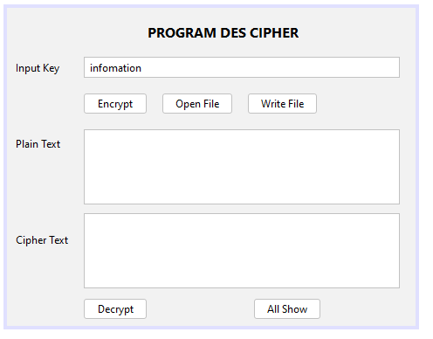

package lab4;

import java.io.BufferedReader;

import java.io.BufferedWriter;

import java.io.FileInputStream;

import java.io.FileOutputStream;

import java.io.FileReader;

import java.io.FileWriter;

import java.io.IOException;

import java.io.InputStream;

import java.io.OutputStream;

import javax.crypto.Cipher;

import javax.crypto.CipherInputStream;

import javax.crypto.CipherOutputStream;

import javax.crypto.SecretKey;

import javax.crypto.SecretKeyFactory;

import javax.crypto.spec.DESKeySpec;

import javax.swing.JOptionPane;

import java.util.logging.*;

public class DES_Cipher extends javax.swing.JFrame {

public DES_Cipher() {

initComponents();

}

private int mode;

private static void doCopy(InputStream is, OutputStream os) throws IOException{

byte[] bytes = new byte[64];

int numBytes;

while((numBytes = is.read(bytes)) != -1){

os.write(bytes,0,numBytes);

}

os.flush();

os.close();

is.close();

}

public static void encrypt(String key, InputStream is, OutputStream os) throws Throwable{

encryptOrDecrypt(key, Cipher.ENCRYPT_MODE, is, os);

}

public static void decrypt(String key, InputStream is, OutputStream os) throws Throwable{

encryptOrDecrypt(key, Cipher.DECRYPT_MODE, is, os);

}

public static void encryptOrDecrypt(String key,int mode, InputStream is, OutputStream os) throws Throwable{

DESKeySpec dks = new DESKeySpec(key.getBytes());

SecretKeyFactory skf = SecretKeyFactory.getInstance("DES");

SecretKey desKey = skf.generateSecret(dks);

Cipher cipher = Cipher.getInstance("DES");

if(mode == Cipher.ENCRYPT_MODE){

cipher.init(Cipher.ENCRYPT_MODE, desKey);

CipherInputStream cis = new CipherInputStream(is,cipher);

doCopy(cis, os);

} else if (mode == Cipher.DECRYPT_MODE){

cipher.init(Cipher.DECRYPT_MODE, desKey);

CipherOutputStream cos = new CipherOutputStream(os,cipher);

doCopy(is, cos);

}

}

private void btnEncryptActionPerformed(java.awt.event.ActionEvent evt) {

// TODO add your handling code here:

try{

String key = this.txtKey.getText();

FileInputStream fis = new FileInputStream("D:\\Des.txt");

FileOutputStream fos = new FileOutputStream("D:\\EnDes.txt");

encrypt(key, fis, fos);

JOptionPane.showMessageDialog(null, "Encrypted!!!");

} catch(Throwable e){

e.printStackTrace();

}

}

private void btnWriteFileActionPerformed(java.awt.event.ActionEvent evt) {

// TODO add your handling code here:

try

{

BufferedWriter bw = null;

String fileName = "D:\\Des.txt";

String s = txtPlainText.getText();

bw = new BufferedWriter(new FileWriter(fileName));

bw.write(s);

bw.close();

JOptionPane.showMessageDialog(null, "Wrote File Success!!!");

//txtCipherText.setText(s);

}

catch (IOException ex)

{

Logger.getLogger(DES_Cipher.class.getName()).log(Level.SEVERE, null,ex);

}

}

private void btnOpenFileActionPerformed(java.awt.event.ActionEvent evt) {

// TODO add your handling code here:

try{

BufferedReader br = null;

String fileName = "D:\\EnDes.txt";

br = new BufferedReader(new FileReader(fileName));

StringBuffer sb = new StringBuffer();

JOptionPane.showMessageDialog(null, "Opened File!!!");

char[] ca = new char[5];

while(br.ready()){

int len = br.read(ca);

sb.append(ca,0,len);

}

br.close();

System.out.println("Data is: " + sb);

String chuoi = sb.toString();

txtCipherText.setText(chuoi);

} catch(IOException ex){

Logger.getLogger(DES_Cipher.class.getName()).log(Level.SEVERE,null,ex);

}

}

private void btnDecryptActionPerformed(java.awt.event.ActionEvent evt) {

// TODO add your handling code here:

FileInputStream fis2 = null;

try{

String key = this.txtKey.getText();

fis2 = new FileInputStream("D:\\Des.txt");

FileOutputStream fos2 = new FileOutputStream("D:\\EnDes.txt");

decrypt(key, fis2, fos2);

BufferedReader br = null;

br = new BufferedReader(new FileReader("D:\\Des.txt"));

StringBuffer sb = new StringBuffer();

JOptionPane.showMessageDialog(null, "Decrypted!!!");

char[] ca = new char[5];

while(br.ready()){

int len = br.read(ca);

sb.append(ca,0,len);

}

br.close();

System.out.println("Data is: " + sb);

String chuoi = sb.toString();

txtPlainText.setText(chuoi);

} catch(Throwable ex){

Logger.getLogger(DES_Cipher.class.getName()).log(Level.SEVERE,null,ex);

}

finally{

try{

fis2.close();

} catch(IOException ex){

Logger.getLogger(DES_Cipher.class.getName()).log(Level.SEVERE,null,ex);

}

}

}

private void btnAllShowActionPerformed(java.awt.event.ActionEvent evt) {

// TODO add your handling code here:

}

}

**LAB4_2: fm3DES_Cipher**

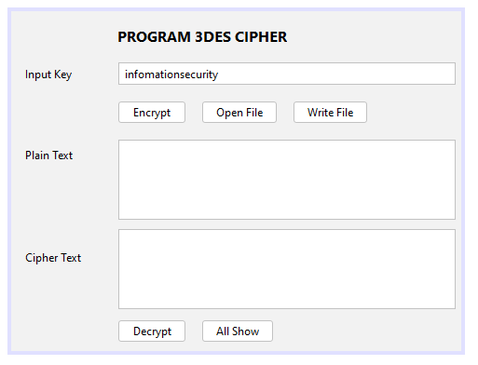

package lab4;

import java.io.BufferedReader;

import java.io.BufferedWriter;

import java.io.FileReader;

import java.io.FileWriter;

import java.io.IOException;

import java.security.spec.KeySpec;

import javax.crypto.Cipher;

import javax.crypto.SecretKey;

import javax.crypto.SecretKeyFactory;

import java.util.Base64;

import java.util.logging.*;

import javax.crypto.spec.DESedeKeySpec;

import javax.swing.JOptionPane;

public class fm3DES_Cipher extends javax.swing.JFrame {

public fm3DES_Cipher() {

initComponents();

}

private static final String UNICODE_FORMAT = "UTF8";

public static final String DESEDE_ENCRYPTION_SCHEME = "DESede";

private KeySpec myKeySpec;

private SecretKeyFactory mySecretKeyFactory;

private Cipher cipher;

byte[] keyAsBytes;

private String myEncryptionKey;

private String myEncryptionScheme;

SecretKey key;

public String encrypt(String unencryptedString){

String encryptedString = null;

try{

cipher.init(Cipher.ENCRYPT_MODE, key);

byte[] plainText = unencryptedString.getBytes(UNICODE_FORMAT);

byte[] encryptedText = cipher.doFinal(plainText);

encryptedString = Base64.getEncoder().encodeToString(encryptedText);

}catch (Exception e){

e.printStackTrace();

}

return encryptedString;

}

public String decrypt(String encryptedString){

String decryptedText = null;

try{

cipher.init(Cipher.DECRYPT_MODE, key);

byte[] encryptedText = Base64.getDecoder().decode(encryptedString);

byte[] plainText = cipher.doFinal(encryptedText);

String a = new String(plainText);

System.out.println("plainText: " + a);

decryptedText = a;

}catch (Exception e){

e.printStackTrace();

}

return decryptedText;

}

private void btnEncryptActionPerformed(java.awt.event.ActionEvent evt) {

// TODO add your handling code here:

try{

myEncryptionKey = this.txtKey.getText();

myEncryptionScheme = DESEDE_ENCRYPTION_SCHEME;

keyAsBytes = myEncryptionKey.getBytes(UNICODE_FORMAT);

//add them

if (keyAsBytes.length < 24){

System.out.println("Input 24 byte of Input Key!");

return;

}

//

myKeySpec = new DESedeKeySpec(keyAsBytes);

mySecretKeyFactory = SecretKeyFactory.getInstance(myEncryptionScheme);

cipher = Cipher.getInstance(myEncryptionScheme);

key = mySecretKeyFactory.generateSecret(myKeySpec);

System.out.println("Key k: " + key);

String plainText = txtPlainText.getText();

String encrypted = encrypt(plainText);

System.out.println("Encrypted Value: " + encrypted);

txtCipherText.setText(encrypted);

} catch(Exception ex){

ex.printStackTrace();

}

}

private void btnOpenFileActionPerformed(java.awt.event.ActionEvent evt) {

// TODO add your handling code here:

try{

BufferedReader br = null;

String fileName = "D:\\3Des.txt";

br = new BufferedReader(new FileReader(fileName));

StringBuffer sb = new StringBuffer();

JOptionPane.showMessageDialog(null, "Opened File!!!");

char[] ca = new char[5];

while(br.ready()){

int len = br.read(ca);

sb.append(ca,0,len);

}

br.close();

System.out.println("Data is: " + sb);

String chuoi = sb.toString();

txtPlainText.setText(chuoi);

} catch(IOException ex){

Logger.getLogger(fm3DES_Cipher.class.getName()).log(Level.SEVERE,null,ex);

}

}

private void btnWriteFileActionPerformed(java.awt.event.ActionEvent evt) {

// TODO add your handling code here:

try

{

BufferedWriter bw = null;

String fileName = "D:\\3Des.txt";

String s = txtPlainText.getText();

bw = new BufferedWriter(new FileWriter(fileName));

bw.write(s);

bw.close();

JOptionPane.showMessageDialog(null, "Wrote File Success!!!");

//txtCipherText.setText(s);

}

catch (IOException ex)

{

Logger.getLogger(fm3DES_Cipher.class.getName()).log(Level.SEVERE, null,ex);

}

}

private void btnDecryptActionPerformed(java.awt.event.ActionEvent evt) {

// TODO add your handling code here:

try{

myEncryptionKey = this.txtKey.getText();

myEncryptionScheme = DESEDE_ENCRYPTION_SCHEME;

keyAsBytes = myEncryptionKey.getBytes(UNICODE_FORMAT);

//add them

if (keyAsBytes.length < 24){

System.out.println("Input 24 byte of Input Key!");

return;

}

//

myKeySpec = new DESedeKeySpec(keyAsBytes);

mySecretKeyFactory = SecretKeyFactory.getInstance(myEncryptionScheme);

cipher = Cipher.getInstance(myEncryptionScheme);

key = mySecretKeyFactory.generateSecret(myKeySpec);

System.out.println("Key k: " + key);

String cipherText = txtCipherText.getText();

String decrypted = decrypt(cipherText);

System.out.println("Decrypted Value: " + decrypted);

txtPlainText.setText(decrypted);

} catch(Exception ex){

ex.printStackTrace();

}

}

private void btnAllShowActionPerformed(java.awt.event.ActionEvent evt) {

// TODO add your handling code here:

}

}

**LAB5: AES_Encrypt**

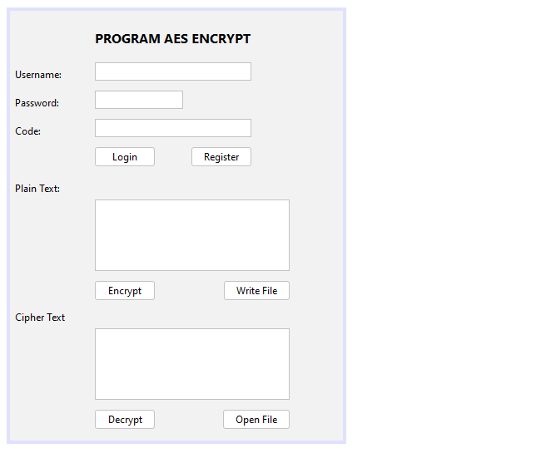

package lab5;

import java.io.BufferedReader;

import java.io.BufferedWriter;

import java.io.FileReader;

import java.io.FileWriter;

import java.io.IOException;

import java.security.NoSuchAlgorithmException;

import java.util.Base64;

import java.util.logging.Level;

import java.util.logging.Logger;

import javax.crypto.Cipher;

import javax.crypto.KeyGenerator;

import javax.crypto.SecretKey;

import javax.swing.JOptionPane;

public class AES_Encrypt extends javax.swing.JFrame {

public AES_Encrypt() {

initComponents();

}

private String user;

private String pass;

private String khoa;

SecretKey secretKey;

byte[] byteCipherText;

private void btnLoginActionPerformed(java.awt.event.ActionEvent evt) {

// TODO add your handling code here:

try{

user = txtUser.getText();

pass = txtPass.getText();

khoa = user + pass;

BufferedReader br = null;

String fileName = "D:\\AES.txt";

br = new BufferedReader(new FileReader(fileName));

StringBuffer sb = new StringBuffer();

char[] ca = new char[5];

while(br.ready()){

int len = br.read(ca);

sb.append(ca,0,len);

}

br.close();

System.out.println("Key is: " + sb);

String chuoi = sb.toString();

Boolean k = khoa.equals(chuoi);

if (k == true){

JOptionPane.showMessageDialog(null, "Login Successful!!!");

} else {

JOptionPane.showMessageDialog(null, "Login Fail!!!");

}

txtKey.setText(chuoi.getBytes().toString());

KeyGenerator keyGen = KeyGenerator.getInstance("AES");

keyGen.init(128);

secretKey = keyGen.generateKey();

} catch (NoSuchAlgorithmException ex){

} catch (Exception ex){ }

}

private void btnRegisterActionPerformed(java.awt.event.ActionEvent evt) {

// TODO add your handling code here:

try{

user = txtUser.getText();

pass = txtPass.getText();

khoa = user + pass;

BufferedWriter bw = null;

String fileName = "D:\\AES.txt";

String s = txtPlainText.getText();

bw = new BufferedWriter(new FileWriter(fileName));

bw.write(khoa);

bw.close();

JOptionPane.showMessageDialog(null, "Register successfull. Login please!!!");

txtKey.setText(khoa.getBytes().toString());

}catch (IOException ex){

Logger.getLogger(AES_Encrypt.class.getName()).log(Level.SEVERE, null,ex);

}

}

private void btnEncryptActionPerformed(java.awt.event.ActionEvent evt) {

// TODO add your handling code here:

try{

System.out.println("Create key: " + secretKey);

Cipher aesCipher = Cipher.getInstance("AES");

aesCipher.init(Cipher.ENCRYPT_MODE, secretKey);

String strData = txtPlainText.getText();

byte[] byteDataToEncrypt = strData.getBytes();

byteCipherText = aesCipher.doFinal(byteDataToEncrypt);

String strCipherText = Base64.getEncoder().encodeToString(byteCipherText);

System.out.println("Cipher Text generated using AES is: " + strCipherText);

txtCipherText.setText(strCipherText);

}catch (Exception ex){

System.out.println("Encrypt error: " + ex);

}

}

private void btnDecryptActionPerformed(java.awt.event.ActionEvent evt) {

// TODO add your handling code here:

try{

String cipherText = txtCipherText.getText();

txtPlainText.setText(cipherText);

Cipher aesCipher = Cipher.getInstance("AES");

aesCipher.init(Cipher.DECRYPT_MODE, secretKey, aesCipher.getParameters());

byte[] byteDecryptedText = aesCipher.doFinal(byteCipherText);

String strDecryptedText = new String(byteDecryptedText);

System.out.println("Decrypted Text messaage is: " + strDecryptedText);

txtCipherText.setText(strDecryptedText);

}catch (Exception ex){

System.out.println("Decrypt error: " + ex);

}

}

private void btnWriteFileActionPerformed(java.awt.event.ActionEvent evt) {

// TODO add your handling code here:

try

{

BufferedWriter bw = null;

String fileName = "D:\\WriteAES.txt";

String s = txtCipherText.getText();

bw = new BufferedWriter(new FileWriter(fileName));

bw.write(s);

bw.close();

JOptionPane.showMessageDialog(null, "Wrote File D:\\WriteAES.txt Success!!!");

}

catch (IOException ex)

{

Logger.getLogger(AES_Encrypt.class.getName()).log(Level.SEVERE, null,ex);

}

}

private void btnOpenFileActionPerformed(java.awt.event.ActionEvent evt) {

// TODO add your handling code here:

try

{

BufferedReader br = null;

String fileName = "D:\\WriteAES.txt";

br = new BufferedReader(new FileReader(fileName));

StringBuffer sb = new StringBuffer();

JOptionPane.showMessageDialog(null, "Opened File!!!");

char[] ca = new char[5];

while(br.ready())

{

int len = br.read(ca);

sb.append(ca,0,len);

}

br.close();

System.out.println("Data is: " + sb);

String chuoi = sb.toString();

this.txtPlainText.setText(chuoi);

btnDecrypt.enable(true);

}

catch (IOException ex)

{

Logger.getLogger(AES_Encrypt.class.getName()).log(Level.SEVERE, null,ex);

}

}

}

**LAB6: Thuật toán RSA**

package lab6;

import java.io.BufferedReader;

import java.io.IOException;

import java.io.InputStreamReader;

import java.math.BigInteger;

import java.util.Random;

public class RSA {

int primeSize;

BigInteger p,q;

BigInteger N;

BigInteger r;

BigInteger E,D;

public RSA(){

}

public RSA(int primeSize){

this.primeSize = primeSize;

generatePrimeNumbers();

generatePublicPrivateKeys();

}

public void generatePrimeNumbers(){

p = BigInteger.probablePrime(primeSize / 2, new Random());

do{

q = BigInteger.probablePrime(primeSize / 2, new Random());

}while (q.compareTo(p) == 0);

}

public void generatePublicPrivateKeys(){

N = p.multiply(q);

r = p.subtract(BigInteger.valueOf(1));

r = r.multiply(q.subtract(BigInteger.valueOf(1)));

do{

E = new BigInteger(2 * primeSize, new Random());

} while((E.compareTo(r) != -1) || (E.gcd(r).compareTo(BigInteger.valueOf(1)) != 0));

D = E.modInverse(r);

}

public BigInteger[] encrypt(String message){

int i;

byte[] temp = new byte[1];

byte[] digits = message.getBytes();

BigInteger[] bigdigits = new BigInteger[digits.length];

for(i = 0; i < bigdigits.length; i++){

temp[0] = digits[i];

bigdigits[i] = new BigInteger(temp);

}

BigInteger[] encrypted = new BigInteger[bigdigits.length];

for(i = 0; i < bigdigits.length; i++){

encrypted[i] = bigdigits[i].modPow(E, N);

}

return encrypted;

}

public BigInteger[] encrypt(String message, BigInteger userD, BigInteger userN){

int i;

byte[] temp = new byte[1];

byte[] digits = message.getBytes();

BigInteger[] bigdigits = new BigInteger[digits.length];

for(i = 0; i < bigdigits.length; i++){

temp[0] = digits[i];

bigdigits[i] = new BigInteger(temp);

}

BigInteger[] encrypted = new BigInteger[bigdigits.length];

for(i = 0; i < bigdigits.length; i++){

encrypted[i] = bigdigits[i].modPow(userD, userN);

}

return encrypted;

}

public String decrypt(BigInteger[] encrypted, BigInteger D, BigInteger N){

int i;

BigInteger[] decrypted = new BigInteger[encrypted.length];

for(i = 0; i < decrypted.length; i++){

decrypted[i] = encrypted[i].modPow(D, N);

}

char[] charArray = new char[decrypted.length];

for(i = 0; i < charArray.length; i++){

charArray[i] = (char)(decrypted[i].intValue());

}

return (new String(charArray));

}

public BigInteger getp(){

return p;

}

public BigInteger getq(){

return q;

}

public BigInteger getr(){

return r;

}

public BigInteger getN(){

return N;

}

public BigInteger getE(){

return E;

}

public BigInteger getD(){

return D;

}

public static void main(String[] args) throws IOException{

int primeSize = 8;

RSA rsa = new RSA(primeSize);

System.out.println("Key size: [" + primeSize + "]");

System.out.println("");

System.out.println("Generated prime numbers p and q");

System.out.println("p: [" + rsa.getp().toString(16).toUpperCase() + "]");

System.out.println("q: [" + rsa.getq().toString(16).toUpperCase() + "]");

System.out.println("");

System.out.println("The public key is the pair (N,E) which will be published.");

System.out.println("p: [" + rsa.getN().toString(16).toUpperCase() + "]");

System.out.println("q: [" + rsa.getE().toString(16).toUpperCase() + "]");

System.out.println("");

System.out.println("The private key is the pair (N,D) which will be kept private.");

System.out.println("p: [" + rsa.getN().toString(16).toUpperCase() + "]");

System.out.println("q: [" + rsa.getD().toString(16).toUpperCase() + "]");

System.out.println("");

System.out.println("Please enter message (plaintext):");

String plainText = (new BufferedReader(new InputStreamReader(System.in))).readLine();

System.out.println("");

BigInteger[] cipherText = rsa.encrypt(plainText);

System.out.print("Ciphertext: [");

for(int i = 0; i < cipherText.length; i++){

System.out.print(cipherText[i].toString(16).toUpperCase());

if(i != cipherText.length - 1){

System.out.print(" ");

}

}

System.out.println("]");

System.out.println("");

RSA rsa1 = new RSA(8);

String recoveredPlaintext = rsa1.decrypt(cipherText, rsa.getD(), rsa.getN());

System.out.print("Recovered plaintext: [" + recoveredPlaintext + "]");

}

}

**LAB6: Form RSA**

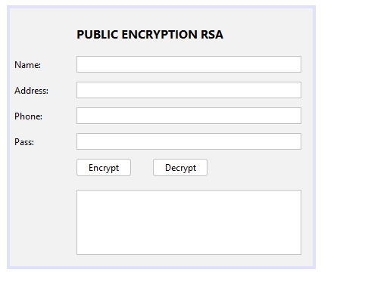

package lab6;

import java.math.BigInteger;

import java.util.Scanner;

public class fRSA extends javax.swing.JFrame {

public fRSA() {

initComponents();

}

private void btnEncryptActionPerformed(java.awt.event.ActionEvent evt) {

// TODO add your handling code here:

Scanner in = new Scanner(System.in);

String nhash;

BigInteger[] ciphertext = null;

BigInteger n = null;

BigInteger d = null;

String password = "";

password = txtPass.getText();

RSA rsa = new RSA(8);

n = rsa.getN();

d = rsa.getD();

ciphertext = rsa.encrypt(password);

StringBuffer bf = new StringBuffer();

for(int i = 0; i < ciphertext.length; i++){

bf.append(ciphertext[i].toString(16).toUpperCase());

if(i != ciphertext.length - 1){

System.out.print("");

}

}

String message = bf.toString();

if (txtCipherText.getText().length() > 0){

txtCipherText.append("\nPass encrypted is: " + message);

}else

txtCipherText.append("Pass encrypted is: " + message);

}

private void btnDecryptActionPerformed(java.awt.event.ActionEvent evt) {

// TODO add your handling code here:

Scanner in = new Scanner(System.in);

String nhash;

BigInteger[] ciphertext = null;

BigInteger n = null;

BigInteger d = null;

String password = "";

password = txtPass.getText();

RSA rsa = new RSA(8);

n = rsa.getN();

d = rsa.getD();

ciphertext = rsa.encrypt(password);

String dhash = rsa.decrypt(ciphertext, d, n);

txtCipherText.append("\nPass after decrypt is: " + dhash);

}

}

**LAB7: Crypto.java**

package lab7;

public class Crypto {

public static final String toHexString(byte[] block)

{

StringBuffer buf = new StringBuffer();

int len = block.length;

for (int i = 0; i < len; i++)

{

byte2hex(block[i], buf);

if (i < len-1)

{

buf.append(":");

}

}

return buf.toString();

}

public static final void byte2hex(byte b, StringBuffer buf)

{

char[] hexChars = { '0', '1', '2', '3',

'4', '5', '6', '7',

'8', '9', 'A', 'B',

'C', 'D', 'E', 'F' };

int high = ((b & 0xf0) >> 4);

int low = (b & 0x0f);

buf.append(hexChars[high]);

buf.append(hexChars [low]);

}

}

**LAB7_2: Alice**

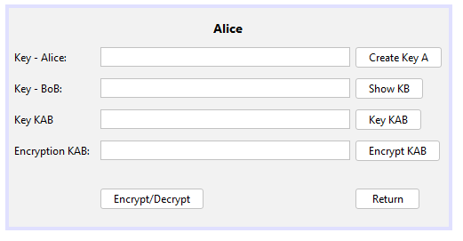

package lab7;

import java.io.BufferedWriter;

import java.io.FileInputStream;

import java.io.FileOutputStream;

import java.io.FileWriter;

import java.security.AlgorithmParameterGenerator;

import java.security.AlgorithmParameters;

import java.security.KeyFactory;

import java.security.KeyPair;

import java.security.KeyPairGenerator;

import java.security.PublicKey;

import java.security.spec.X509EncodedKeySpec;

import javax.crypto.Cipher;

import javax.crypto.KeyAgreement;

import javax.crypto.SecretKey;

import javax.crypto.spec.DHParameterSpec;

public class Alice extends javax.swing.JFrame {

KeyAgreement aliceKeyAgree;

PublicKey bobPubKey;

SecretKey aliceDesKey;

Cipher aliceCipher;

public Alice() {

initComponents();

}

private void btnCreateKeyAActionPerformed(java.awt.event.ActionEvent evt) {

// TODO add your handling code here:

try {

AlgorithmParameterGenerator paramGen=AlgorithmParameterGenerator.getInstance("DH");

paramGen.init(512);

AlgorithmParameters params = paramGen.generateParameters();

DHParameterSpec dhSkipParamSpec=(DHParameterSpec) params.getParameterSpec (DHParameterSpec.class);

System.out.println("Generating a DH Keypair...");

KeyPairGenerator aliceKpairGen = KeyPairGenerator.getInstance("DH");

aliceKpairGen.initialize (dhSkipParamSpec);

KeyPair aliceKpair = aliceKpairGen.generateKeyPair();

System.out.println("Initializing the KeyAgreement Engine with DH private key");

aliceKeyAgree= KeyAgreement.getInstance("DH");

aliceKeyAgree.init(aliceKpair.getPrivate());

byte[] alicePubKeyEnc= aliceKpair.getPublic().getEncoded();

FileOutputStream fos =new FileOutputStream("D:/A.pub");

fos.write(alicePubKeyEnc);

fos.close();

txtKeyA.setText(alicePubKeyEnc.toString());

} catch (Exception e) {

}

}

private void btnShowKhoaBActionPerformed(java.awt.event.ActionEvent evt) {

// TODO add your handling code here:

try {

FileInputStream fis = new FileInputStream("D:/B.pub");

byte[] bkeyP=new byte[fis.available()];

fis.close();

txtKeyB.setText (bkeyP.toString());

} catch (Exception e) {

}

}

private void btnEncryptKABActionPerformed(java.awt.event.ActionEvent evt) {

// TODO add your handling code here:

try {

aliceKeyAgree.doPhase (bobPubKey, true);

aliceDesKey = aliceKeyAgree.generateSecret("DES");

txtEncryptionKAB.setText(aliceDesKey.toString());

BufferedWriter bw = null;

String fileName="D:\\KeyA.txt";

bw = new BufferedWriter(new FileWriter(fileName));

bw.write(aliceDesKey.toString());

bw.close();

} catch (Exception e) {

}

}

private void btnKeyABActionPerformed(java.awt.event.ActionEvent evt) {

// TODO add your handling code here:

try {

FileInputStream fis = new FileInputStream("D:/B.pub");

byte[] bobPubKeyEnc = new byte[fis.available()];

fis.read(bobPubKeyEnc);

fis.close();

KeyFactory aliceKeyFac=KeyFactory.getInstance("DH");

X509EncodedKeySpec x509KeySpec=new X509EncodedKeySpec (bobPubKeyEnc);

bobPubKey= aliceKeyFac.generatePublic(x509KeySpec);

System.out.println("Executing PHASEl of key agreement...");

aliceKeyAgree.doPhase (bobPubKey, true);

byte[] aliceSharedSecret=aliceKeyAgree.generateSecret();

System.out.println("Key KAB: secret (DEBUG ONLY): " + Crypto.toHexString(aliceSharedSecret));

txtKeyAB.setText (Crypto.toHexString(aliceSharedSecret));

} catch (Exception ex) {}

}

private void btnEncryptDecryptActionPerformed(java.awt.event.ActionEvent evt) {

// TODO add your handling code here:

Bob des = new Bob();

des.setVisible(true);

}

private void btnReturnActionPerformed(java.awt.event.ActionEvent evt) {

// TODO add your handling code here:

Alice n = new Alice();

n.setVisible(true);

}

}

**LAB7_3: Bob**

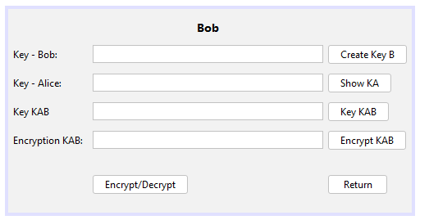

package lab7;

import java.io.BufferedWriter;

import java.io.FileInputStream;

import java.io.FileOutputStream;

import java.io.FileWriter;

import java.security.KeyFactory;

import java.security.KeyPair;

import java.security.KeyPairGenerator;

import java.security.PublicKey;

import java.security.spec.X509EncodedKeySpec;

import javax.crypto.Cipher;

import javax.crypto.KeyAgreement;

import javax.crypto.SecretKey;

import javax.crypto.interfaces.DHPublicKey;

import javax.crypto.spec.DHParameterSpec;

public class Bob extends javax.swing.JFrame {

KeyAgreement bobKeyAgree;

PublicKey alicePubKey;

SecretKey bobDesKey;

Cipher bobCipher;

public Bob() {

initComponents();

}

private void btnCreateKeyBActionPerformed(java.awt.event.ActionEvent evt) {

// TODO add your handling code here:

try {

boolean read = false;

while(!read) {

try {

FileInputStream fis = new FileInputStream("D:/A.pub");

fis.close();

read=true;

} catch (Exception ex) {}

}

FileInputStream fis = new FileInputStream("D:/A.pub");

byte[] alicePubKeyEnc = new byte[fis.available()];

fis.read(alicePubKeyEnc);

fis.close();

KeyFactory bobKeyFac = KeyFactory.getInstance("DH");

X509EncodedKeySpec x509KeySpec = new X509EncodedKeySpec(alicePubKeyEnc);

alicePubKey = bobKeyFac.generatePublic (x509KeySpec);

DHParameterSpec dhParamSpec = ((DHPublicKey) alicePubKey).getParams();

System.out.println("Generate DH keypair...");

KeyPairGenerator bobKpairGen = KeyPairGenerator.getInstance("DH");

bobKpairGen.initialize (dhParamSpec);

KeyPair bobKpair = bobKpairGen.generateKeyPair();

System.out.println("initializing KeyAgreement engine...");

bobKeyAgree = KeyAgreement.getInstance("DH");

bobKeyAgree.init(bobKpair.getPrivate());

byte[] bobPubKeyEnc = bobKpair.getPublic().getEncoded();

FileOutputStream fos=new FileOutputStream("D:/B.pub");

fos.write(bobPubKeyEnc);

fos.close();

txtkhoab.setText (bobPubKeyEnc.toString());

} catch (Exception e) {

}

}

private void btnShowKAActionPerformed(java.awt.event.ActionEvent evt) {

// TODO add your handling code here:

try {

FileInputStream fis = new FileInputStream("D:/A.pub");

byte[] akeyP=new byte[fis.available()];

fis.read(akeyP);

fis.close();

txtkhoaa.setText (akeyP.toString());

} catch (Exception e) {

}

}

private void btnKeyABActionPerformed(java.awt.event.ActionEvent evt) {

// TODO add your handling code here:

try {

bobKeyAgree.doPhase (alicePubKey, true);

byte[] bobSharedSecret = bobKeyAgree.generateSecret ();

System.out.println("Key KAB shared secret (DEBUG ONLY)"+ Crypto.toHexString(bobSharedSecret));

txtkhoachung.setText(Crypto.toHexString(bobSharedSecret));

} catch (Exception e) {}

}

private void btnEncryptKABActionPerformed(java.awt.event.ActionEvent evt) {

// TODO add your handling code here:

try {

bobKeyAgree.doPhase (alicePubKey, true);

bobDesKey = bobKeyAgree.generateSecret("DES");

txtmahoakab.setText(bobDesKey.toString());

BufferedWriter bw = null;

String fileName="D:\\KhoaB.txt";

bw = new BufferedWriter(new FileWriter(fileName));

bw.write(bobDesKey.toString());

bw.close();

} catch (Exception e) {}

}

private void btnEncryptDecryptActionPerformed(java.awt.event.ActionEvent evt) {

// TODO add your handling code here:

Alice des = new Alice();

des.setVisible(true);

}

private void btnReturnActionPerformed(java.awt.event.ActionEvent evt) {

// TODO add your handling code here:

Bob n = new Bob();

n.setVisible(true);

}

}

**LAB8: DESCS**

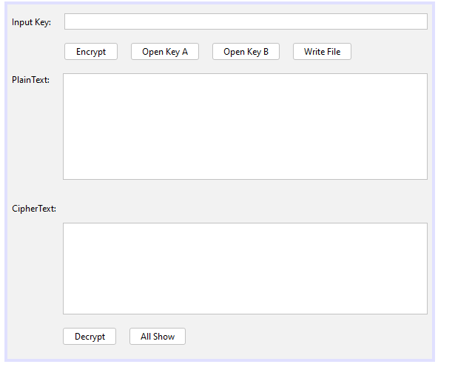

package lab8;

import java.io.BufferedReader;

import java.io.BufferedWriter;

import java.io.FileInputStream;

import java.io.FileOutputStream;

import java.io.FileReader;

import java.io.FileWriter;

import java.io.IOException;

import java.io.InputStream;

import java.io.OutputStream;

import java.util.logging.*;

import javax.crypto.Cipher;

import javax.crypto.CipherInputStream;

import javax.crypto.CipherOutputStream;

import javax.crypto.SecretKey;

import javax.crypto.SecretKeyFactory;

import javax.crypto.spec.DESKeySpec;

import javax.swing.JOptionPane;

public class DESCS extends javax.swing.JFrame {

public DESCS() {

initComponents();

}

private static void doCopy (InputStream is, OutputStream os) throws IOException{

byte[] bytes = new byte[64];

int numBytes;

while ((numBytes = is.read(bytes))!= -1) {

os.write(bytes, 0, numBytes);

}

os.flush();

os.close();

is.close();

}

public static void encrypt(String key, InputStream is, OutputStream os) throws Throwable {

encryptOrDeCrypt(key, Cipher.ENCRYPT_MODE, is, os);

}

public static void decrypt(String key, InputStream is, OutputStream os) throws Throwable {

encryptOrDeCrypt(key, Cipher.DECRYPT_MODE, is, os);

}

public static void encryptOrDeCrypt(String key, int mode, InputStream is, OutputStream os) throws Throwable {

DESKeySpec dks = new DESKeySpec(key.getBytes());

SecretKeyFactory skf = SecretKeyFactory.getInstance("DES");

SecretKey desKey = skf.generateSecret (dks);

Cipher cipher = Cipher.getInstance("DES");

if (mode == Cipher. ENCRYPT_MODE) {

cipher.init(Cipher.ENCRYPT_MODE, desKey);

CipherInputStream cis = new CipherInputStream(is, cipher);

doCopy(cis, os);

}else if (mode == Cipher. DECRYPT_MODE) {

cipher.init(Cipher.DECRYPT_MODE, desKey);

CipherOutputStream cos = new CipherOutputStream(os, cipher);

doCopy(is, cos);

}

}

private void btnEncryptActionPerformed(java.awt.event.ActionEvent evt) {

// TODO add your handling code here:

try {

String key = txtkhoa.getText();

FileInputStream fis = new FileInputStream("D:\\Des.txt");

FileOutputStream fos = new FileOutputStream("D:\\EnDes.txt");

encrypt (key, fis, fos);

JOptionPane.showMessageDialog(null, "Encrypted");

} catch (Throwable e) {

e.printStackTrace();

}

}

private void btnOpenKeyAActionPerformed(java.awt.event.ActionEvent evt) {

// TODO add your handling code here:

try {

BufferedReader br = null;

String fileName="D:\\KeyA.txt";

br = new BufferedReader(new FileReader (fileName));

StringBuffer sb = new StringBuffer();

JOptionPane.showMessageDialog(null, "Opened File");

char[] ca = new char[5];

while (br.ready()) {

int len = br.read(ca);

sb.append(ca, 0, len);

}

br.close();

System.out.println("Data is: " + " " + sb);

String chuoi = sb.toString();

txtkhoa.setText(chuoi);

} catch (IOException ex) {

Logger.getLogger(DESCS.class.getName()).log (Level. SEVERE, null, ex);

}

}

private void btnOpenKeyBActionPerformed(java.awt.event.ActionEvent evt) {

// TODO add your handling code here:

try {

BufferedReader br = null;

String fileName = "D:\\KeyB.txt";

br = new BufferedReader(new FileReader (fileName));

StringBuffer sb = new StringBuffer();

JOptionPane.showMessageDialog(null, "Opended File");

char[] ca = new char[5];

while (br.ready()) {

int len = br.read(ca);

sb.append(ca, 0, len);

}

br.close();

System.out.println("Data is: " + " " + sb);

String chuoi = sb.toString();

txtkhoa.setText(chuoi);

} catch (IOException ex) {

Logger.getLogger(DESCS.class.getName()). log (Level. SEVERE, null, ex);

}

}

private void btnWriteFileActionPerformed(java.awt.event.ActionEvent evt) {

// TODO add your handling code here:

try {

BufferedWriter bw = null;

String fileName = "D:\\Des.txt";

String s = txtvanban.getText();

bw = new BufferedWriter(new FileWriter(fileName));

bw.write(s);

bw.close();

JOptionPane.showMessageDialog(null, "Wrote File");

txtmahoa.setText(s);

} catch (IOException ex) {

Logger.getLogger(DESCS.class.getName()).log(Level. SEVERE, null, ex);

}

}

private void btnDecryptActionPerformed(java.awt.event.ActionEvent evt) {

// TODO add your handling code here:

FileInputStream fis2 = null;

try {

String key = txtkhoa.getText();

fis2 = new FileInputStream("D:\\EnDes.txt");

FileOutputStream fos2 = new FileOutputStream("D:\\DeDes.txt");

decrypt (key, fis2, fos2);

BufferedReader br = null;

String fileName = "D:\\DeDes.txt";

br = new BufferedReader(new FileReader(fileName));

StringBuffer sb =new StringBuffer();

JOptionPane.showMessageDialog(null, "Decrypted!");

char[] ca = new char[5];

while (br.ready()) {

int len = br.read(ca);

sb.append(ca, 0, len);

}

br.close();

System.out.println("Data is: " + " " + sb);

String chuoi = sb.toString();

txtmahoa.setText(chuoi);

} catch (Throwable ex) {

}

}

private void btnAllShowActionPerformed(java.awt.event.ActionEvent evt) {

// TODO add your handling code here:

try {

BufferedReader br = null;

String fileName = "D:\\DeDes.txt";

br = new BufferedReader(new FileReader (fileName));

StringBuffer sb = new StringBuffer();

JOptionPane.showMessageDialog(null, "Opened File");

char[] ca = new char[5];

while (br.ready()) {

int len = br.read(ca);

sb.append(ca, 0, len);

}

br.close();

String ff = "D:\\EnDes.txt";

br = new BufferedReader(new FileReader(ff));

StringBuffer sb1 = new StringBuffer();

char[] ca1 = new char[5];

while (br.ready()) {

int len = br.read(ca1);

sb1.append(ca1, 0, len);

}

System.out.println("Data is: "+" "+sb);

String chuoi = sb.toString();

String chuoi1= sb1.toString();

txtvanban.setText(chuoi);

txtmahoa.setText(chuoi1);

} catch (IOException ex) {}

}

}

**LAB9: Main Form**

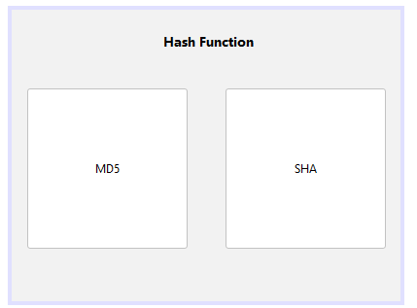

package lab9;

public class Main extends javax.swing.JFrame {

public Main() {

initComponents();

}

private void btnMD5ActionPerformed(java.awt.event.ActionEvent evt) {

// TODO add your handling code here:

MD5 md = new MD5();

md.show();

this.dispose();

}

private void btnSHAActionPerformed(java.awt.event.ActionEvent evt) {

// TODO add your handling code here:

SHA sha = new SHA();

sha.show();

this.dispose();

}

}

**LAB9_2: MD5**

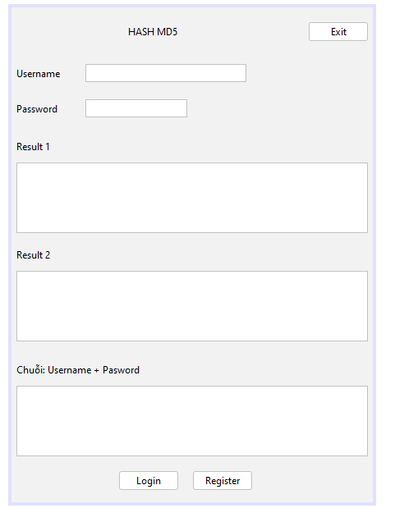

package lab9;

import java.io.BufferedReader;

import java.io.BufferedWriter;

import java.io.FileReader;

import java.io.FileWriter;

import java.security.MessageDigest;

import javax.swing.JOptionPane;

public class MD5 extends javax.swing.JFrame {

public MD5() {

initComponents();

txtUser.setText("LeNgocHao");

txtPass.setText("Abc12345");

}

private void btnLoginActionPerformed(java.awt.event.ActionEvent evt) {

// TODO add your handling code here:

String user = txtUser.getText();

String pass = txtPass.getText();

String bam = "";

bam = user + pass;

BufferedReader br = null;

String filename = "D:\\HashMD5.txt";

try {

br = new BufferedReader(new FileReader (filename));

StringBuffer sb = new StringBuffer();

char[] ca = new char[5];

while (br.ready()) {

int len = br.read(ca);

sb.append(ca, 0, len);

}

br.close();

System.out.println("Authentication: " + sb);

String chuoi = sb.toString();

MessageDigest md = MessageDigest.getInstance("MD5");

md.update (bam.getBytes());

byte[] byteData = md.digest();

StringBuffer hexString = new StringBuffer();

for (int i = 0; i < byteData.length; i++) {

String hex = Integer.toHexString(0xff & byteData[i]);

if (hex.length() == 1) {

hexString.append('0');

}

hexString.append (hex);

}

} catch (Exception e) {

}

}

private void btnRegisterActionPerformed(java.awt.event.ActionEvent evt) {

// TODO add your handling code here:

try {

String user = txtUser.getText();

String pass = txtPass.getText();

String bam = "";

bam = user + pass;

MessageDigest md = MessageDigest.getInstance("MD5");

md.update (bam.getBytes());

byte[] byteData = md.digest();

StringBuffer sb = new StringBuffer();

for (int i = 0; i < byteData.length; i++) {

sb.append(Integer.toString((byteData[i] & 0xff) + 0x100, 16).substring(1));

}

System.out.println("Digest (in hex format): " + sb.toString());

txtHash1.setText(sb.toString());

StringBuffer hexString = new StringBuffer();

for (int i = 0; i < byteData.length; i++) {

String hex = Integer.toHexString(0xff & byteData[i]);

if (hex.length() == 1) {

hexString.append('0');

}

hexString.append(hex);

}

System.out.println("Digest(in hex format): " + hexString.toString());

txtHash2.setText(hexString.toString());

txtString.setText(bam.toString());

BufferedWriter bw = null;

String filename = "D:\\HashMD5.txt";

bw = new BufferedWriter(new FileWriter(filename));

bw.write(hexString.toString());

bw.close();

JOptionPane.showMessageDialog(null, "Registed Success. Please Login");

} catch (Exception ex) {

JOptionPane.showMessageDialog(null, "Error Hash User and Pass: " + ex);

}

}

private void btnExitActionPerformed(java.awt.event.ActionEvent evt) {

// TODO add your handling code here:

Main main = new Main();

main.setLocationRelativeTo(null);

main.show();

this.dispose();

}

}

**LAB9_3: SHA**

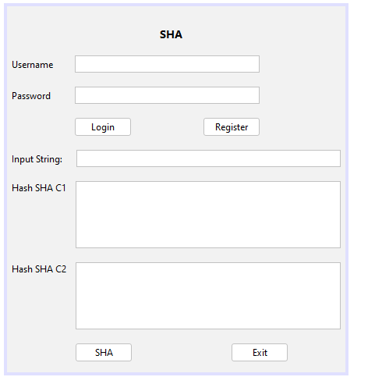

package lab9;

import java.io.BufferedReader;

import java.io.BufferedWriter;

import java.io.FileReader;

import java.io.FileWriter;

import java.security.MessageDigest;

import java.security.NoSuchAlgorithmException;

import javax.swing.JOptionPane;

import java.util.logging.*;

public class SHA extends javax.swing.JFrame {

boolean role;

public SHA() {

initComponents();

role = false;

txtUser.setText("LeNgocHao");

txtPass.setText("Abc1234");

txtString.setText("informationSecurity");

}

private void btnLoginActionPerformed(java.awt.event.ActionEvent evt) {

// TODO add your handling code here:

String user = txtUser.getText();

String pass = txtPass.getText();

String bam = "";

bam = user + pass;

BufferedReader br = null;

String filename = "D:\\SHA.txt";

try {

br = new BufferedReader(new FileReader (filename));

StringBuffer sb = new StringBuffer();

char[] ca = new char[5];

while (br.ready()) {

int len = br.read(ca);

sb.append(ca, 0, len);

}

br.close();

System.out.println("Authentication: " + sb);

String chuoi = sb.toString();

MessageDigest md = MessageDigest.getInstance("SHA-256");

md.update (bam.getBytes());

byte[] byteData = md.digest();

StringBuffer hexString = new StringBuffer();

for (int i = 0; i < byteData.length; i++) {

String hex = Integer.toHexString(0xff & byteData[i]);

if (hex.length() == 1) {

hexString.append('0');

}

hexString.append(hex);

}

System.out.println("Hash username and password: " + hexString.toString());

Boolean k = hexString.toString().equals(chuoi);

if (k == true) {

role = true;

JOptionPane.showMessageDialog(null, "Login Success!");

txtbam1.setText (hexString.toString());

txtbam2.setText(chuoi);

System.out.println("Username: " + user + "\n" + "Password: "+ pass);

} else {

JOptionPane.showMessageDialog(null, "Fail Login!");

role = false;

}

} catch (Exception e) {

JOptionPane.showMessageDialog(null, "Login Error!");

}

}

private void btnRegisterActionPerformed(java.awt.event.ActionEvent evt) {

// TODO add your handling code here:

try{

String user = txtUser.getText();

String pass = txtPass.getText();

String bam = "";

bam = user + pass;

MessageDigest md = MessageDigest.getInstance("SHA-256");

md.update (bam.getBytes());

byte[] byteData = md.digest();

StringBuffer sb = new StringBuffer();

for (int i = 0; i < byteData.length; i++) {

sb.append(Integer.toString((byteData[1] & 0xff) + 0x100, 16).substring(1));

}

System.out.println("Digest (in hex format): " + sb.toString());

txtbam1.setText(sb.toString());

StringBuffer hexString = new StringBuffer();

for (int i = 0; i < byteData.length; i++) {

String hex = Integer.toHexString(0xff & byteData[i]);

if (hex.length() == 1) {

hexString.append('0');

}

hexString.append (hex);

}

BufferedWriter bw = null;

String filename = "D:\\SHA.txt";

bw = new BufferedWriter(new FileWriter(filename));

bw.write(hexString.toString());

bw.close();

JOptionPane.showMessageDialog(null, "Registed Success. Login Please!");

} catch (Exception ex) {

JOptionPane.showMessageDialog(null, "Hash error:user and pass: " + ex);

}

}

private void btnSHAActionPerformed(java.awt.event.ActionEvent evt) {

// TODO add your handling code here:

if (role == true) {

try {

String chuoi = "";

chuoi = txtString.getText();

MessageDigest md = MessageDigest.getInstance("SHA-256");

md.update (chuoi.getBytes());

byte[] byteData = md.digest();

StringBuffer sb = new StringBuffer();

for (int i = 0; i < byteData.length; i++) {

sb.append(Integer.toString((byteData[i] & 0xff) + 0x100, 16).substring(1));

}

System.out.println("Hex formatl: " + sb.toString());

txtbam1.setText(sb.toString());

StringBuffer hexString = new StringBuffer();

for (int i = 0; i < byteData.length; i++) {

String hex = Integer.toHexString(0xff & byteData[i]);

if (hex.length() == 1) {

hexString.append('0');

}

hexString.append(hex);

}

System.out.println("Hex format2: " + hexString.toString());

txtbam2.setText (hexString.toString());

} catch (NoSuchAlgorithmException ex) {

Logger.getLogger(SHA.class.getName()).log(Level. SEVERE, null, ex);

}

}else{

JOptionPane.showMessageDialog(null, "Login Please!");

}

}

private void btnExitActionPerformed(java.awt.event.ActionEvent evt) {

// TODO add your handling code here:

Main main = new Main();

main.setLocationRelativeTo(null);

main.show();

this.dispose();

}

}