FUNCTIONAL EVIDENCE REPORT
AI Harness Desktop and Web
Functional Screenshot Audit
  - Desktop startup, functional verification, issue record, and historical archive
Evidence batch: 2026-08-05 / Review date: 2026-08-07
SCOPE
Native Electron · 25 current web feature views · Historical web visual assets
Preset: compact_reference_guide / Cover: editorial_cover

1. Executive Summary
OUTCOME After rebuilding native desktop dependencies, Electron starts successfully, the desktop bridge connects, and a deterministic offline task completes through the UI with a local result. Twenty-five primary web routes were captured with no horizontal overflow; 23 render a functional or intentional redirect state, while Data Management and Specialists preserve two terminal error states.

This report separates visible product failures, test-fixture drift, and environment gates so that 38 automation failures are not misreported as 38 independent product defects.

Coverage Overview
Scope | Count / status | Evidence boundary
Current web features | 25 views · 23 rendered / 2 error states | Visible state and horizontal layout
Native desktop | Bridge, windows, offline, sync | Real Electron with isolated user-data
Historical web assets | 25 archived files | Representative finals and unique interaction states
Automated verification | 43 + 287 + 5 passed | Backend, desktop tests, and startup contracts
Release browser smoke | 12 passed / 38 failed | Primarily AuthProvider and stale mock-fixture drift

Key Issues
Priority | Issue | Impact and interpretation | Recommended action
P1 | Data Management route returns 404 | `/settings/data` enters the console route error boundary instead of rendering local data, export, and cleanup controls. | Restore the route or its loader/API contract, then add a browser smoke assertion.
P1 | Specialists route cannot load its target | `/subagents/specialists` reaches a terminal subagent load failure that asks for a valid ID or permission instead of rendering the catalog. | Repair the catalog/detail route mapping or ID/permission contract, then add a terminal-state browser assertion.
P2 | Release smoke fixtures omit new auth requests | Most cases fall into API connection error after `/api/auth/me`; this is not evidence of 38 independent product defects. | Centralize auth and new Agent-request mocks in the shared fixture.
P2 | Unauthenticated desktop sync returns 401 | The offline result is generated, but automatic sync enters scheduled retry. | Retest after sign-in and reduce retry noise when credentials are absent.
P3 | Repeated Electron EGL warnings | This host emits `eglQueryDeviceAttribEXT: Bad attribute`; window creation and offline execution still succeed. | Track as a GPU compatibility observation.
Resolved | Missing `better-sqlite3` native binding | Offline sync failed on first launch; runtime and tests recovered after rebuilding native dependencies. | Keep `install-app-deps` in install and packaging flows.

Verification Matrix
Verification | Result | Fresh evidence
Backend desktop tests | PASS · 43 | All desktop-related backend tests passed
Desktop Vitest | PASS · 32 files / 287 tests | Desktop unit and integration coverage passed
Desktop startup contracts | PASS · 5 | Startup contracts passed
Desktop build:main | PASS | Electron main process compiled
Agent Console production build | PASS · 2408 modules | Frontend production build completed
Native offline UI | PASS | Task status=completed; modelSource=deterministic-local
Release browser smoke | PARTIAL · 12 / 50 | 38 failures cluster around auth and new-request mock gaps

Evidence Interpretation
Screenshots prove the visible state at capture time; they do not replace API contracts or sustained runtime testing.
The historical `first-agent-run` demo uses local mocked SSE/API flows and does not prove an external model provider or Docker execution.
`23-data-management.png` intentionally preserves the expanded `404 Not Found` error boundary as current defect evidence rather than presenting a stale loading skeleton.
`15-specialists.png` intentionally preserves the terminal ID-or-permission load failure rather than presenting the earlier loading skeleton.
`06-desktop-offline-after-rebuild.png` captured the wrong foreground window and is retained only for traceability, not acceptance.

2. Native Desktop Evidence
These pages come from real Electron instances. `D-03` is the retained pre-fix defect capture; the remaining images are accepted post-fix or fresh-relaunch evidence.
D-01 · PASS Native desktop bridge connected

Native desktop bridge connected
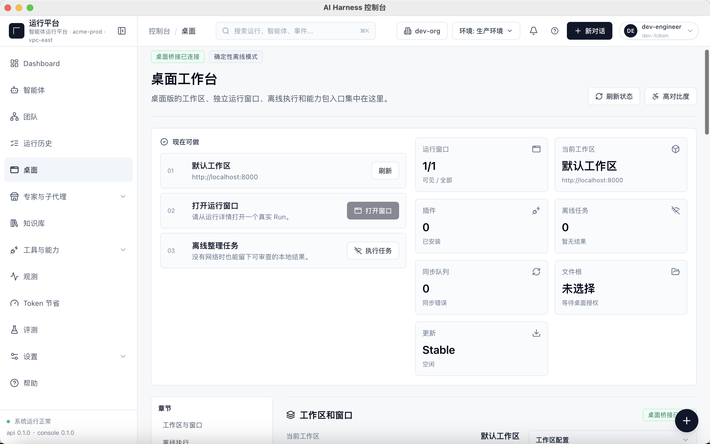
The native bridge, offline mode, and desktop workbench are visible together.

D-02 · PASS Workspace and system operations

Workspace and system operations
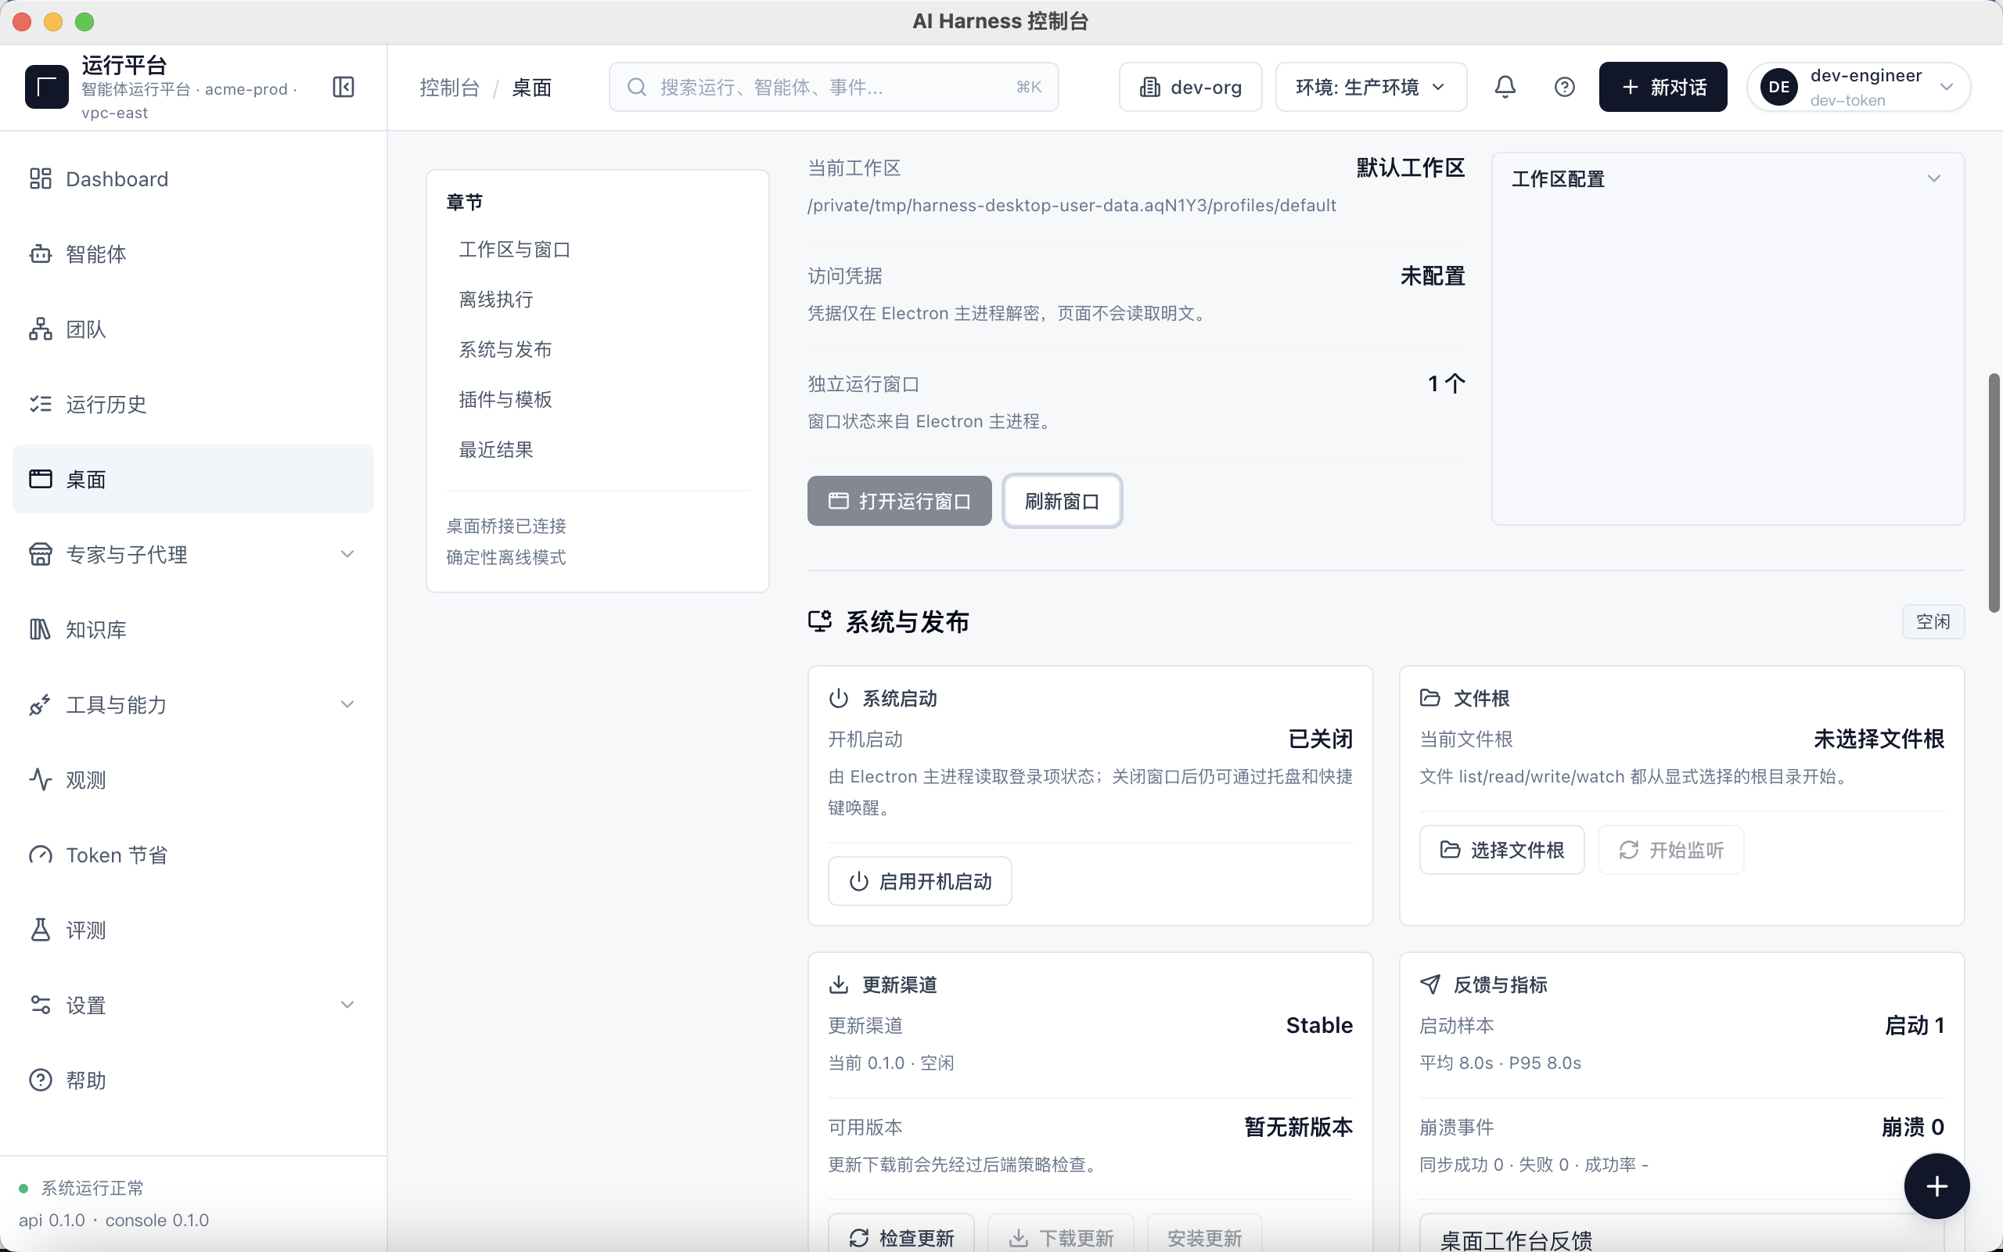
Workspace, independent window, startup, file-root, and update capabilities.

D-03 · PRE-FIX EVIDENCE Pre-fix SQLite native binding failure

Pre-fix SQLite native binding failure
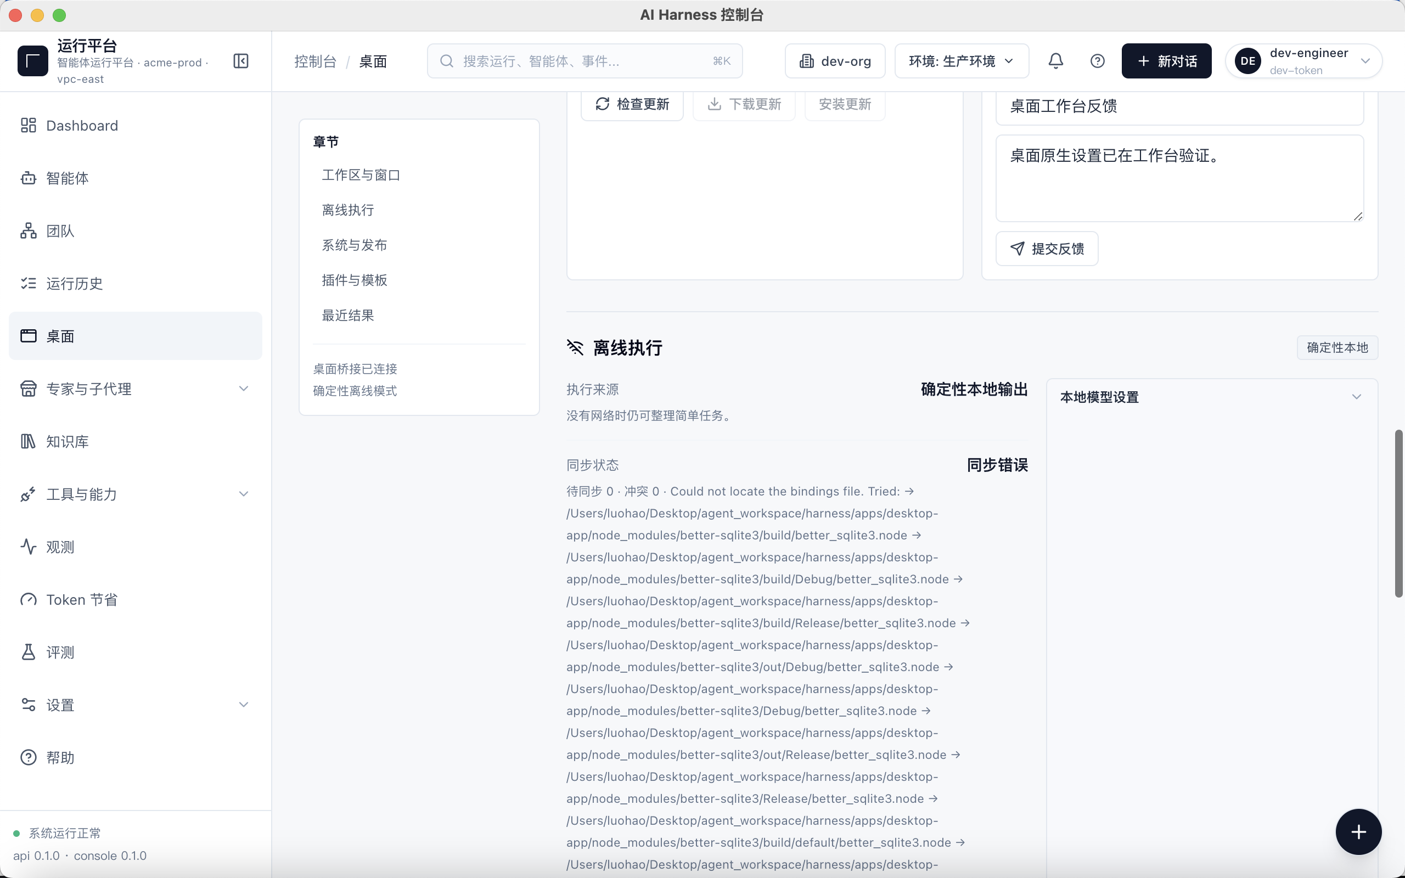
Retained as defect evidence; this state disappeared after native dependency rebuild.

D-04 · PASS Desktop workbench restored after rebuild

Desktop workbench restored after rebuild
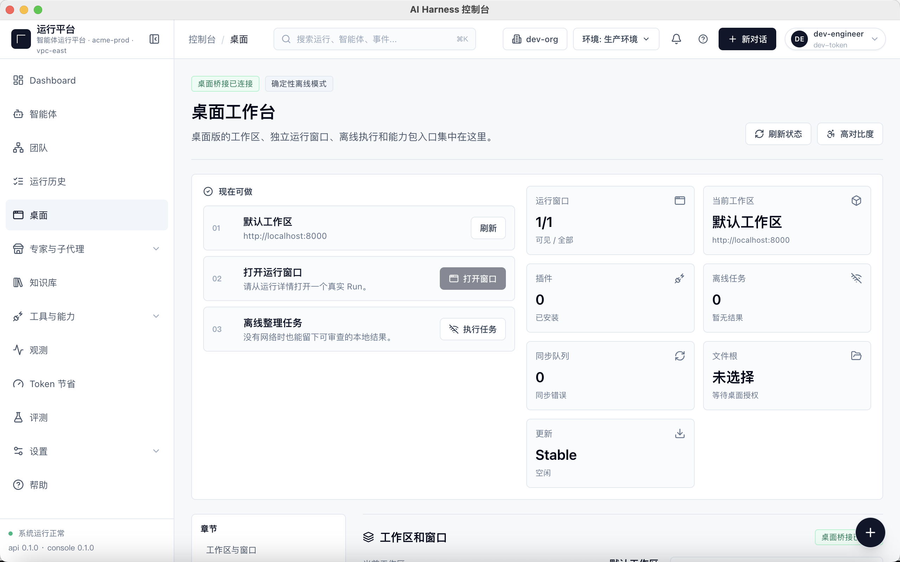
The bridge is connected, window state is readable, and sync error count is zero.

D-05 · OBSERVATION Offline execution UI and sync gate

Offline execution UI and sync gate
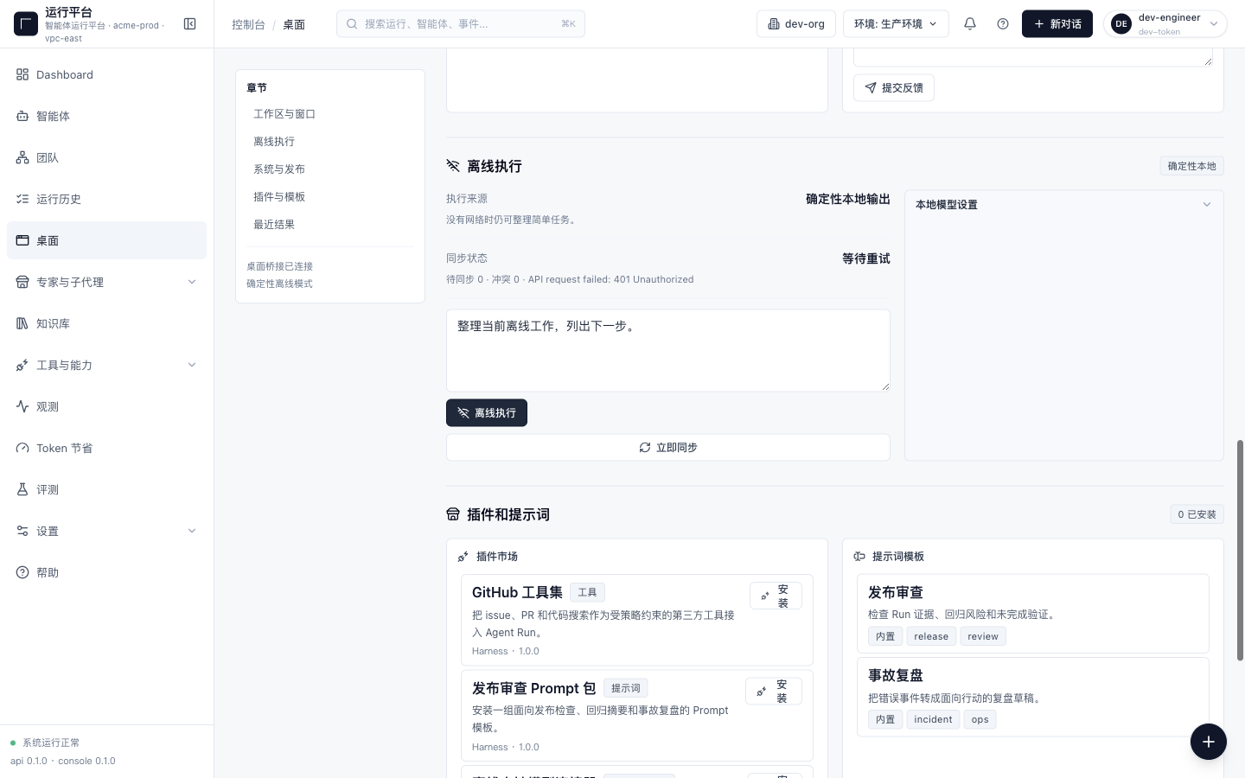
Deterministic local execution is available; unauthenticated API sync reports 401 Unauthorized.

D-06 · PASS Deterministic local task completed

Deterministic local task completed
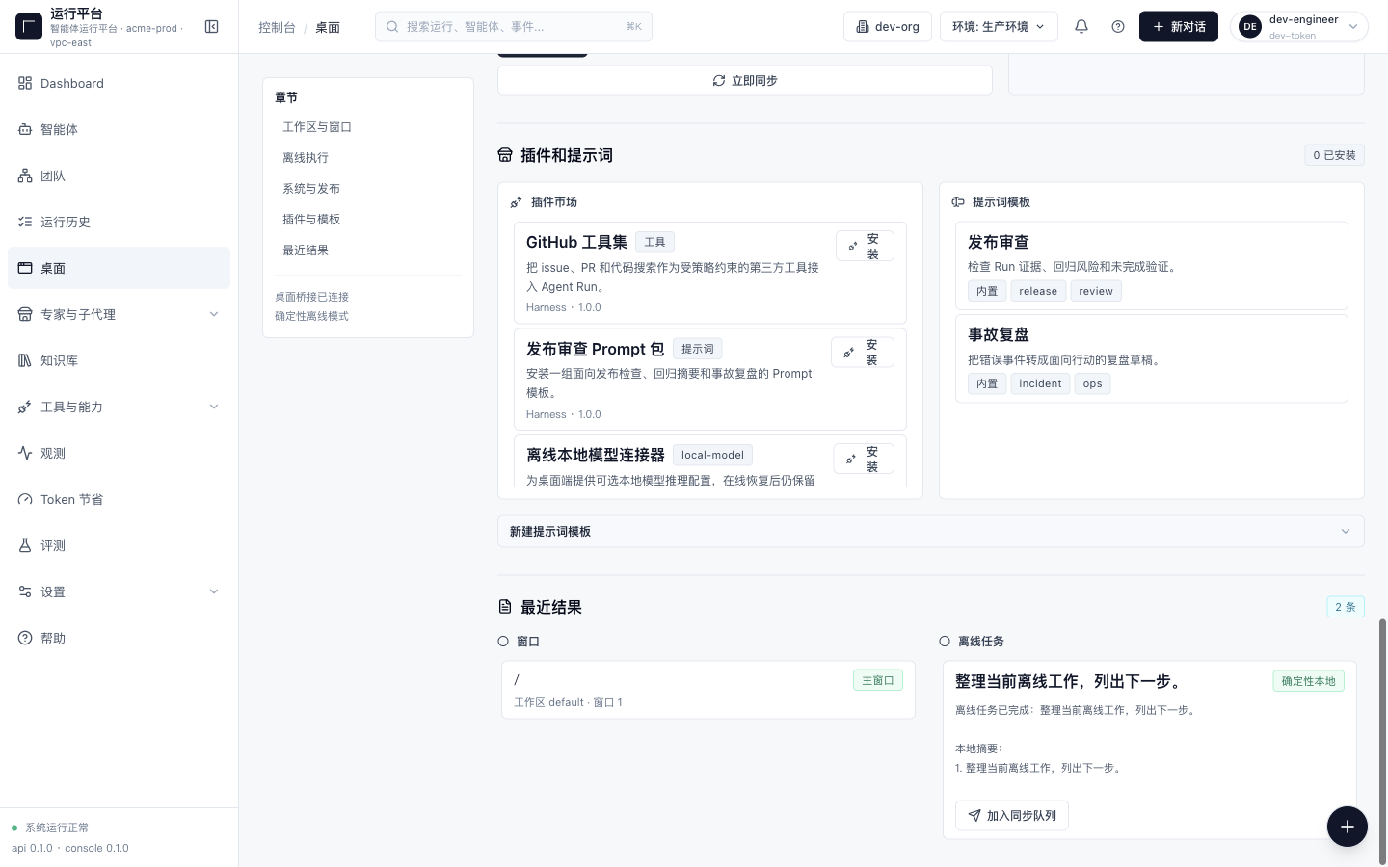
The result list shows completion, summary output, and the sync-queue action.

3. Current Web Feature Screenshots
This section includes 25 current feature routes. Horizontal overflow was checked on every page and measured zero. Trace Explorer uses the correct `/observability/trace` route. Data Management is retained as an expanded 404 error-boundary capture, Specialists is retained as a terminal ID-or-permission load failure, and the other 23 views show a functional or intentional redirect state.

W-01 · Dashboard
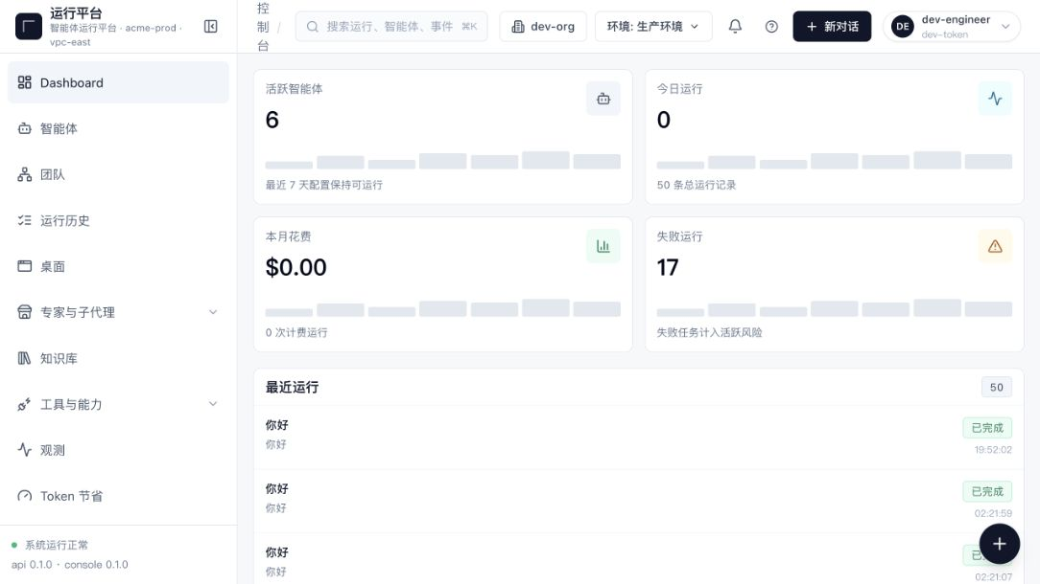
Route: /dashboard. Runtime overview and primary metrics.
W-02 · Agents
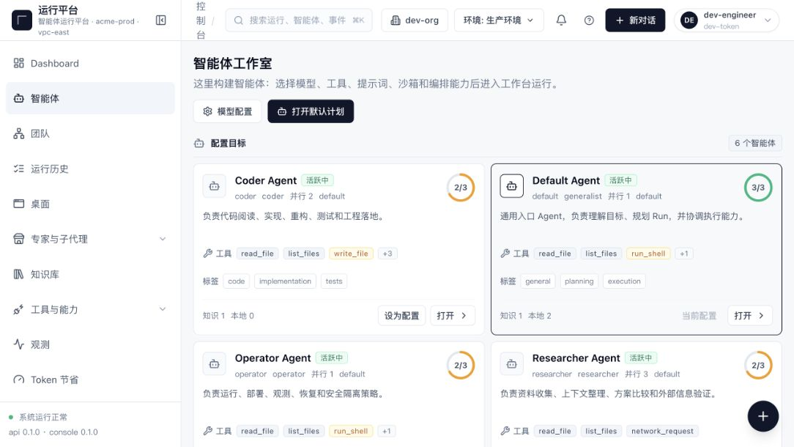
Route: /agents. Agent discovery, status, and launch entry points.

W-03 · Agent Workspace
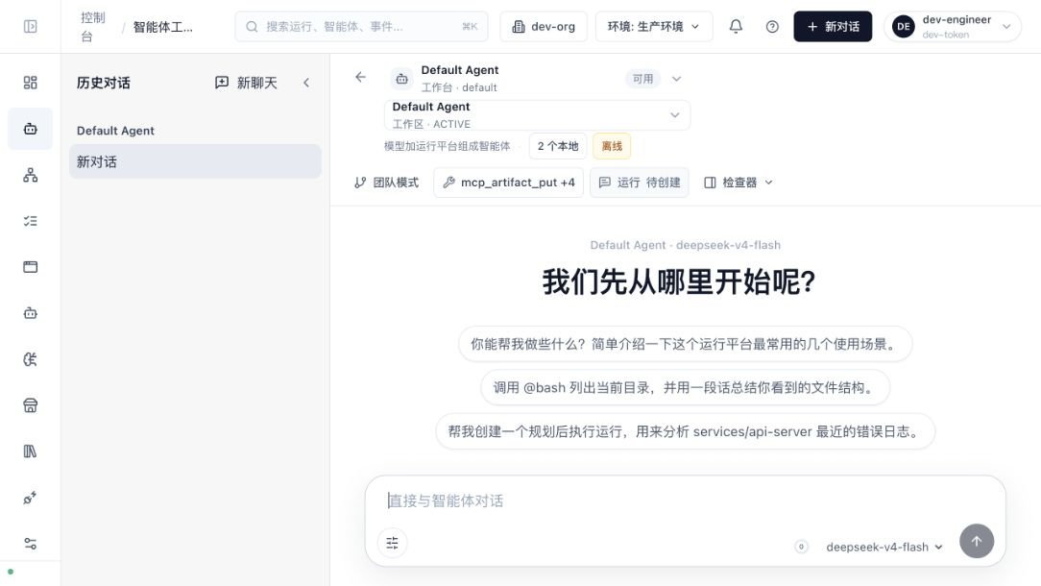
Route: /agents/:id/workspace. Conversation, tool, and context workspace.
W-04 · Teams
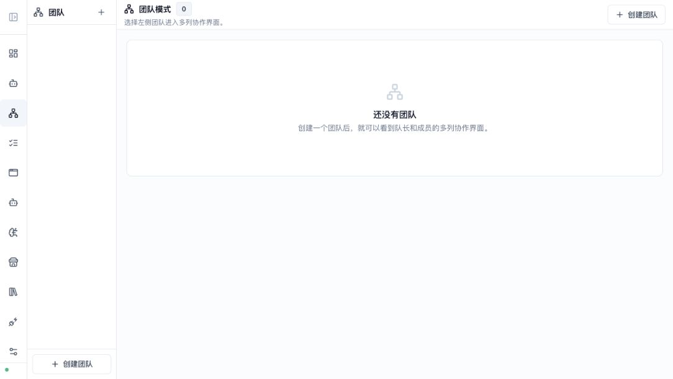
Route: /teams. Team collaboration and orchestration entry point.

W-05 · Run History
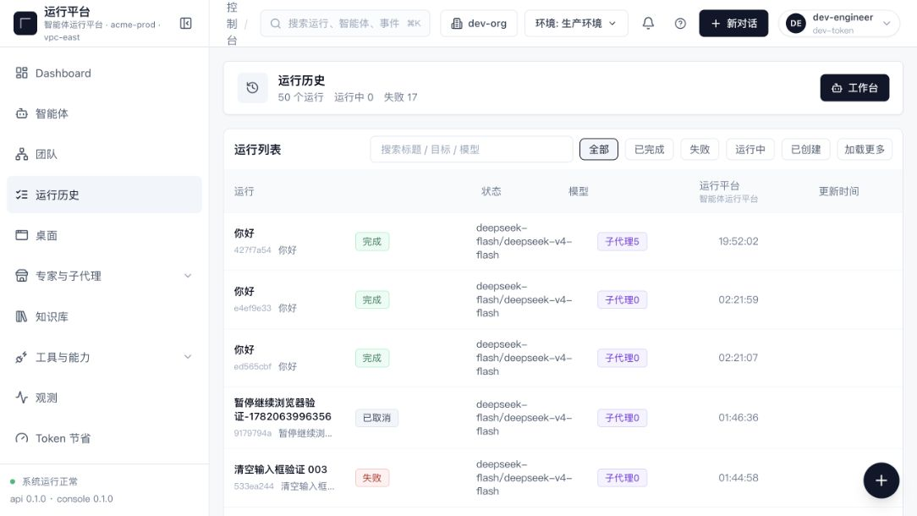
Route: /runs. Run records, status, and filters.
W-06 · Run Detail
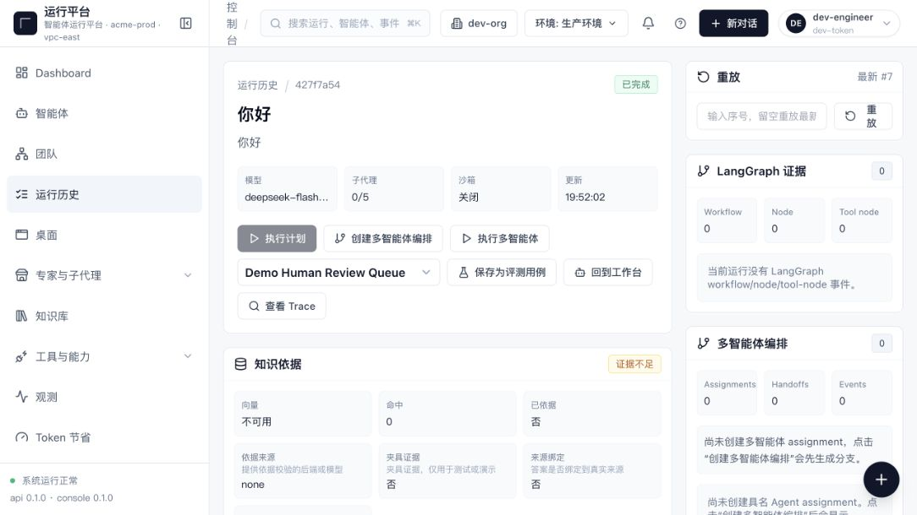
Route: /runs/:id. Evidence, steps, and events for one run.

W-07 · Knowledge
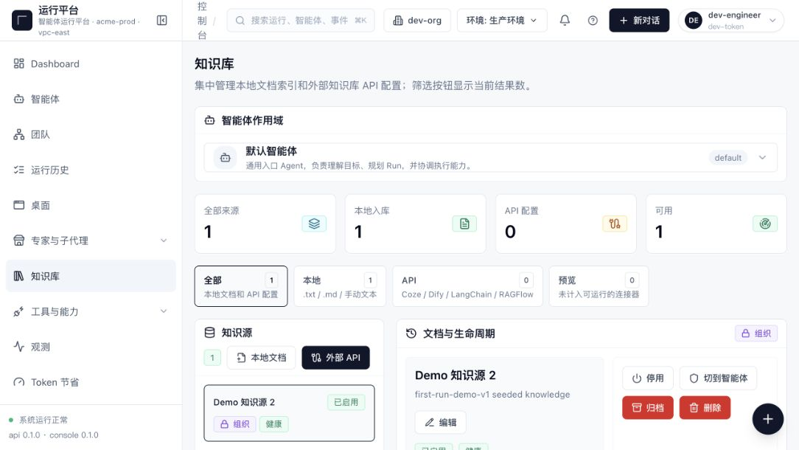
Route: /knowledge. Knowledge-source and retrieval management.
W-08 · Tool Registry
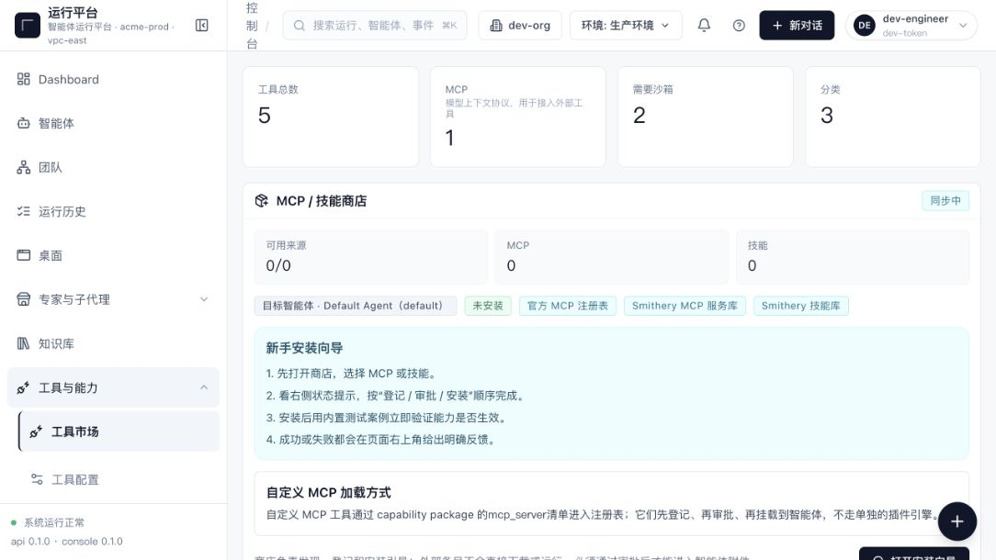
Route: /tools. Tool capabilities, sources, and enablement.

W-09 · Sandboxes
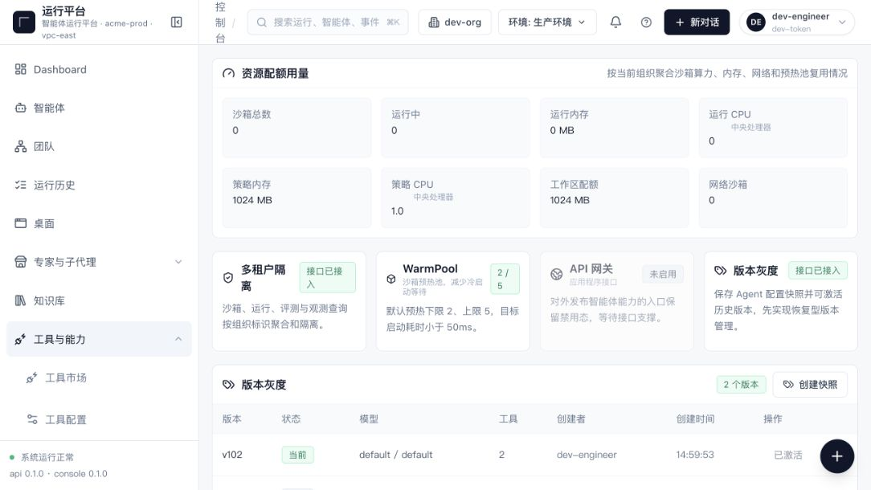
Route: /sandboxes. Isolated environments and lifecycle controls.
W-10 · Terminal
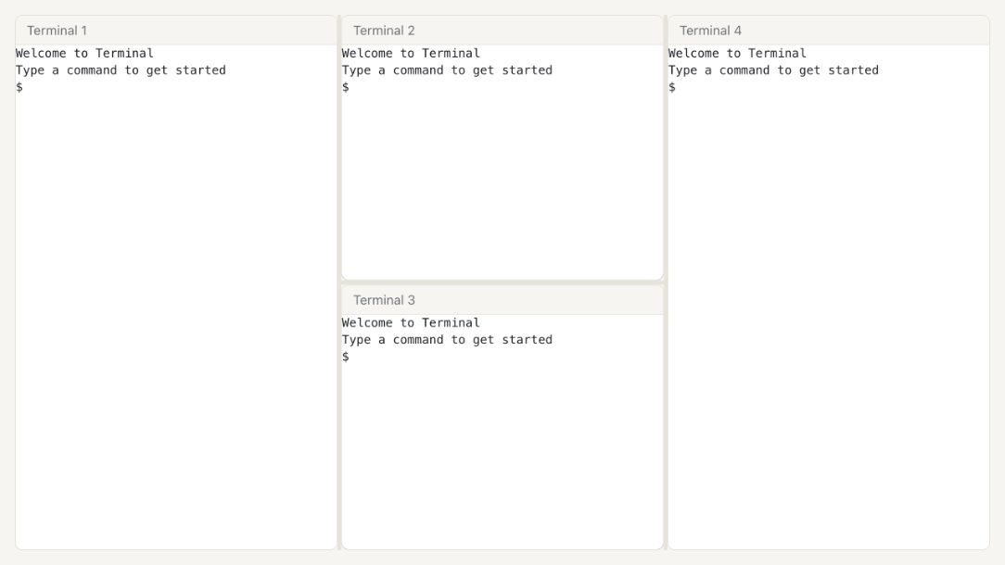
Route: /terminal. Multi-terminal workspace and command execution.

W-11 · Observability
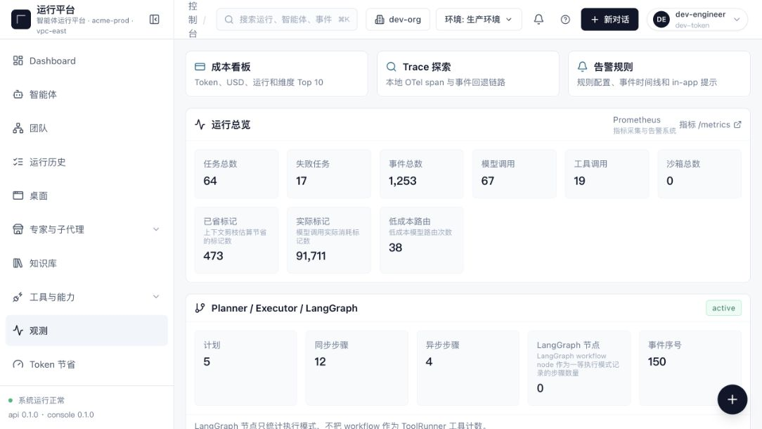
Route: /observability. Runtime events and diagnostic signals.
W-12 · Token Savings
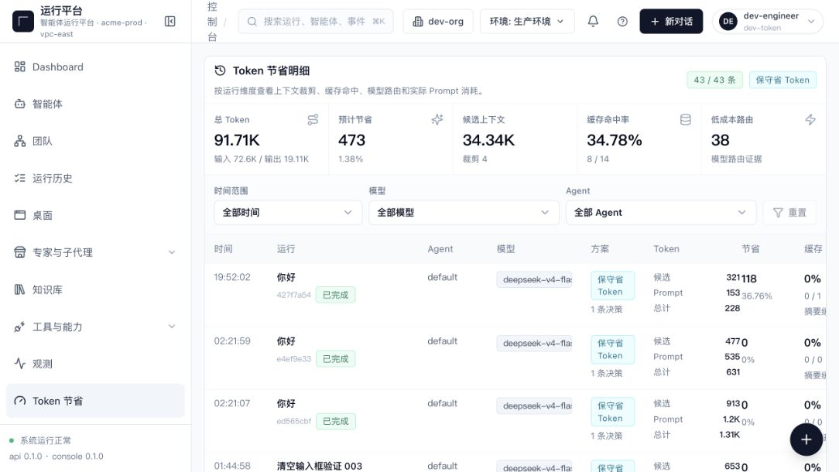
Route: /token-savings. Context compression and savings metrics.

W-13 · Evaluations
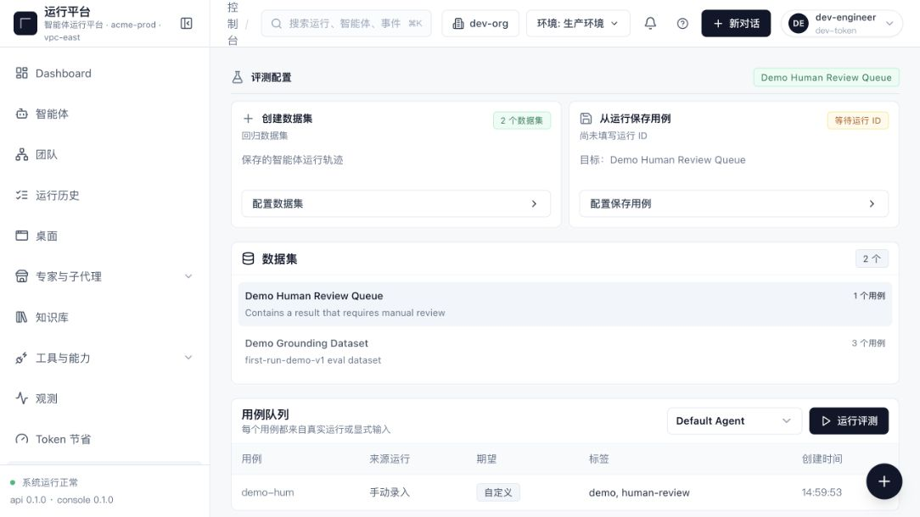
Route: /evals. Evaluation jobs, results, and trends.
W-14 · Subagents
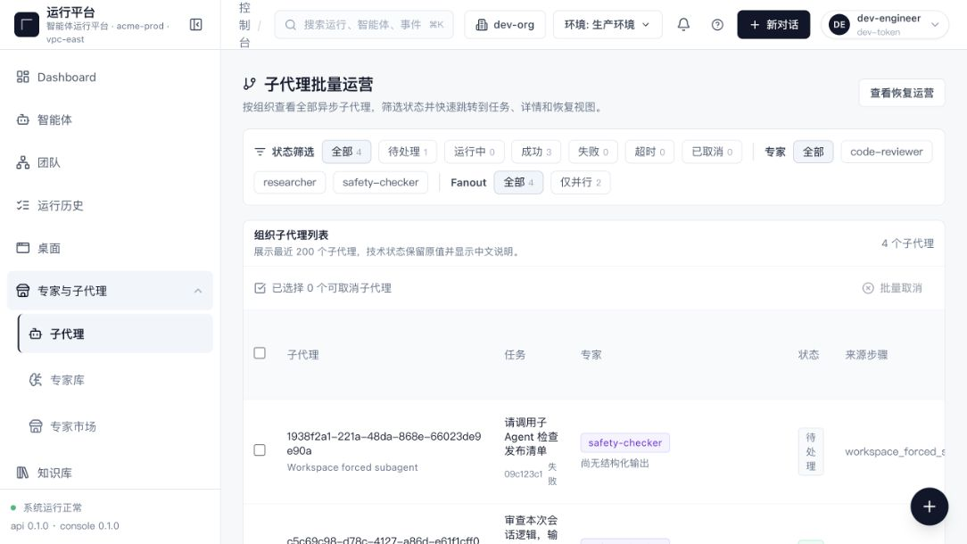
Route: /subagents. Subagent inventory and execution entry points.

W-15 · Specialists
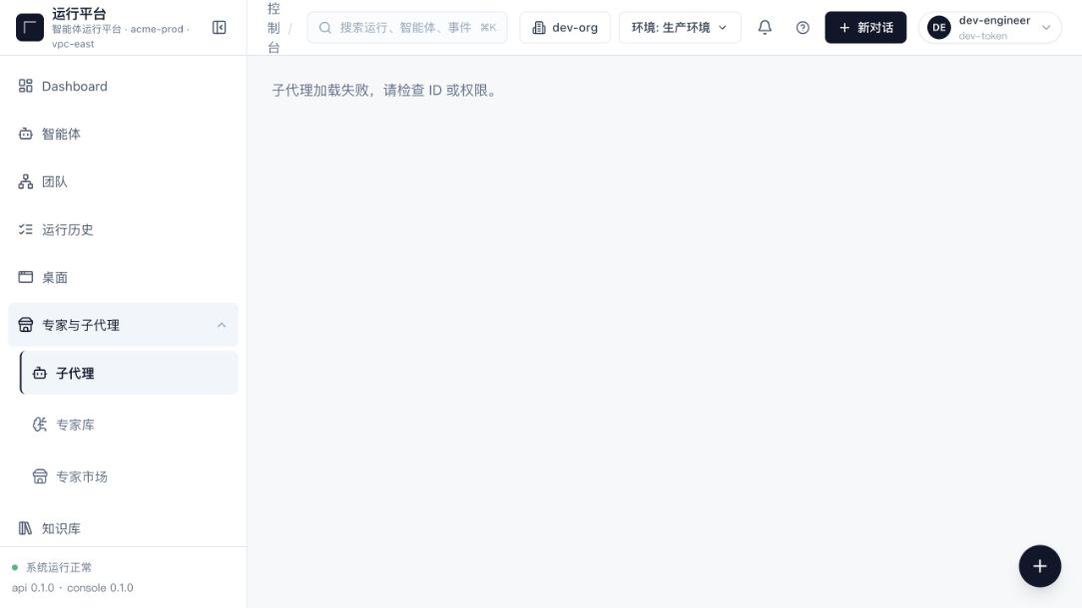
Route: /subagents/specialists. The current route reaches a terminal subagent load failure that asks the operator to check the ID or permission.
W-16 · Model Settings
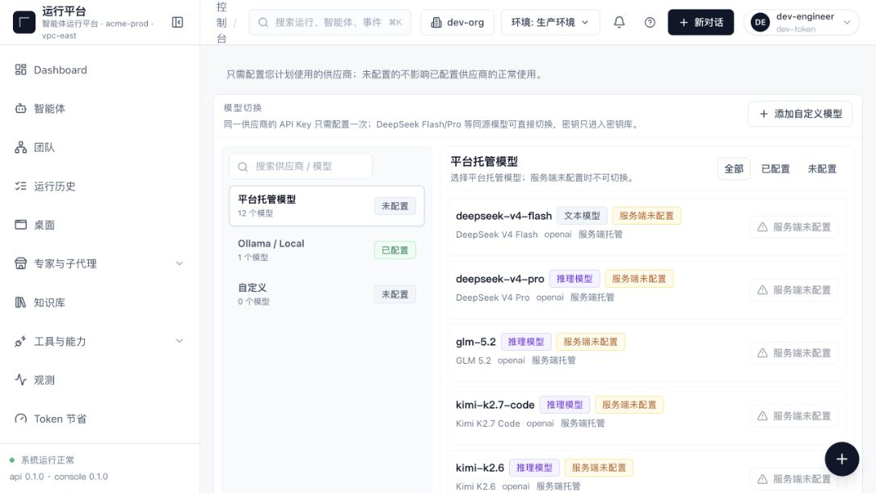
Route: /settings/models. Model, provider, and policy configuration.

W-17 · Advanced Settings
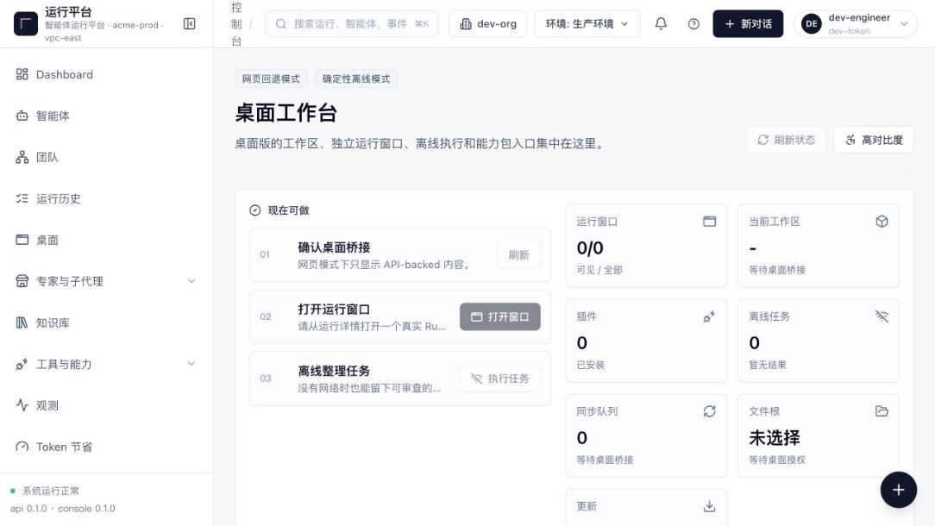
Route: /settings/advanced. Advanced and desktop-specific settings.
W-18 · Help Center
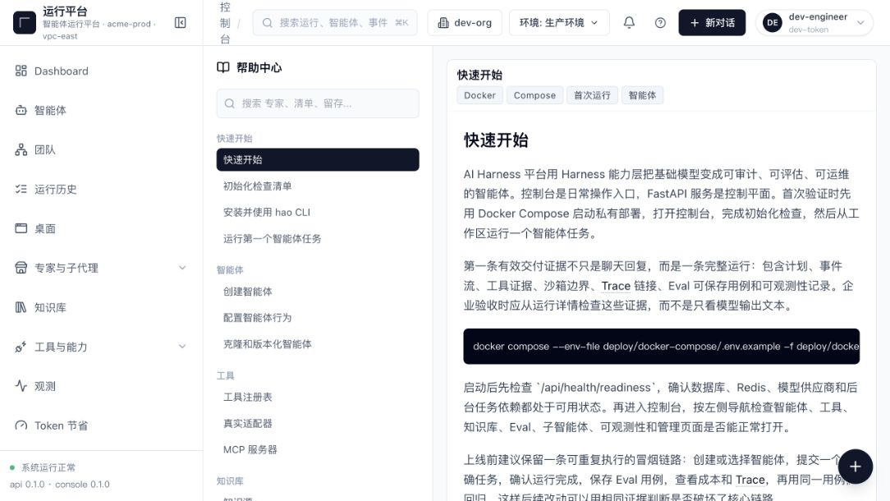
Route: /help. Product help and operating documentation.

W-19 · Desktop Browser Fallback
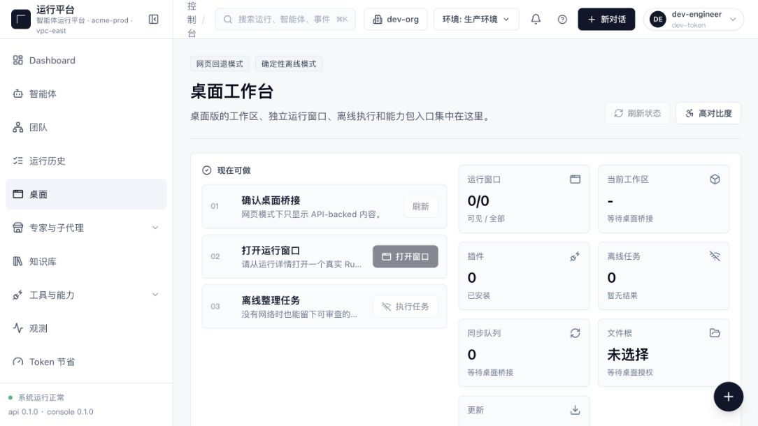
Route: /desktop. Desktop fallback state without a native bridge.
W-20 · Onboarding
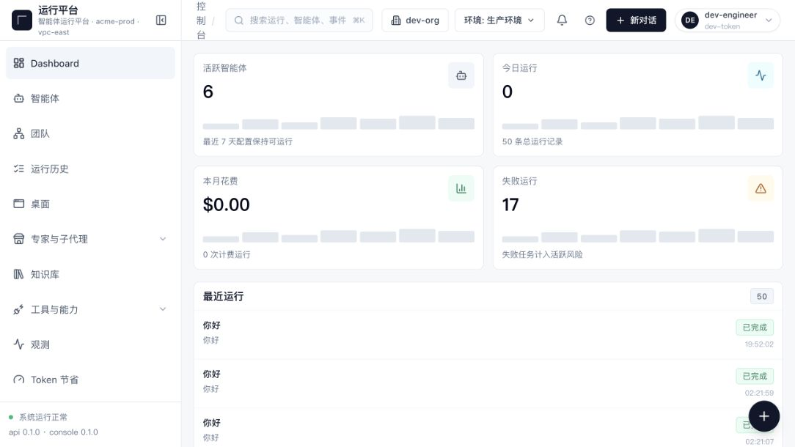
Route: /onboarding. Completed environments redirect to the configured dashboard.

W-21 · Cost Dashboard
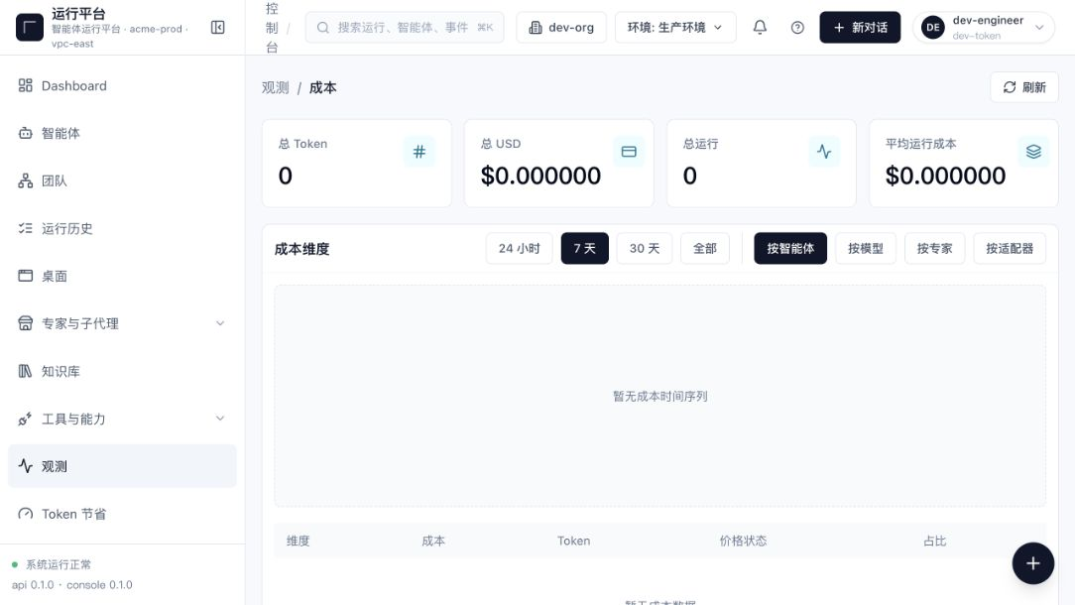
Route: /observability/cost. Model cost and usage analysis.
W-22 · Trace Explorer
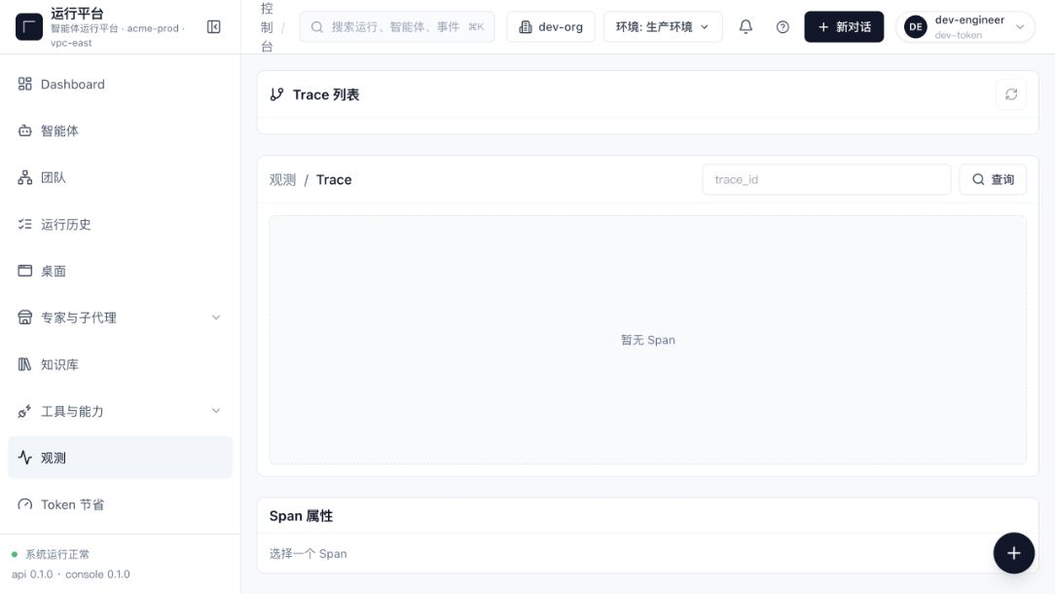
Route: /observability/trace. Trace search and execution diagnostics.

W-23 · Data Management
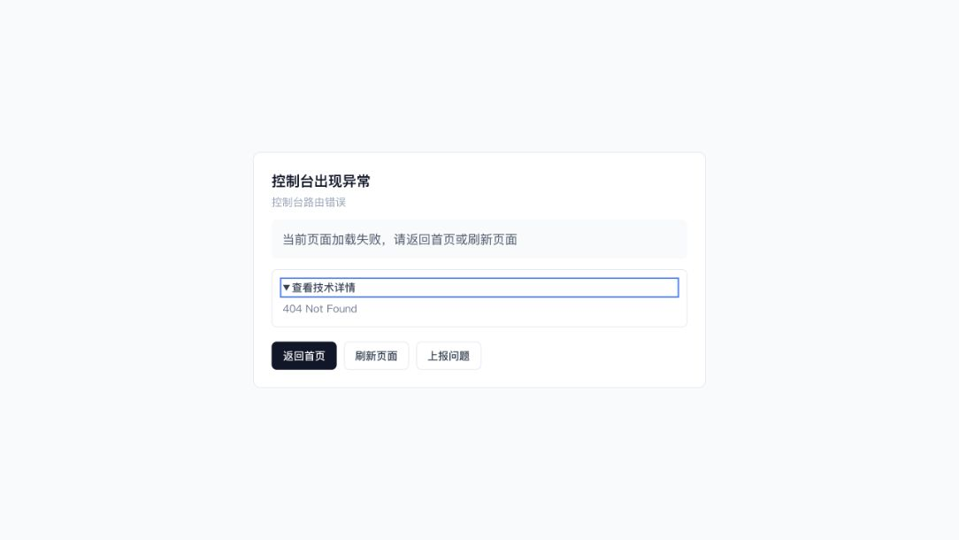
Route: /settings/data. The current route enters the console error boundary with 404 Not Found.
W-24 · Subagent Marketplace
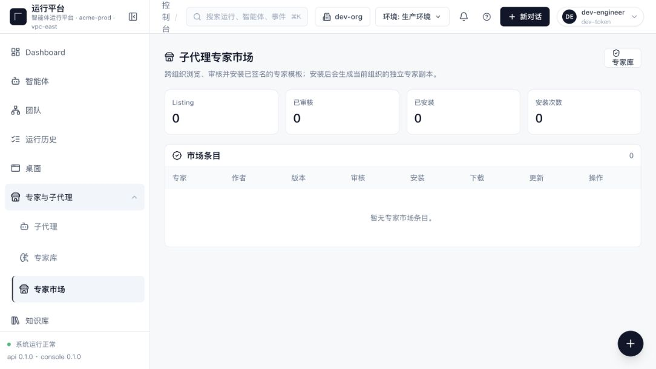
Route: /subagents/marketplace. Installable subagent capabilities.

W-25 · Tool Configuration
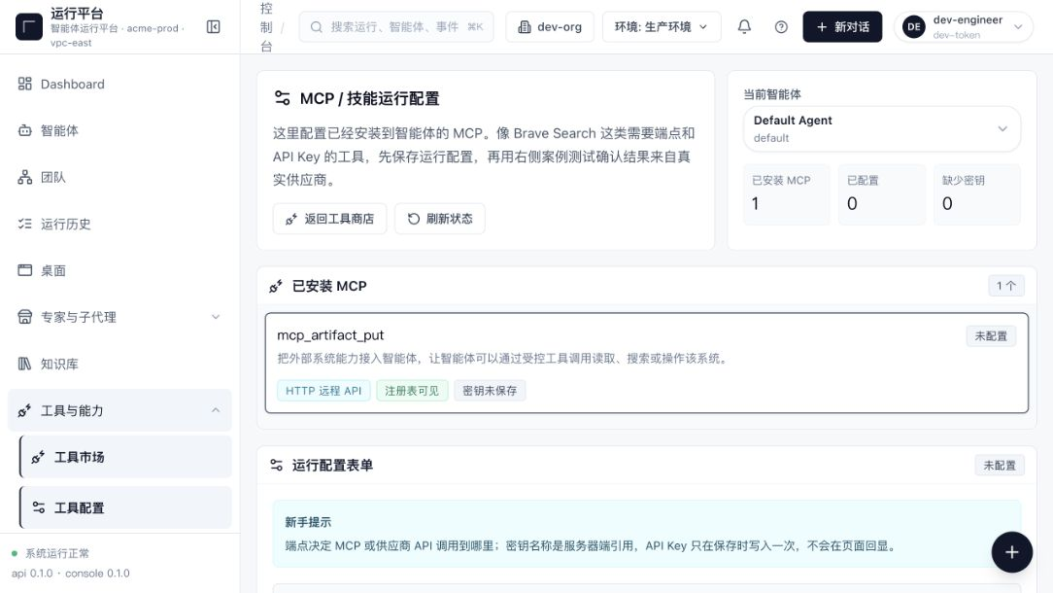
Route: /tools/config. Tool connections and runtime parameters.

4. Historical Web Screenshot Archive
ARCHIVE POLICY Original files are not moved or deleted. Only accepted finals and unique interaction states are copied. Pixel diffs, references, duplicate variants, and intermediate drafts are excluded.

Source batch | Archived content | Date basis
Repository root | Final verification images and unique interactions | Git commit e397e1e · 2026-06-21
docs/gifs | first-agent-run GIF and companion still | Git commit 722802f · 2026-06-21
Visual Ralph Team Mode | Five non-diff outputs | Wiki handoff · 2026-08-04

A-01 · 2026-06-21 · Foundation and onboarding
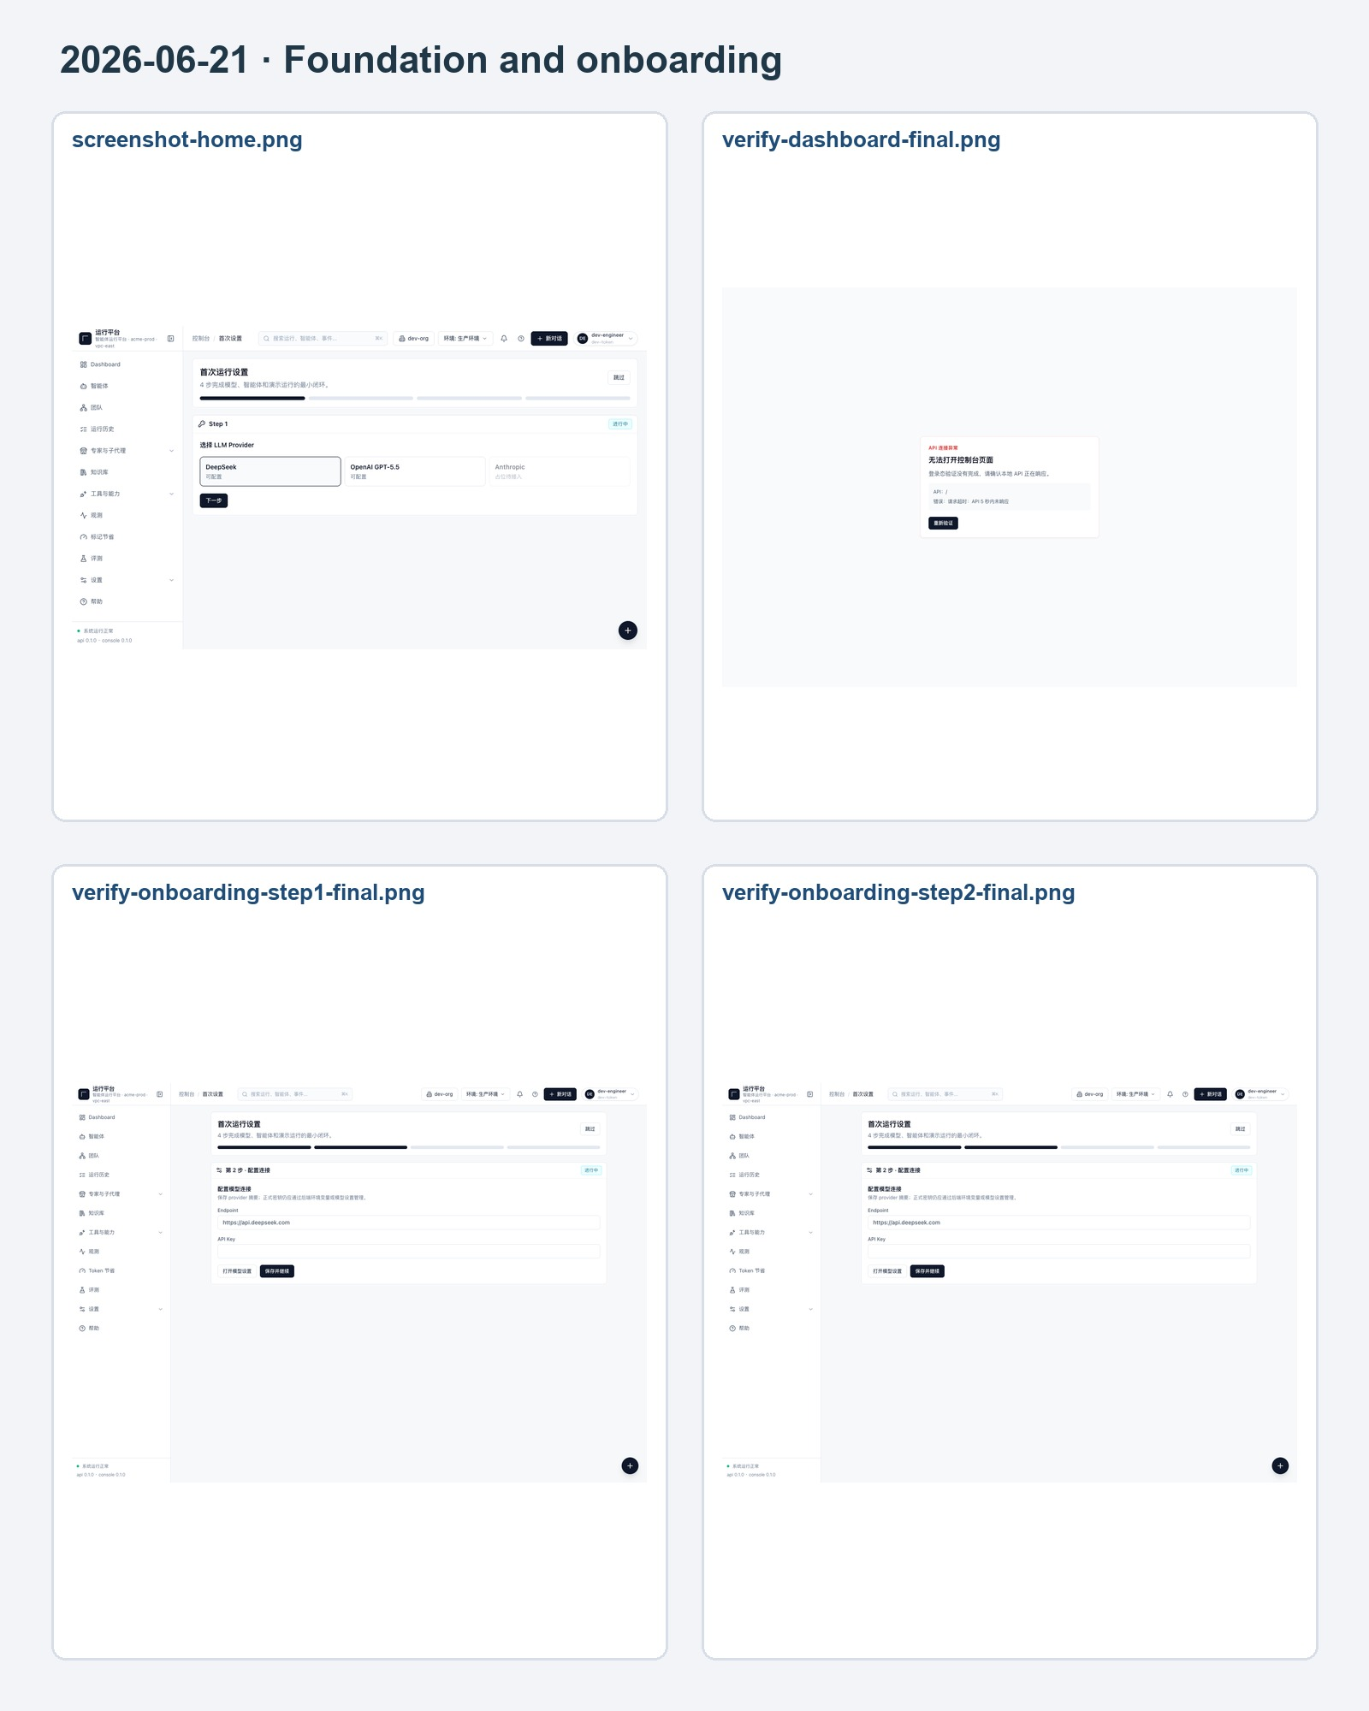
The contact sheet is for quick review; full-resolution originals remain in `docs/screenshots/archive/web-legacy/`.

A-02 · 2026-06-21 · Workspace and runs
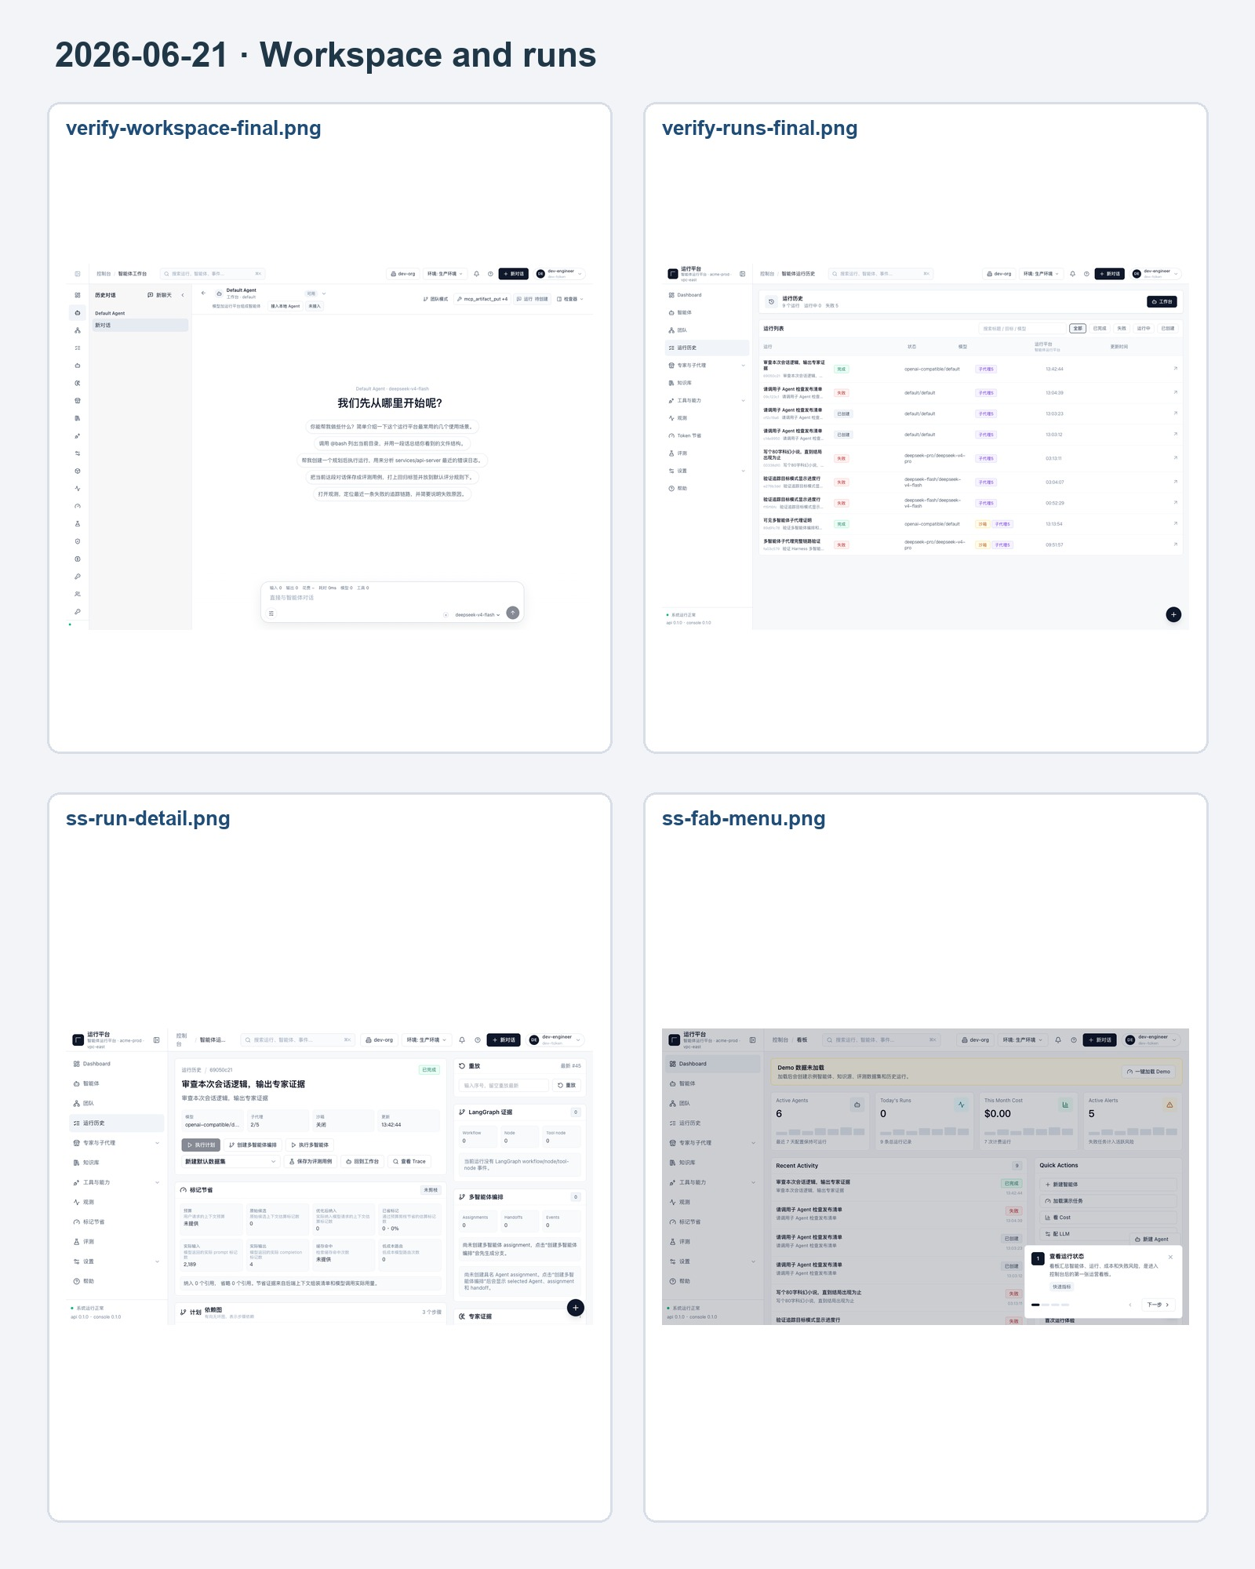
The contact sheet is for quick review; full-resolution originals remain in `docs/screenshots/archive/web-legacy/`.

A-03 · 2026-06-21 · Knowledge, evaluations, and tools
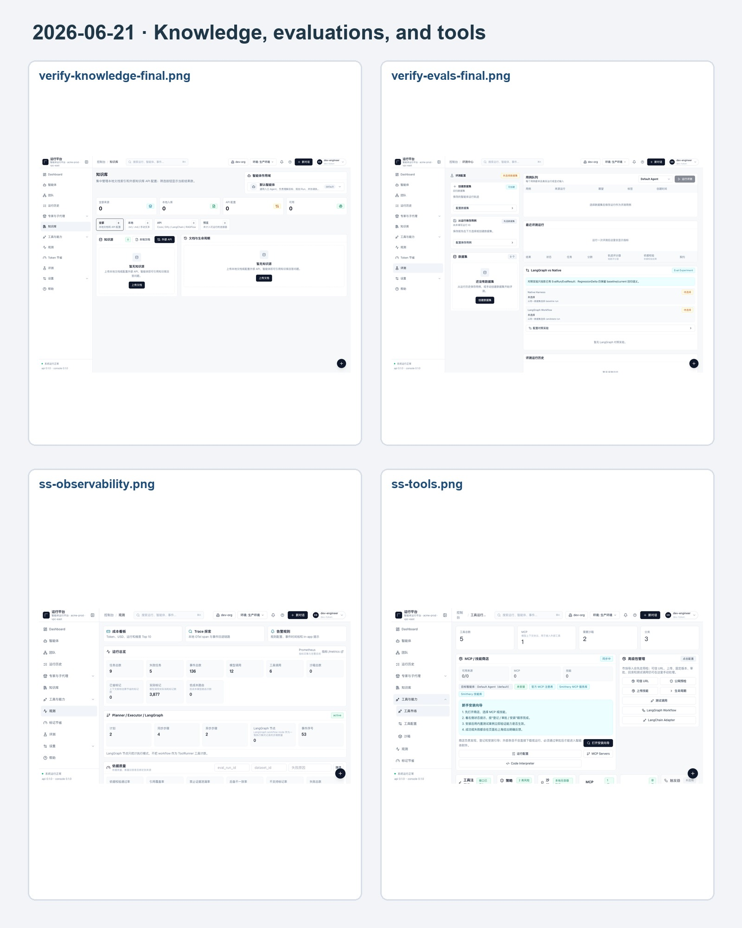
The contact sheet is for quick review; full-resolution originals remain in `docs/screenshots/archive/web-legacy/`.

A-04 · 2026-06-21 · Settings and specialists
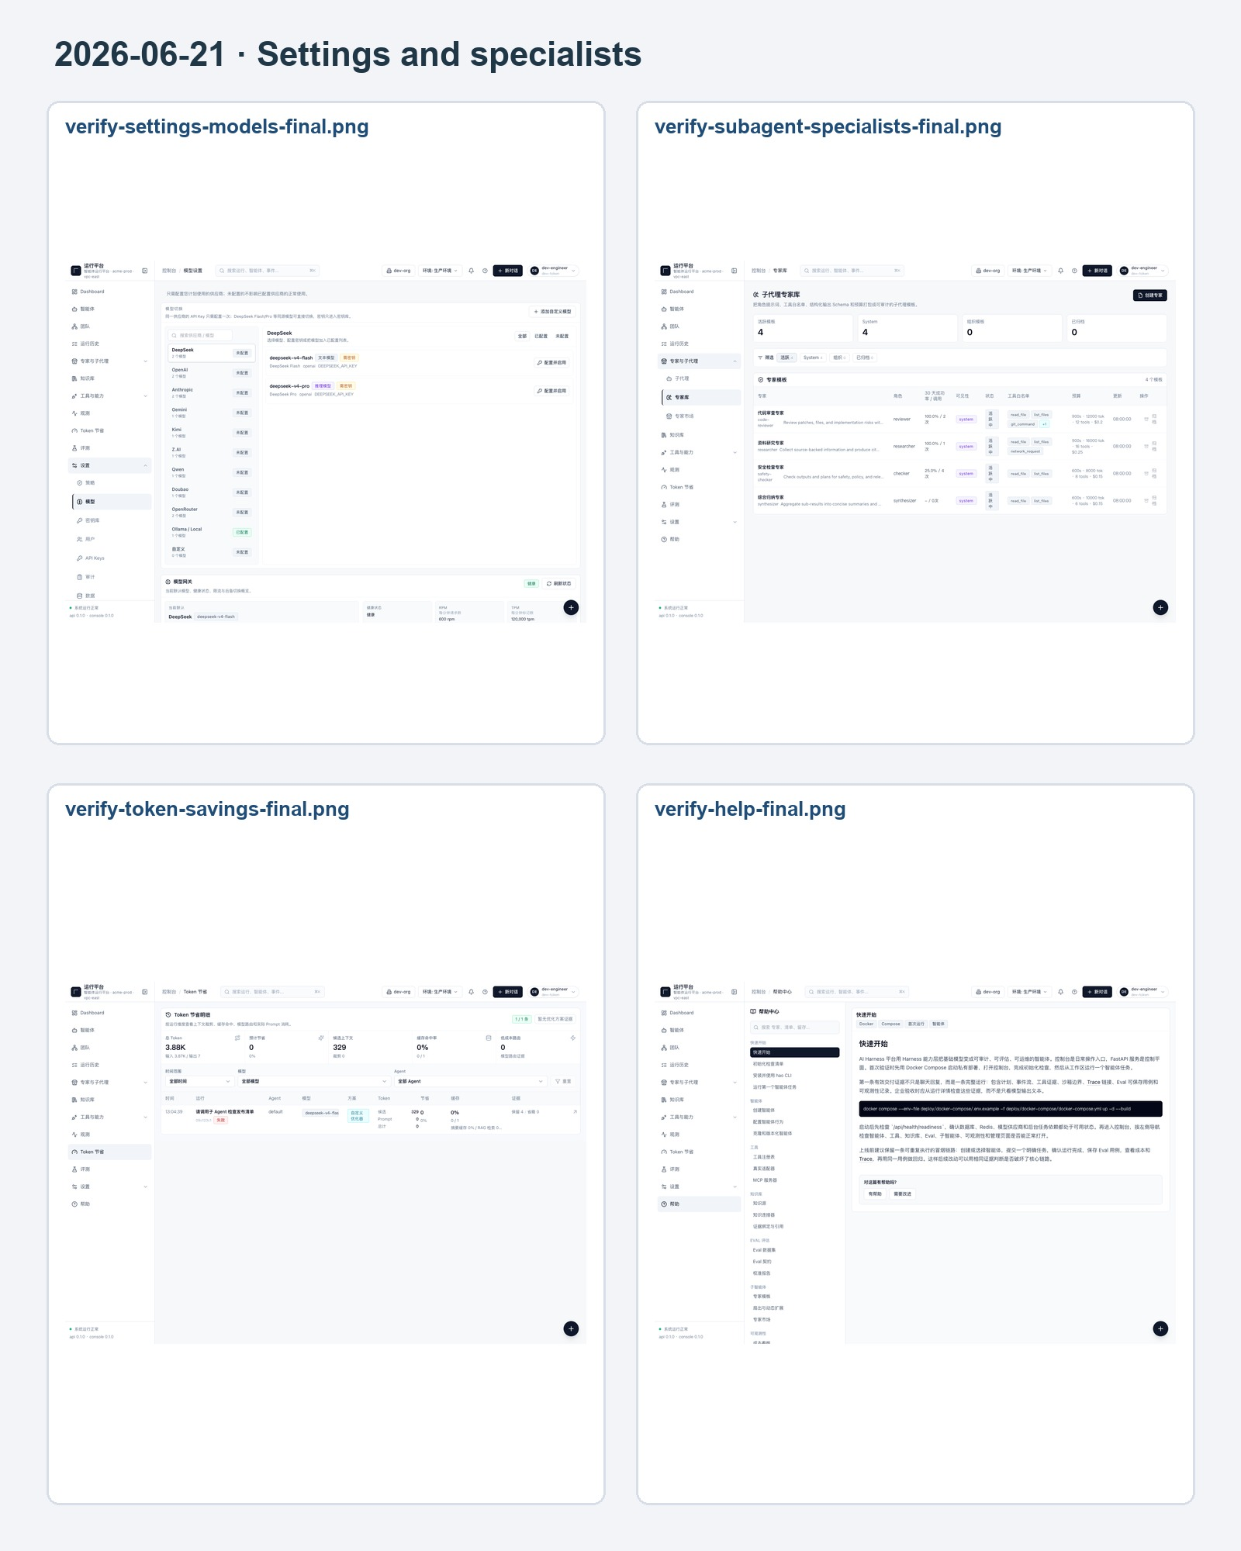
The contact sheet is for quick review; full-resolution originals remain in `docs/screenshots/archive/web-legacy/`.

A-05 · 2026-06-21 · Demo and interaction entry points
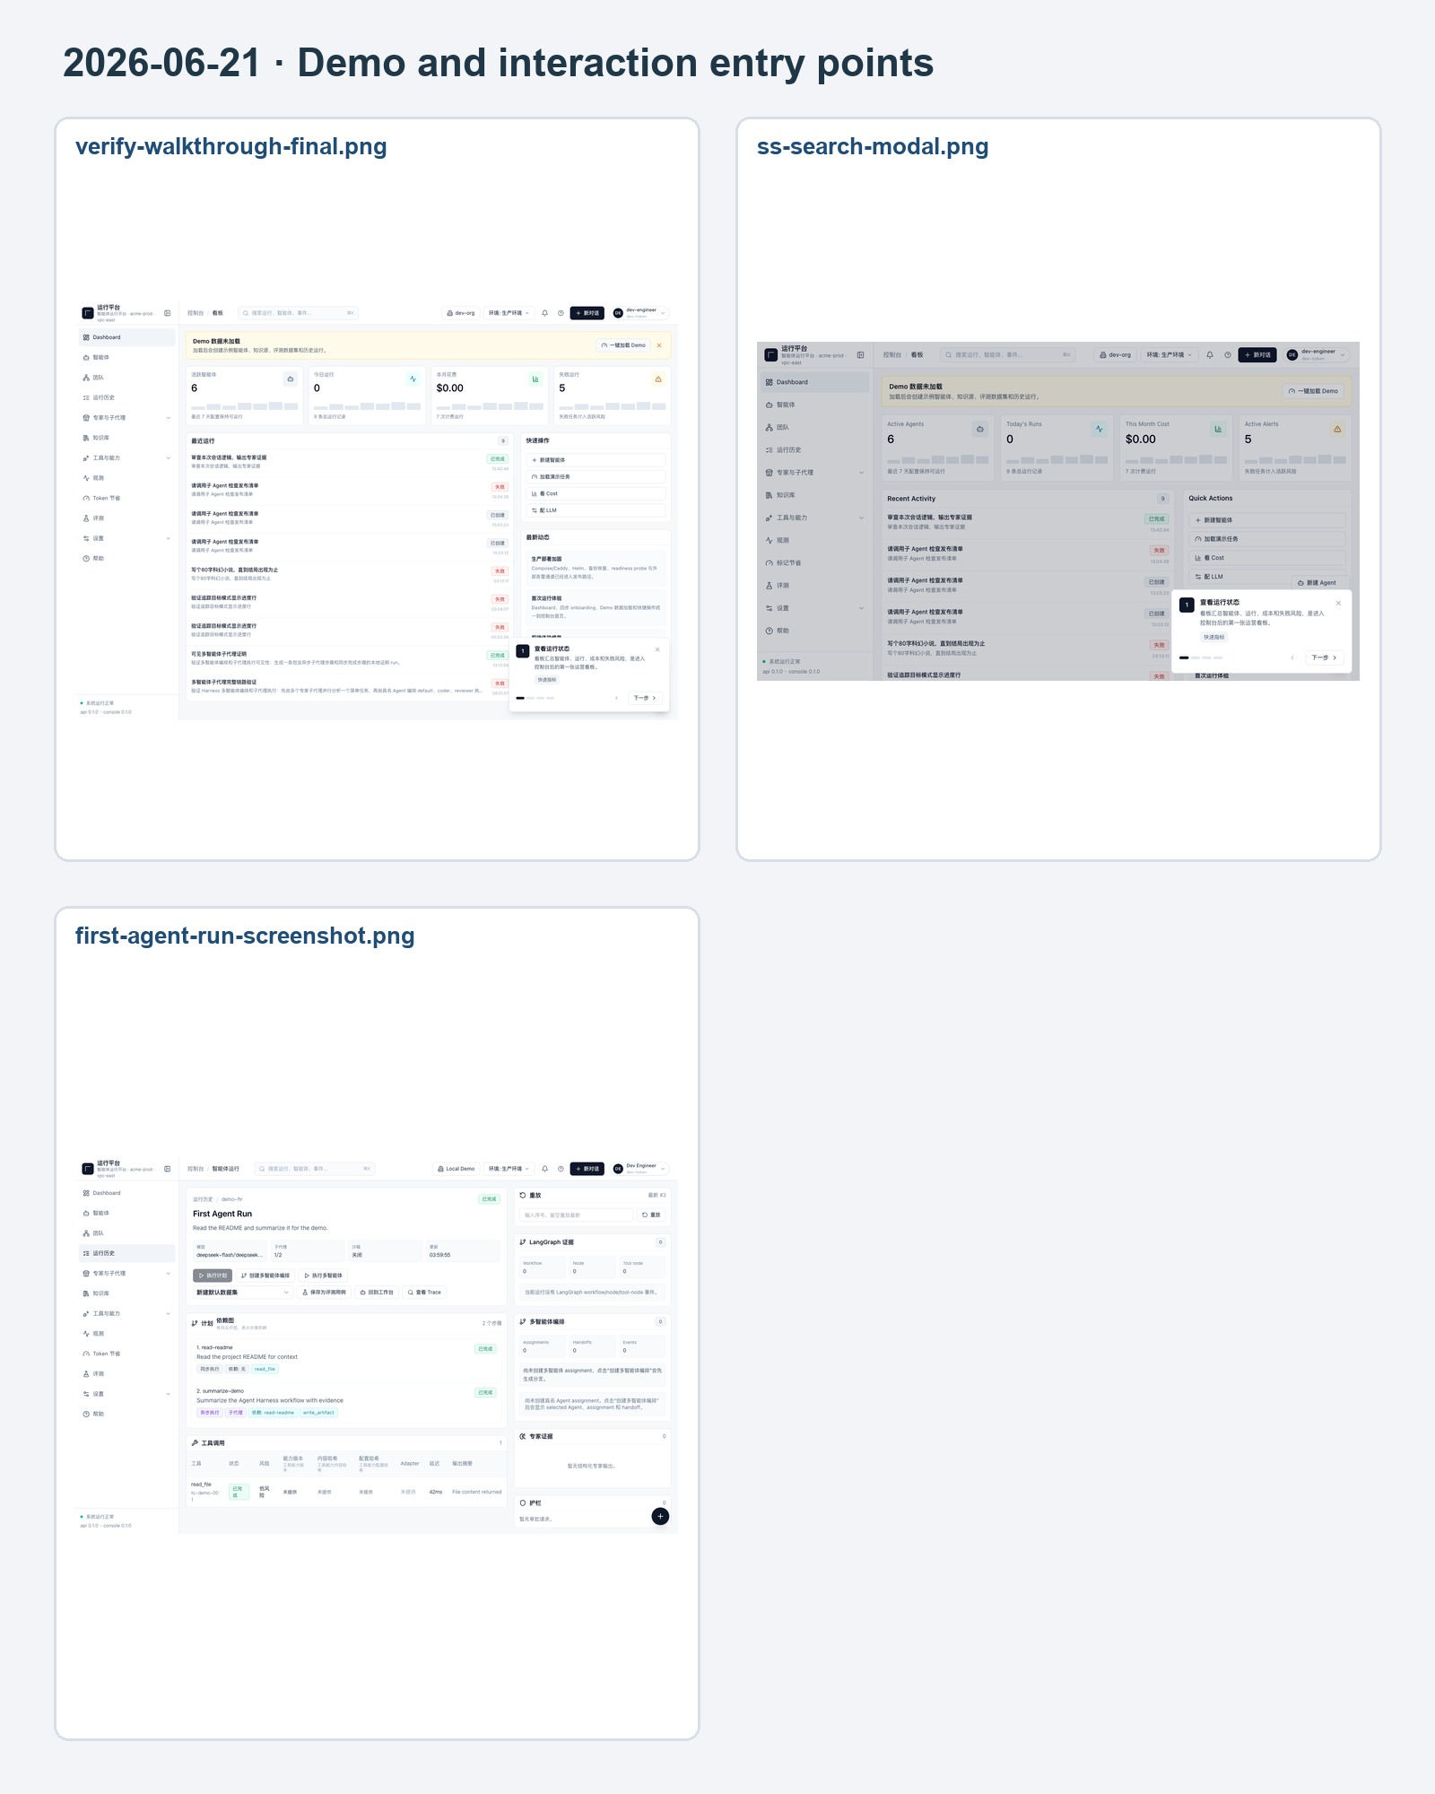
The contact sheet is for quick review; full-resolution originals remain in `docs/screenshots/archive/web-legacy/`.

A-06 · 2026-08-04 · Team Mode visual acceptance
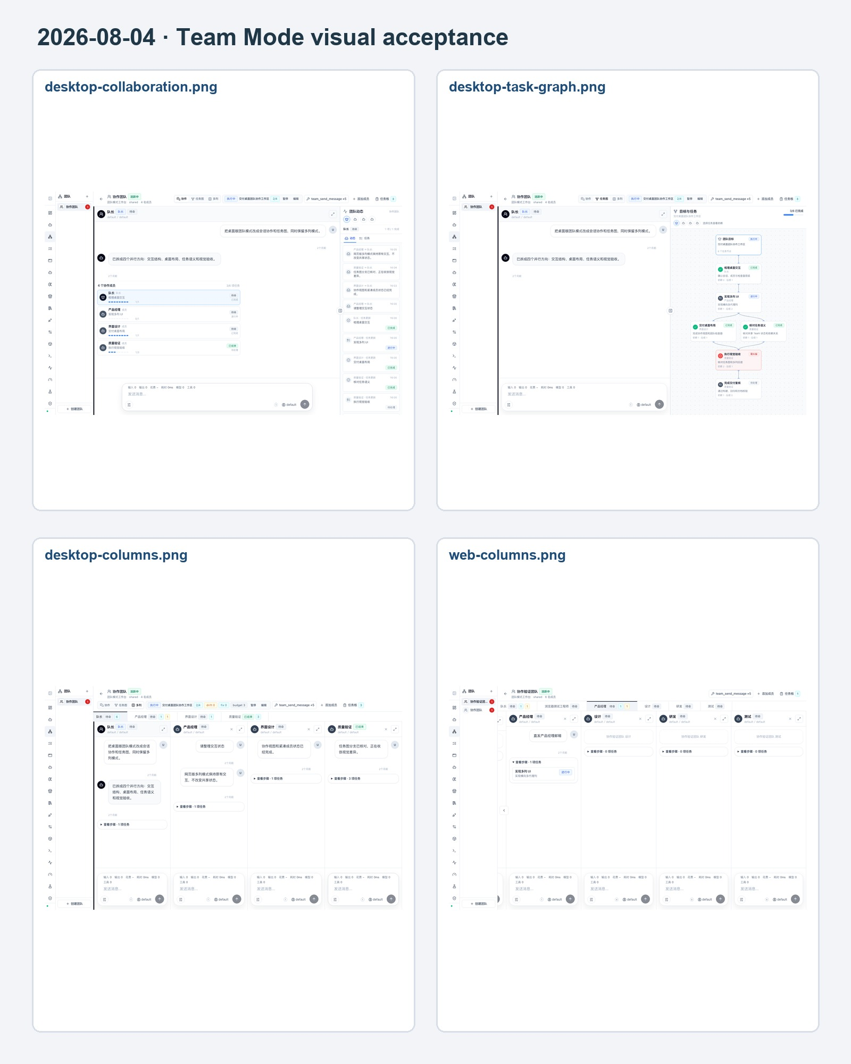
The contact sheet is for quick review; full-resolution originals remain in `docs/screenshots/archive/web-legacy/`.

A-07 · 2026-08-04 · Team Mode mobile layout
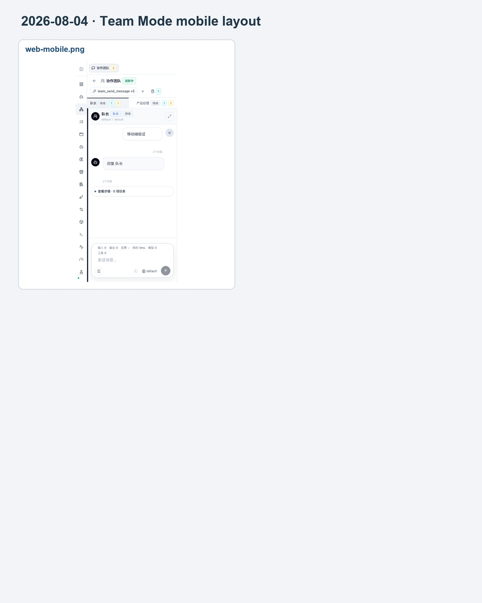
The contact sheet is for quick review; full-resolution originals remain in `docs/screenshots/archive/web-legacy/`.

5. File Inventory and Follow-up
Collection | Path | Files
Current web | docs/screenshots/2026-08-05/web-current/ | 25
Native desktop | docs/screenshots/2026-08-05/desktop-current/ | 9
Historical web 2026-06-21 | docs/screenshots/archive/web-legacy/2026-06-21/ | 20
Team Mode 2026-08-04 | docs/screenshots/archive/web-legacy/2026-08-04-team-mode/ | 5

Recommended Closure
Automation: update the shared Playwright fixture for `/api/auth/me`, Agent list parameters, and local-Agent connection requests.
Data Management: restore `/settings/data` and its loader/API contract, then replace the error evidence with a loaded feature screenshot.
Specialists: repair `/subagents/specialists` route resolution or its ID/permission contract, then replace the terminal error evidence with a loaded catalog screenshot.
Desktop sync: retest Add to Sync Queue in an authenticated Electron session and capture success and conflict-handling states.
Graphics compatibility: recheck the EGL warning in a packaged build and on a second macOS host.
Screenshot maintenance: refresh the current batch after material UI changes; append to the historical archive without overwriting original evidence.

Acceptance Statement
CURRENT STATE The desktop app has been relaunched and remains running; the API and web development services are ready. Current web evidence preserves one confirmed 404 and one specialist load failure, while fixture drift is recorded separately from product defects.

