1. install yarn failed:

git config --global --edit

文件增加

[url "https://"]

insteadOf = ssh://

[url "https://"]

insteadOf = git://

2. sudo service thingsboard start

/etc/systemd/system/multi-user.target.wants$ nano thingsboard.service

3. modify hosts file

140.82.112.4 github.com
199.232.68.133 raw.githubusercontent.com
185.199.108.133 user-images.githbuusercontent.com
185.199.108.133 avatars2.githubusercontent.com
185.199.108.133 avatars1.githubusercontent.com

then you will access github.com from ubuntu

4. in ofbiz project modify ./gradle/init-gradle-wrapper.sh, line 46,change $2/$1 to $2$1

5. ubuntu compile thingsboard

sudo apt-get install maven
git clone git@github.com:thingsboard/thingsboard.git
# checkout latest release branch
git checkout release-3.4

sudo mvn clean install -DskipTests
mvn clean install -DskipTests -Ddockerfile.skip=false

6.[ERROR] Failed to execute goal com.github.eirslett:frontend-maven-plugin:1.12.0:yarn (yarn install) on project ui-ngx: Failed to run task: 'yarn install' failed. org.apache.commons.exec.ExecuteException: Process exited with an error: 128 (Exit value: 128) -> [Help 1]

try again,finally you will success.

7.Fatal error compiling: invalid flag: --release -> [Help 1]

mvn -v
check java_home must be java-11
env | grep JAVA_HOME
change JAVA_HOME to java-11
source ~/.bashrc

8. cd ./application/target
sudo dpkg -i thingsboard.deb

9. chmod 777 ./gradlew

10. ./gradlew cleanAll loadAll

11. download postgresql-42.4.1.jar and copy to /home/lhx/IdeaProjects/haina/lib

12.modify entityengine.xml
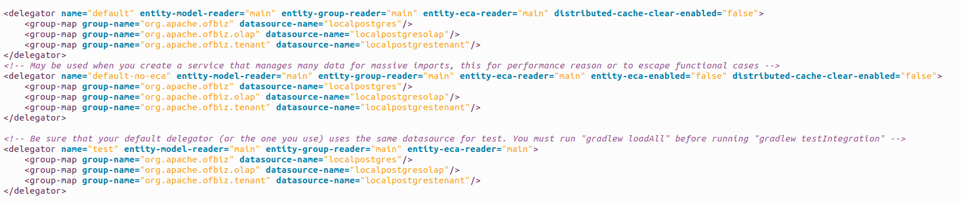

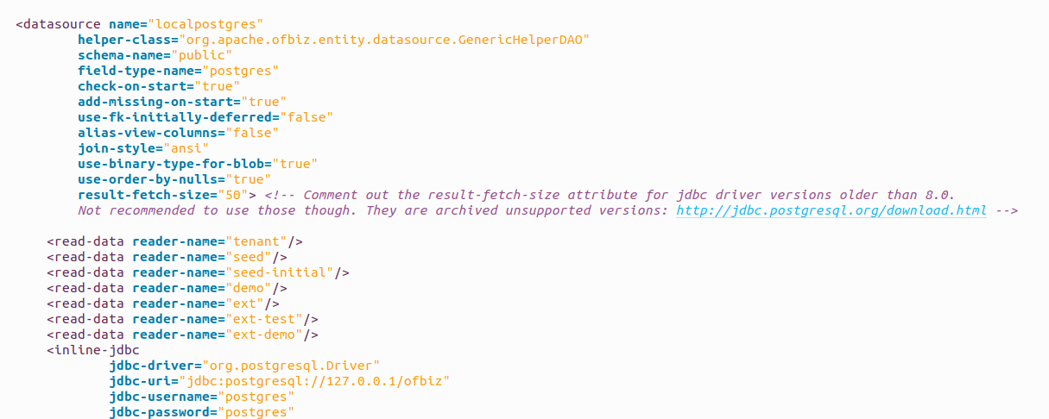
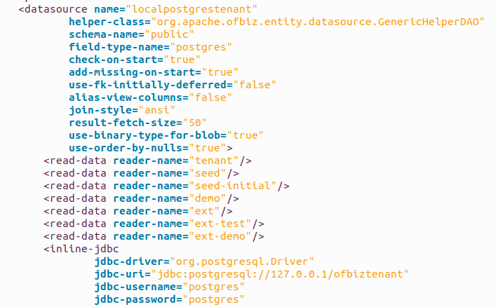
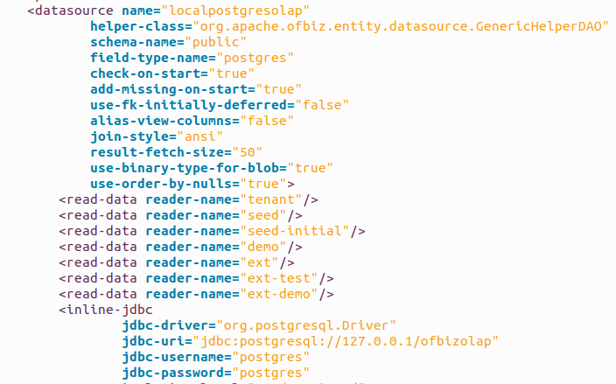
13. install postgresql and set username and password

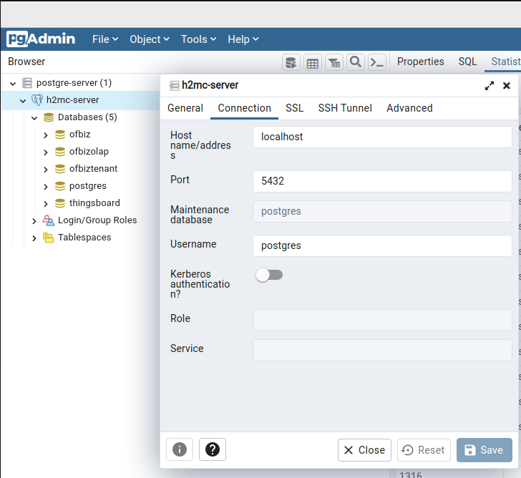

14. ./gradle/init-gradle-wrapper.sh
15. ./gradlew cleanAll loadAll
16. ./gradlew ofbiz

