**Design: (Get Current Weather)**

Frontend: Angular 2

Backend: restfull service

Weather WS:

url: https://api.darksky.net/forecast/[api]/[latitude],[longitude

api: 8884a820e1096e7ea0be7e236bd830e0

1. Get Current Weather

A, Choose city in the dropdown list and show its current weather from Weather WS

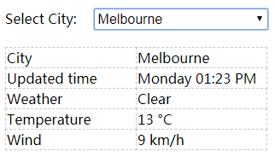

User guide:

Browser : chrome

1.Access url: <http://localhost:8080/>

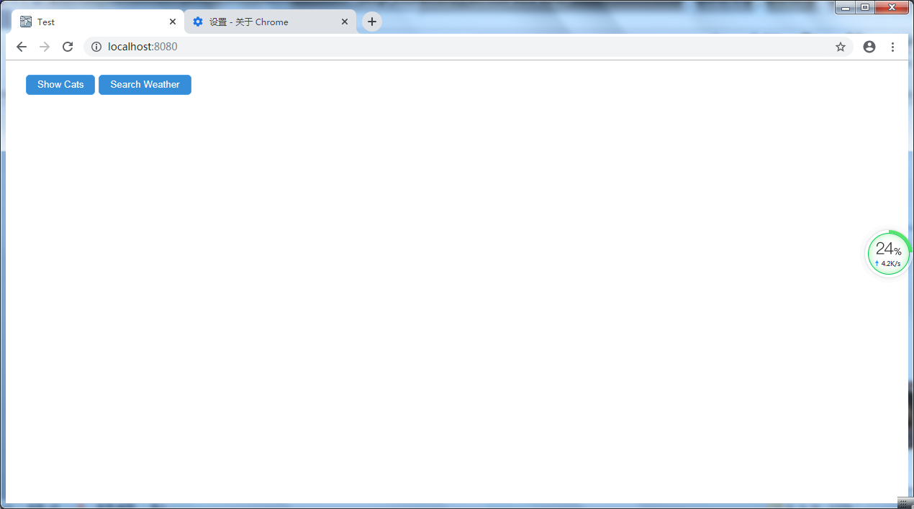

2.Click [Show Cats] button, and show cats by gender of their owners.

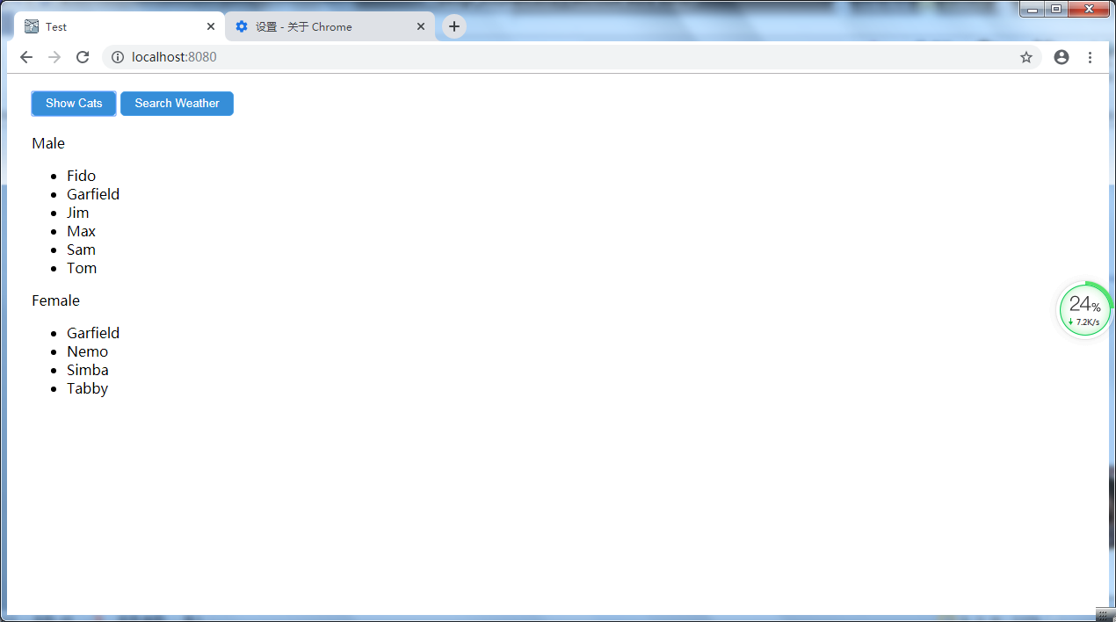

3.Click [Show Weather] button, and show current weather for the city.

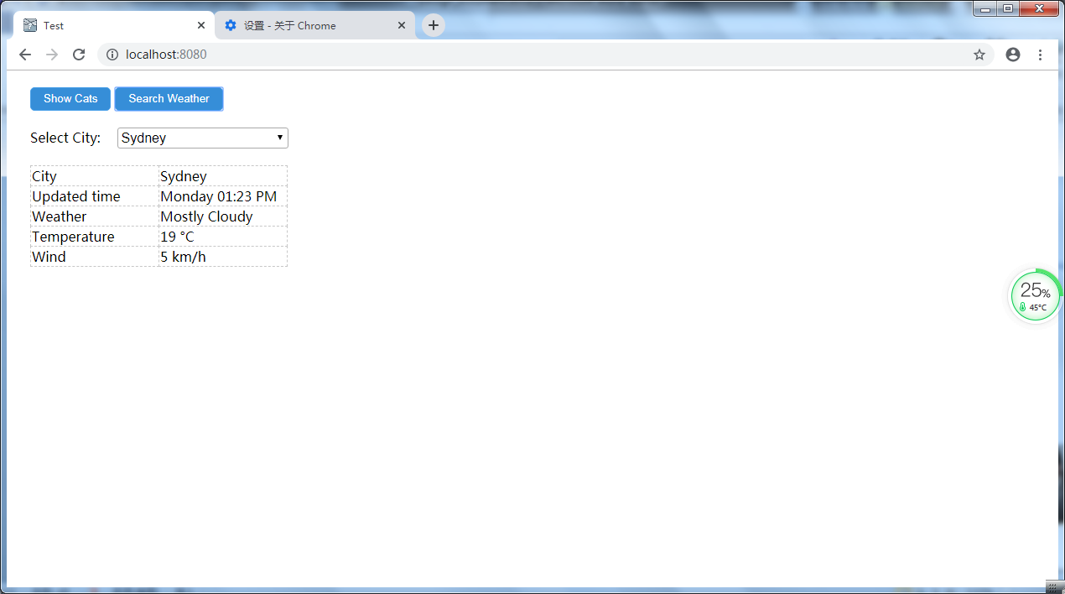

4. Choose city in the dropdown list and show its current weather.

