**Tableau (3)**

**By Fangling Zhang**

**Dashboard #1:**

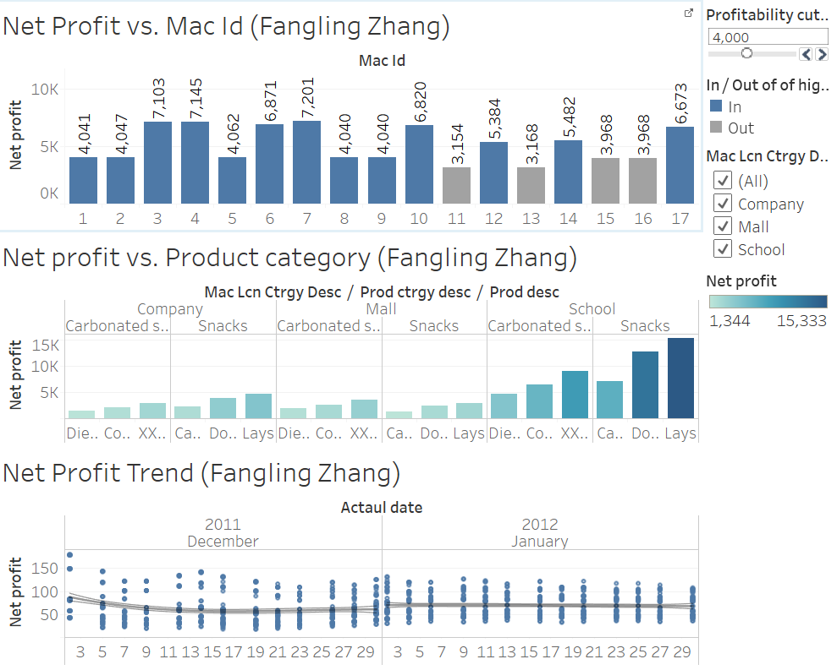

**Dashboard #2:**

1. In this task, I used Tableau Assignment_HR_comma_sep.csv as our dataset. I apply the following formula to form a measure called ‘Attrition Rate’: sum([left])/sum([Number of Records]). I compared Attrition Rate between different average monthly hours bin and created cut-off and set for attrition rate.
2. I apply the following formula to form a measure called ‘Average Satisfaction Level”: sum([Satisfaction Level])/sum([Number of Records]). I compared Average Satisfaction Level between different average monthly hours bin and created cut-off and set for Average Satisfaction Level.
3. From the graph 1, we found that when average monthly hours are between 160 and 230, attrition rates are very less than 0.2. From graph 2, employee’s satisfaction level are highest in this working hours range. So, HR managers may conclude that company should adjust the average monthly hours to between 160 and 230. Then, I want to know how many records are out of this working hours range now. If too few records are out of this working region, it is meaningless to do such adjustment. In graph 3, I also used the attrition rate cut-off and found that more than half employees will benefit if company do such working hours adjustment.

