**Tableau(2) from Fangling Zhang**

1. The dashboard

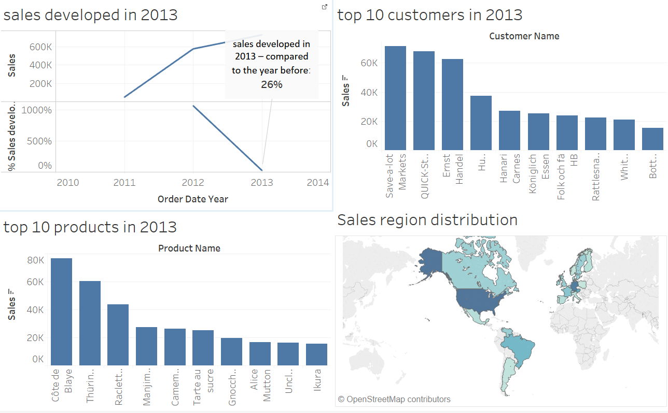

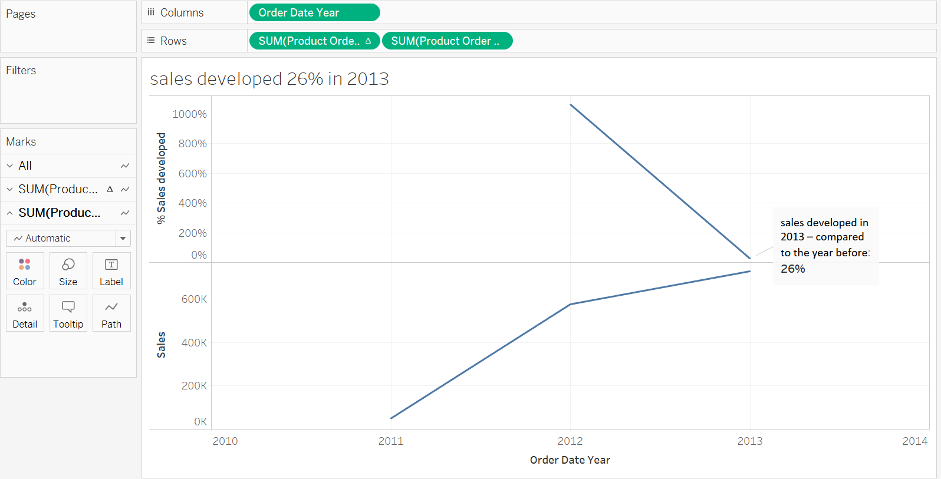

* How have sales developed in 2013 – compared to the year before?

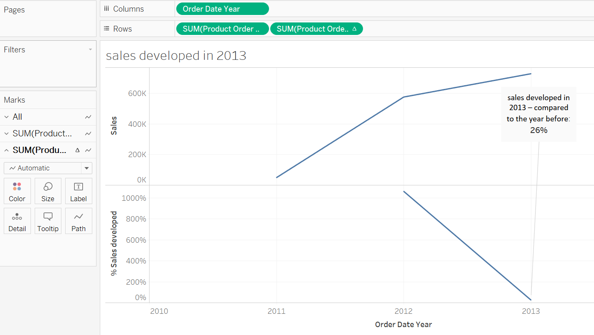The above graph is the sales each year, the below one is the developed rate compared to last year.

* Who were our top 10 customers in 2013?

‘keep only’ the top 10 customers in 2013

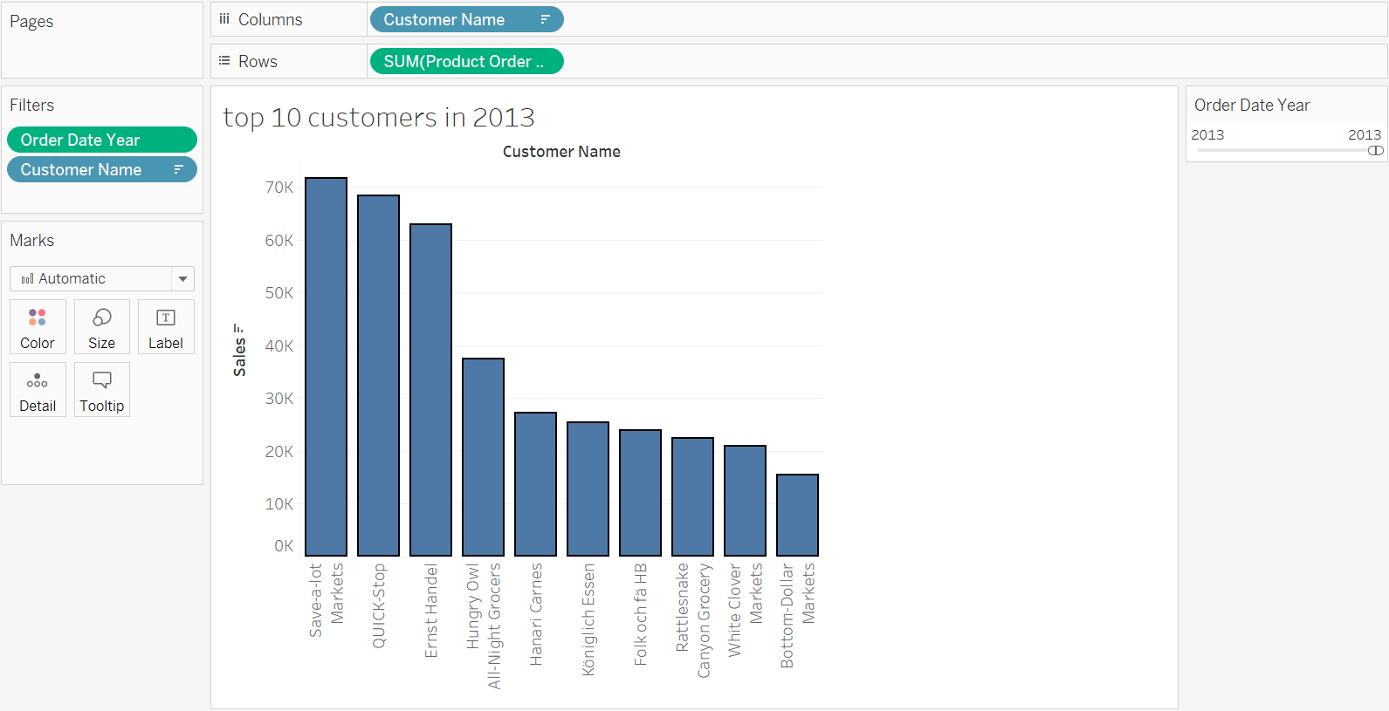

* What were our top 10 products in 2013?

‘keep only’ the top 10 products in 2013

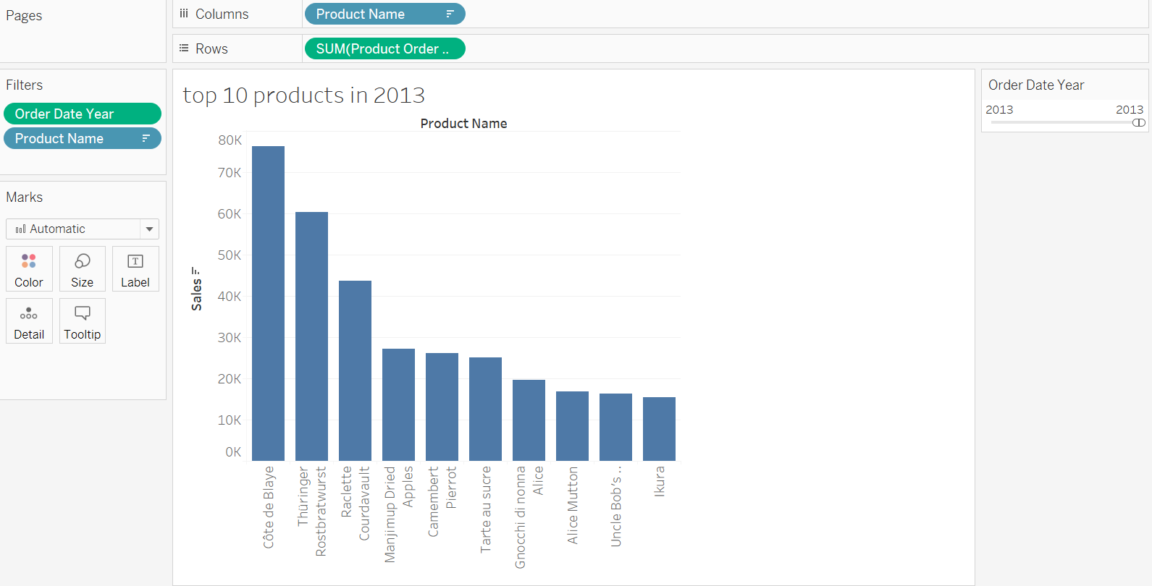

* How were sales distributed over the regions?

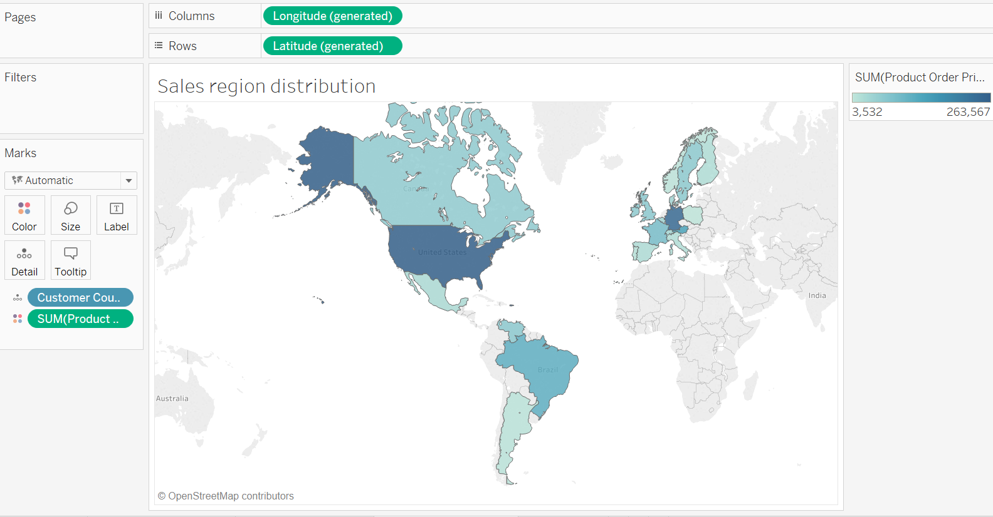The region distribution

1. 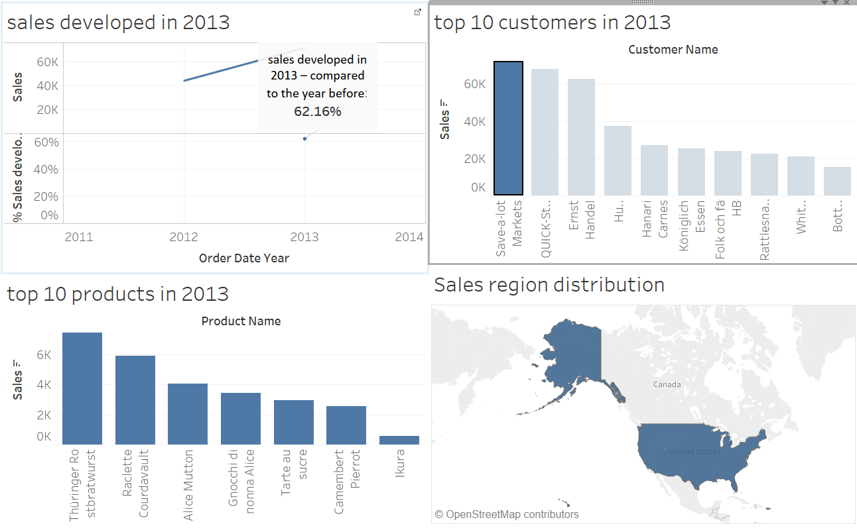choose any one of the customers in graph ‘top 10 customers in 2013’, then click the triangle ‘use as filter’ in the right top of the graph. Now you click on one customer, you will only see sales and products associated with that customer in the other charts on the dashboard.

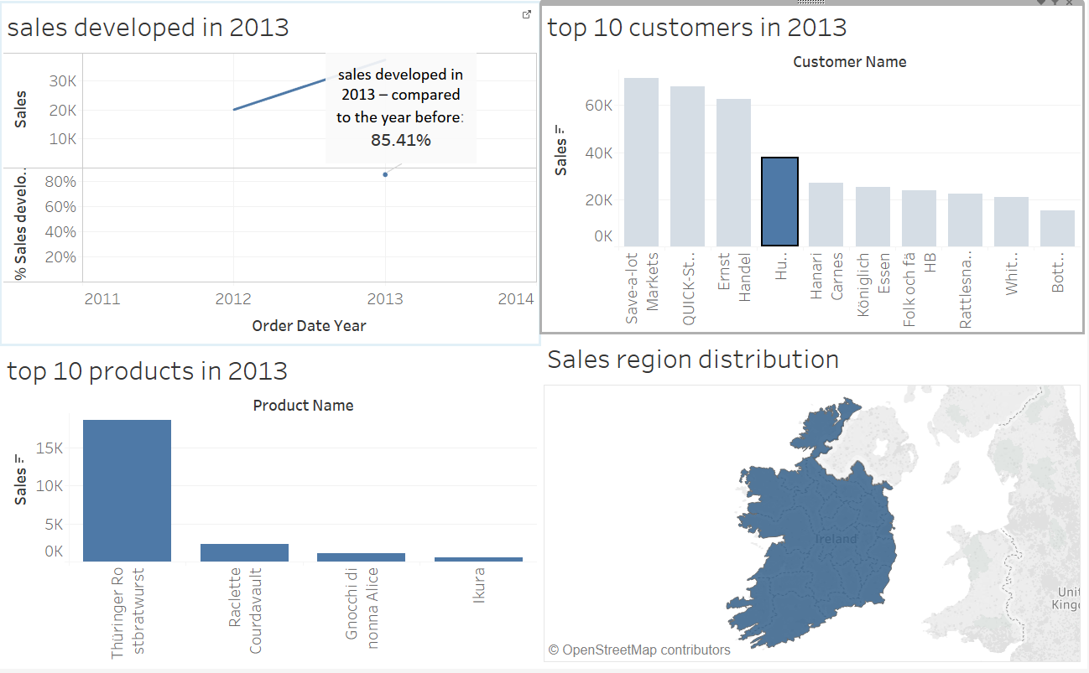

1. **One additional question**: For each month in 2013, how its sales year over year growth change?

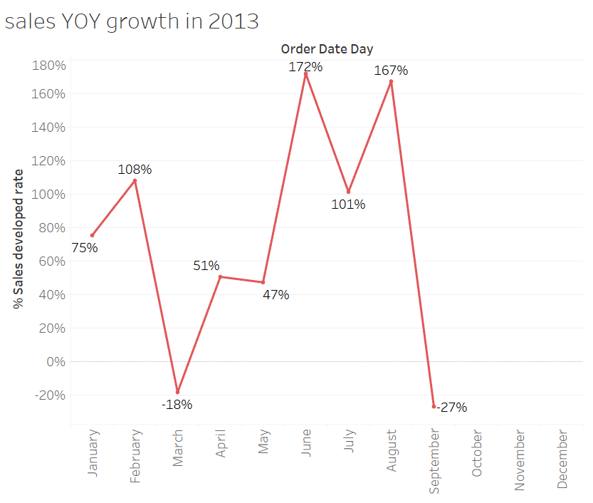From the graph below, we can see that in February and September of 2013, sales YOY growth is negative. We can use dashboard to find which customer or which product caused this deduction.

After I add this graph to the dashboard, I can check each 10 products’ and 10 customers’ sales monthly growth trend in 2013. For example, I click ‘Cote de Blaye’ in ‘top 10 products in 2013’, now we can see its monthly sales growth trend in graph ‘sales YOY growth in 2013’. We found that this product’ sales YOY growth is -100% in February. As it is the best sale product in 2013, it affect the whole sales in February a lot.

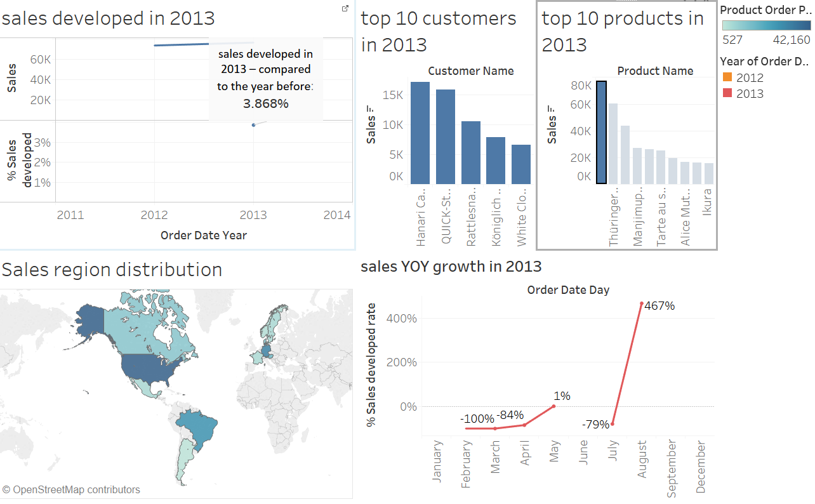

Now, lest check the top 10 customers’ purchasing trend. We clicked on ‘Ernst Handel’ and found that in graph ‘sales YOY growth in 2013, its February’s number is -100%. That means that this customer did not purchase in February. As it is the top 3 customer in 2013, it affects the whole February’s sales a lot.

