**HW14**

**Fangling Zhang**

14.4

(a)

Plot of the logistic function:

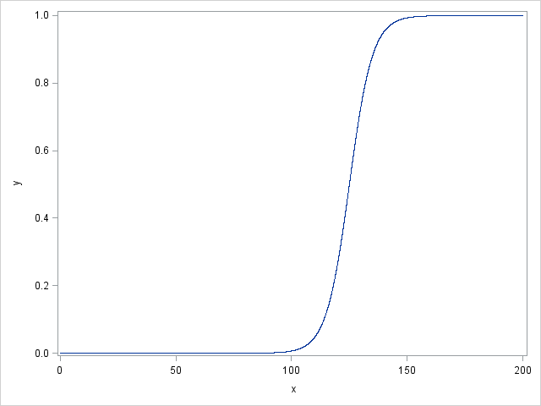

(b)

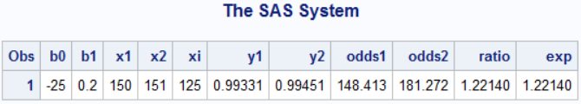

When E(Y)=1/(1+exp(-(-25+0.2*X)))=0.5,

Then -25+0.2*X=0

X=25/0.2=125

(c)

When X=150: Odds=148.413

When X=151: Odds=181.272

OR=1.2214

exp(b1)=1.2214

Yes, the odds ratio is the same as the exp(beta1).

14.13

(a)

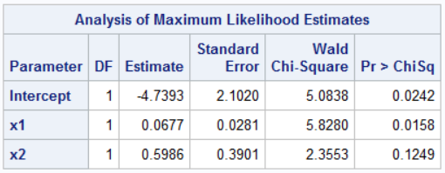

$$E(Yi)=Pi=\frac{\exp\left(-4.7393+0.0677x1+0.5986x2\right)}{1+exp⁡-4.7393+0.0677x1+0.5986x2)}$$

(b)

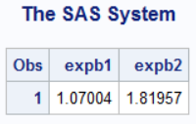

Exp(b1)=1.07004

The odds of the family purchasing a new car are estimated to increase by 7.004% when annual family income increase one thousand dollars.

Exp(b2)=1.81957

The odds of the family purchasing a new car are estimated to increase by 8.1957% with each one year’s increase in the current age of the oldest family automobile.

(c)

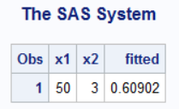

When x1=50, x2=3,

pi=0.60902, which is the estimated probability.

19

(a)

Full model:

$$Pi={[1+exp⁡(-β_{0}-β_{1}x1-β_{2}x2)]}^{-1}$$

Reduced model:

$$Pi={[1+exp⁡(-β_{0}-β_{1}x1)]}^{-1}$$

Hypothesis:

$$H_{0}:β_{2}=0$$

$$H_{a}:β_{2}≠0$$

Test statistic:

$$G^{2}=-2[\log_{e}L\left(R\right)-\log_{e}L\left(F\right)]$$

Decision rule:

If $G^{2}≤χ^{2}(0.95, 1)$, (or p>α) conclude H0

If $G^{2}>χ^{2}(0.95, 1)$, (or p<α) conclude Ha.

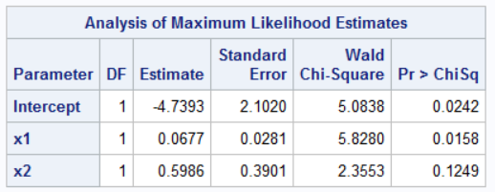

p-value=0.1249, therefore we conclude Ha, which means we can drop X2 from the model under 0.05 significant level.

(d)

Full model:

$$Pi={[1+exp⁡(-β_{0}-β_{1}x1-β_{2}x2-β_{11}{x1}^{2}-β_{22}{x2}^{2}-β_{12}x1x2)]}^{-1}$$

Reduced model:

$$Pi={[1+exp⁡(-β_{0}-β_{1}x1-β_{2}x2)]}^{-1}$$

Hypothesis:

$$H_{0}:β_{11}=β_{22}=β_{12}=0$$

$$H_{a}:Not H0$$

Test statistic:

$$G^{2}=-2[\log_{e}L\left(R\right)-\log_{e}L\left(F\right)]$$

Decision rule:

If $G^{2}≤χ^{2}(0.95, 3)$, (or p>α) conclude H0

If $G^{2}>χ^{2}(0.95, 3)$, (or p<α) conclude Ha.

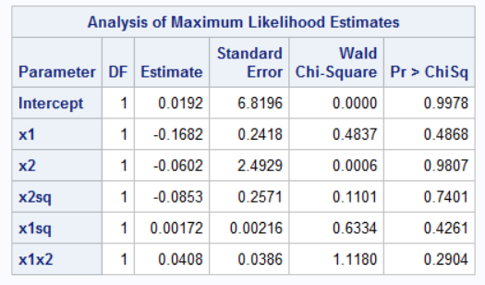

p-values>0.05, therefore we conclude Ha, which means we can drop these three second-order terms from the model under 0.05 significant level.

14.27

(b)

The studentized Pearson residuals are as follows. In this case, the lowess smooth approximates a line having zero slope and intercept, we conclude that no significant model inadequacy is obvious.

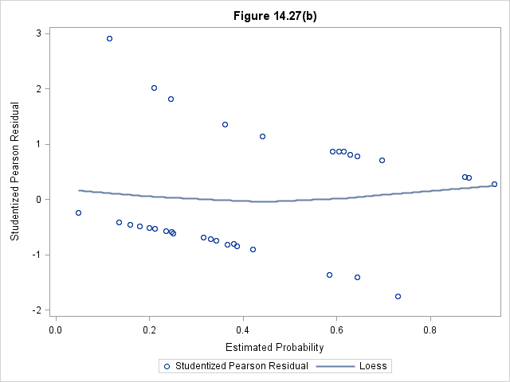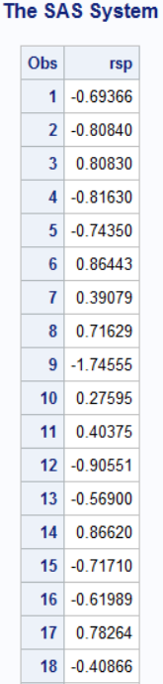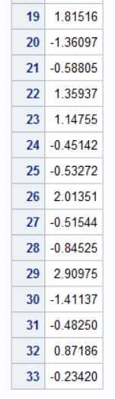

14.31

(a)

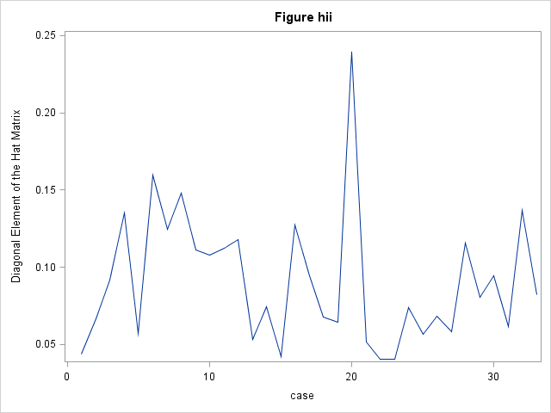

The leverage plot identifies case 20 as being somewhat outlying in the X space.

(b)

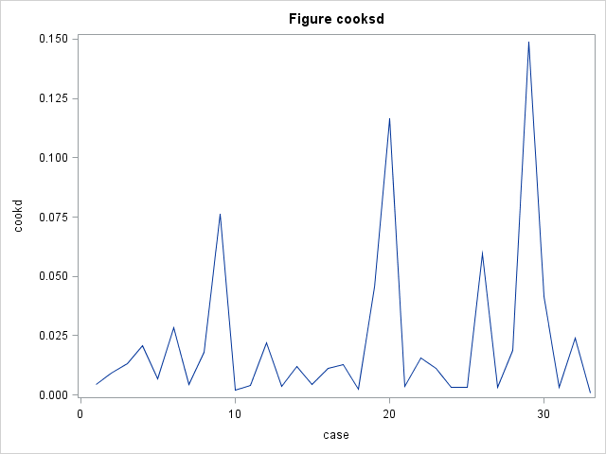

The plot of cook’s distances indicates that case 29 is the most influential in terms of effect on the linear predictior.

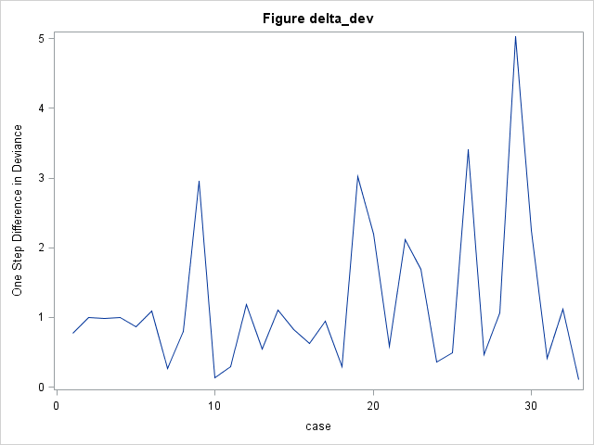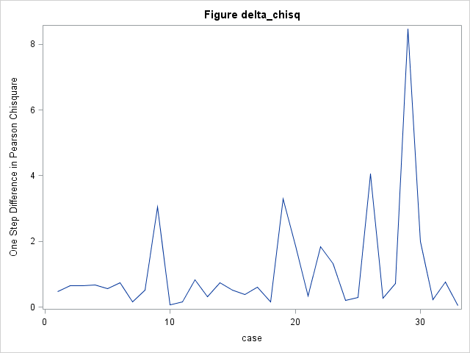

The delta chisq and delta deviance plots also identify the case 29 as most influential.