**Homework 2**

**Fangling Zhang**

**2.7**

**a.**

As, the change in the mean hardness is estimated to be 2.03.

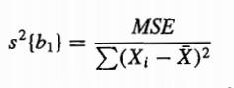 , so s(b1)=0.09.

The 1-α confidence limits for β1 are: 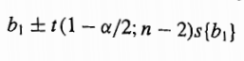.

Here α=0.01, n=16, so t(0.995,14)=2.977.

Hence, the 99 percent confidence interval here are [(2.03-2.977*0.09), (2.03+2.9770.09)] = [1.76, 2.30]

With confidence coefficient 0.99, we estimate that the mean hardness increases by somewhere between 1.76 and 2.30 Brinell units for each additional unit in the elapsed time.

**b.** The standard is being satisfied, because the 99% confidence interval are [1.76, 2,30] and 2 Brinell units is in the confidence interval.

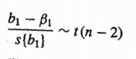 (2-2.03)/0.09=-0.38. The P-value of the test is 0.35.

**c.** 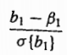 is a standard normal variable. 0.3/0.1=3 and the responding p-value is 0.9987. Therefore, the standard in part (b) is being refused.

**2.12**

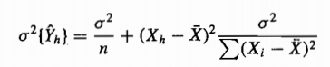

Given a fixed σ^2>0, and an Xh value in the range of possible X values, if we want to ensure , we need Xh equals the mean of X values.



As >0 and σ^2>0, nothing we can do to ensure that .

**2.16**

**a.** The 1-α confidence limits for the mean hardness of modeled items are:



Here α=0.02, n=16, =30, =168.60+2.03*30=229.63.

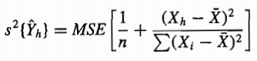=3.23 * [1/16 + (30-28)^2/1280] = 0.21

t(0.99;14)=2.624

Therefore, the confidence intervals are [228.43, 230.83]

**b.** for the hardness of a newly modeled test

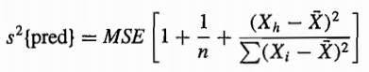=3.45

The 0.98 confidence limits are:

Therefore, the confidence intervals are [224.76, 234.50]

**c.** For the mean hardness of 10 newly molded test items:

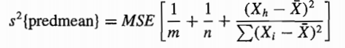=1.00

The 0.98 confidence limits are: 

Therefore, the confidence intervals are [227.01, 232.25]

**d.** Yes and it should be, because 1/m here is 0.1<1.

**e.** =2*F(0.98;2;14)=2*43=86, so W= 9.27

The 0.98 confidence band limits are:

Therefore, the confidence band are [225.40, 233.90].

Yes, the confidence band here are wider at this point than the confidence interval in part(a). It should be, because W=9.27>t(0.99,14).

**2.26**

**a.** ANOVA is as follows:

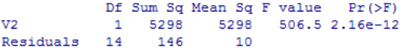

**b.** Yes, P-value here is 2.16e-12, which is much smaller than α=0.01. Therefore, there is a linear association between the hardness of the plastic and the elapsed time.

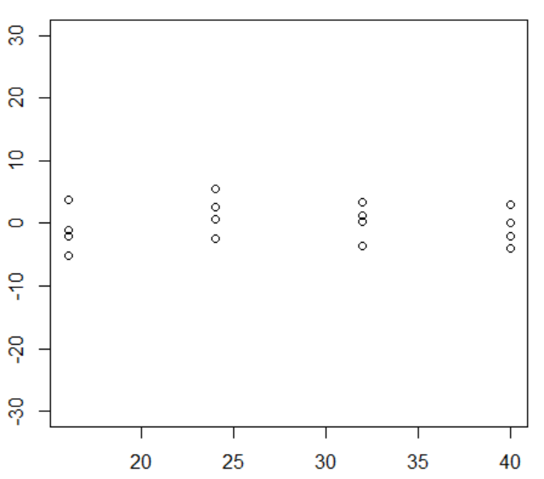**c.** The left graph shows deviations , and the right graph shows 

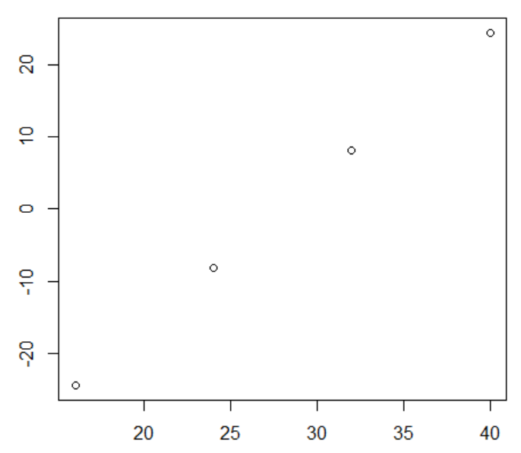

From the above two graphs, SSR appears to be the larger of SSTO, which imply that R^2>0.5.

**d.** 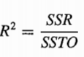=0.973, r=+ $\sqrt{R^{2}}$ =0.986