4.9

The Bonferroni confidence limits for regression model are:

where: , and 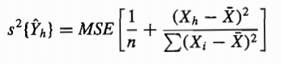

Here α=0.1

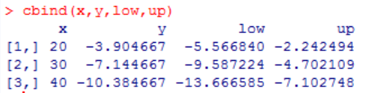

We get

5.26