**HW7**

**Fangling Zhang**

**Q7**

**(a)**

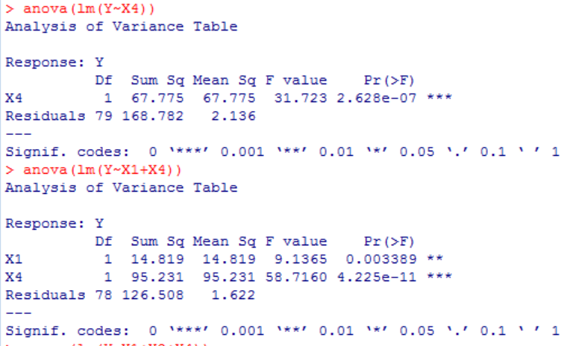

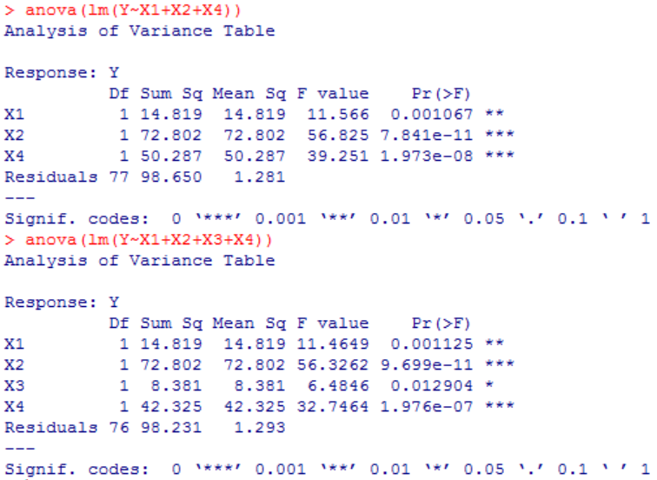

From the above four tables, we get SSR(X4)=67.775, SSE(X4)=168.782, SSE(X1,X4)=126.508, SSE(X1,X2,X4)=98.650, SSE(X1,X2,X3,X4)=98.231. Thus SSR(X1|X4)=SSE(X4)-SSE(X1,X4)=42.274, SSR(X2|X1,X4)= SSE(X1,X4)-SSE(X1,X2,X4)=27.888, SSR(X3|X1,X2,X4)= SSE(X1,X2,X4)- SSE(X1,X2,X3,X4)=0.419.

Thus, the analysis of variance table that decomposes the regression sum of squares to extra sums of squares is as follows:

|  |  |  |  |
| --- | --- | --- | --- |
| **source** | **ss** | **df** | **ms** |
| **regression** | 138.326 | 4 | 34.582 |
| **x4** | 67.775 | 1 | 67.775 |
| **x1/x4** | 42.274 | 1 | 42.274 |
| **x2/x1,x4** | 27.888 | 1 | 27.888 |
| **x3/x1,x2,x4** | 0.419 | 1 | 0.419 |
| **error** | 98.231 | 76 | 1.293 |
| **total** | 236.557 | 80 |  |

(b)

The alternatives: $H_{0},$: $β_{3}=0$ $H_{1},$: $β_{3}≠0$

The full model: $Y_{i}$ = $β_{0}+β_{1}X_{i1}$ + $β_{2}X_{i2}$ + $β_{3}X_{i3}$ + $β_{4}X_{i4}$ + $ε_{i}$

The reduced model: $Y_{i}$ = $β_{0}+β_{1}X_{i1}$ + $β_{2}X_{i2}$ + $β_{4}X_{i4}$ + $ε_{i}$

Decision rule: if $F^{*}≤F_{\left(1-α,1,n-5\right)},conclude H_{0};F^{*}>F_{\left(1-α,1,n-5\right)},conclude H_{1}$

$F^{*}=\frac{SSR\left(X3|X1,X2,X4\right)/1}{SSE(X_{1},X_{2},x3,X_{4})/(n-5 )}$ =0.419/1.293=0.324; F(0.99,1,76)=6.981

Conclusion: $F^{*}<F\left(0.99,1,76\right), we conclude H_{0}, that is, X3 can be dropped.$

p-value=0.571

**Q8**

The alternatives: $H_{0},$: $β_{2}=β_{3}=0 ;$

$H_{1},$: $β_{2}≠0$ or $β_{3}≠0$

The full model: $Y_{i}$ = $β_{0}+β_{1}X_{i1}$ + $β_{2}X_{i2}$ + $β_{3}X_{i3}$ + $β_{4}X_{i4}$ + $ε_{i}$

The reduced model: $Y_{i}$ = $β_{0}+β_{1}X_{i1}$ + $β_{4}X_{i4}$ + $ε_{i}$

Decision rule: if $F^{*}≤F_{\left(1-α,2,n-5\right)},conclude H_{0};F^{*}>F_{\left(1-α,2,n-5\right)},conclude H_{1}$.

$F^{*}=\frac{SSR\left(X2,X3|X1,X4\right)/2}{SSE(X_{1},X_{2},x3,X_{4})/(n-5 )}$ = $\frac{(SSE\left(X1,X4)-SSE(X1,X2,X3,X4\right))/2}{SSE(X_{1},X_{2},x3,X_{4})/(n-5 )}$ = $\frac{(126.508-98.231)/2}{1.293}$ =10.94

F(0.99,2,76)=4.986

Conclusion: $F^{*}>F\left(0.99,2,76\right)$. $we conclude H_{1}. That is, x2 and x3 can not be dropped at the same time.$

p-value= 0.0000668

**Q10**

The alternatives: $H_{0},$: $β_{1}=-0.1, β_{2}=0.4;$ $H_{1},$: $β_{1}≠-0.1$ or $β_{2}≠0.4$

The full model: $Y_{i}$ = $β_{0}+β_{1}X_{i1}$ + $β_{2}X_{i2}$ + $β_{3}X_{i3}$ + $β_{4}X_{i4}$ + $ε_{i}$

$Y_{i}$ = $β_{0}-0.1X_{i1}$ +0.4 $X_{i2}$ + $β_{3}X_{i3}$ + $β_{4}X_{i4}$ + $ε_{i}$,

so the reduced model is: $Y_{i}^{'}$ = $β_{0}+β_{3}X_{i3}$ + $β_{4}X_{i4}$ + $ε_{i}$, where $Y_{i}^{'}=Y_{i}+0.1X_{i1}$-0.4 $X_{i2}$

The analysis of variance table of reduced model is as follows:

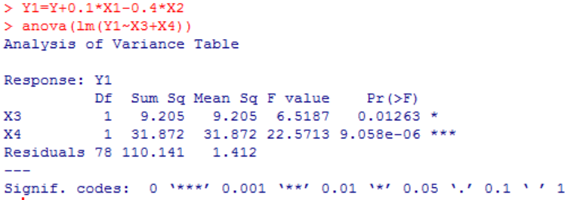

Decision rule: if $F^{*}≤F_{\left(1-α,2,n-5\right)},conclude H_{0};F^{*}>F_{\left(1-α,2,n-5\right)},conclude H_{1}$.

$F^{*}$ = $\frac{(SSE\left(R)-SSE(F\right))/2}{SSE(F)/(n-5 )}$ = $\frac{(110.141-98.231)/2}{1.293}$ =4.606

Conclusion: $F^{*}<F\left(0.99,2,76\right).$ so we conclude $H_{0}$: $β_{1}=-0.1 and β_{2}=0.4$ at 99% significant.

**Q15**

$R_{Y4}^{2}=$ SSR(X4)/SSTO(X4) = $\frac{SSR(X4)}{SSE\left(X4\right)+SSR(X4)}$ = $\frac{67.775}{67.775+168.782}$ =0.285

SSTO=236.557

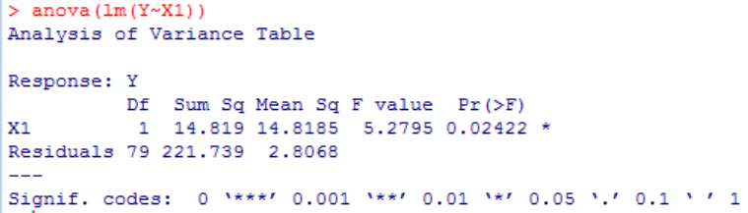

$R_{Y1}^{2}=$ SSR(X1)/SSTO(X1) = $\frac{SSR(X1)}{SSE\left(X1\right)+SSR(X1)}$ = $\frac{14.819}{14.819+221.739}$ =0.0626

X4 can explain 28.5% of variability of Y; X1 can explain 6.26% of variability of Y.

$$R_{Y1|4}^{2}=\frac{SSR(X1|X4)}{SSE(X4)}=\frac{42.274}{168.782}=0.2505$$

x1 is added into regression model inclueding x4, the error sum of squares is reduced by 25.05%.

$$R_{14}^{2}=\frac{SSR(X1,X4)}{SSTO}=\frac{236.557-126.508}{236.557}=0.4652$$

x1,x4 can explain 46.52% of variability of Y.

$$R_{Y2|14}^{2}=\frac{SSR(X2|X1,X4)}{SSE(X1,X4)}=\frac{27.857}{126.508}=0.2202$$

X2 is added into regression model which including X1, X4, the error sum of squares is reduced by 22.02%.

$$R_{Y3/124}^{2}=\frac{SSR(Y3/X1,X2,X4)}{SSE(X1,X2,X4)}=\frac{0.419}{98.650}=0.0043$$

X3 is added into a regression model which including x1,x2,x4, the sse is reduced by 0.43%.

**19**

**(a)(Just obtain the standardized coefficients)**

The correlation transformation function:

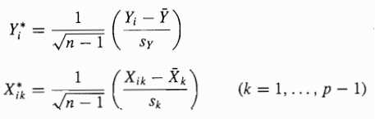

The standardized coefficients are : $β_{0}^{*}=0, β_{1}^{*}=-0.548,β_{2}^{*}=0.424,β_{3}^{*}=0.048,β_{4}^{*}=0.503$

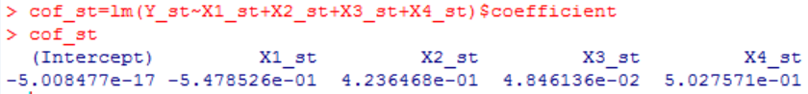

(b)

$b_{2}^{*}$ represents the difference in the predicted value of Y* for each one-unit difference in (X2*). When X2* increases 1 unit, the Y* will increase 0.424